Assignment – 10

public class ThreadExample extends Thread {  
  
 public void run() {  
 // This code will run in a separate thread  
 System.*out*.println("Thread is running");  
 }  
  
 public static void main(String[] args) {  
 ThreadExample thread = new ThreadExample();  
 thread.start(); // Start the thread  
  
 try {  
 Thread.*sleep*(1000); // Pause the main thread for 1 second  
 } catch (InterruptedException e) {  
 e.printStackTrace();  
 }  
  
 System.*out*.println("Main thread is running");  
  
 if (thread.isAlive()) {  
 System.*out*.println("Thread is still running");  
 } else {  
 System.*out*.println("Thread has finished");  
 }  
 }  
}

Output-

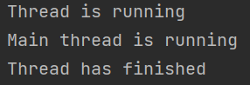

Github Link-

https://github.com/NachiketRopia2003/Java-Assignment/tree/main/Assignment%201