PROJECT 2
Individual Reflective Report
Vision Screening Management System (VSMS)
Name | Nachiketh Reddy
Student ID | p2523541
Module | ST0528 Database Systems (Project)
Academic period | 2026/2027 Semester 1

GitHub: https://github.com/soc-DBSP/react-nodejs-project2-cryptix
Final Lucidchart ERD: [INSERT FINAL LUCIDCHART LINK]
Demonstration: [INSERT DEMONSTRATION VIDEO LINK]
Purpose of this report
This is my reflection on how I contributed to VSMS, how my thinking changed during the project, and what I learned from the decisions and problems behind the final system. Technical details are included only where they help explain that journey.

1. Looking Back at My Contribution
When I look back at this project, my biggest contribution was not one isolated feature. I helped connect the different parts of VSMS into one believable workflow: an event could be prepared, staff could be assigned, participants could move through screening, doctors could review the results, and the system could keep a reliable record of what happened. I worked across the database, backend and frontend because the difficult problems often appeared between those layers rather than inside only one of them.
At first, I was focused on getting the visible workflow working. As the project developed, my attention shifted towards the less visible questions: Who is allowed to perform this action? What happens if the same request is sent twice? What if two staff members update the same participant? What data should a QR lookup reveal? These questions changed the way I approached the project. I stopped seeing security and database integrity as final checks and started treating them as part of the feature itself.
My main takeaway
The strongest work I did was making the secure and correct path feel like the normal path. I tried to keep the interface simple while placing the difficult rules in shared backend services, database constraints and transactions.

2. How I Worked with the Team
I used GitHub issues, commits and pull requests to make my work visible to the team. Issues helped me turn broad requirements into smaller problems with a clear expected result. Commits allowed me to separate implementation from follow-up fixes. Pull requests gave the team a place to review not only the code, but also the reason for a decision and the evidence that it worked.
This was especially useful because our areas overlapped. Database changes affected APIs; APIs affected the dashboard; and workflow changes affected testing and documentation. I learned that ownership does not mean working alone. It means being responsible for understanding how my change affects the rest of the system and making that impact clear to other people.
One decision that stayed with me involved referral PDFs. A password based on NRIC and phone digits would have been easier for a participant to remember, but it would also be predictable and reusable. I argued for a random one-time passphrase with a safer hand-off process. This reminded me that the easiest option for implementation is not always the simplest option for the whole system once risk is considered.
Evidence of sustained work
Across the project period, GitHub records 360 commits under my two author names and 37 pull requests authored by me, of which 35 were merged. I use these numbers as supporting evidence, not as a measure of quality by themselves.

3. Database Design: What I Learned
My early database contribution was the event and clinical foundation in PR #39. I added models for events, staffing, reviews, referrals, generated documents, notification delivery and offline synchronization. At that stage I was thinking mainly about whether the system could store every required object. Later, I realised that a good schema must also explain ownership, history and invalid states.
For example, a staff member may register participants at one event and screen participants at another. A single global role could not describe that correctly. This led me towards event memberships, event-specific duties and station assignments. In the same way, queue movements and route steps needed to preserve history rather than simply overwrite the current value. These choices made the schema larger, but they made the behaviour easier to explain and audit.
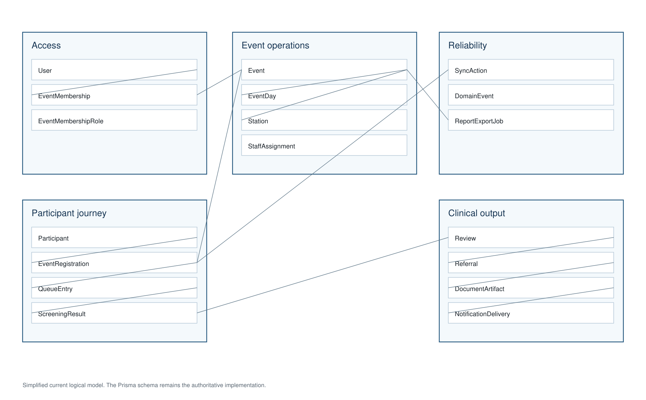
Figure 1. Simplified view of the main VSMS data relationships.

Integrity became part of my design process
I began using unique indexes, foreign keys, check constraints, transactions, version fields and row locks as ways of expressing business rules. A participant should not have two active queue positions. A retry should not create a second screening result. An event should not be deleted using an old preview after its data has changed. Handling these cases taught me that application validation alone is not enough when multiple requests can reach the system at the same time.
The project also taught me to describe contribution boundaries honestly. The final repository contains registration stored functions authored by Mike-Franco. I worked on the surrounding schema, service integration, constraints, transactions and verification, but I should not present his stored-function implementation as my own. A reflective report is more useful when it explains the real collaboration instead of claiming every merged line.

4. Features That Changed My Thinking

Event operations and access control
I implemented and refined the event lifecycle, staffing, schedules and event workspace through PRs such as #43, #85, #110, #113, #133 and #137. The difficult part was not displaying an event. It was making sure each action matched the user's responsibility for that specific event. I learned not to treat a hidden button as security; the backend service must make the final decision.

Clinical review and referrals
In PR #54 and later integration work, I built reviewer queues, participant result views, signed decisions, referrals and report delivery. I deliberately kept the reviewer as the final clinical authority. Automated rules could highlight unusual results, but they should not behave as a diagnosis. This helped me understand the importance of designing software around professional responsibility rather than only around automation.

One QR and participant routing
QR handling looked simple at first, but it exposed several risks. Returning a full participant record could reveal NRIC, contact information or internal tokens. I reduced the lookup response to the minimum information needed at a station. Later, in PR #121, I helped move the workflow towards one participant QR and a stable server-owned route. Atomic route progression meant that retries or two devices could not silently move a participant twice.

Offline screening
Offline support forced me to set a clear boundary. A complete offline copy of the system would have increased exposure and created authority that was difficult to revoke. I kept offline support limited to encrypted, expiring station packs and queued screening results. Review and administrative actions remained online. This was a practical compromise: enough resilience for a screening station, without pretending that every workflow was safe offline.

Evidence, performance and recovery
Near the end of the project, I became more careful about what the word ‘completed’ meant. A passing unit test is not the same as a live deployment test, and a generated report is not the same as a successfully delivered email. I added synthetic acceptance data, a 500-participant performance run and backup/restore checks. The retained performance evidence recorded no request errors, while recovery checks compared rows, constraints and indexes after restoration.

5. Challenges, Mistakes and Adjustments

I initially underestimated concurrency
My first instinct was often to validate a condition and then write the new state. That works in a single-user demonstration, but it can fail when two staff members act together or when an offline client retries. I adjusted by using idempotency keys, request ledgers, transactions, version checks and row locks. The lesson was not that every query needs heavy locking; it was that I should identify the state transitions where two correct requests could combine into an incorrect result.

Requirements continued to evolve
The station model, event scheduling and participant route became clearer only after we connected the full workflow. Some earlier assumptions no longer fit. Instead of protecting the first design because work had already been spent on it, I used migrations, focused pull requests and regenerated API contracts to change the model openly. I learned that changing direction is not wasted work when the reason is understood and the transition is controlled.

Security sometimes reduced convenience
Manual lookup, QR scanning, offline packs and PDF passwords all had tempting shortcuts. I had to repeatedly ask what information or authority the shortcut would expose. The better solution was usually a smaller response, a shorter expiry, a random credential or a server-side check. This made me more confident in explaining security trade-offs rather than treating security as a list of tools to run before submission.

6. My Growth During the Project
Technically, I became more comfortable working through a complete data flow. I can now trace a user action from the React interface to the API, service, Prisma query, PostgreSQL constraint and audit record. That end-to-end view helped me diagnose root causes instead of patching only the screen where a problem appeared.
I also improved in testing and evidence. Earlier, I saw tests mainly as a way to confirm expected output. By the end, I was using them to preserve security boundaries, concurrency behaviour, API contracts and recovery guarantees. I became more precise about separating automated proof, local verification and checks that still required cloud access or physical devices.
The project improved my communication as well. I learned to explain why a decision mattered, acknowledge another teammate's contribution and leave a reviewable trail. If I did the project again, I would define the trust boundaries and event-scoped role model earlier. That would reduce later migration work and make several frontend decisions clearer from the beginning.
What I would carry forward
I would continue using small reviewable changes, database-backed invariants, event-scoped authorization and synthetic verification data. I would add architecture only when a measured workflow needs it, not because it looks impressive.

7. Selected Evidence
The following items are a concise record of the work discussed above. The complete history remains available in the repository; I have avoided reproducing a long technical inventory inside the reflection.
Area | Representative evidence | What it supports
Database foundation | PR #39 | Event, clinical, document and synchronization models
Event workflow | PR #43, #85, #113, #133, #137 | Lifecycle, permissions, staffing and schedules
Clinical workflow | PR #54, #67, #115 | Review, referral and secure delivery
Security | PR #69–#73, #110 | Audit context, QR minimisation and event-scoped access
Routing and offline | PR #121, #123 | One QR, atomic progression and offline recovery
Quality evidence | PR #100–#107, #126 | Testing, performance, recovery, logging and final validation

