The Lightweight IBM Cloud Garage Method for Data Science

Architectural Decisions Document Template

# Architectural Components Overview

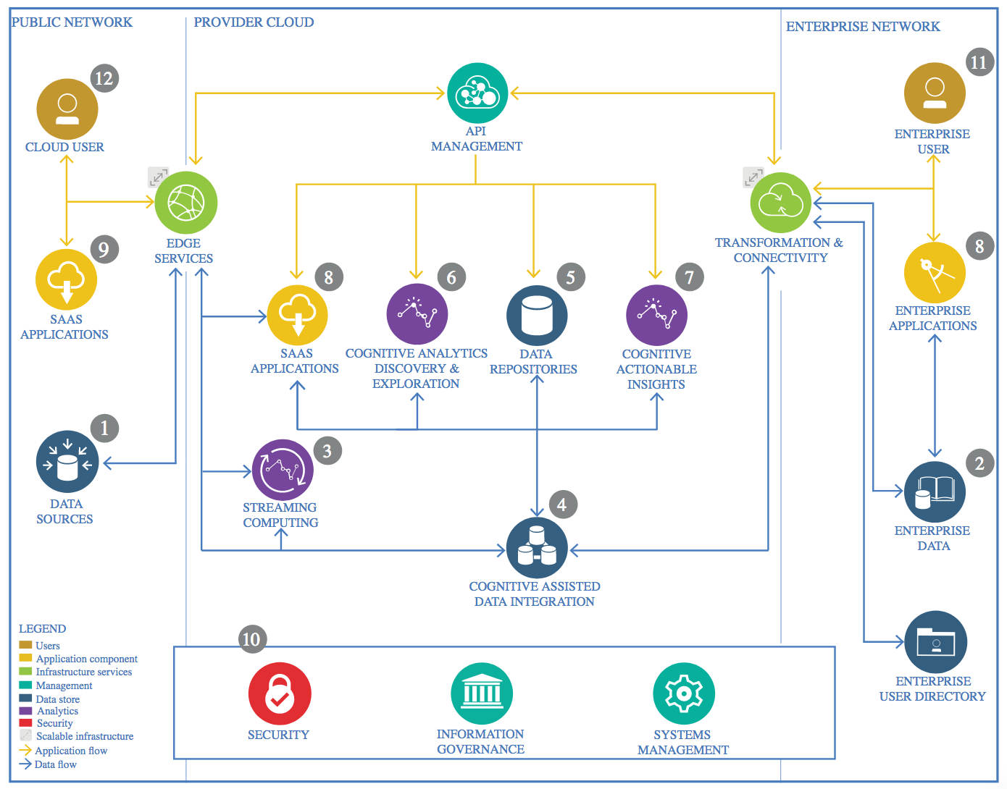

IBM Data and Analytics Reference Architecture. Source: IBM Corporation

## Data Source

### Technology Choice

Wine Quality dataset from UCI. Found at: [archive.ics.uci.edu](https://archive.ics.uci.edu/dataset/186/wine+quality)

### Justification

The dataset contains multivariate features and can be used for multiple purposes (either regression or classification). It can also be directly imported to python without having a physical file or set of files on your local computer.

## Enterprise Data

### Technology Choice

GitHub Repository

### Justification

It allows easy version control of the project with sequential updates.

## Streaming analytics

### Technology Choice

N/A – No streaming analytics tool was used.

### Justification

N/A

## Data Integration

### Technology Choice

N/A – No data integration tool was used.

### Justification

N/A

## Data Repository

### Technology Choice

Python Pandas Repository

### Justification

Easy to handle and transform.

## Discovery and Exploration

### Technology Choice

Mainly data science python libraries such as pandas (data storing), numpy (mathematical operations and list handle), matplotlib and seaborn (data visualization) and scikit-learn (data science transformations).

### Justification

Accessibility to functions

## Actionable Insights

### Technology Choice

Mainly data science & AI python libraries. Pandas for sorting the data, scikit learn for the non-deep learning evaluated models and Torch for the deep learning models.

### Justification

Accessibility to the algorithms in case of scikit and in case of torch, the easy-use tools it provides for creating neural network models.

## Applications / Data Products

### Technology Choice

Jupyter Notebook report.

### Justification

Sufficient as no application is being developed and we just care about numeric results.

## Security, Information Governance and Systems Management

### Technology Choice

N/A – Not security management has been developed.

### Justification

N/A