Consider a simple analog clock. The only hand forms an angle of a degree with the vertical axis. What time does it show?

Return an array of two elements, where the first element is an hour, and the second element is a minute. Both values should be rounded down to the nearest integer.

**Example**

* For a = 45, the output should be  
  ClockDirection(a) = [1, 7].
* For a = 564, the output should be  
  ClockDirection(a) = [6, 34].

Check out the images below for better understanding.

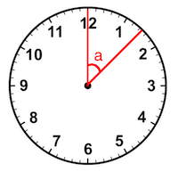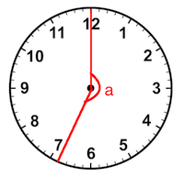

**Input/Output**

* **[time limit] 3000ms (cs)**
* **[input] integer a**

An integer denoting the value of the angle.

*Constraints:*  
0 ≤ a ≤ 1000.

* **[output] array.integer**

Array of two integers, hours and minutes the hand shows, respectively.

<https://codefights.com/challenge/6pmcHPne2nLH3sYF3/main>

using System;

using System.Collections.Generic;

using System.Linq;

using System.Text;

namespace ConsoleApplication1

{

class Program

{

static int[] ClockDirection(int a)

{

if (a > 360)

{

a = a % 360;

}

if (a == 360)

{

return new int[] { 0, 0 };

}

int horas = (int) Math.Floor((double)a / 30);

int min = (int)Math.Floor((double)a / 6);

Console.WriteLine(horas + " " + min);

return new int[2] { horas, min };

}

static void Main(string[] args)

{

ClockDirection(45);

Console.ReadLine();

}

}

}