Mafia Role Card

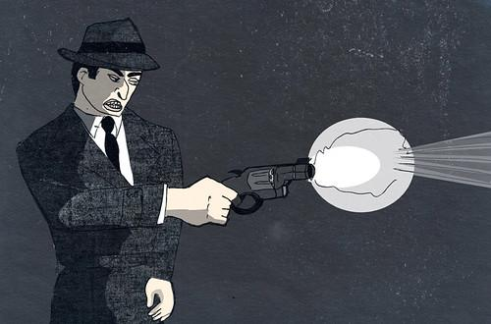
Mafia

Win Condition: Work with fellow mafia members to eliminate the townspeople and come out victorious.

Ability (Night): You may privately message other mafia members at night time, additionally, as a group the mafia may have a majority vote to kill one non-mafia townsperson at night.

Mafia Role Card

Traitor

Win Condition: Work with fellow mafia members to eliminate the townspeople and come out victorious.

Ability (Night): You may choose any non-unique town role to show as for the night. Any detective work done on you will show under this role for that night.

Fellow mafia members will have names revealed every second night. Make the town turn against each other!

Town Role Card

Doctor
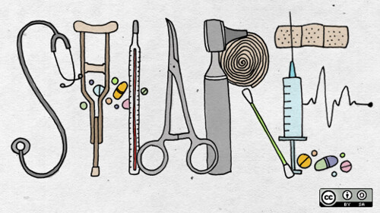
Win Condition: Strategize with other town members to lynch all evil lurking in the town.

Ability (Night): Select one member to heal, if this player is attacked this night, they will survive this attack.
This ability will let the player know they were healed.

Town Role Card

Detective

Win Condition: Strategize with other town members to lynch all evil lurking in the town.

Ability (Night): Select one player to investigate. At the end of the night, two potential roles will be shown that the player could be.

Neutral Role Card

Serial Killer

Win Condition: Blend in and terrorize the town, eliminating all other players.

Ability (Night): Select one player each night. You will visit their home and attempt to murder this player.

Passive: You may not be killed by base level
attacks during the night time

Neutral Role Card

Backup

Win Condition: Pick up a different role to have a better chance at winning! You can gather a neutral win by playing with town.

Ability: Select a player at any time from the graveyard menu. This will allow you to fill in this player's role for the remainder of the game.

Neutral Role Card

Jester

Win Condition: Trick the town into lynching you by acting like a sussy baka.

Ability (Once Dead): Kill any person in the town who was once against you during your time alive.

Ability (Passive): See all whispers that occur during the game. Mentioning whispers may give you away!

