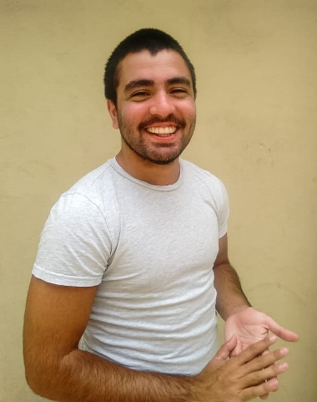

**IGNACIO VARNI**

Looking to make my first steps working as a developer.   
Always open to learn and get better.

**ABOUT ME**

* Email: nachovarni6@gmail.com
* Number: 11 6409 1233
* ID: 40.134.771
* Birth date: January 14, 1997
* Location: Chacarita, CABA, Argentina.

**COURSES**

* **Backend at Course[It].** *November 2020 to present*
* **Frontend at Course[It].** *February 2020 to August 2020*
* **Advanced frontend at Course[It].** *August 2020 to November 2020*

**STUDIES**

* *High school*
  + **Marie Manoogian Institute:** Bachelor with job training in computerized accounting administration.

**SKILLS**

* HTML
* CSS
* JAVASCRIPT
* REACT
* REDUX
* NEXT.JS
* GIT

**LANGUAGES**

* SPANISH *(native)*
* ENGLISH *(advanced)*