## Part A: Multi-dimension Array with Text File Processing (Average & SD)

The file *attendace.csv* contains an attendance score (0 = absent, 0.5 = late, 1 = present) for 6 weeks. The file is in the “Comma-separated Value” format (<http://en.wikipedia.org/wiki/Comma-separated_values>) with the first line being the header labels describing the order of data on the other lines.

* Read [Java](http://docs.oracle.com/javase/8/docs/api/java/util/Scanner.html) API (google - class Scanner)to learn how to read a text file using an instance of the Scanner class.
* Open the file in a spreadsheet application (such as MS Excel). If you do not have any spreadsheet application on your machine, try using Google Spreadsheet.
* Write a Java program (ClassAttendance.java) to compute “an average of class attendance score **for each week**” and fill in the table below
  + Hint: Please use the template code “ClassAttendanceStat_Template.java”!

## Part B: Understanding Given Resources/Backgrounds

1. Get yourself familiar with the RGB color model. Play around with the color picker on <http://www.colorpicker.com/> and answer the following questions.
2. Read the source code of *Java101ImageUtilExample.java* and try executing the program. Try to understand what the program does. (** It is recommended NOT TO open big images. The program was not optimized in any ways. Try the program on some images with a few hundreds of pixels in their width/height)

## Part C: Creating RGB arrays for Desired Images

1. Write a program performing the following steps.
   1. Create a 3-D array of int that when used with showViewer(int [ ][ ][ ],String), the program shows a 256-pixel (width) x 128-pixel (height) **all-yellow** image.
      1. Note the method to refer to each pixel is “image[columIndex][rowIndex]”
   2. Show the image with showViewer(int [ ][ ][ ],String)

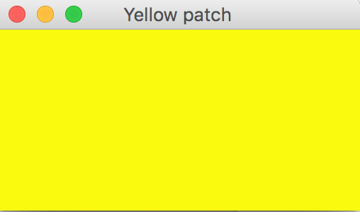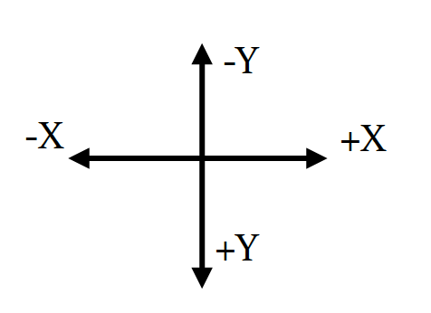

1. Write another program performing the following steps.
   1. Ask the user to input the value of w and h, which are integers in the range of 100 to 200.
   2. Show an image as shown in the figure below. Use the colors of your choice.
   3. The interpolation concept is needed.

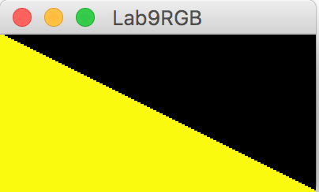

## Part D: Image Manipulation

Modify *DesaturateIt_Template.java* to obtain a Java program performing the following steps.

1. Ask the user to select a gif or a jpg file. (Some example files are provided.)
2. Show the original image, grayscale, and its sapia version using showViewer()

Note: Converting a color image into sepia image is very simple. All we have to do is repeat 3 simple steps for each pixels of the image.

1. Get the RGB value of the pixel.
2. Calculate tr, tg and tb using the formula

tr = 0.393R + 0.769G + 0.189B

tg = 0.349R + 0.686G + 0.168B

tb = 0.272R + 0.534G + 0.131B

Take the integer value.

1. Set the new RGB value of the pixel as per the following condition:

If tr > 255 then r = 255 else r = tr

If tg > 255 then g = 255 else g = tg

If tb > 255 then b = 255 else b = tb

