**2110233 Com Eng Math Lab - (1/2024) Take Home Quiz**

**Submission: (1) pdf file and (2) ipynb before 23:59, 19 September 2024**

**Instructions:**

* This exam is an open book exam.
* You are also allowed to open online resources, but you will have to answer in your own words and understanding. You must provide all references at the end of this document.
* The exam must be taken completely alone. You cannot share your answers or code with anyone.
* You can ask questions on discord in **#labexam1**, further announcement will be posted on **#announcement**
* You must complete the exam within this exam paper and submit in PDF file. The PDF file will be primarily scored, while the IPYNB file will be used as a reference for validating the PDF file. Make sure you provide **clear** and **original** **answers** to all questions **in your own words**.
* **Any student who does not obey the regulations listed above will receive punishment under the Faculty of Engineering Official Announcement on July 27, 2017 regarding the exam regulations.**

**a) With implicit evidence or showing intention for cheating, student will receive an F in that subject and will receive a lower ethical behavior score.**

**b) With explicit evidence for cheating, student will force to withdraw from Chulalongkorn University, or students will an F in that subject during that semester and will be required to withdraw all subjects and receive a lower ethical behavior score.**

I acknowledge all instructions above. This exam represents **only my own work**. I did not give or receive help on this exam.

Signature …………………………Chotpisit……………….............

Date ………………13 September 2024……....................

All required files and parameters have been sent to your Chula email.

**1. (15 points) Audio Analysis**

Download **file1.wav** and **file2.wav** from the links provided in your email. Perform a DFT to analyze and compare the signals.

* 1. Plot the **file1** and **file2** signals in time domain and its frequency spectrum (low frequency at the center)

**file1 and file2**:

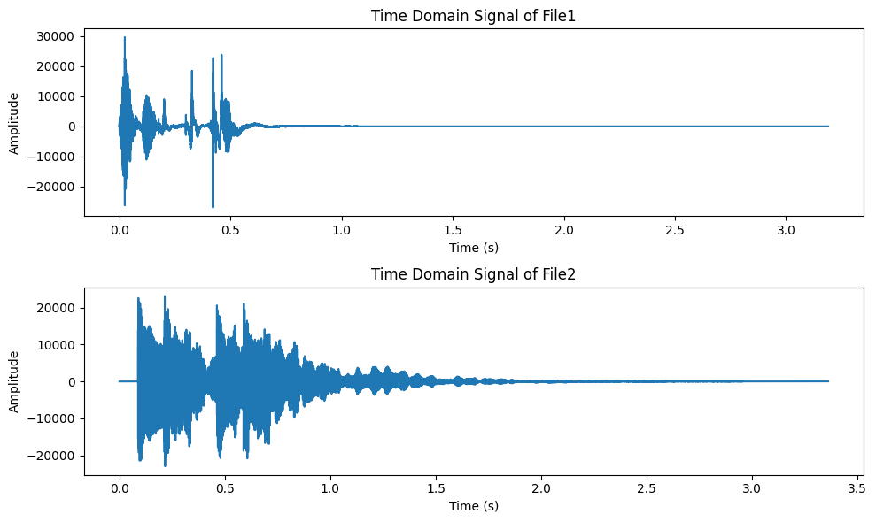

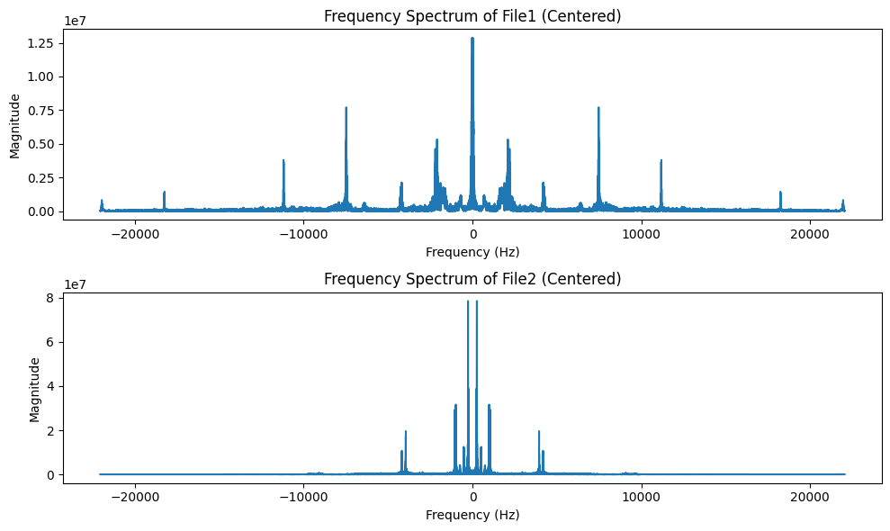

1.2) Determine top three dominant frequencies of each signal in Hz. EXCLUDING the dc component and those that are the consequence of the **complex conjugate symmetry** property. Explain how you obtain these values.

**Note:** The 1st, 2nd, and 3rd dominant frequencies are those with the highest, second highest, and third highest magnitudes in the spectrum.

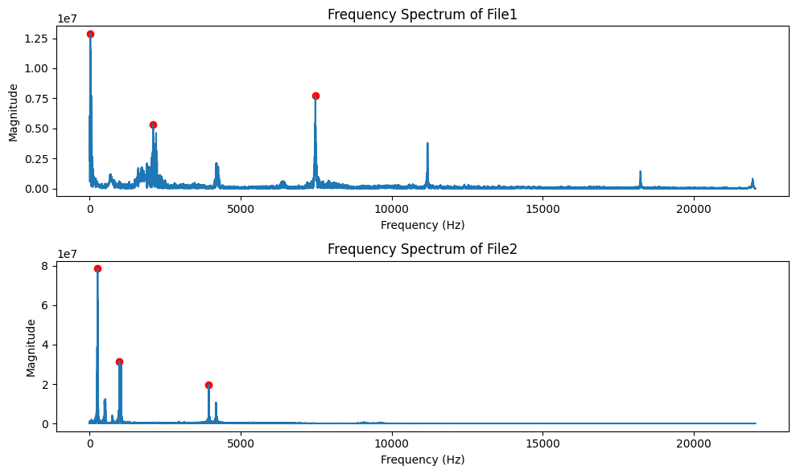

**File1**:

1st dominant frequency: 22.88 Hz

2st dominant frequency: 7476.18 Hz

3st dominant frequency: 2098.12 Hz

**file2:**

1st dominant frequency: 263.35 Hz

2st dominant frequency: 987.03 Hz

3st dominant frequency: 3946.33 Hz

Explanation:

|  |
| --- |
| Find the peaks of the frequency domains using the find_peaks function from Scipy and set the distance_between_peaks to 1% of the total frequency to clean the nearby high magnitude in one peak. See more explanations in the codes |

1.3) Analyze and compare the frequencies of the two signals and their corresponding sounds in your own words.

|  |
| --- |
| File1.wav has high frequency sound at the start and has low-frequency sound afterward. So there are both low (22 Hz) and high frequencies(2000-7500 Hz).  File2.wav has a pattern with a high frequency at the start and a low afterward. This repeats two times. So there are both low (300-900 Hz) and high (4000 Hz) |

**Note:**

-If you use python, you can use “scipy.io.wavfile.read” for reading WAV file,

see <https://docs.scipy.org/doc/scipy/reference/generated/scipy.io.wavfile.read.html>

2) (15 points)

Hamtaro plans to design a system where the relationship between the input $x[n]$ and the output $y[n]$ is defined as follows:

$$y\left[n\right]=a_{1}x\left[n\right]+a_{2}x\left[n+n_{1}\right]+a_{3}x\left[n+n_{2}\right]$$

The parameters $a_{1},a_{2},a_{3},n_{1},$ and $n_{2}$ are defined in params.json. Provide the values below:

|  |  |  |  |  |  |  |  |  |  |
| --- | --- | --- | --- | --- | --- | --- | --- | --- | --- |
| $$a_{1}=$$ | -3 | $$a_{2}=$$ | -1 | $$a_{3}=$$ | 2 | $$n_{1}=$$ | -3 | $$n_{2}=$$ | -3 |

2.1) Determine the impulse response $h[n]$ and frequency response $H\left(e^{jω}\right)$ of the system and demonstrate the solution steps in your own words.

|  |
| --- |
| 1. Impulse Response h[n]  The impulse response h[n] represents how the system responds when the input is a unit impulse [n], which is just a signal that is zero everywhere except at n=0, where it's  The system equation becomes: h[n]=a1​δ[n]+a2​δ[n+n1​]+a3​δ[n+n2​]  Substituting the values from the parameters: h[n]=−3δ[n]+(−1+2)δ[n−3]=−3δ[n]+1δ[n−3]  2. Frequency Response H(e^jω)  The frequency response H(e^jω) describes how the system behaves at different frequencies. It's calculated by taking the Discrete-Time Fourier Transform (DTFT) of the impulse response h[n].   * The Fourier transform of δ[n] is 1. * The Fourier transform of δ[n−3] is e^−(3jω).   So, the frequency response is:  H(e^jω)=−3+e^(−j3ω) |

2.2) Plot magnitude and phase of the frequency response.

|  |
| --- |
|  |

2.3) Determine and plot the DFT of the system output using your student id as the input sequence $x[n]$ to the system. For example, if your student ID is 6531313221, the input sequence $x[n] =\{6,5,3,1,3,1,3,2,2,1\}$. Finally, show the solution steps in your own words.

|  |
| --- |
| 1. The system's impulse response was derived from the given parameters and calculated by applying the system equation to a unit impulse. 2. The frequency response H(e^jω) was calculated using the DTFT of the impulse response. 3. Based on the student ID, the input sequence was used to compute the output y[n], and its DFT was plotted to analyze the frequency content of the system's output. |

References

|  |
| --- |
| ChatGPT 4o (main code)  Claude 3.5 Sonnet (for validation)  Gemini in Google Colab (for validation)  Llama 3.1 (for validation)  CEM 2 Slides |