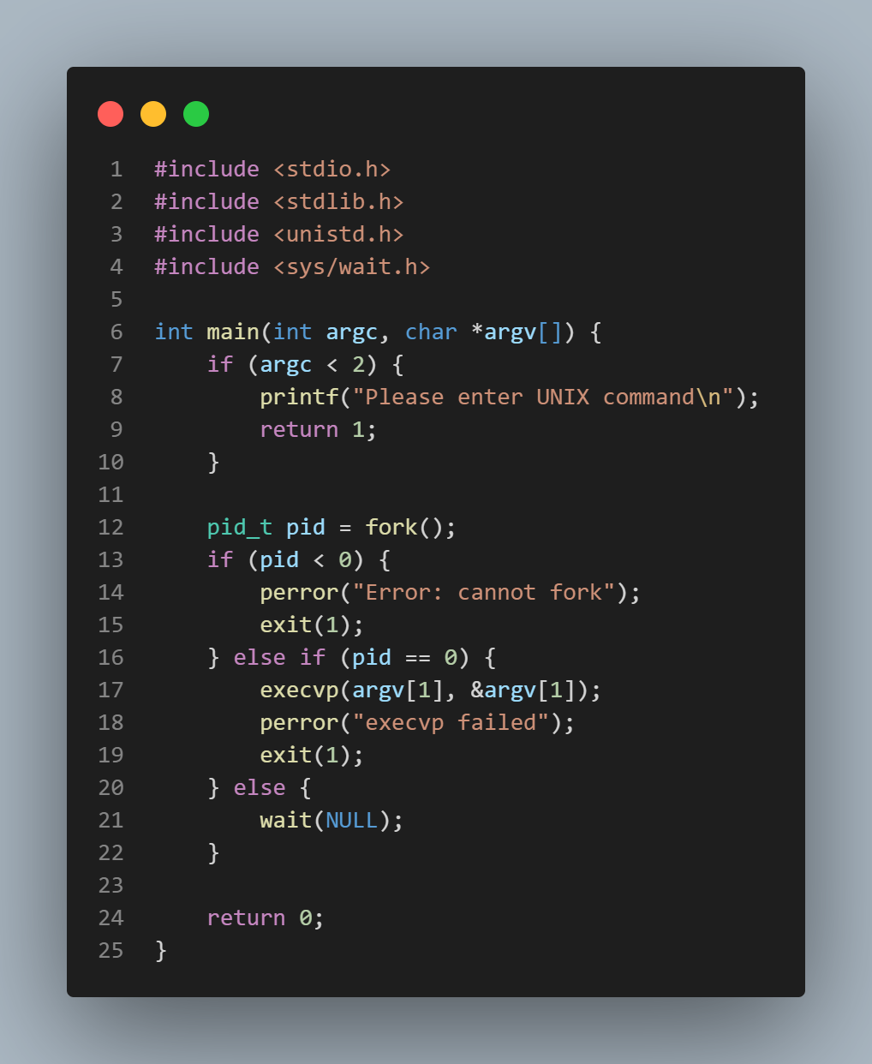**1.**

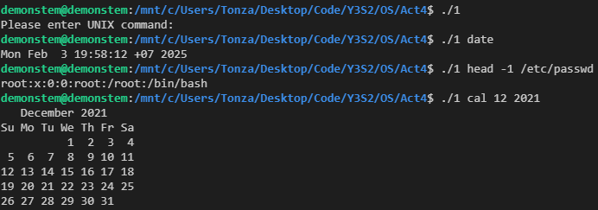

**2.**

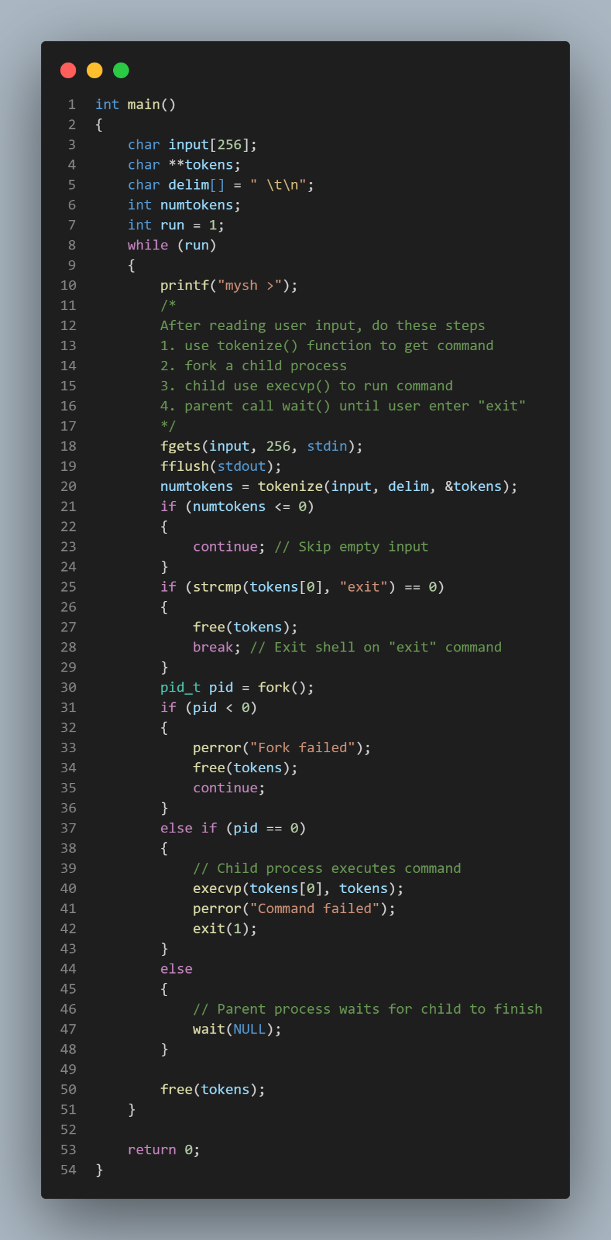

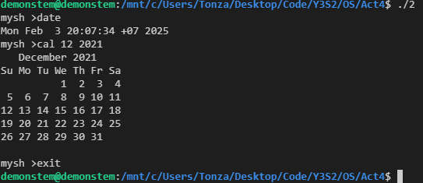

**MEMBERS:**

* **6532040021 Chanatip Pattanapen**
* **6531313221 Chotpisit Adunsehawat**
* **6532068721 Nutthapat Pongtanyavichai**