Contents

Creating GitHub repository for group collaboration 1

Creating an Initial GitHub repository 1

How to Integrate GitHub in Visual Studio Code and clone an existing repository 1

How to commit code to your GitHub repository 1

# Creating GitHub repository for group collaboration

## Creating an Initial GitHub repository

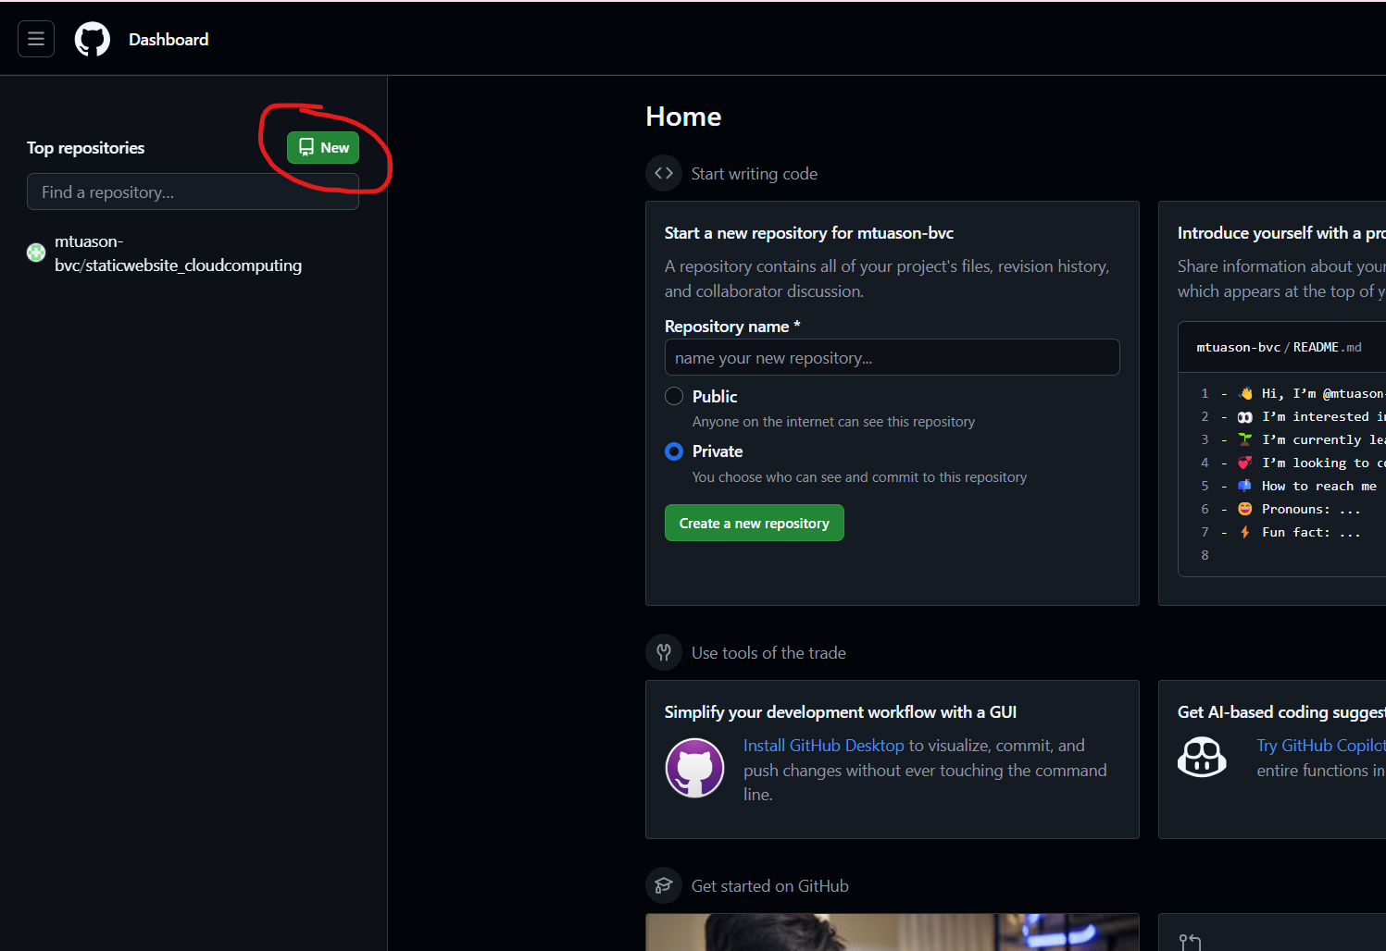

Create a GitHub account and login. When you get into the dashboard click on New Repository.

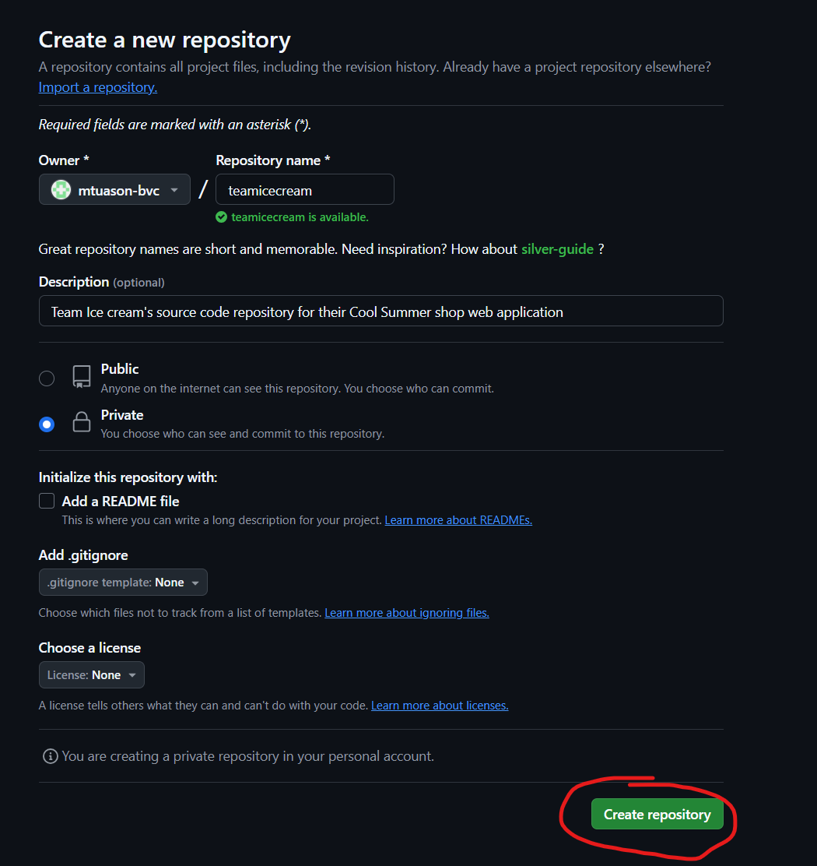

Create a unique repository name and put a meaningful description to easily describe the contents of the project repository. In this example we make it a private repository since we do not want the public to see the contents of the source code. If the project’s intention is to be collaborative with everyone then create a public repository instead. Click “Create the repository” afterwards.

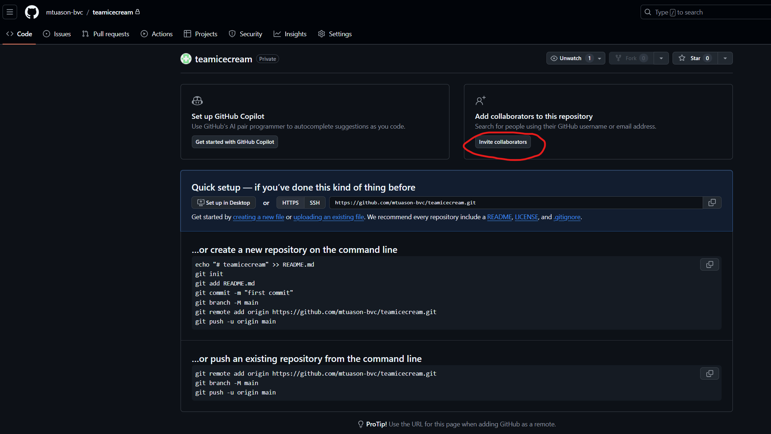

Since it is the intention of the project to be a collaborative one then the “invite collaborators” function adds the teammates which makes them a part of the private repository.

Add people to the currently empty collaborators list.

You will need to enter each group member either via their GitHub username, full name, or email address used to create their account.

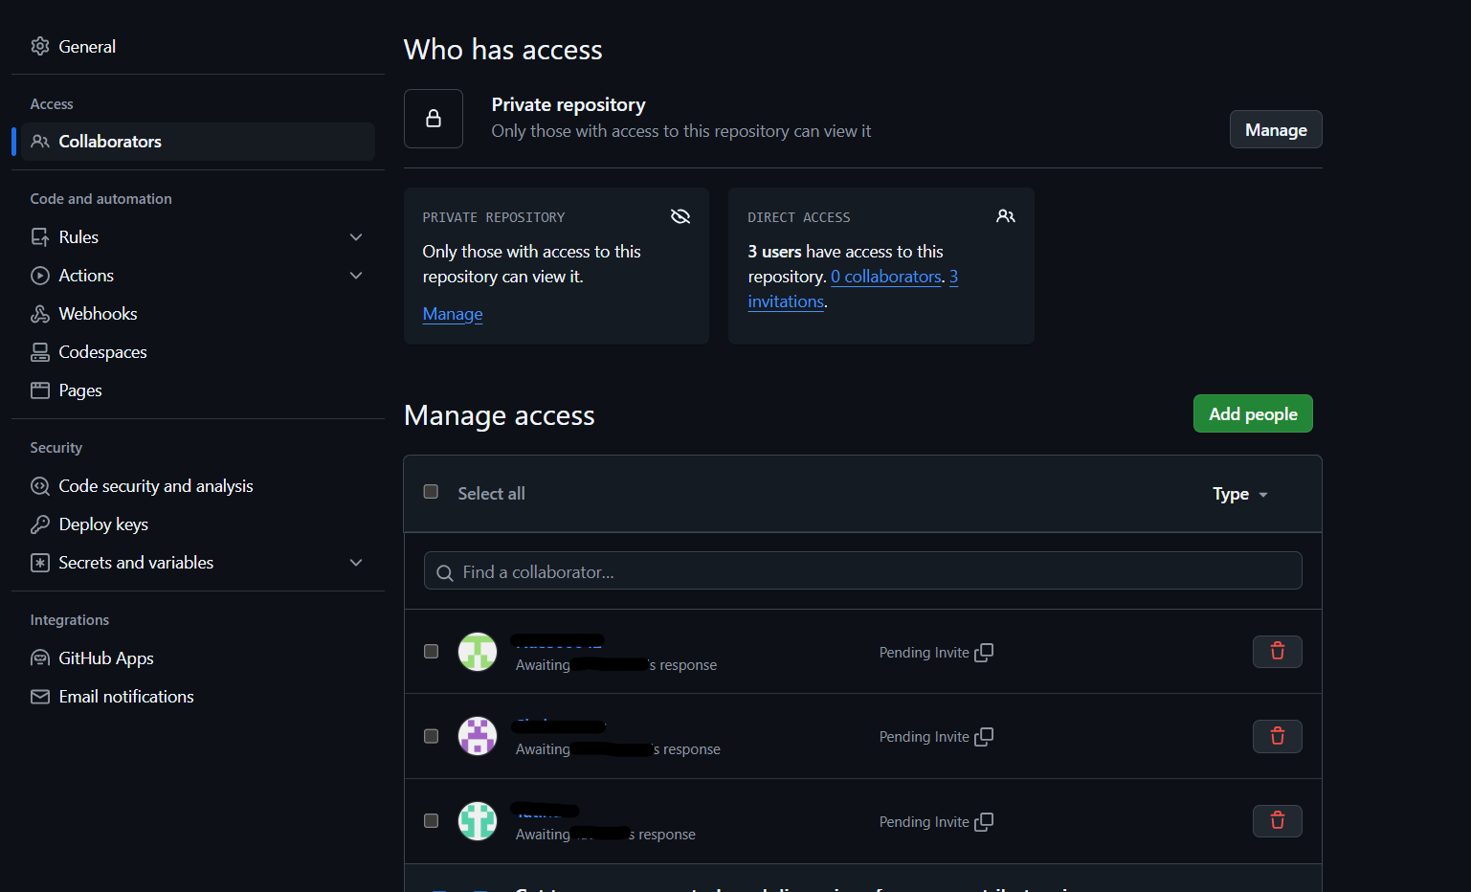

Once collaborators have been added they will need to approve of the invite before being able to see the project repository contents. You can add more members or delete members from the repository collaboration from this window.

## How to Integrate GitHub in Visual Studio Code and clone an existing repository

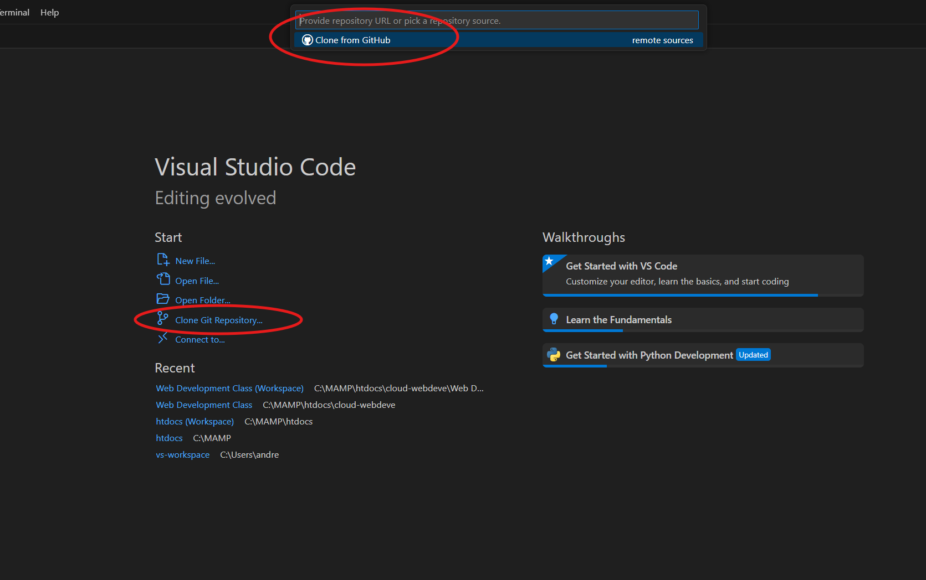

Close any current workspaces you are currently in to get into the Visual Studio Code main menu. Select “Clone Git Repository” and a Clone from GitHub option would show at the top.

If this is the first time integrating GitHub to your Visual studio then this window would appear. Click Allow and enter your GitHub credentials using the account you will use to collaborate with your group.

Give Visual Studio Code Authorization to connect to your GitHub account.

Once Visual Studio Code has authorization to your GitHub account select the correct GitHub repository. Having a good repository name and meaningful description would make it easy to differentiate the different repositories available in your account. If you are an invited to for collaboration, ensure that you have accepted the invite first.

Select a local directory where the repository files will be stored on your computer.

One the repository has been cloned Visual Studio would ask if you would like to open the contents of the repository into a new workspace.

## How to commit code to your GitHub repository

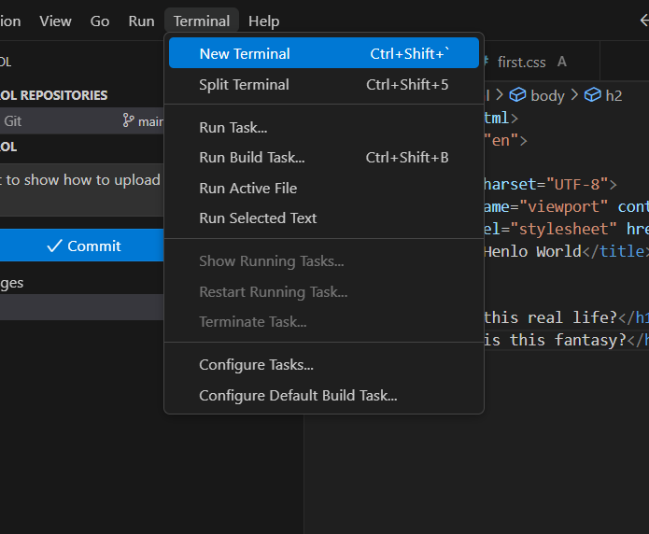

Before being able to commit your code to your repository you would need to set your username and email address to the Git config. Open a new terminal and enter the following commands with your details:

In this example we currently have an empty repository. We have created two files, an html and a CSS file, and would like to perform the first code commits. They are currently unstaged as they are new files.

Enter a short but descriptive reason for the commits to the repository so that your teammates know what changes have been made in a single glance. Since the files are new, they are not considered staged. When you click the Commit button then it will ask you if you want to stage all new files to the repository.

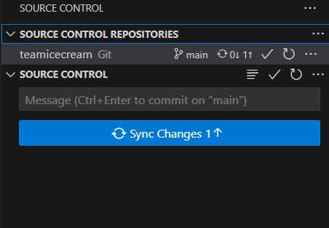

A commit does not automatically upload the changes to your repository. This would only happen upon a sync or a push to your repository. Commit as much as possible if there’s any significant changes you have made to the code but to minimize upload bandwidth consumption then push or sync only after you intend to upload and be seen by your teammates.