

Ivypots

Pinout for the circuit

Nayel Khouatra | Contest Wiznet Design 2022 | 21/10/22

# 

# Wizfi360-EVB-Pico

Since RP2040 is a perfectly timed product it wasn’t long before everyone started making boards and modules using it. Even we are making a series of RP2040-based boards called Mitayi. More about that will be in an upcoming post. WIZnet, a South Korean semiconductor company, has introduced its new RP2040-based board by combining its WizFi360 pre-certified Wi-Fi module. WizFi360 is based on the [W600 SoC](http://www.winnermicro.com/en/html/1/156/158/497.html) from Winnermirco, a Chinese semiconductor company. The new development/evaluation board is called WizFi360-EVB-Pico.

Rasberry Pico Pinouts :

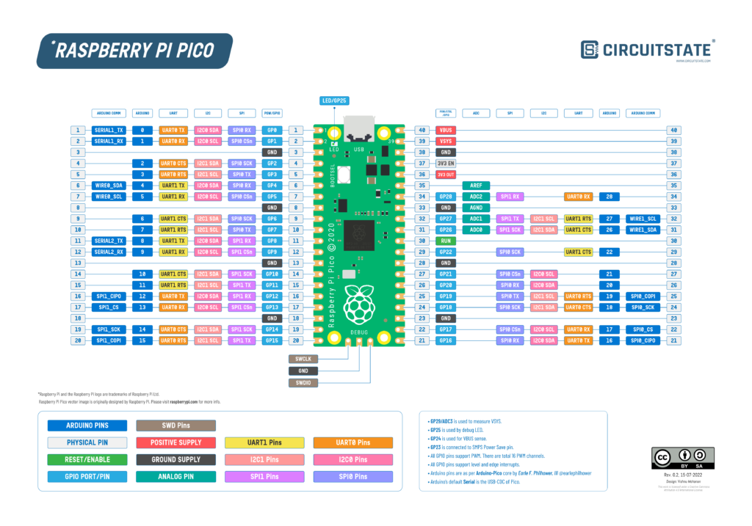

[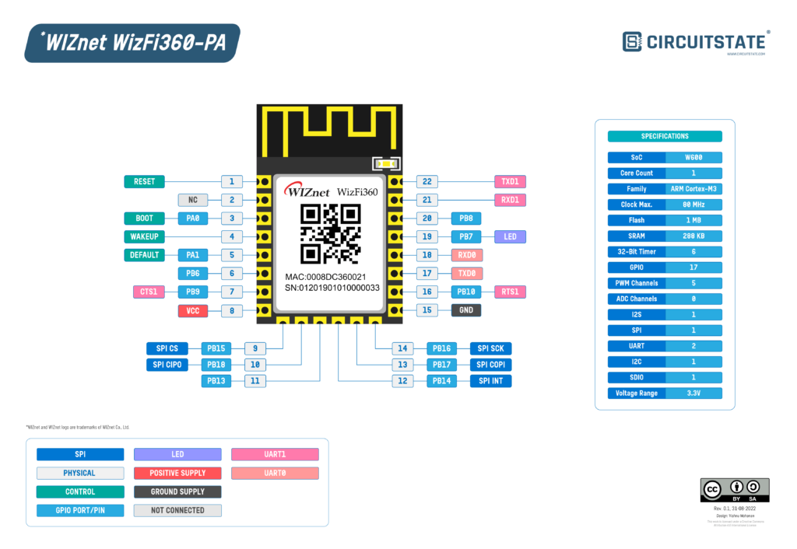](https://circuitstate.com/wp-content/uploads/2022/08/WIZnet-WizFi360-PA-Pinout-Diagram-r0.1-CIRCUITSTATE-Electronics-01.png)Wizfi360 PA Module :

Ivypots Circuits :

