Xinlei Bian(002197091)

**Program Structures & Algorithms**

**Fall 2021**

**Assignment No. 5**

* **Task (List down the tasks performed in the Assignment)**

1. A cutoff (defaults to, say, 1000) which you will update according to the first argument in the command line when running. It's your job to experiment and come up with a good value for this cutoff. If there are fewer elements to sort than the cutoff, then you should use the system sort instead.
2. **Recursion depth or the number of available threads. Using this determination, you might decide on an ideal number (*t*) of separate threads (stick to powers of 2) and arrange for that number of partitions** to be parallelized (by preventing recursion after the depth of *lg t* is reached).
3. An appropriate combination of these.

* **Relationship Conclusion:**

1. To achieve the best performance, the number of available threads is above 16. At first, with the increase of available threads, the performance increased. But when the available threads reach 16, it stops increasing.
2. The best ratio of cutoff and array size is around 0.07~0.1.
3. Combination parallel sorting and cutoff can have a better performance for merge sort.

* **Evidence to support the conclusion:**

1. **Output (Snapshot of Code output in the terminal)**

图形用户界面

图形用户界面

应用程序

电脑屏幕截图

电脑屏幕截图

电脑屏幕的照片

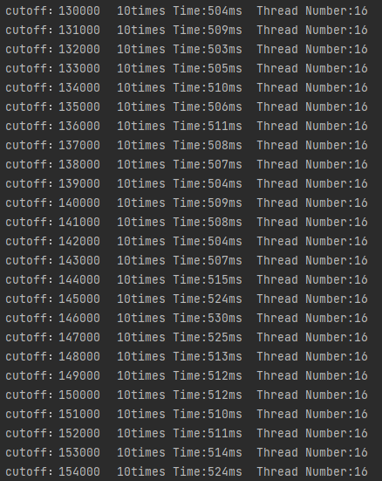

1. **Graphical Representation(Observations from experiments should be tabulated and analyzed by plotting graphs(usually in excel) to arrive on the relationship conclusion)**

**Line Chart with Cutoff and Times in Different Thread Number**

The line chart shows that when the thread number is above 16, the time cost does not decrease.

The array size is 2000000. From the chart, it can be found that when the cutoff is around 13000~20000, the time cost is the least. That means when the ratio of cutoff and array size is around 0.07~0.1, it has a better performance.

Combining the parallel sort and cutoff show better performance as it can be found from the chart. Comparing the result with 1 thread and 16 threads, the one with 16 threads or more has a better performance.