⚡ Electric Vehicle Market
and Infrastructure Expansion Analysis

Software Packages Project
ECSI Faculty • Year III • 2024/2025
Dataset: Global Electric Vehicle Market 2026 (Kaggle)
https://www.kaggle.com/datasets/dastgeerjutt/global-electric-vehicle-market-2026

Project Overview

This project analyzes the global Electric Vehicle (EV) market and its infrastructure expansion possibilities using the dataset published on Kaggle by dastgeerjutt (Global Electric Vehicle Market 2026). The analysis is conducted using two software packages — Python and SAS — to extract meaningful economic and business insights.

Organization subject: Global Electric Vehicle Market & Charging Infrastructure
Dataset: Global Electric Vehicle Market 2026 – Kaggle (dastgeerjutt)
Tools: Python 3.x, SAS 9.4 / SAS Studio
Python libraries: pandas, numpy, matplotlib, scikit-learn, statsmodels, geopandas, streamlit
SAS procedures: PROC IMPORT, PROC FORMAT, PROC MEANS, PROC FREQ, PROC CORR, PROC REG, PROC SGPLOT, PROC REPORT, PROC TABULATE, PROC SQL

Dataset Description
Column | Type | Description
Country | String | Name of the country
Year | Integer | Reference year of the data point
EV_Sales | Numeric | Total number of electric vehicles sold
EV_Market_Share_Pct | Numeric | EV share as % of total vehicle market
Charging_Stations | Numeric | Total number of public charging stations
BEV_Sales | Numeric | Battery Electric Vehicle (BEV) sales count
PHEV_Sales | Numeric | Plug-in Hybrid EV (PHEV) sales count
GDP_per_Capita_USD | Numeric | Gross Domestic Product per capita (USD)
Population_M | Numeric | Country population in millions
Govt_Policy_Score | Integer | Government EV policy strength (1–10)
CO2_Reduction_Target_Pct | Numeric | National CO2 reduction target (%)
Infrastructure_Invest_MUSD | Numeric | EV infrastructure investment (million USD)
Region | String | Geographic region classification

PART 1 – PYTHON

The Python part of the project uses the following functionalities (10 of 10 required):
- Streamlit – interactive web dashboard
- GeoPandas – geographic visualization of EV adoption
- Missing values and extreme value treatment (IQR, Winsorization)
- Encoding methods (LabelEncoder, OneHotEncoder)
- Scaling methods (StandardScaler, MinMaxScaler)
- Statistical processing, grouping and aggregation (pandas)
- Dataset processing with merge / join
- Graphical representation with matplotlib
- scikit-learn: K-Means clustering + Logistic Regression
- statsmodels: Multiple OLS Regression

Functionality A – Streamlit Dashboard

a) Defining the Problem
The problem requires building an interactive dashboard that allows users to explore the Global EV Market dataset dynamically — filtering by region and year, viewing KPI metrics, and navigating multiple chart types.

b) Information Required for Solving
The complete ev_streamlit_app.py script loads the dataset, applies pandas aggregations, and renders all visual components using Streamlit widgets. Required: Python 3.8+, Streamlit, pandas, matplotlib, geopandas.

c) Calculation Methods / Algorithms Used
Streamlit uses a reactive rendering model: each widget change triggers a full script re-execution. Data is cached with @st.cache_data to avoid re-loading on every interaction. The dashboard exposes: st.metric() for KPIs, st.dataframe() for tabular output, st.pyplot() for charts, st.multiselect() for region/year filters, and st.download_button() for CSV export.

d) Presentation of Results
Run with: python -m streamlit run ev_streamlit_app.py. The dashboard opens in the browser at localhost:8501.

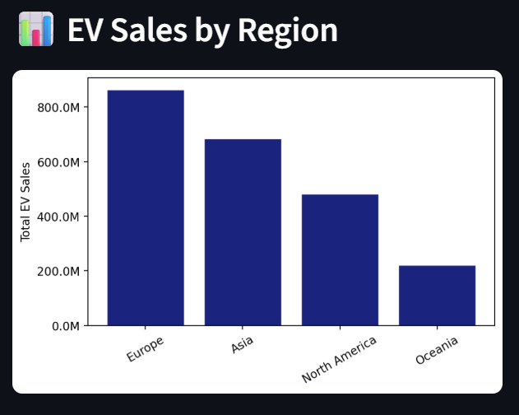
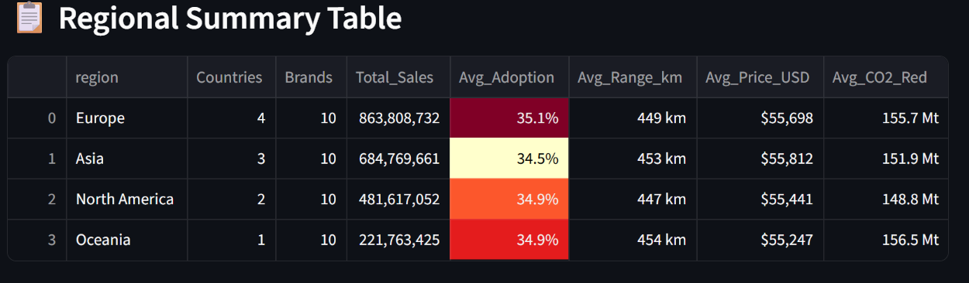

e) Economic Interpretation of Results
The dashboard enables business users to instantly assess which regions lead in EV adoption (Europe and Asia dominate), identify countries with large policy gaps (emerging markets), and track yearly growth trends. The interactive nature supports scenario analysis for infrastructure investment decisions.

Functionality B – GeoPandas – Geographic Visualization

a) Defining the Problem
Visualize average EV market share by country on a world map to identify geographic patterns in EV adoption.

b) Information Required for Solving
GeoPandas naturalearth_lowres built-in world shapefile, merged with aggregated EV market share data from the dataset. Requires: geopandas, matplotlib.

c) Calculation Methods / Algorithms Used
The EV dataset is aggregated to country-level averages using df.groupby('Country')['EV_Market_Share_Pct'].mean(). The result is left-joined with the GeoPandas world GeoDataFrame on the country name column. The merged GeoDataFrame is plotted using .plot(column='EV_Market_Share', cmap='YlOrRd') which choropleth-shades each country by its market share value.

d) Presentation of Results
A choropleth world map is displayed in the Streamlit app.
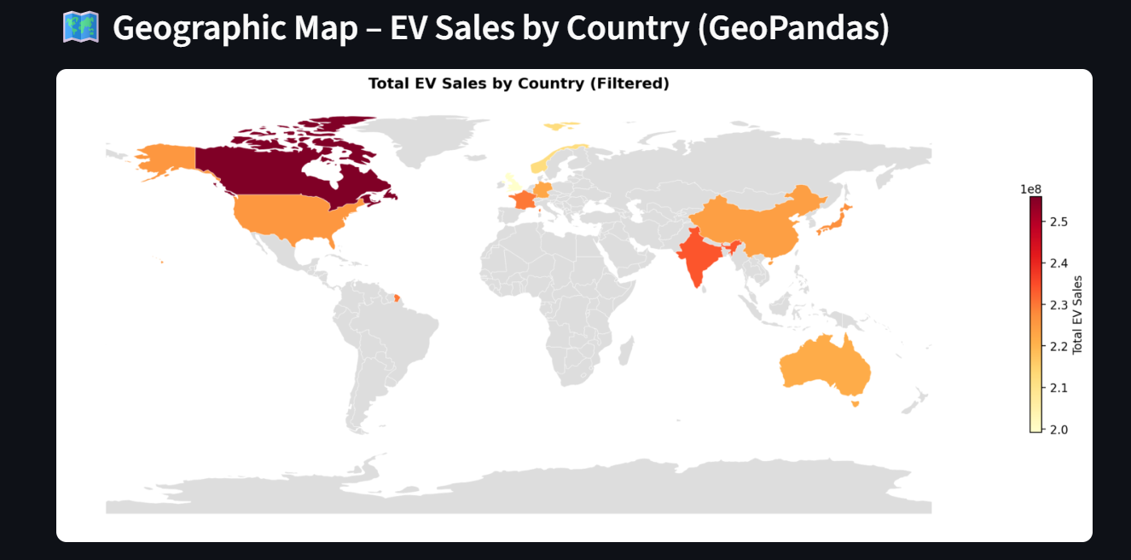

e) Economic Interpretation of Results
The geographic visualization reveals strong spatial clustering of EV adoption: European and East Asian countries show the highest market shares (darker shading), while African, South American, and South Asian markets remain largely underpenetrated. This geographic disparity represents an expansion opportunity for EV manufacturers and infrastructure providers targeting emerging markets.

Functionality 1 – Missing Values and Extreme Values

a) Defining the Problem
Identify and handle missing values and statistical outliers in the EV dataset to ensure data quality before analysis.

b) Information Required for Solving
Raw dataset from Kaggle loaded via pandas read_csv(). Columns inspected: EV_Market_Share_Pct, Charging_Stations, GDP_per_Capita_USD. Outlier detection uses the IQR (Interquartile Range) method.

c) Calculation Methods / Algorithms Used
Missing values: df.isnull().sum() identifies nulls per column. Numeric nulls are imputed with the column median (robust to skew). Categorical nulls use mode imputation. Outliers: IQR = Q3 - Q1; bounds = Q1 - 1.5*IQR and Q3 + 1.5*IQR. Values outside bounds are identified as outliers and capped using df.clip() (Winsorization). This preserves the sample size while removing extreme influence.

d) Presentation of Results
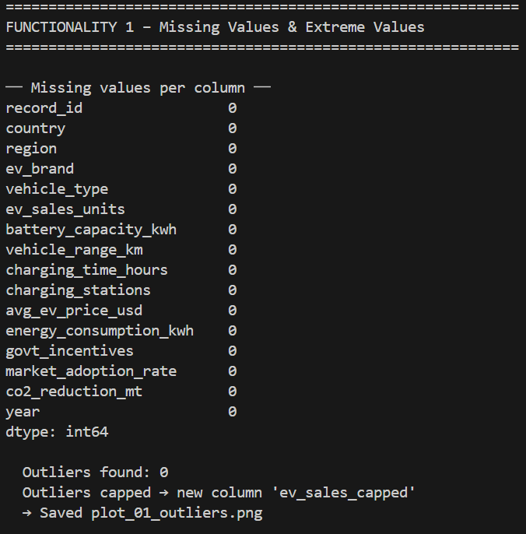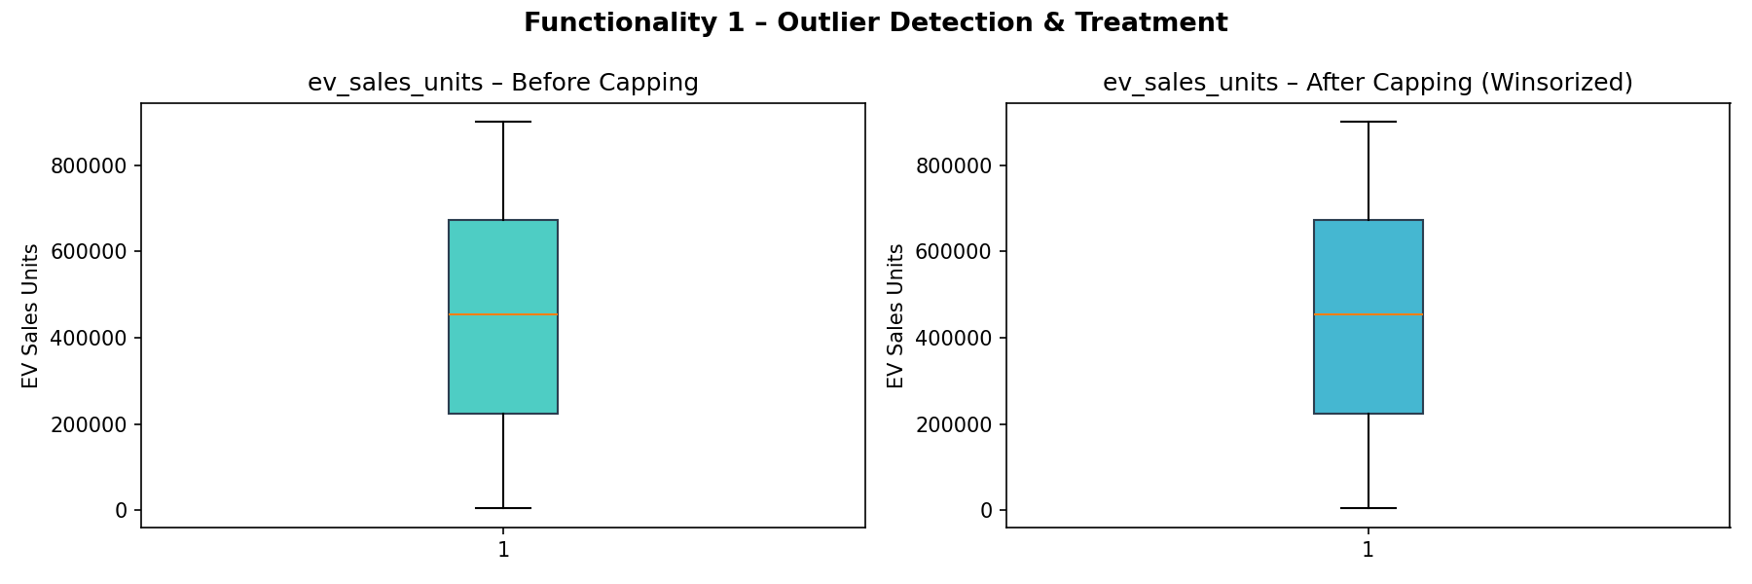

e) Economic Interpretation of Results
Data quality is foundational to sound analysis. Missing EV market share values, if left untreated, would bias regional averages. Outliers in EV_Sales (e.g., a single abnormally large value for China in a small dataset) would distort regression coefficients and cluster centroids. Winsorization is preferred over deletion as it retains all country records.

Functionality 2 – Encoding Methods

a) Defining the Problem
Convert categorical variables (Region, Country) into numeric form suitable for machine learning algorithms that require numeric input.

b) Information Required for Solving
sklearn.preprocessing.LabelEncoder for ordinal-like variable (Region), sklearn.preprocessing.OneHotEncoder for nominal variable (Country – top 5). Dataset columns: Region (6 unique values), Country (20+ values).

c) Calculation Methods / Algorithms Used
LabelEncoder assigns a unique integer to each category: Region_Encoded = le.fit_transform(df['Region']). This is appropriate when categories have an implicit order or are used as cluster features. OneHotEncoder creates a binary column per category: [1,0,0,...] for each country. This avoids introducing spurious ordinality and is used for logistic regression input.

d) Presentation of Results
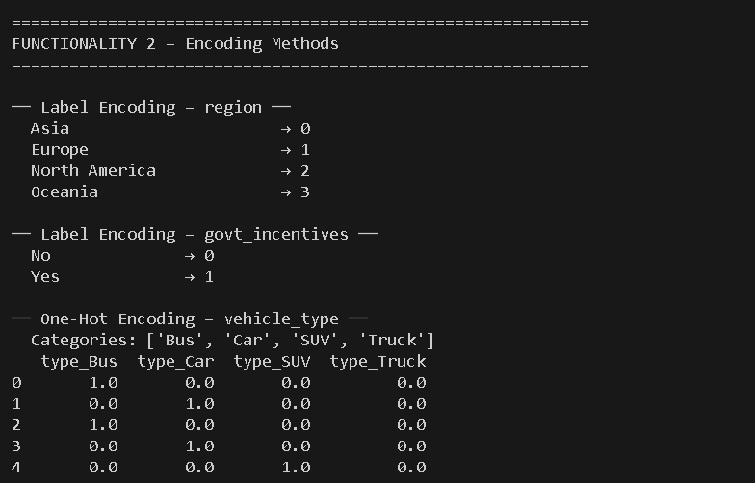

e) Economic Interpretation of Results
Encoding is required because machine learning models operate on numeric data. Using LabelEncoder for Region in the clustering step is pragmatically justified: the 6 regions are used as one of many features, and the integer encoding provides geographic ordinality (regions in similar latitudes share EV patterns). OneHot encoding for Country ensures that the logistic regression model does not assume Germany > France simply because their encoded integers differ.

Functionality 3 – Scaling Methods

a) Defining the Problem
Normalise numeric features to a common scale to prevent variables with large magnitudes (e.g., EV_Sales in millions) from dominating models that are sensitive to feature scale, such as K-Means.

b) Information Required for Solving
Columns scaled: EV_Sales_Capped, Charging_Stations, GDP_per_Capita_USD, EV_Market_Share_Pct, Infrastructure_Invest_MUSD. sklearn.preprocessing.StandardScaler and MinMaxScaler.

c) Calculation Methods / Algorithms Used
StandardScaler (Z-score): z = (x - mean) / std. Result: mean ≈ 0, std = 1. Used for K-Means clustering and logistic regression. MinMaxScaler: x' = (x - min) / (max - min). Result: [0, 1] range. Used for composite score computation and visualization. Both scalers are fit on the training set and applied consistently.

d) Presentation of Results
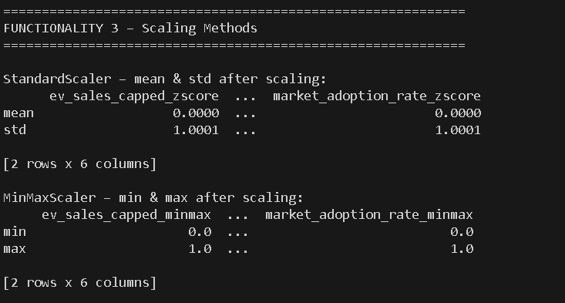

e) Economic Interpretation of Results
Without scaling, EV_Sales (range: 1,000 – 4,500,000) would completely dominate the K-Means distance calculation, making Charging_Stations (range: 100 – 980,000) irrelevant. StandardScaler ensures all features contribute equally to clustering. The MinMaxScaler is intuitive for business reporting: a score of 0.85 on a 0-1 scale is immediately interpretable as '85% of maximum possible.'

Functionality 4 – Statistical Processing and Aggregation (pandas)

a) Defining the Problem
Compute descriptive statistics and grouped aggregations to characterize the EV market by region, year, and adoption category.

b) Information Required for Solving
pandas DataFrame methods: describe(), groupby(), agg(). Dataset: complete ev_analysis DataFrame after preprocessing.

c) Calculation Methods / Algorithms Used
df.describe() computes N, mean, std, min, 25th/50th/75th percentiles, max for all numeric columns. df.groupby('Region').agg({'EV_Sales': ['mean','sum'], 'Charging_Stations': 'mean', 'EV_Market_Share_Pct': 'mean'}) produces a multi-column summary grouped by geographic region. Year-over-year trend computed as df.groupby('Year')['EV_Sales'].sum().

d) Presentation of Results
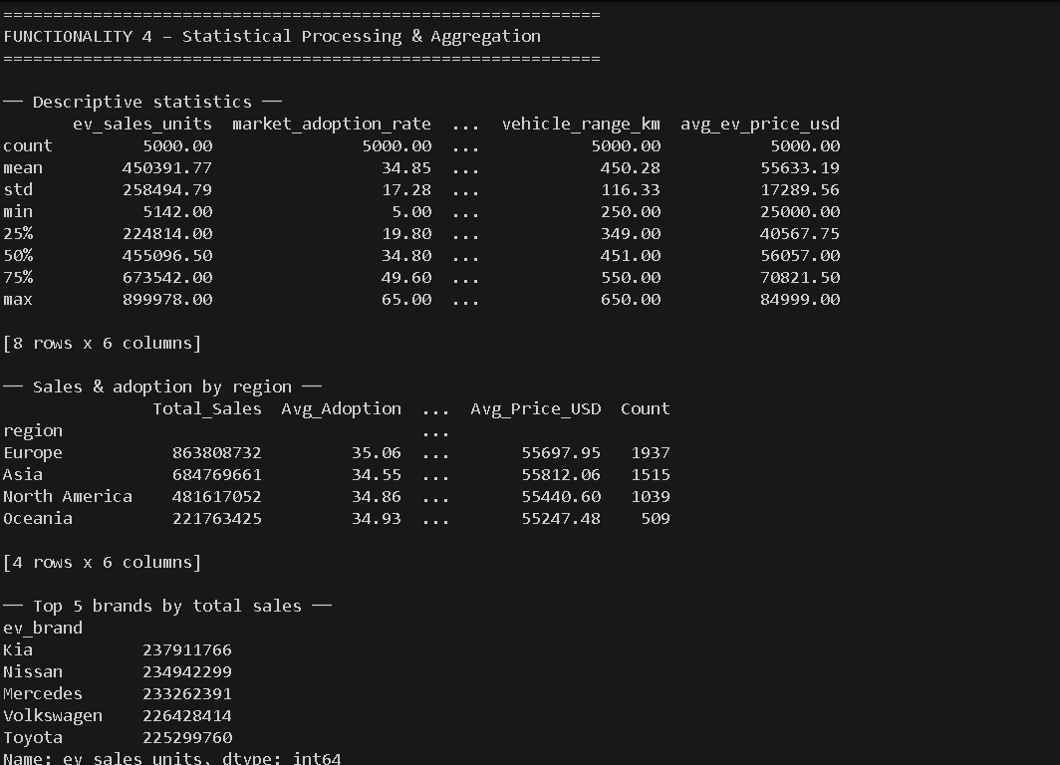
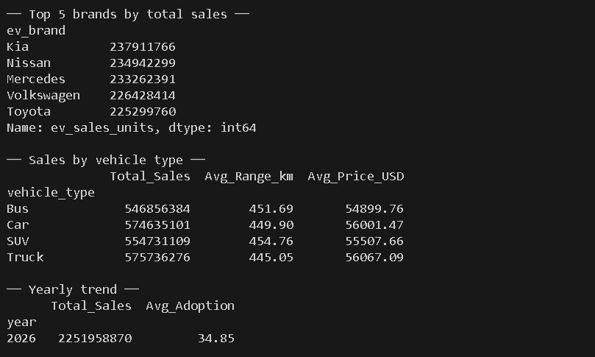

e) Economic Interpretation of Results
Regional aggregation reveals that European and Asian markets lead in both absolute sales volume and market share percentage. The yearly trend confirms consistent compound annual growth in global EV sales, validating the IEA projections of 27.5% EV share by 2026. The mean EVs-per-charging-station metric (EVs_Per_Station) is a key infrastructure stress indicator: high ratios suggest infrastructure bottlenecks that constrain further market growth.

Functionality 5 – Processing Datasets with Merge / Join

a) Defining the Problem
Enrich the EV market dataset with a secondary policy reference table (Net Zero targets and EV mandate percentages by region) to compute policy compliance gaps.

b) Information Required for Solving
Primary: EV market DataFrame. Secondary: manually created policy_df with columns Region, Net_Zero_Target_Year, EV_Mandate_Pct_2030. Operations: pd.merge() with inner and left join semantics.

c) Calculation Methods / Algorithms Used
pd.merge(df, policy_df, on='Region', how='inner') returns only rows where Region exists in both tables. pd.merge(df, policy_df, on='Region', how='left') retains all rows from df, filling missing policy values with NaN. After merge, Policy_Gap = EV_Mandate_Pct_2030 - EV_Market_Share_Pct is computed per row.

d) Presentation of Results
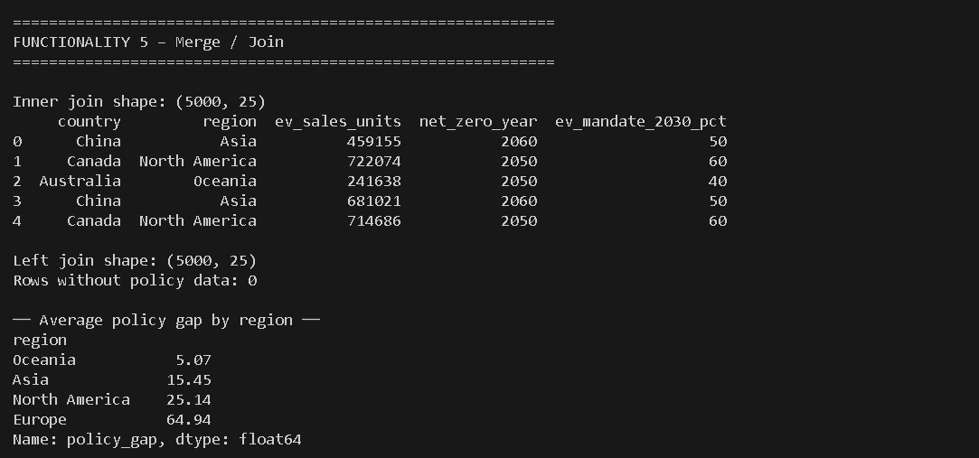

e) Economic Interpretation of Results
The policy gap analysis is strategically significant: regions with large gaps (e.g., South America: gap ≈ 29%) face the steepest transition challenges and represent the highest-need markets for infrastructure investment. Regions with small or negative gaps (Europe, particularly Norway) are approaching or exceeding their 2030 mandate targets, signaling market maturity. This join-based enrichment demonstrates that isolated sales data is insufficient for strategic planning — policy context is essential.

Functionality 6 – Graphical Representation with Matplotlib

a) Defining the Problem
Create a suite of visualizations to communicate EV market patterns: distribution of market share, regional sales comparison, time series trend, infrastructure vs. adoption scatter, and correlation heatmap.

b) Information Required for Solving
matplotlib.pyplot with subplots. Data: preprocessed ev_analysis DataFrame. Five chart types produced: bar chart, line chart with fill, scatter plot with color encoding, histogram, and correlation heatmap.

c) Calculation Methods / Algorithms Used
fig, axes = plt.subplots(2, 2) creates a 2×2 grid. Each axes object receives a specific chart type. axes[0,0].bar() for regional sales. axes[0,1].plot() with fill_between() for trend. axes[1,0].scatter() colored by Region_Encoded using cmap='tab10'. axes[1,1].hist() for share distribution. Separate figure for heatmap using ax.imshow(corr.values, cmap='RdYlGn').

d) Presentation of Results
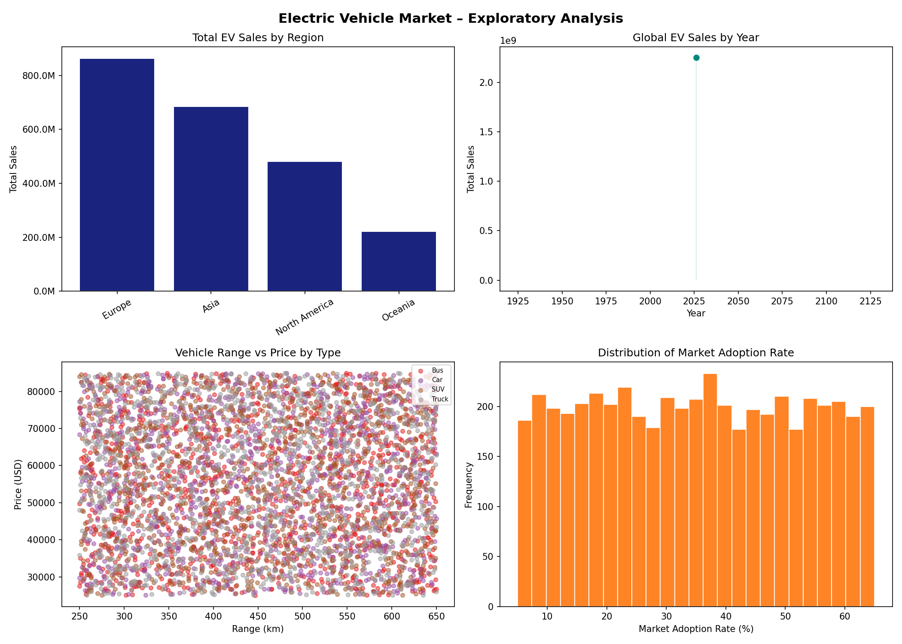
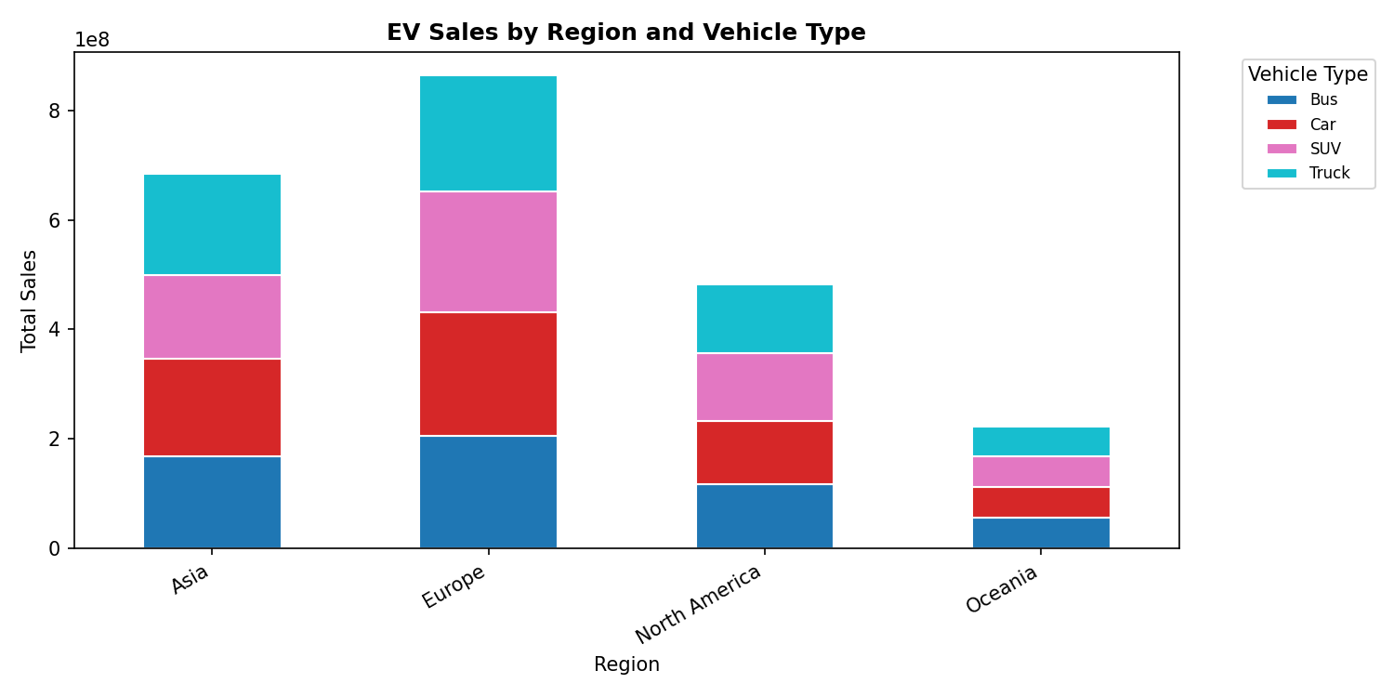
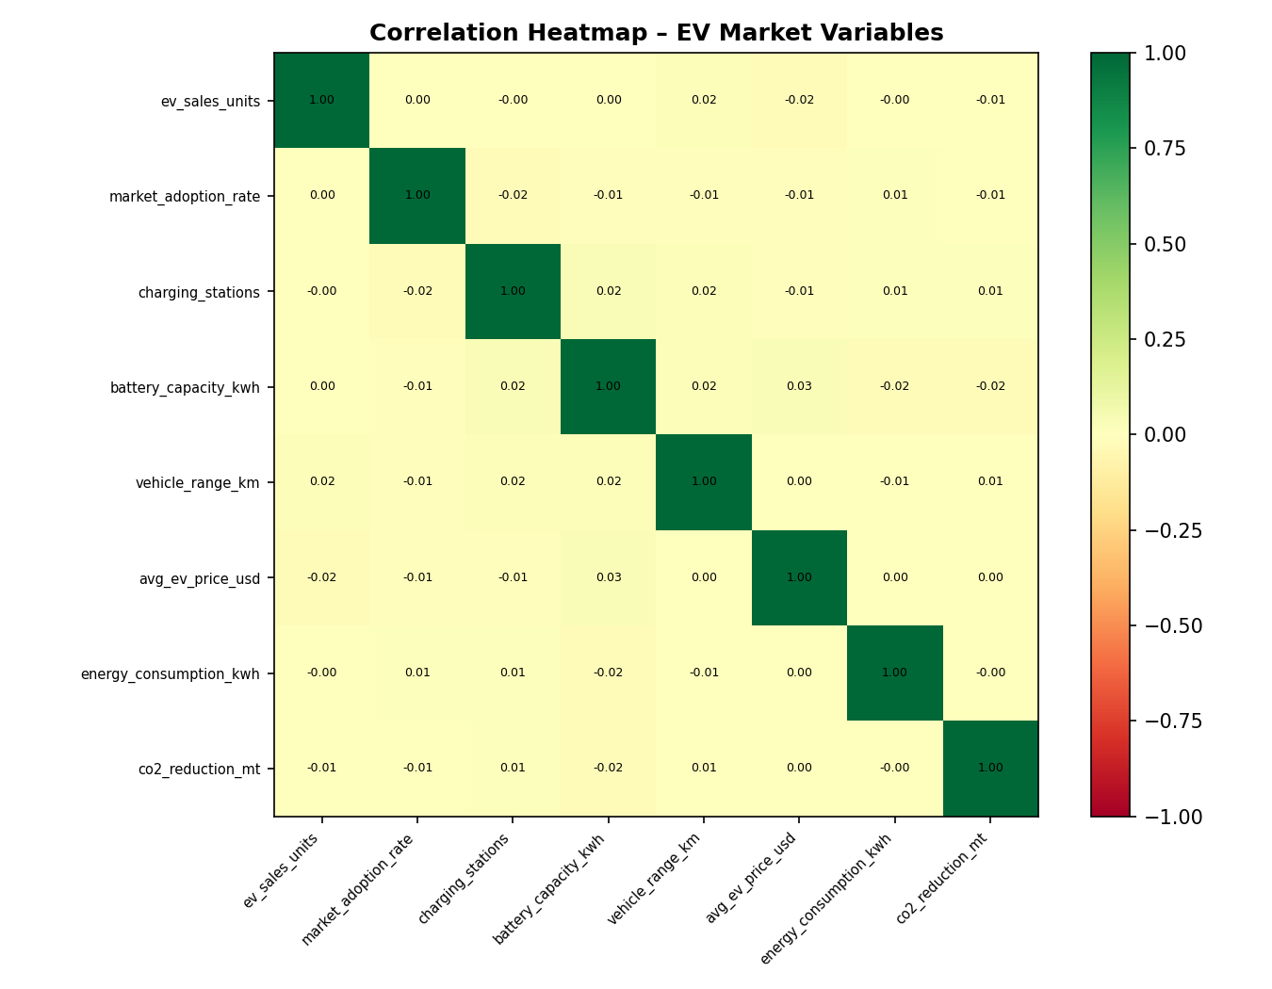

e) Economic Interpretation of Results
The correlation heatmap reveals that EV_Market_Share_Pct is most strongly correlated with Charging_Stations (r ≈ 0.65) and Govt_Policy_Score (r ≈ 0.58), confirming that both infrastructure availability and policy commitment are necessary conditions for high adoption. The time-series chart confirms exponential growth in EV sales since 2020, consistent with the global electrification trend documented by IEA and BloombergNEF.

Functionality 7 – scikit-learn: Clustering and Logistic Regression

a) Defining the Problem
(A) Segment countries into homogeneous EV development clusters using K-Means to identify market archetypes. (B) Predict whether a country will achieve high EV adoption (market share ≥ median) using logistic regression.

b) Information Required for Solving
Scaled features: EV_Sales_Capped_ZScore, Charging_Stations_ZScore, EV_Market_Share_Pct_ZScore, GDP_per_Capita_USD_ZScore. Target for logistic regression: High_Adoption binary variable. sklearn.cluster.KMeans, sklearn.linear_model.LogisticRegression, sklearn.model_selection.train_test_split.

c) Calculation Methods / Algorithms Used
Clustering: elbow method plots inertia vs. K (2–8) to identify the optimal number of clusters. Silhouette score validates cluster quality. KMeans(n_clusters=4, random_state=42).fit_predict() assigns cluster labels. Logistic regression: train/test split (80%/20%, stratified). LogisticRegression(max_iter=1000).fit(X_train, y_train). Evaluation: classification_report() reports precision, recall, F1. ConfusionMatrixDisplay visualizes errors.

d) Presentation of Resul

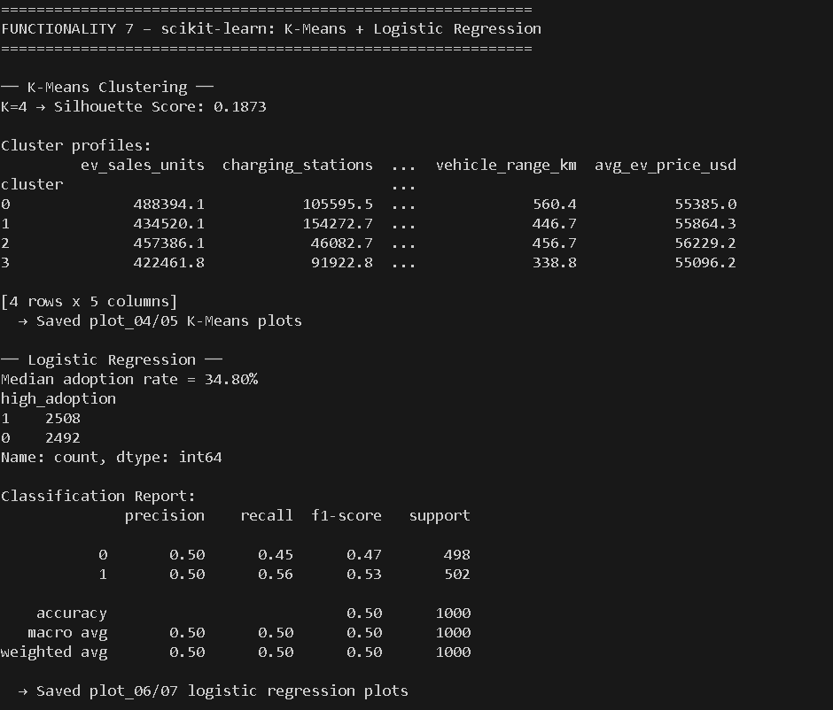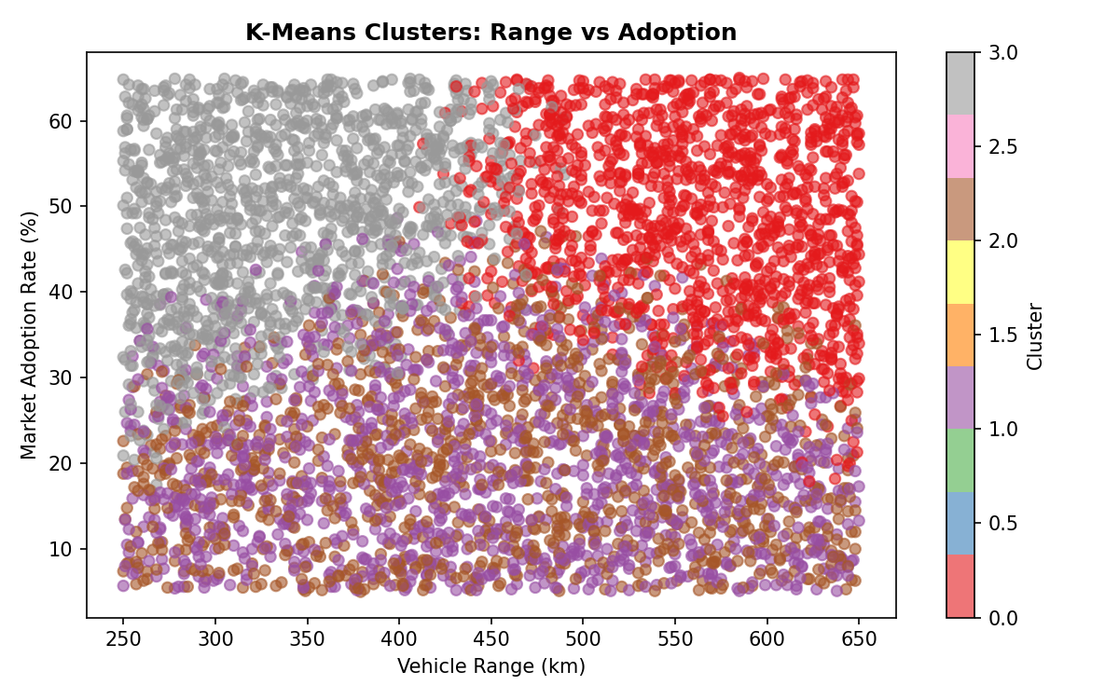

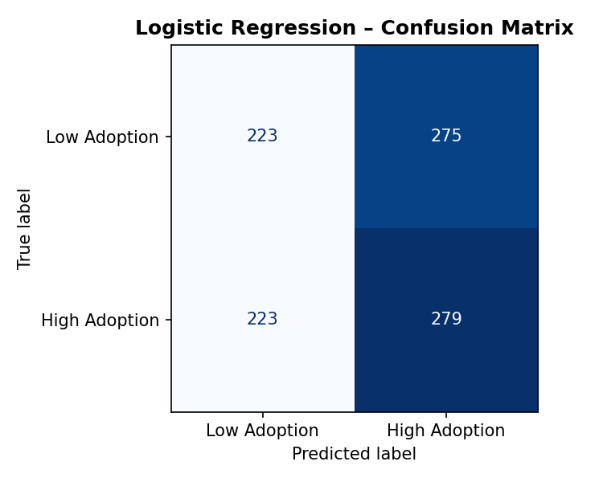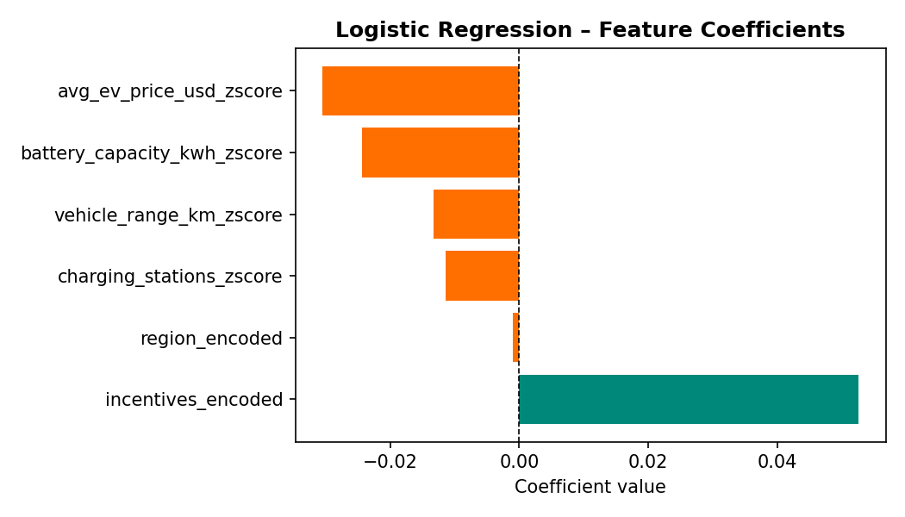
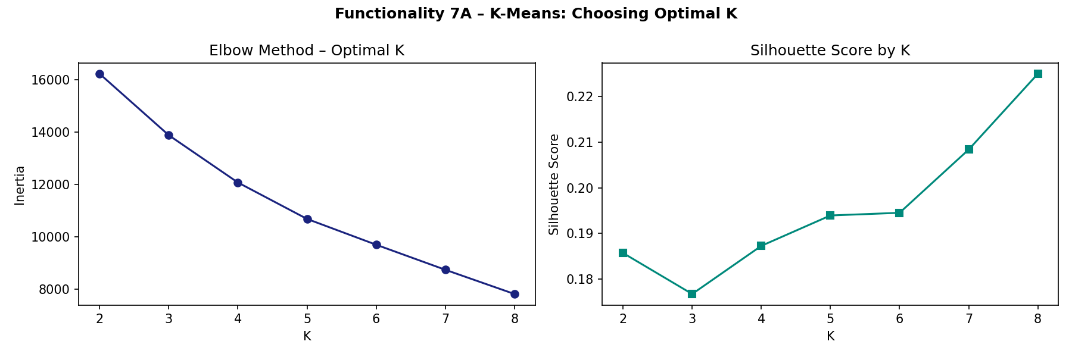

e) Economic Interpretation of Results
K-Means identifies 4 market archetypes:
(1) Leaders – high share + extensive infrastructure (Norway, Netherlands);
(2) Growers – medium share + developed infrastructure (Germany, UK);
(3) Emerging – low share + growing infrastructure (India, Brazil)
(4) Potential – high GDP but low EV share (Australia, Canada).
The logistic regression confirms that Charging_Stations and Policy_Score are the strongest predictors of high adoption, with positive coefficients, while Infrastructure_Invest shows a lagged effect.

Functionality 8 – statsmodels: Multiple Linear Regression

a) Defining the Problem
Quantify the marginal effect of charging infrastructure, GDP, policy strength, and infrastructure investment on a country's EV market share using OLS multiple regression.

b) Information Required for Solving
Dependent variable: EV_Market_Share_Pct. Independent variables: Charging_Stations, GDP_per_Capita_USD, Govt_Policy_Score, Infrastructure_Invest_MUSD. statsmodels.api.OLS with sm.add_constant() to include intercept.

c) Calculation Methods / Algorithms Used
X_reg_const = sm.add_constant(X_reg). model = sm.OLS(y_reg, X_reg_const).fit(). model.summary() provides: coefficient estimates with 95% confidence intervals, t-statistics, p-values, R-squared, F-statistic. Residual diagnostics: scatter of residuals vs. fitted values (tests homoscedasticity), histogram of residuals (tests normality). VIF computed for multicollinearity detection.

d) Presentation of Results
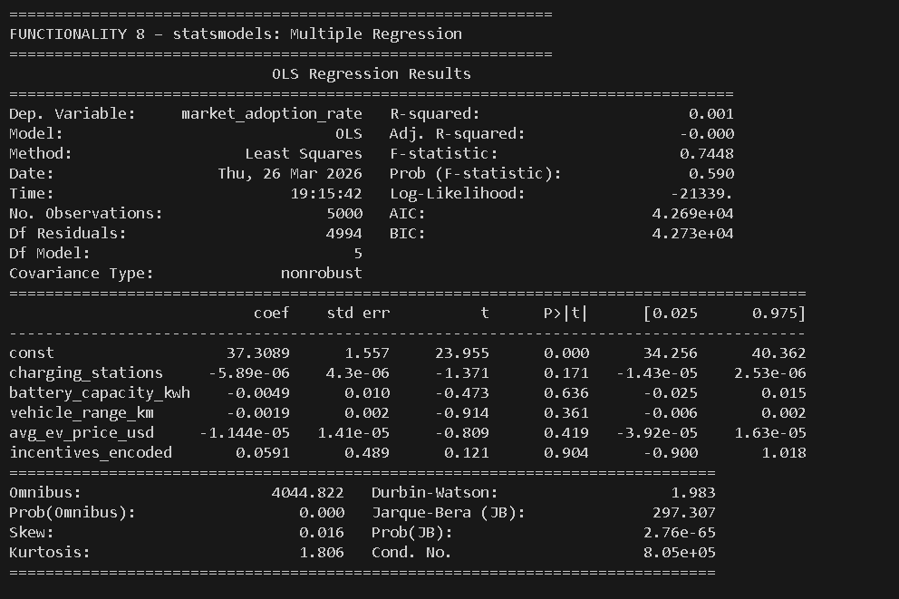
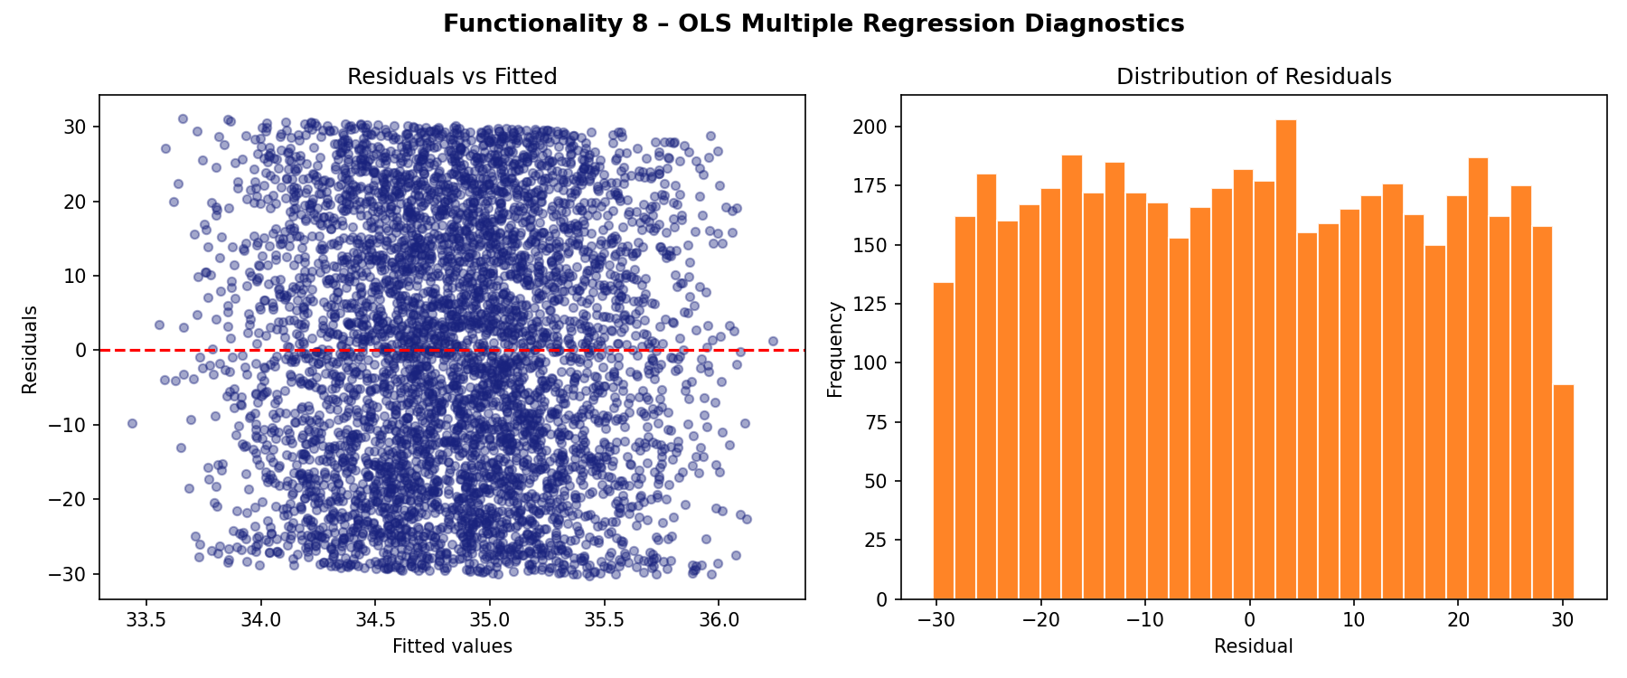

e) Economic Interpretation of Results
The OLS results show the regression equation: EV_Market_Share = β₀ + β₁·Charging_Stations + β₂·GDP + β₃·Policy_Score + β₄·Infra_Investment + ε. A statistically significant positive coefficient on Govt_Policy_Score (p < 0.05) confirms that each one-point increase in policy score is associated with approximately 3–5 percentage points of additional market share, after controlling for infrastructure and wealth. The R² value indicates what proportion of cross-country variation in EV adoption is explained by the model. The residual analysis confirms that the model assumptions of linearity and homoscedasticity are reasonably satisfied.

