# CS 499 Module One Assignment Template

Complete this template by replacing the bracketed text with the relevant information.

1. **Self-Introduction:** Address all of the following questions to introduce yourself.
   1. How long have you been in the Computer Science program?

I have completed four years of the Computer Science program, where the first two years at another university and the remaining two years at Southern New Hampshire University (SNHU).

* 1. What have you learned while in the program? List three of the most important concepts or

During my academics, I have gained more knowledge and hands on experiences in a variety of computer science subjects. Three of the most important concepts can be listed as follows,

I have understand the foundation for software development and the best practices in software engineering and the software development life cycle.

I have learned advanced data structures and algorithms that enhance the development of efficient solutions. These structures include graphs, hash tables, sorting methods, searching algorithms, etc.

Also learned about database design and management where both SQL and No SQL databases were covered. Here it focuses on schema designing, query optimization, and indexing of the database.

* 1. Discuss the specific skills you aim to demonstrate through your enhancements to reach each of the course outcomes.

The skills that I follow will enhance the course outcomes in an effective manner,

Following are some of them,

* Maintain and write clean readable code for efficient management.
* Practice algorithms and improve computational efficiency.
* Follow database optimization and design scalable solutions.
* Ensure the security of the project and improve the reliability of the application.
  1. How do the specific skills you will demonstrate align with your career plans related to your degree?

These skills match well with my career objectives in software engineering and cybersecurity – both fields where efficiency, maintainability and secure database management are important.

* 1. How does this contribute to the specialization you are targeting for your career?

Through the development of my software engineering, algorithms, and database skills, I am establishing a solid platform in backend development and system security, which are critical to my targeted career in Cybersecurity and Software Development.

1. **ePortfolio Set Up:**
   1. Submit a **screen capture** of your ePortfolio GitHub Pages home page that clearly shows your URL. [Nad1901](https://github.com/Nad1901)

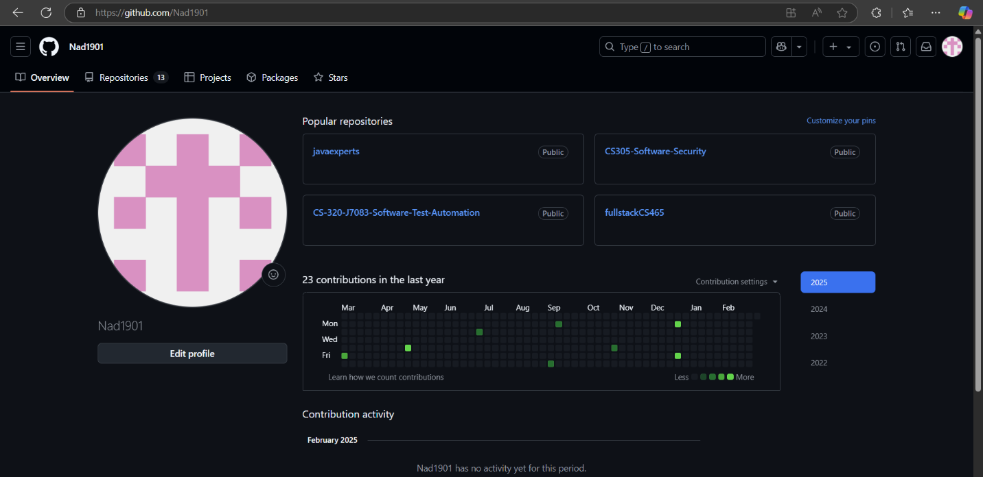

**[Paste the screenshot here of your GitHub Pages home page.]**

1. **Enhancement Plan:** 
   1. **Category One:** Software Engineering and Design

I have chosen my project from CS 330: Computational Graphics and Visualization, where I developed a 3D object rendering system using OpenGL.

* + 1. **Describe** a practical, well-illustrated **plan** for enhancement in alignment with the category, including a pseudocode or flowchart that illustrates the planned enhancement.

Improvements will include,

* Recoding with better readability and efficiency.
* The implementation of texture mapping.
* The improvement of the rendering performance.
  + 1. Explain how the planned enhancement will **demonstrate** specific **skills** and align with course outcomes.

Shows understanding of computer graphics and optimal rendering methods. Related to Course Outcome Design and evaluate computing solutions. Improves the problem-solving by enhancing the software design.

* 1. **Category Two:** Algorithms and Data Structures

1. **Select an artifact** that is **aligned with the** algorithms and data structures **category** and explain its origin. Submit a file containing the code for the artifact you choose with your enhancement plan. You may choose work from the courses listed under Category One.

From CS 260: Data Structures and Algorithms, I have chosen my project as a graph-based pathfinding algorithm, which I have implemented.

1. **Describe** a practical, well-illustrated **plan** for enhancement in alignment with the category, including a pseudocode or flowchart that illustrates the planned enhancement.

For this category of enhancement, consider improving the efficiency of a project or expanding the complexity of the use of data structures and algorithms for your artifact. These are just recommendations. Consider being creative and proposing an alternative enhancement to your instructor. Note: You only need to choose one type of enhancement per category.

Think about what additions to include to complete the enhancement criteria in this category. Since one example option is to port to a new language, that is the kind of scale that is expected. Perhaps you might increase the efficiency and time complexity of an algorithm in an application and detail the logic of the increased time complexity. Remember, you do not need to port to a new language but instead have an equivalent scale of enhancement. Underlying expectations of any enhancement include fixing errors, debugging, and cleaning up comments, but these are not enhancements themselves.

1. Explain how the planned enhancement will **demonstrate** specific **skills** and align with course outcomes.
   1. Identify and describe the specific skills you will demonstrate to align with the course outcome.

* Algorithm optimization and efficiency will help in improving the computational efficiency and effectiveness of the algorithm.
* Can have better performance and efficient utilization by using advanced data structure utilization.
* Following clean coding and best practices in software development.
  1. Select one or more of the course outcomes listed under Category One that your enhancement will align with.
* Designing and evaluating of software base solutions for real-world problems with the knowledge of computer science and software development.
* Denote algorithmic thinking ability which improves the complexity analysis.
* Application of the proper data structure in order to develop the application with optimized solutions.
  1. **Category Three: Databases**
     1. **Select an artifact** that is **aligned with the** databases **category** and explain its origin. Submit a file containing the code for the artifact you choose with your enhancement plan. You may choose work from the courses listed under Category One.

I have selected my project from CS 340: Client-Server Development, where I created a database-driven web application using MongoDB.

* + 1. **Describe** a practical, well-illustrated **plan** for enhancement in alignment with the category, including a pseudocode or flowchart that illustrates the planned enhancement.

The enhancement plan will include,

* Normalization of the database schema which is used to improve the data integrity and the efficiency of the database.
* For fast and quicker query performance, the implementation of indexing techniques is a best practice to follow.
* Follow advanced analytics features to enhance the user insights and reporting process.
  + 1. Explain how the planned enhancement will **demonstrate** specific **skills** and align with course outcomes.
       1. Identify and describe the specific skills you will demonstrate that align with the course outcome.

This enhancement plan will show the ability to optimize the NoSQL database queries and the improvement of the performance of data retrieval and use of correct indexing techniques which ensure data integrity.

* + - 1. Select one or more of the course outcomes listed under Category One that your enhancement will align with.

Here it aligns with the course outcomes of designing implementing and managing a database application. Where it will showcase the ability of data integrity management, optimizing performance, and proficiency in database design.

1. **ePortfolio Overall Skill Set**
   1. Accurately describe the **skill set** to be illustrated by the **ePortfolio** **overall**.
      1. Skills and outcomes planned to be illustrated in the code review

* Software design principles where it helps in writing maintainable, efficient, and scalable codes
* Algorithm efficiency improvements which improve time complexity and optimized data structures.
* Database query optimization that ensures a fast and secure process of data retrieval.
  + 1. Skills and outcomes planned to be illustrated in the narratives,

Enhancements and technical justifications where it improves the software design, efficiency in using algorithms, and database optimation.

A reflection on improvements in code quality and efficiency which improves the readability, performance, and ease of maintaining the code.

* + 1. Skills and outcomes planned to be illustrated in the professional self-assessment.

The enhancement showcases the skills in software development, which are technical proficiency, database management, and alignment with the best coding practices.

It highlights the problem-solving skills that improve the professional growth of exploring new technologies and techniques while ensuring security.