Methodology
For the Vehicle Service Booking System, we have selected the Agile Methodology as the primary framework for project management and software development.
** Why Agile?
* Flexibility and Adaptability: It allows the team to easily accommodate changes, user feedback, and updates throughout the project lifecycle.
* Iterative Development: The system is built through small, manageable cycles or iterations (Sprints), ensuring that core features—such as user registration, vehicle booking, and admin dashboards—are continuously developed, tested, and refined.
* Effective Collaboration: It facilitates smooth communication, task distribution, and progress tracking among team members.
** Agile Phases Implemented in Our Project:
1-Planning & Requirements Gathering: Defining core system needs, user stories, and functional requirements for customers and garage staff.
2-Design (UI/UX): Creating intuitive and user-friendly interfaces for booking services, tracking appointments, and managing the garage dashboard.
3-Implementation (Development): Writing the code for both the front-end and back-end components of the platform.
4-Testing: Verifying that all booking functionalities, database connections, and user interfaces operate smoothly without errors or bugs.
5-Deployment & Review: Delivering the final system and reviewing its performance against the initial project objectives.

Case study
Executive Summary:
Traditional car maintenance and repair garages often face significant operational challenges due to manual appointment scheduling, vehicle congestion, paper-based record-keeping, and poor customer communication. These inefficiencies lead to wasted mechanic time, long customer waiting times, and reduced revenue. This case study presents the development and implementation of the Vehicle Service Booking System (VSBS)—a web-based platform built using HTML, CSS, JavaScript, and MySQL designed to digitize the booking process, organize schedules, and track vehicle maintenance histories efficiently using a unique Vehicle ID .
** Background & Problem Statement:
Current Situation
The garage currently relies on manual phone calls and paper logs to schedule and manage vehicle service appointments.
1-Core Problems :
A_ Difficulty in Booking & Scheduling: Customers struggle to find available time slots and schedule vehicle maintenance services easily.
B_Disorganized Appointments & Long Waiting Times: The lack of an automated scheduling system leads to double bookings, center congestion, and extended waiting times for customers .
C_ Tracking Service History & Costs: It is difficult to track past vehicle service records, maintenance logs, and accumulated service costs manually .
D_Risk of Regular Maintenance Omission: Without automated reminders, customers frequently miss regular maintenance schedules, leading to preventable vehicle damage and costly repairs.

**Proposed Solution:

The VSBS web application is developed to be responsive and accessible via any browser on PCs or mobile devices, providing the following core solutions:

1- Flexible Booking & Scheduling: Enables customers to easily select their required service type, date, preferred center, and available time slot .
2-Comprehensive Tracking via Vehicle ID: Links all service history, maintenance logs, and financial records to a unique Vehicle ID for rapid retrieval and precise tracking.
3-Concurrency Control: Prevents double-booking by locking a selected time slot instantly when another customer reserves it.
4-Automated Maintenance Reminders: Automatically sends SMS or email notifications to remind customers of upcoming regular maintenance services, ensuring optimal vehicle condition and repeat business.
** Implementation Roadmap:
- Phase 1 (Weeks 1-2): Requirements gathering, feasibility analysis, UI design, and database schema structuring.
- Phase 2 (Weeks 3-5): Core development, implementing the Vehicle ID link, and building concurrency controls for time slots.
- Phase 3 (Weeks 6-7): Integrating automated notification systems (SMS/Email) and performing rigorous system testing.
- Phase 4 (Week 8): Staff training, final deployment, and public launch of the live system .

Activity | Description | Predecessors | Duration
A | System request | - | 2
B | Feasibility study | - | 4
C | methodology | B | 3
D | Time estimation | A , C | 3
E | Case study | B | 5
F | Pert & Gantt chart | D , E | 4
Pert chart

The pert Chart:-

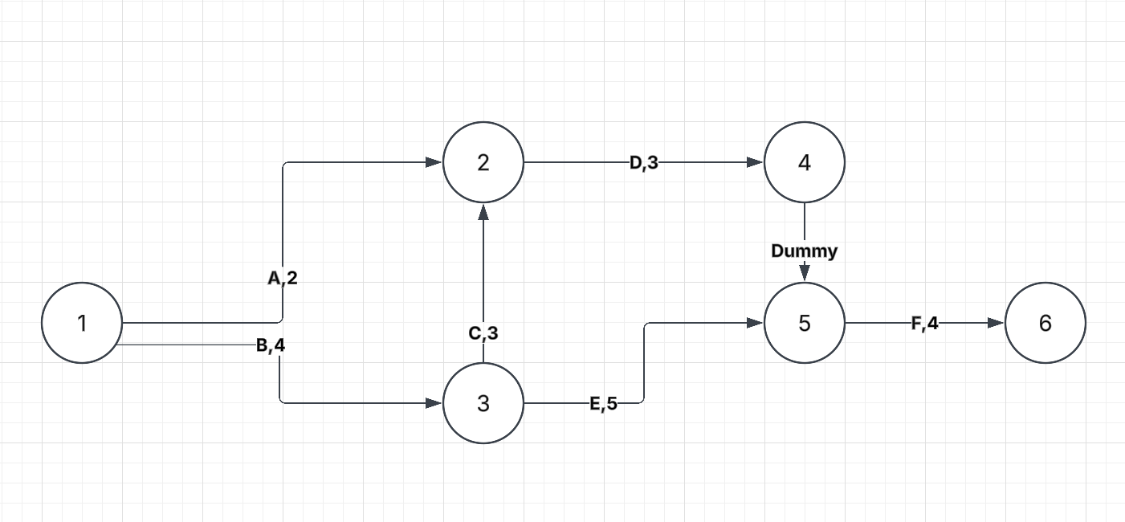

Activity | Predecessors | Duration
A | - | 2
B | - | 4
C | B | 3
D | A , C | 3
E | B | 5
F | D , E | 4
Gantt chart
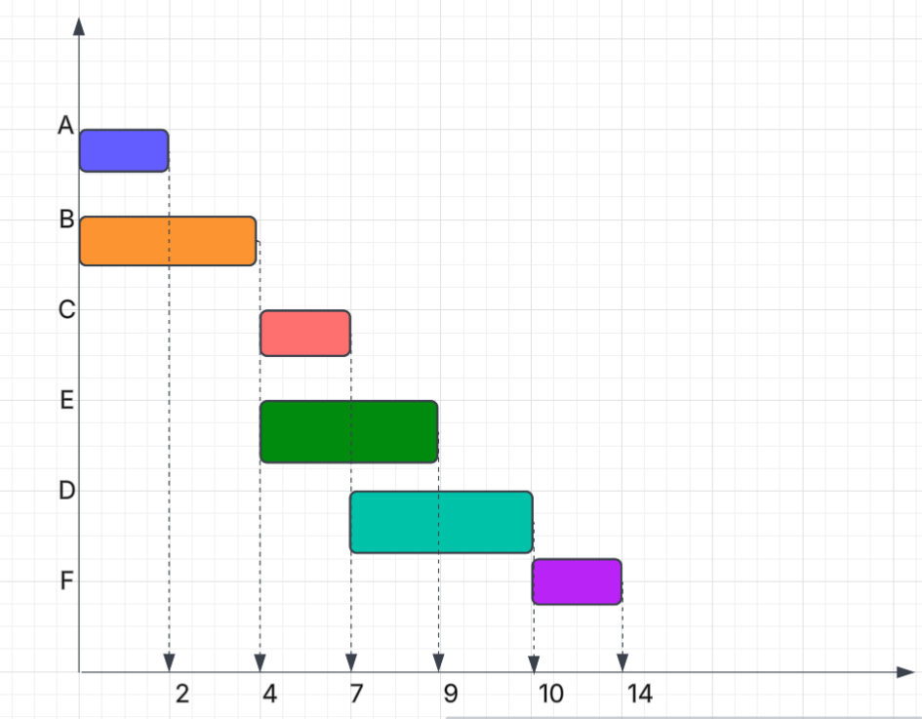

Time Estimation

 | Planning | Analysis | Design | Implementation
Standard  percentages | 15% | 20% | 35% | 30%
Estimated time  based on planning  time | 4 days | 6 days | 10 days | 9 days

Tasks Identification
System Request | Name of Task
9/11/2020 | Start Date
12/11/2020 | End Date
Doha Ramadan | Person assigned to task
High | Priority
Microsoft word | Resources Needed
4 hours | Estimated Time
2hours | Actual Time

Feasibility Study | Name of Task
12/11/2020 | Start Date
17/11/2020 | End Date
Nouran Elshanshoury | Person assigned to task
High | Priority
Microsoft word | Resources Needed
8 hours | Estimated Time
5 hours | Actual Time

Pert Chart, Grantt Chart | Name of Task
17/11/2020 | Start Date
19/11/2020 | End Date
Mai Haider | Person assigned to task
High | Priority
Ms project | Resources Needed
9 hours | Estimated Time
6 hours | Actual Time

Interview | Name of Task
19/11/2020 | Start Date
24/11/2020 | End Date
Nada Elsaadany | Person assigned to task
Medium | Priority
Microsoft word | Resources Needed
16 hours | Estimated Time
14 hours | Actual Time

Questionnaire | Name of Task
19/11/2020 | Start Date
23/11/2020 | End Date
Walla Eldahshan | Person assigned to task
medium | Priority
Form drive | Resources Needed
5 hours | Estimated Time
2 hours | Actual Time

