CNC Machine Tools: Workflow
From the website to the dashboard

1. Workflow diagram
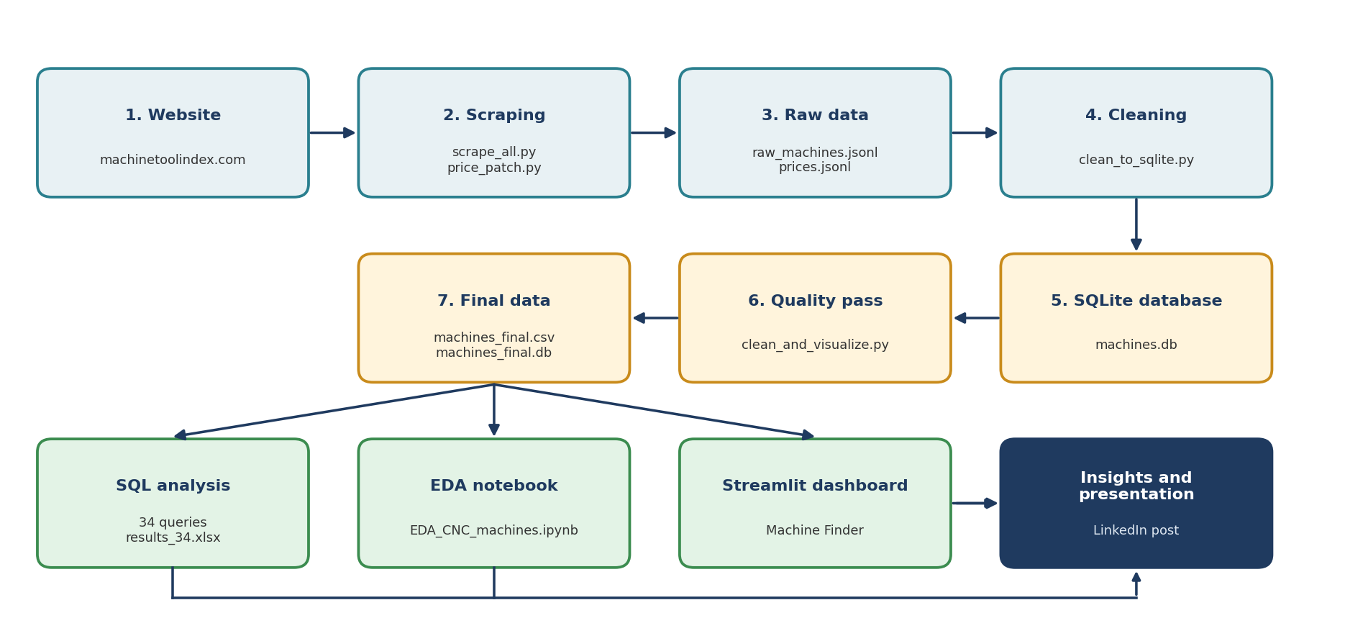
Blue: data collection. Yellow: cleaning and storage. Green: analysis outputs. Dark: delivery.

2. Steps in detail
Step | What happens | Tool | Output
1. Scraping | Read the category pages, then every machine page. Save after each machine, retry failures, log failed URLs. | Python, requests, BeautifulSoup | 02_raw_data/ raw_machines.jsonl, prices.jsonl
2. Cleaning | Merge duplicate columns, parse text specifications into numbers with one unit (mm, kg, kW, rpm), split price into low, mid and high, fix encoding. | Python, pandas | 04_database/ machines.db
3. Quality pass | Merge manufacturer spellings, fix impossible values, flag outliers, add price type and a completeness score. | Python, pandas | 07_data_outputs/ machines_final.csv, cleaning_report.csv
4. SQL analysis | 34 read-only queries: coverage, medians, price bands and a machine finder. | SQLite | 05_sql/ results_34.xlsx
5. EDA | Distributions, category comparison, price versus size, data limits. | Jupyter, pandas, matplotlib | 06_notebook/ EDA_CNC_machines.ipynb, 08_visuals/
6. Dashboard | Budget-based machine finder and charts. | Streamlit | 09_dashboard/
7. Delivery | Presentation, LinkedIn post, Use Case and Workflow documents. | PowerPoint, Word | 10_presentation/

3. Design decisions
- Raw data is never edited. Every cleaning step starts from raw_machines.jsonl, so the whole pipeline can be re-run.
- Flag, do not delete. Extreme machines are real, so they get an outlier flag instead of being removed.
- Never guess missing values. A made-up specification or price would be wrong data.
- Estimated prices are labeled. Every price chart states whether the price is an estimate.
- Every script finds its own files, so the project runs from any folder as long as the folder structure is kept.

4. Team split (5 members)
The scraping can be split by category and merged afterwards (for example python scrape_all.py 0 4 for one member and python scrape_all.py 4 8 for the next). After that, cleaning, SQL analysis, the notebook, the dashboard and the presentation can run in parallel on the same machines_final.csv.

