**Implementation of Laboratory Information Management System**

1. **Main Form:**

When the system starts to run a main form shall display to the user.

**The function of this form:**

* Define the type of the user weather he is a doctor or receptionist or HR manager
* Open a specific form for each type of user after login

Figure 1:Main Form

1. **Login Form:**

A login form for security and access control, the user enters his password and username and check if the password and the user name are correct.

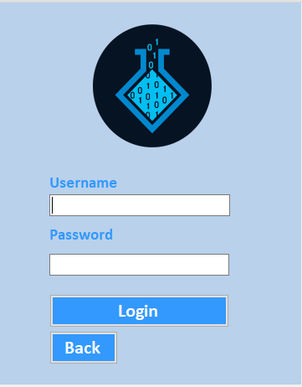

Figure 2: Login Form

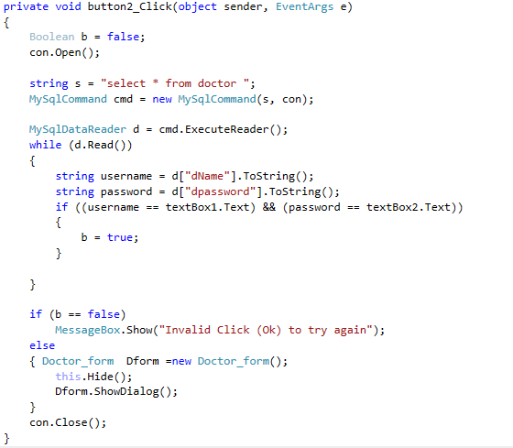

Figure 3: Login Form Code

1. **Add Patient Information:**

The receptionist is responsible for this process there are two steps for adding new patient information:

* Preview patient information that check that all necessary data has been entered such as name, age, gender, National ID and his analyses.
* Submit the patient information this mean that a new patient record is added and a unique patient ID is made for that patient.

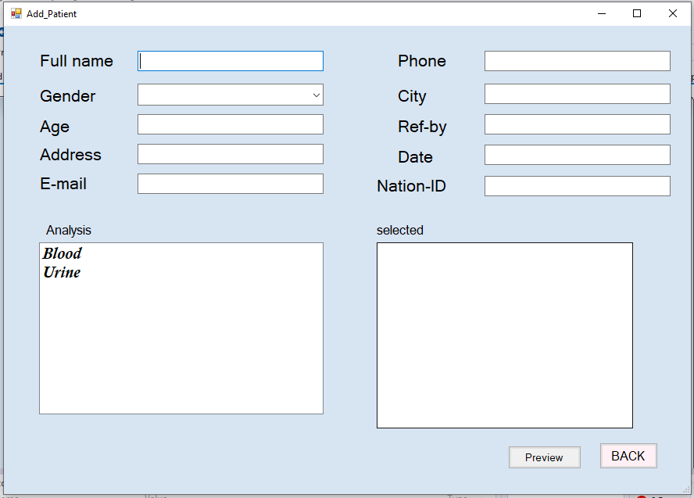

Figure 4:Add Patient Form

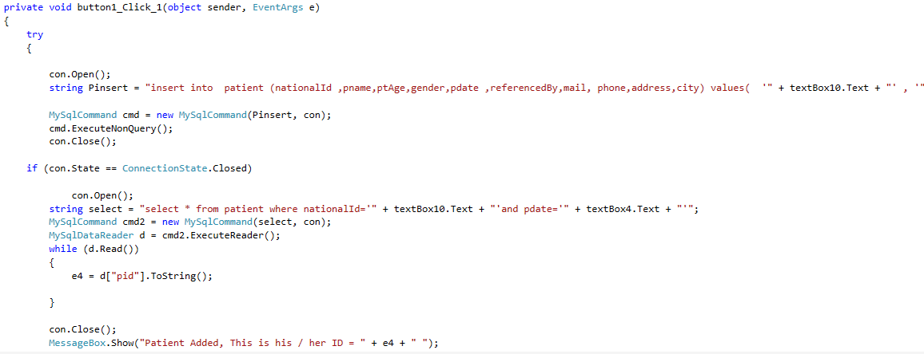

Figure 5:Check the entered data

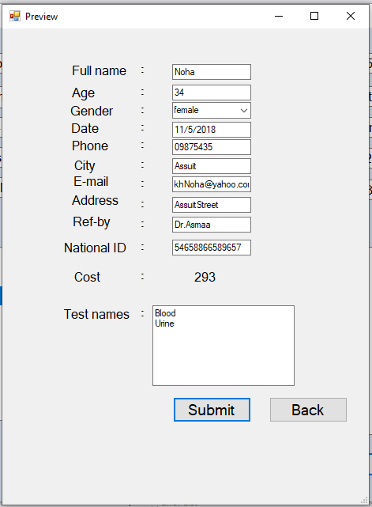

Figure 6:Submit Form



Figure 7:Submit Code

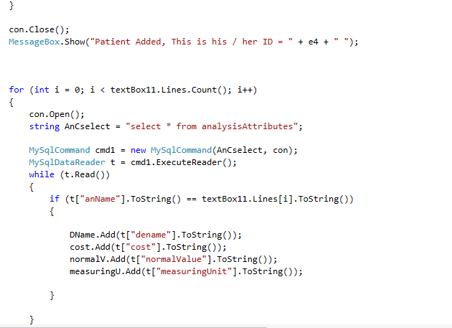

Figure 8:Submit Code

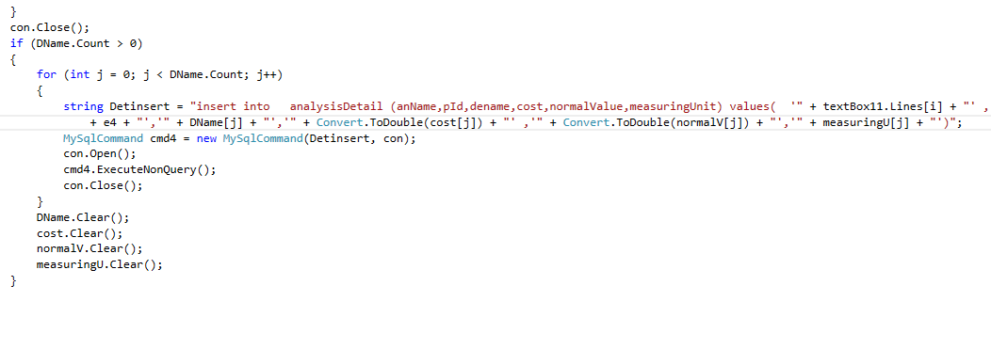

Figure 9:Submit Code

1. **Update and Delete Patient Information:**

The receptionist can update and delete patient information this form consist of four buttons **Help, Update, Delete and Back.**

* **Help:** it helps the user to understand the functionality of this form and how to use it.
* **Update:** the receptionist enters patient National ID so he can update patient information.
* **Delete:** the receptionist enters patient ID to delete a specific patient.
* **Back:** to return to the receptionist form.

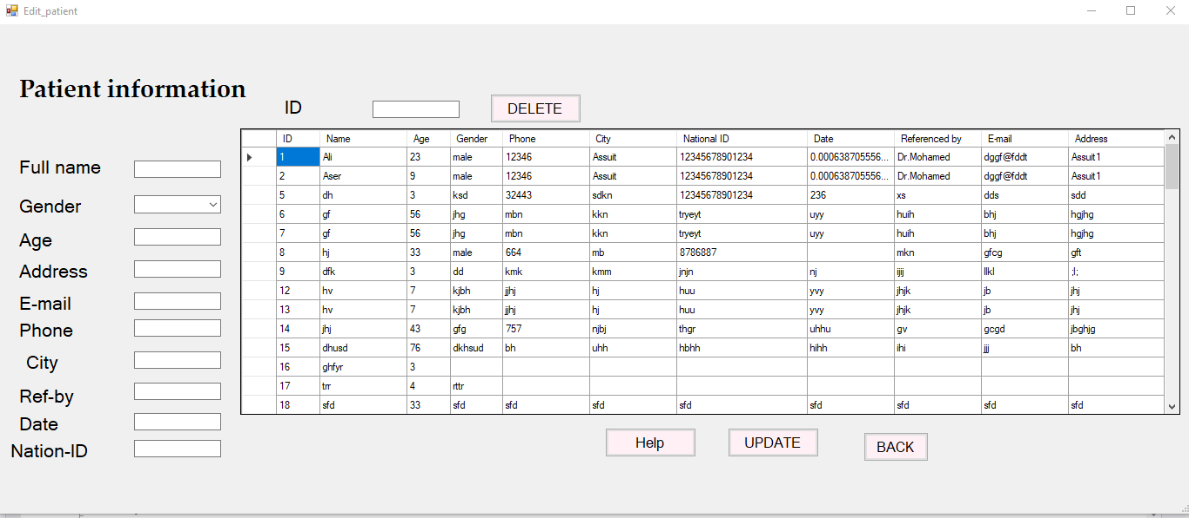

Figure 10:Patient information

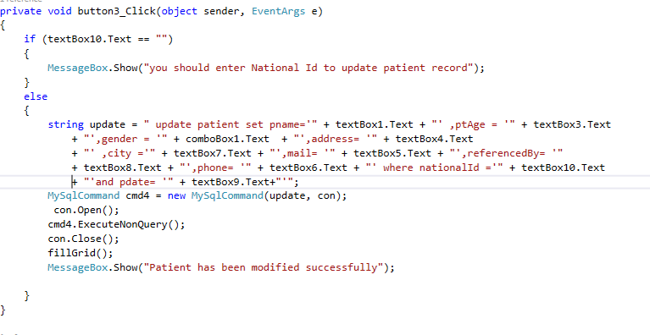

Figure 11:Update Function

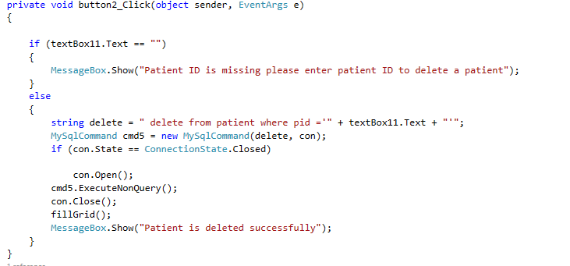

Figure 12:Delete Function

1. **Add, Update and Delete Analysis Categories and Details:**

Doctors use this form to add new analysis category and new analysis details.

This form consists of:

Category list box that contain analysis name that the laboratory provides.

Details grid view table that display detail name, normal values, measuring unit and analysis cost.

Three buttons:

* **Save:** to save the update occur in the analysis detail
* **Delete Analysis Category:** to delete analysis category
* **Back:** to return back to Doctor Form

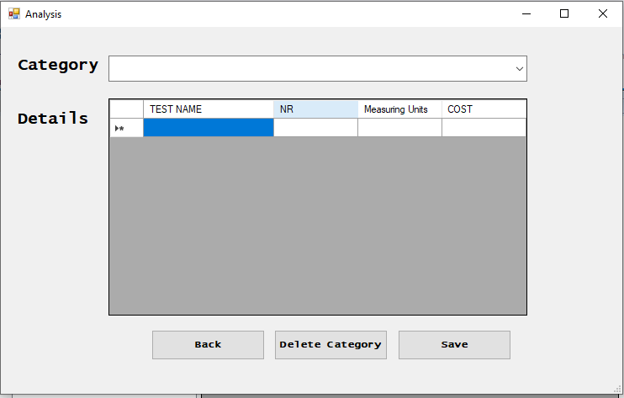

Figure 13:Analysis Form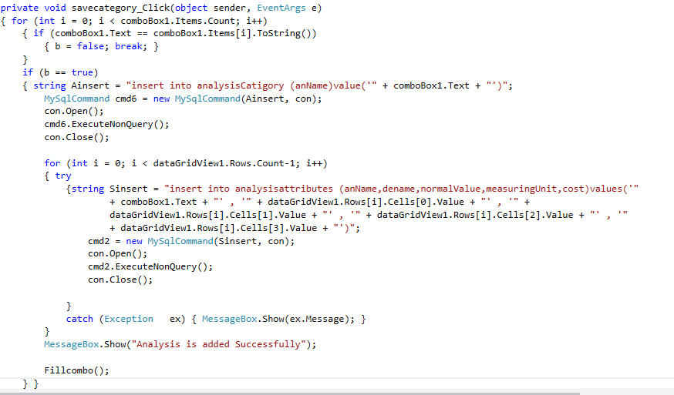

Figure 14:Save Category

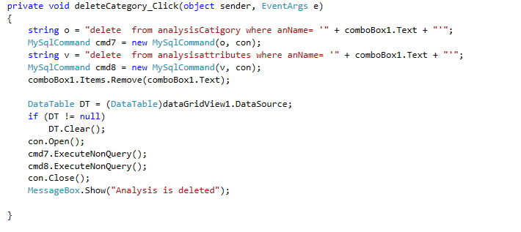

Figure 15:Delete Category

1. **Add Patient Results:**

Doctor search for a patient through his unique ID number if it is found patient name, age, gender and his analysis is displayed for the doctor.

Doctor add analysis results for a specific patient and save the results.

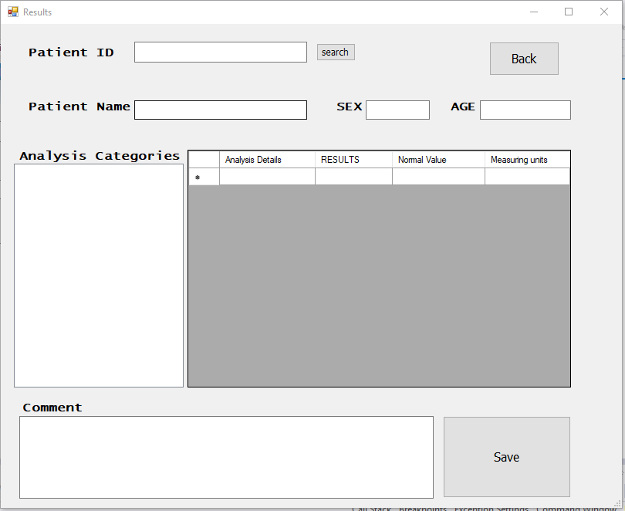

Figure 16:Add Patient Results

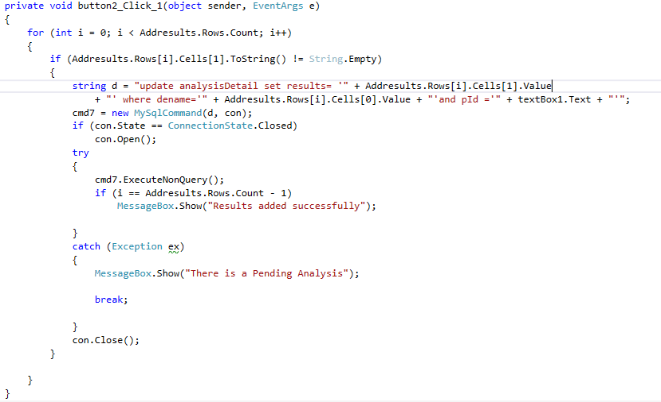

Figure 17:Add Patient Result And Save It