

**ORCHIDS**

Under supervision of

Dr. Doaa Saleh

Our team

Nada Emad Mohamed 20201189

Shahd Fekry Ali 20201101

Shreen Samhi Abdo 20201098

Alaa Essam Ali 20201024

Karim Ahmed 20200389

Shereen Shawky Hassan 20201102

**Project idea**

**Events planning company**

**Logo**



**Slogan**

**A day to remember**

**Introduction**

Party decorations and event planning experts. Simply dream and your wish will be fulfilled. We will assist you in enjoying your special day, whether it is a wedding, engagement, birthday, or corporate party, by adding a touch of beauty and cheer.

The orchid flower was chosen as the name of our project as it has been classified as the most diverse plant species, and this is what distinguishes our project.

Simply contact us and choose from a wide range of budget options.

Functions of management

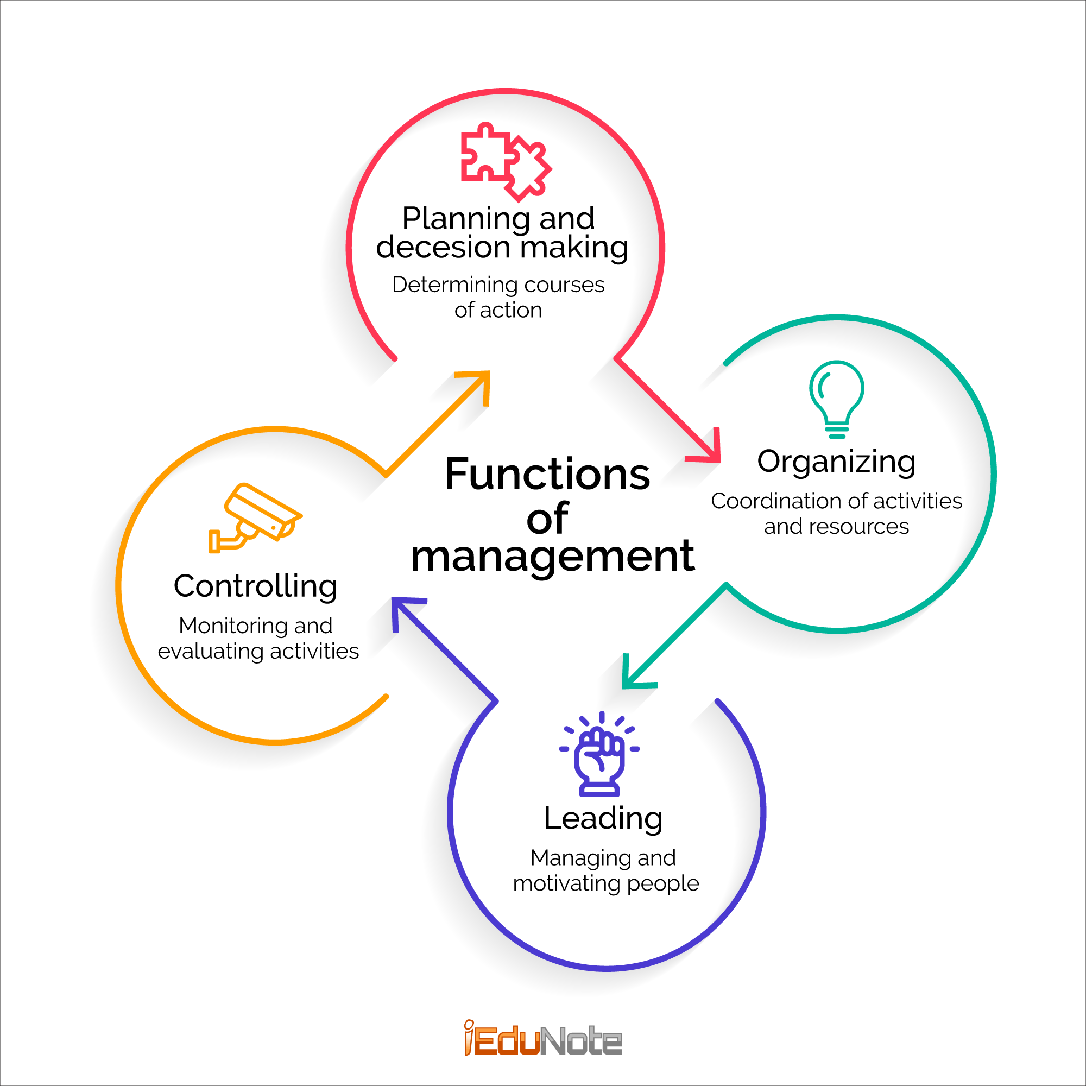

**planning**

* ***Organization's main objective:***

- As expressed in our slogan, our essential goal is to design and execute special memorable events which fulfill our clients and make them enjoy every moment in their event while preserving the values and ethics of the society in which our organization operates. As well as achieving a satisfactory profit for our organization.

1***. Organization’s Short-term objectives:***

* Increase awareness of our organization. - Increase the trust in our organization.
* Organizing social events (Birthday parties, Engagements, Weddings, Anniversaries, Baby showers, and milestone parties (Commemorate a special achievement such as a promotion, graduation, or retirement)).
* Achieving a net profit of 10% of the total profit.

2. ***Organization’s middle-term objectives:***

* Expanding the organization of events to include business-related events (Conferences, Trade Shows, Workshops, Seminars, Corporate off-sites & executive meetings, and Company parties).
* Increasing the net profit by 10% to be 20% of the total profit.

3. ***Organization’s Long-term objectives:***

* Achieving 95% positive customer feedback.
* Opening new branches in three new cities.
* Hiring 2000 new employees in the new branches.
* Increasing the net profit by 30% percent to be 50% of the total profit.
* ***List of alternatives:***

1. Follow up on market developments in terms of the latest ideas and trends related to organizing events.

2. Work to make our clients' thoughts and ambitions for their events a reality.

3. Using organizational ideas from other countries and different cultures to make our clients' events unique and special.

4. Creating and developing new and innovative ideas to become

a scoop in the world of event planning.

***Premises upon which each alternative is based:***

* The vast majority of people nowadays follow the new trends and are always eager to try them. So, this alternative can achieve tremendous success.
* Who among us does not wish his dreams and hopes to come true?

The joy and satisfaction that this alternative will

offer to our clients are unimaginable. This alternative, in our

opinion, will be the most successful.

* Everyone needs a change now and then, and planning our clients' events in the style of their favorite country will be a beautiful, unique, and original experience that will bring our organization great success and fame.
* One of the most important factors in any organization's success is the ability to generate fresh ideas that demonstrate creativity and innovation. This alternative will result in rapid succession.

**Choosing the best alternative:**

- Our chosen alternative is a mix of all previous

alternatives. This is because we will always attempt to

satisfy all of our customers' various ideas, hopes, and

desires, as well as our company's profit goals.

* **Develop plans to pursue the chosen alternative:**

Short-term objectives:

1. **Increase awareness of our organization:**

* Creating pages for the organization on different social media platforms (Facebook, Instagram, and Twitter), Through these pages we can attract clients’ attention by showing the organization's achievements and presenting some special offers.
* Put the name of the organization and its website on the invitations to the events that will be held.
* Organizing some sessions in which we will talk about the different activities that our organization does.

1. **Increase the trust in our organization:**

* Ensuring that the best materials are used in the event organizing within our budget including the material used in the decoration process, types of flowers to be used, banners, and invitation cards.
* Contracting with the best and finest restaurants which serve food in a good way and good taste.
* Hiring the best photographers to make our clients Have charming photo sessions and take random photo shoots that document that memorable day.
* Understand what the customer needs and propose innovative ideas to develop his idea making his occasion better than he wants.
* Commitment to the prior agreement in terms of budget, types of materials used, quantities ordered (food and drinks), and the Arrangement of entertainment items during the event
* Punctuality.
* Good behavior of all employees and their completion of the required work to the fullest.
* Work on crisis management and solve problems in the fastest and best way.

1. ***Organizing social events:***

* **Birthday parties:**
* Kids:
* By selecting a theme, the fun aspect is immediately increased, and you can get your birthday child thrilled for their special day by selecting something they enjoy. So why not make a theme out of a favorite movie? Very easy! There will be a plethora of relevant decorations and fancy-dress clothing to select from, and a reputable bakery can make a kids' birthday cake to match the chosen film...Spider-Man, or The Little Mermaid...the list goes on...

• Teenagers and Adults:

* Is there any person who does not enjoy viewing movies? Host the party indoors, or if the weather permits, take them outside for a memorable movie night. A few suggestions:
  + - Investing in a projector and screen.
    - Serving movie snacks and candies.
    - Adding comfortable seating.
    - Adding lighting.
* Renting a hotel room for the night is a terrific way to hold a memorable birthday celebration while keeping the mess out of your house.
* You can even arrange neighboring rooms depending on the number of guests in attendance so that they can all be together and have fun till the early hours of the morning.

**A few suggestions**:

* Decorating the room (balloons, helium balloons, streamers, etc.).
* Making Special party cakes of their favorite taste.
* Is our customer an avid gamer? Then a fun gaming party might be a great party to consider! Make a special birthday party with touches of his favorite game. A few suggestions:
* Choosing his color theme (use it in the decoration).
* Making the food/dessert table the focal point.
* Carry out the theme (Amazon has a great selection of gaming party supplies)
* ***Engagements:***
* Now that you have the ring and the partner of your dreams, it's time to celebrate with a glass of bubbly. While a traditional engagement party is always a good choice, we understand that you want to make your event special. We've compiled a list of unique engagement party ideas to help you get creative. Whether you're a movie fanatic, an art connoisseur, a sports fan, or simply enjoy any reason to have a themed party,
* there are plenty of inventive engagement party ideas to choose from:
* If you've got a sweet tooth, your best choice is a dessert party. Create a special engagement party with a dessert bar filled with treats like white chocolate, cheesecake, and chocolate-dipped strawberries, along with typical after-dinner beverages like espresso, coffee, and tea.
* Prepare to see a lot of "I'm on a boat" selfies. To celebrate your engagement, take your friends and family out on a sunset sail. It provides an intimate setting in which you may chat with your guests and for them to bond with one another.
* An art gallery opening party is a great way to debut your engagement photos. It is suggested that you get your engagement photos blown up to poster size and put on foam core. You may then use easels with spotlights to showcase them throughout your event space.
* Invite friends and family to a beach campfire with oceanside games, warm drinks, and soft music at sunset. The event should be scheduled so that guests can assemble in the daylight before the sky turns pink and orange. Bring the fire to a roar after sunset. It's time for a traditional campfire dessert and some traditional bonfire music.

• Host a socially responsible engagement party. Purchase decorations made by local artists. Instead of engagement gifts, encourage your friends and family to make charitable contributions to organizations near to your heart by handing out scratch-off cards that donate to charity as party favors

* ***Weddings*:**
* before the night of the wedding, we will have the night of henna (its budget may be included in the budget of the wedding as an offer) in this night we can take you to different cultures (like Indian, Greek, Moroccan) we can have peasant or popular ambiances.
* Because the wedding day is the most important in the bride's life especially, most of our attention will be on the bride, but we will not forget the groom as well. first, we will book a hotel room to prepare the bride in case the wedding is open air, in a wedding hall, on a boat overlooking the river, or even on the beach, and if this place is not close to a hotel, we will pitch a tent to prepare the bride.
* The wedding day will be organized as follows: the photoshoots for the hotel's room of the bride while preparing her (her dressing and makeup) we can suggest a fashion house or an atelier for the dress\dresses of the wedding, as well as one of the most professional make-up artists then this photoshoots, will be added to another photo shoots during the wedding
* as for the wedding time, A video will be shown showing moments from the lives of the newlyweds from their childhood to the age of their youth, and photos of moments that unit them together, such as engagement photos, and the marriage contract. However, this does not prevent us from concluding the video with clips from our organization. Then the bride walks down the aisle with the singing organized before as we will have a dancing program with a group of different songs for each dance (we can suggest a dancing coach if you want). After cutting the cake by the newlyweds, the buffet is opened for the ceremonies and the serving of food, sweets, and drinks is organized according to a list prepared with the newlyweds in advance, and we may have an open buffet too.
* for the decorations, we can suggest a specific kind of flowers (maybe orchids as our organization's name) the shape of chairs that fit the place, and the decoration also the lighting will play a role in making the place more beautiful (we can suggest a specific dress's color for the bride's maids to have the best photoshoots in the photo session with the bride, this color will fit with the decorations or the place at all).
* as for the bouquet, we will make a new idea for it such as putting it on a box and bride maids will have keys for the box, the one with the right key will have the bouquet also we can do entertainment and games like chairs game to have the bouquet. -Fun guest book will be a beautiful thing to show how guests love the newlyweds.
* ***Anniversaries:***
* Surprise your partner with a romantic meal for two in a setting that evokes your wedding day. We adore how this couple relished every detail of their wedding, from the table setting to the floral decorations. who says you can't relive your wedding day? We will repeat it for you with all details and memories.
* Recreate the magic of your wedding day, and affirm your love. Enjoy creating a wow-worthy ceremony with a floating wedding aisle.
* Use framed images to display your unique love story on a wall. Using a fabric backdrop to turn a "walk through history" into the ideal photo opportunity
* Incorporate a particular color, flower, or gemstone that your partner adores into your wedding anniversary décor.

-Number balloons are a great way to show off how many years you and your partner have been married. They also make for a great photo opportunity

* ***Baby Showers:***
* When planning a baby shower, get these details in writing three weeks ahead of time. Manufacture or buy place cards, and buy or make decorations that aren't perishable (wait until the day before to buy flowers, for example). Complete the menu to match the tastes of the honored visitor. Try the mini fried chicken, small bowls of potato salad, and mini cupcakes if she's yearning for comfort food. To make it easier for attendees to manage the food and participate in the event, serve tiny portions.
* The next step is to create a baby shower schedule. Games, gift opening, eating, and drinking are common at showers. The trick is to plan these activities in a way that keeps attendees entertained and involved. Allow visitors 15 to 20 minutes to arrive, and greet them with beverages as they enter. Begin an activity after everyone has arrived. have attendees contribute photos and comments to a scrapbook for the honored guest. While the gifts are being opened, serve dinner, followed by dessert and coffee.
* ***milestone parties:***
* Graduation:
* Put together a memory board of all the major events that happened in high school/college, this is such a fun thing for the guests and other graduates to look at and reminisce on all that has happened in the last years.
* It is not difficult to create an appealing theme layout. Golden pieces are a terrific idea because they make the overall arrangement look rich and festive. At that time, golden photo frames, golden hanging decorations, and so on can all be employed at the graduation party.
* The rose gold letter balloons are very suitable for graduation parties for girls. This type of decoration may be used both indoors and outdoors, and a basic background is ideal for guests to take pictures.
* We don't forget to ask attendees to offer recommendations for graduates that will help them throughout their lives. You won't need much money; all you'll need are the following message cards and a simple container.
* Invite the guests to share their keys to success. #We can perform the same ideas in promotion and retirement.

1. ***Short-term profit:***

* It will be achieved by organizing the previously described events. Middle-term objectives:
* **Organizing business-related events:**

a. Conferences:

* Alternative venues can lend unexpected flair to a conference. Locations like museums, historical sites, theaters, libraries, and sports arenas have all hosted conferences. But consider the needs of your group: A venue should set the stage for the conference to do its work, not steal the show. Make sure are comfortably sized spaces for the big group seminars or breakout sessions your group requires, that there are adequate restrooms for the event size, catering meets special dietary needs.
* Before the meeting: Allowing participants to import their LinkedIn accounts rather than having to build a separate event profile; allowing people to designate their interests and specialties; showcasing other users interested in the same topics or attending the same sessions
* During the conference: Providing in-app messaging; making it easy to connect with attendees at the same social function.
* Offer a combination of sweet and savory foods as well as dishes that suit different dietary restrictions. When you provide a variety of foods for conferences, you're more likely to satisfy your attendees.
* ***Trade shows:***
  + Finding the right venue (The location of the venue might not even be near the area where you live. If you’re planning to attract exhibitors from all around, you may have to choose a location that would be the most convenient for everyone involved).
  + No successful trade show can consist only of attendees walking around the event all day. To keep people interested and engaged, we need to have special events throughout the day. Many trade shows host several guest speakers who are highly involved in the industry to give a talk that can help educate attendees. It’s also important to have meal times prepared for the day, as well as a caterer for the trade show. For something more unique, we might even consider having contests throughout the day, which is an easy way of keeping your guests excited about the event.
  + Because it works so well, the pop-up tent has become a trade fair staple. It can assist a business in attracting foot traffic and is simple to transport and set up. Pop-up tents provide a more intimate atmosphere than traditional open-air kiosks.
  + Consider giving your trade show booth a more "homey" feels to encourage visitors to come in and unwind. The Dyson example above not only appears inviting to passers-by, but it also provides guests with a better understanding of how the company's goods perform (and look) inside the home. It's the ideal combination of marketing and sales!
* ***Seminars and Workshops:*** 
  + We would love to organize your seminar/workshop according to its topic, we will make the decoration and provide the equipment you need for the seminar/workshop (like projector, internet if needed).
  + Snacks will be provided or patisserie from the restaurant that We contracted with him in advance. Also, the place will be our responsibility according to the number of reservations (in a hall or open-air as you like), we can help you in marketing for yourself by advertising the place where your seminar/workshop will be.
* ***Corporate off-sites & executive meetings:***
* We will organize your meeting in a special place with an Intense system and high precision and also will have snacks and drinks for that day. As for the people who will attend the meeting, we can provide carts to take them to the meeting place also we will provide a special seat for every one of them.
* ***Company parties:***
* Office award shows combine a celebration and an activity for employee recognition into one fun evening. Employee recognition is a beneficial employee engagement tool that makes employees feel valued, respected, and secure in the workplace.
* Hosting an awards ceremony and party for your employees is a great way to make them feel even more appreciated. Most businesses have custom-designed trophies built for them to present to victors, with categories ranging from "rookie of the year" to "customer service award" to "top performer.
* The event will be more memorable if held in a restaurant or event location, but you may create a stir in the office by laying out a red carpet, hanging gold twinkle lights, and floating star-shaped balloons. An extra element of fun and glamour is added by encouraging a fancy-dress code. Provide refreshments for attendees, and hire a compelling emcee to distribute awards and captivate the audience.

*Long-term objectives****:***

* Good and special organization of previous events will be key to achieving our long-term goals.

**Organizing**

The organizing factor helps managers and employees in carrying out the work with high efficiency and with the least effort and at the lowest possible cost, linking the used resources in the best way to produce the best shape that satisfies customers, and implementing all parties, whether engagement parties, birthdays, anniversary, or others, as the customer loves and with his taste in addition to our special touch.

**1. Reflect on plans and objectives**

* We hire full-time employees to deal with social media, download our decorations and ideas, deal with online offers, provide advertisements continuously, increase employees’ salaries and incentives, respect them and appreciate their efforts to love with them, strengthen relationships among them, and conduct training courses on how to treat customers and fashion courses to keep pace with the latest developments that suit the times in decoration and decoration so that we are always at the forefront of development.
* And distribute an identification card on all our social media pages and our numbers to communicate and hold small parties to introduce us. Signing contracts with famous brands, using good materials, flowers, food, invitation cards, and highly qualified photographers. Providing the necessary materials for each type of party.
* To have an imprint on everyone and to praise the beauty of organizing our parties, achieving the largest financial profit, and achieving the main goal, which is to make everyone happy and make that day unforgettable.

**2. Establish major tasks and subtasks**

* Good management
* Finding efficient managers
* Experienced
* Able to deal appropriately with employees
* Able to solve crises
* Able to make the right decisions at the right time
* Finding employees for each department:
* Marketing
* Organizing
* human resources
* Accounting
* public relations
* Employees for cleaning.
* Organizing the sections
* Marketing department
* Organizing department
* Accounting department
* Public Relations department
* human resources department
* Legal Affairs department
* Place of organization

Choosing a suitable place in attractive, high-end, and high-level areas to suit our organization and determine the clients that will be dealt with and from what class.

choose by:

* space
* the shape
* Inspirational place
* Close to all necessary resources
* Capital

In the beginning, there must be a capital that fits the stage of starting the organization, as well as stored capital when needed.

* Public relations

Concluding agreements with large restaurants and companies to supply the requirements of our organization from

* flowers
* decorating
* beautiful places with a stunning view to hold parties and events.

***4. Allocate resources and directives for subtasks***

* Marketing department
* The marketing department needs money to provide advertising and contracts with advertising companies. Also, experience is very important in marketing, in addition to the ability to advertise in a way that attracts people. This is very important in marketing. Marketing works to target a specific category of the community and how to earn them from the salvation of advertisements and invitation cards. Marketing plans and presentation of the current situation and possible, including current and general conditions as well as specific information such as company identification and your knowledge of market prices and market shares and marketing strategies.
* Organizing Department

**Decoration team**

* Decorations are important because they set the ambiance of the party. They accentuate the venue and the ceremony and give them the look fit for the occasion. These are the matter of choice of a person and therefore a person can decide the type and the quality of the wedding decoration. It is an important area where the one wants to put a lot of focus on when planning your wedding, decorations will certainly help and thus making the event look grand and memorable. that need resources through contracting with companies and factories to supply the necessary supplies to show you the best decor and shape that suits the customer. This section decorates the wonderful with roses and balloons, and if the party is a children's party, it provides games for them, and according to each occasion and party, it decorates it's own.

By using a stage or riser, we can attract our guest’s attention and make the stage stand out.

* Responsible for contracting with restaurants and assure food quality

**Creation team**

* In case the client has no idea about the place or decorations he/she wants this team responsible for creating ideas to make the event fit the client's personality
* Accounting Department
* The accounting department needs employees at a good level in accounting so that they contribute to achieving a high-term profit. It calculates employee salaries and calculates costs, expenses, and inputs, and stores all this information.
* Legal Affairs Department
* The department receives and documents all cases and contracts, preserves our rights, and resolves any legal crisis faced by the organization.
* Public Relations Department
* The presence of highly qualified employees and keeping pace with market movements and prices to reduce the cost of purchasing the necessary resources and knowing which companies, restaurants, and farms are the best at all, and the ability to deal with them to reach the most appropriate price for us. Thus, we use the lowest cost and the greatest benefit.
* human resources department
* This section has all the information about all the employees in the organization and their weaknesses and strengths to know how to deal with them and bring out the best of their skills and it determines if we need more employees or not and conducts a job interview with everyone who applies and chooses the best for the position the employee is required for.
* Responsible for understanding what the clients specifically want and informing the organizing department

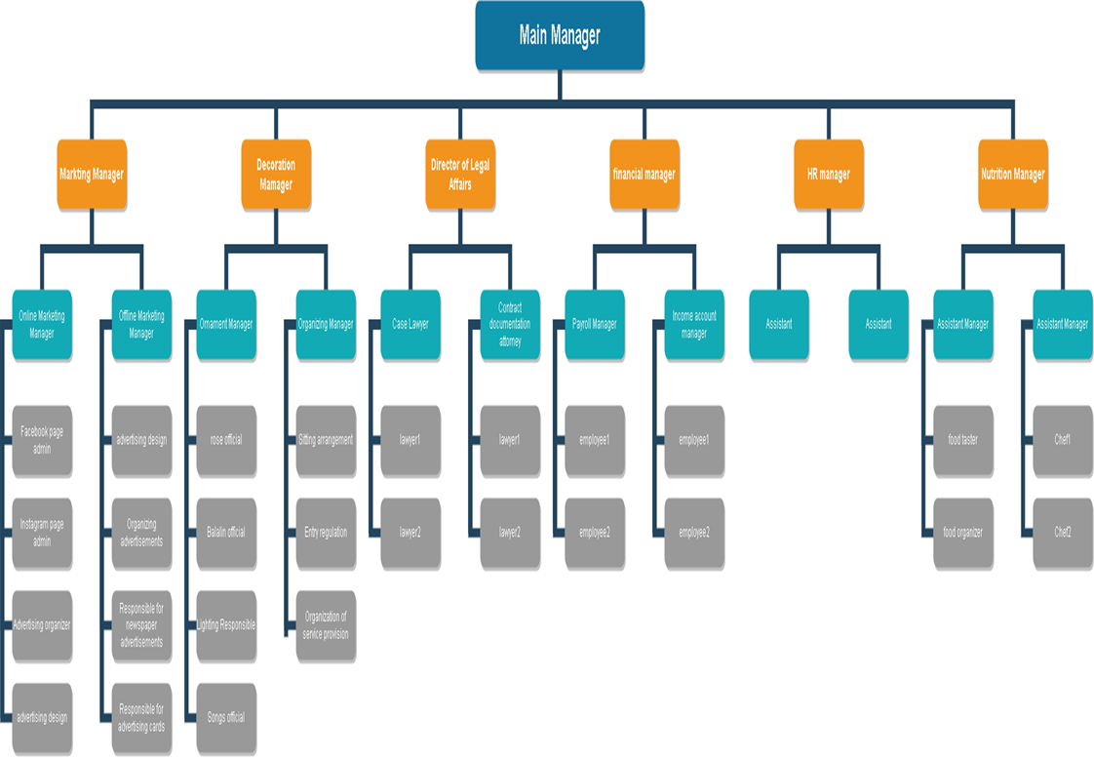

**Organizing chart**

**Influencing**

***1-Emotional Intelligence***

* **Motivation:**

1. **Ask them**

Explain exactly what you need, by when, and why. Explaining the

The bigger picture lets others see how their contributions will matter and provides the context needed to make better decisions about how to accomplish tasks.

1. **Involve them**

Ask them what it will take for them to get involved. Everyone is different, and what may be highly motivating for one person could be agony for someone else. Find out what motivates them and tailor your expectations accordingly.

1. **Trust them**

Give them the autonomy to decide how the work will be done,

within certain parameters. Give them ownership, but make sure they know you are available for questions.

1. **Appreciate them**

Thank them sincerely. Praise publicly and share positive

feedback with their supervisors, as well as with other teammates.

1. **Reward them**

Provide tangible evidence of your gratitude. Send a handwritten

note thanking them for the extra effort on a large project.

Certificates, gift cards, plaques, public recognition, another interesting project, and more responsibility are all ways to reward people. Even if you have only a tiny budget, you can do something to show your gratitude.

* **leadership:**
* Lead by example: Many successful leaders demonstrate how to behave, perform tasks, and do their work. A good leader models excellent behavior and must be able to motivate and encourage people. The most successful companies and organizations have leaders who help their staff understand the value of their vision and show them how everyone can work together to achieve that goal in their role.
* Use technology and innovation: Since technology use in the workplace is widespread, as a leader you should take advantage of the benefits that technology can bring to your organization. Technology can help in the operation of a business, increase productivity, help movement into new markets, and facilitate achieving the company's vision. Communication across the world is easier using new technologies, which helps with collaboration. Teams can now work together even if they are based in different countries.

**2-Communication**

* As we know the majority of people communicate many times in a given day. This is especially apparent in a workplace like our organization, so the Managers have to effectively communicate with others like the developers and the designers, and even the marketing employees, it is important to understand how the communication process works.
* ***Communication Activities:***

• Interpersonal communication.

• Sharing information with other organization members. How interpersonal communication works?

• The source/encoder (source): Is the person in the interpersonal communication situation who originates and encodes information to be shared with others.

• The signal: Encoded information that the source intends to share constitutes a message.

* The decoder/destination (destination): Is the person or persons with whom the source is attempting to share information.
* **Successful and Unsuccessful Interpersonal Communication**

**• Successful Communication:**

An interpersonal communication situation in which the information the source intends to share with the destination and the meaning the destination derives from the transmitted message is the same.

• **Unsuccessful Communication:**

An interpersonal communication situation in which the information the source intends to share with the destination and the meaning the destination derives from the transmitted message is different.

Communication is the essence of human life and society. People all time are engaged in communication. There are various ways to make communication effective. The following are the essential principles of effective communication:

* **Principles of effective communication:**
  + - 1. **The principle of clarity:**

A message should be clear, and free from distortion and noise. A vague message is not only a barrier to creating effective communication but also causes a delay in the communication process and this is one of the most important principles of effective communication.

* + - 1. **Principles of Brevity:**

Communication should be brief i.e., just necessary and sufficient. Repetition and over-explanation are likely to destroy the actual meaning and importance of the message. Moreover, the reader may feel disturbed by receiving a long message.

* + - 1. **The principle of Simplicity:**

The message should be given using simple and familiar words. Vague and technical words should be avoided. Simple words are easy to understand and help the receiver to respond quickly.

* + - 1. **The principle of Timeliness:**

Communication is meant to serve a specific purpose. If communication is made in time, communication becomes effective. If it is made untimely then it may become useless.

* + - 1. **The principle of Compass**:

The communication net should cover the whole organization. The concerned people must know “What exactly they need and “When they need it. And effective communication will serve such.

* + - 1. **The principle of Integrity:**

Communication should consider the level of people, principles & objectives of an organization to create a network or chain. Such a network will provide a better field of internal and external communication.

* + - 1. **The principle of strategic use of Informal Organization:**

The most effective communication results when managers use the informal organization as complementary to formal communication, e.g., arranging sports, cultural functions & dinners for the employees can be an informal organization. 8. The principle of Feedback: To provide a message to the receiver is not a complete communication. The response from a receiver is essential. Therefore, feedback is required for communication to be effective.

**Controlling Function**

**ntrolling Function**

* **Controlling consists of verifying whether everything occurs in conformities with the plans adopted, instructions issued and principles established. Controlling ensures that there is effective and efficient utilization of organizational resources to achieve the planned goals. Controlling measures, the deviation of actual performance from the standard performance, discovers the causes of such deviations and helps in taking corrective actions.**
* **Controlling has got two basic purposes**
* It facilitates co-ordination
* It helps in planning
* **Features of Controlling Function**

Following are the characteristics of the controlling function of management

1. Controlling is an end function- A function that comes once the performances are made in conformities with plans.
2. Controlling is a pervasive function- which means it is performed by managers at all levels and in all types of concerns.
3. Controlling is forward-looking- because effective control is not possible without past being controlled. Controlling always look to the future so that follow-up can be made whenever required.
4. Controlling is a dynamic process- since controlling requires taking reviewal methods, changes must be made wherever possible.
5. Controlling is related to planning- Planning and Controlling are two inseparable functions of management. Without planning, controlling is a meaningless exercise and without controlling, planning is useless. *Planning presupposes controlling and controlling succeeds in planning*.

## **Importance of Controlling**

**After the meaning of control, let us see its importance. Control is an indispensable function of management without which the controlling function in an organization cannot be accomplished and the best plans which can be executed can go away. A good control system helps an organization in the following ways:**

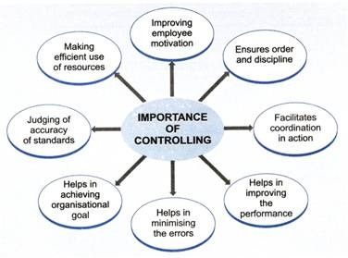

### 1. Accomplishing Organizational Goals

The controlling function is an accomplishment of measures that further makes progress towards the organizational goals & brings to light the deviations & indicates corrective action. Therefore, it helps in guiding the organizational goals which can be achieved by performing a controlling function.

### 2. Judging Accuracy of Standards

A good control system enables management to verify whether the standards set are accurate & objective. The efficient control system also helps in keeping careful and progress check on the changes which help in taking the major place in the organization & the environment and also helps to review & revise the standards in light of such changes.

### 3. Making Efficient use of Resources

Another important function of controlling is that this, each activity is performed in such a manner so under predetermined standards & norms to ensure that the resources are used in the most effective & efficient manner for the further availability of resources.

### 4. Improving Employee Motivation

Another important function is that controlling help in accommodating a good control system which ensures that each employee knows well in advance what they expect & what are the standards of performance based on which they will be appraised. Therefore, it helps in motivating and increasing their potential to make them & helps them to give better performance.

### 5. Ensuring Order & Discipline

Controlling creates an atmosphere of order & discipline in the organization which helps to minimize dishonest behavior on the part of the employees. It keeps a close check on the activities of employees and the company can be able to track and find out the dishonest employees by using computer monitoring as a part of their control system.

### 6. Facilitating Coordination in Action

The last important function of controlling is that each department & employee is governed by such pre-determined standards and goals which are well versed and coordinated with one another. This ensures that overall organizational objectives are accomplished in an overall manner.

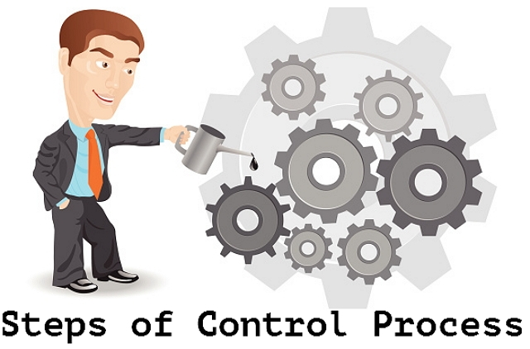

# **Process of Controlling**

**Controlling as a management function involves the following steps:**

1. Establishment of standards- Standards are the plans or the targets which have to be achieved in the course of business function. They can also be called the criteria for judging performance. Standards generally are classified into two
   1. Measurable or tangible - Those standards which can be measured and expressed are called measurable standards. They can be in form of cost, output, expenditure, time, profit, etc.
   2. Non-measurable or intangible- Some standards cannot be measured monetarily. For example- the performance of a manager, deviation of workers, and their attitudes towards a concern. These are called intangible standards.

Controlling becomes easy through the establishment of these standards because controlling is exercised based on these standards.

1. Measurement of performance- The second major step in controlling is to measure the performance. Finding out deviations becomes easy by measuring the actual performance. Performance levels are sometimes easy to measure and sometimes difficult. Measurement of tangible standards is easy as it can be expressed in units, cost, money terms, etc. Quantitative measurement becomes difficult when the performance of a manager has to be measured. The performance of a manager cannot be measured in quantities. It can be measured only by
   1. The attitude of the workers,
   2. Their morale to work,
   3. The development in the attitudes regarding the physical environment, and
   4. Their communication with their superiors.

It is also sometimes done through various reports like weekly, monthly, quarterly, and yearly reports.

1. Comparison of actual and standard performance- Comparison of actual performance with the planned targets is very important. Deviation can be defined as the gap between actual performance and the planned targets. The manager has to find out two things here- the extent of the deviation and the cause of deviation. The extent of deviation means that the manager has to find out whether the deviation is positive or negative or whether the actual performance is in conformity with the planned performance. The managers have to exercise control by exception. He has to find out those deviations which are critical for business. Minor deviations have to be ignored. Major deviations like replacement of machinery, the appointment of workers, quality of raw material, rate of profits, etc. should be looked upon consciously. Therefore, it is said, “If a manager controls everything, he ends up controlling nothing.” For example, if stationery charges increase by a minor 5 to 10%, it can be called a minor deviation. On the other hand, if monthly production decreases continuously, it is called a major deviation.

Once the deviation is identified, a manager has to think about various cause which has led to the deviation. The causes can be

* 1. Erroneous planning,
  2. Co-ordination loosens,
  3. Implementation of plans is defective, and
  4. Supervision and communication are ineffective, etc.

1. Taking remedial actions- Once the causes and extent of deviations are known, the manager has to detect those errors and take remedial measures for them. There are two alternatives here
2. Taking corrective measures for deviations that have occurred; and
3. After taking the corrective measures, if the actual performance is not in conformity with plans, the manager can revise the targets. It is here the controlling process comes to an end. Follow-up is an important step because it is only through taking corrective measures, that a manager can exercise control.

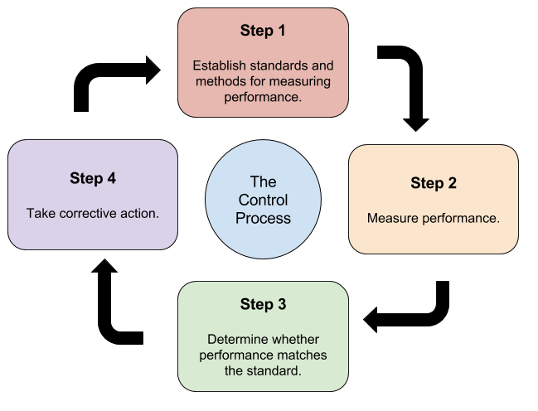

**THE END**