

**Faculty of engineering - Shoubra**

**Benha University**

**Research Article / Research Project / Literature Review**

in fulfillment of the requirements of

|  |  |
| --- | --- |
| **Department** | **Engineering Mathematics and Physics** |
| **Division** | **------------** |
| **Academic Year** | **2019-2020 Preparatory** |
| **Course name** | **Computer** |
| **Course code** | **ECE001** |

**Title: -**

**Artificial Intelligence**

By:

|  |  |  |  |
| --- | --- | --- | --- |
|  | Name | Edu mail | B.N |
| 1 | ندي مسعد عبدالله عبدالرحمن عزت | nada196114@feng.bu.edu.eg | 989 |

**Approved by:**

|  |  |
| --- | --- |
| Examiners committee | Signature |
| Dr. Ahmed Bayoumi |  |
| Dr. Shady Elmashad |  |
| Dr. Abdelhamid Attaby |  |

**Definition of Artificial Intelligence:** It is the study of "intelligent agents, which means any device that perceives its environment and takes actions that maximize its chance of achieving its goals successfully. A definition characterizes AI as "a system's ability to correctly interpret external data, to learn from such data, and to use those learning to achieve certain goals and tasks through flexible adaptation.

**Applications of Artificial Intelligence:**

AI where programs are developed to perform specific tasks, that is being used for a wide range of activities including [medical diagnosis](https://en.wikipedia.org/wiki/Medical_diagnosis), [electronic trading platforms](https://en.wikipedia.org/wiki/Electronic_trading_platform), [robot control](https://en.wikipedia.org/wiki/Robot_control), and [remote sensing](https://en.wikipedia.org/wiki/Remote_sensing).

Artificial Intelligence has been used to develop and advance many fields and industries, including finance, healthcare, education and transportation.

**Github Link**: <https://github.com/Nada196114>

**Github page:** [**https://nada196114.github.io/html-project/**](https://nada196114.github.io/html-project/)

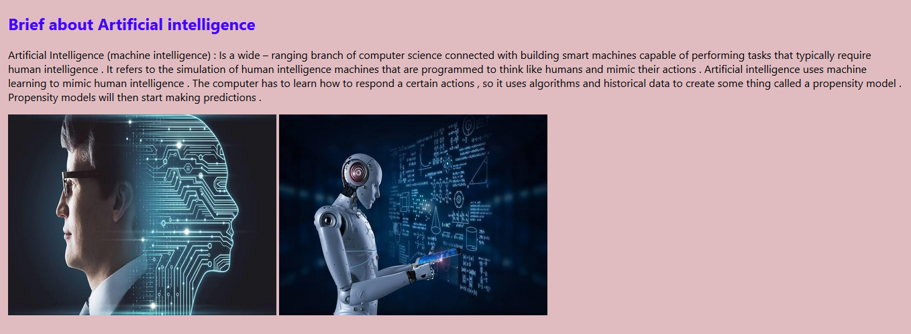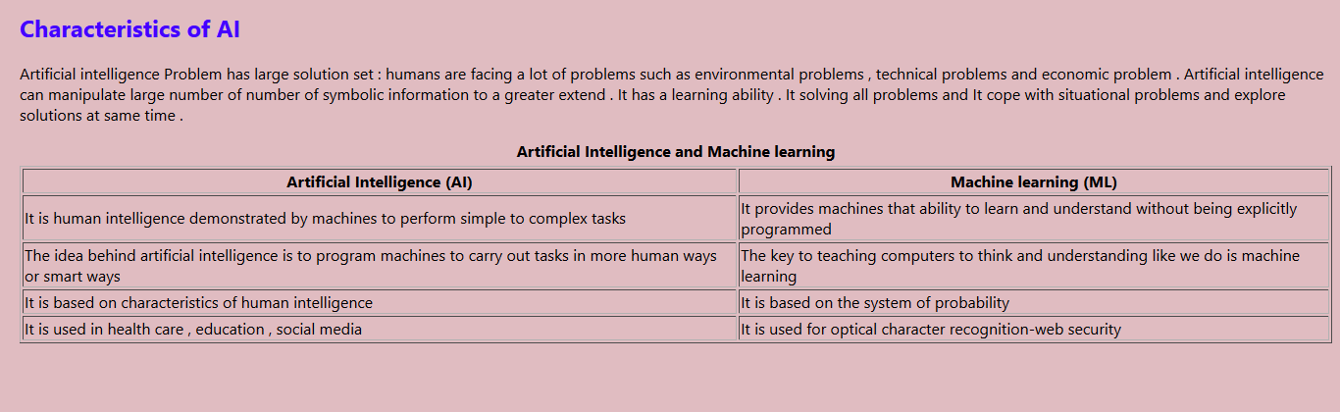**Screenshot:**

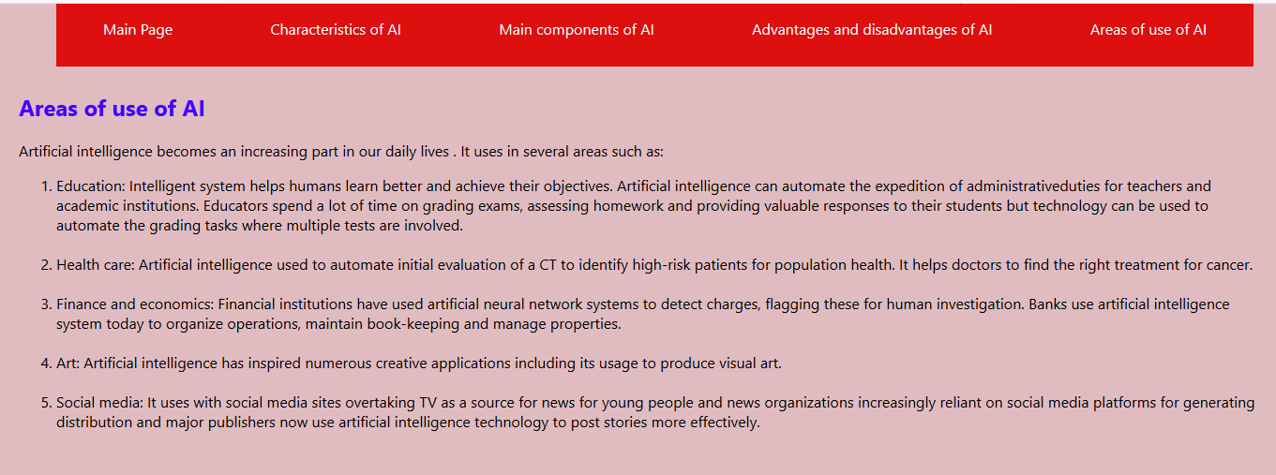

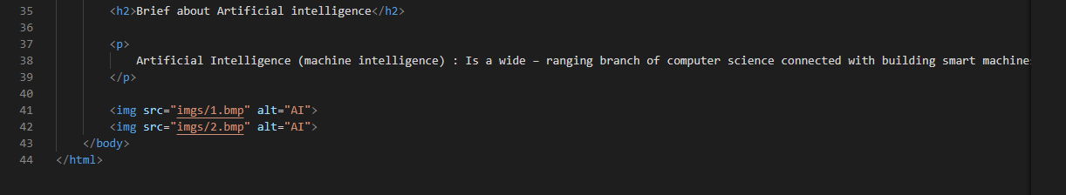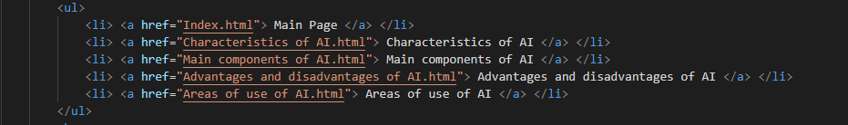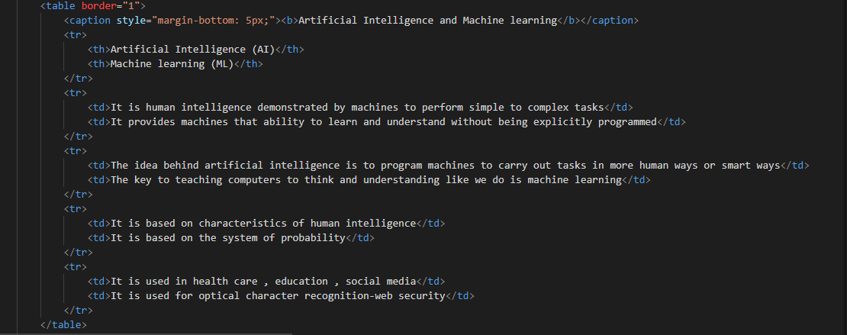

**Source code:**