**Lab2**

1. create users called itiuser1, itiuser2

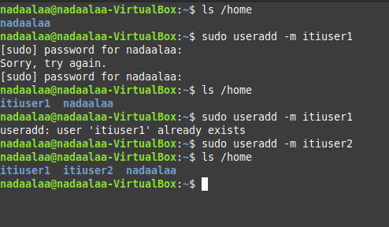

2. create group called os_team

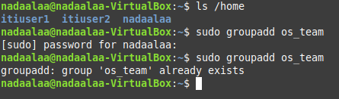

3. create directory called os_team_workspace

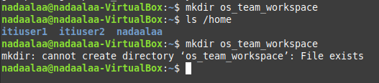

4. assign os_team group to the directory

os_team_workspaceand change mode to setgid (hint use

sudo) 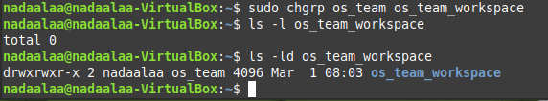

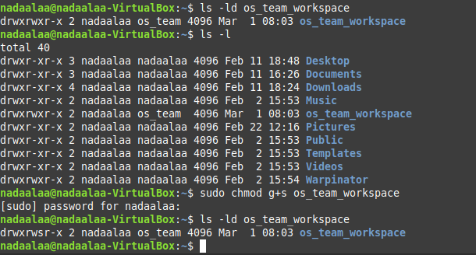

5. add users itiuser1 and itiuser2 to os_teamgroup



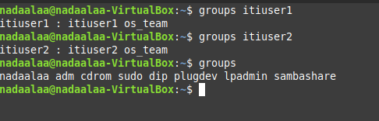

6. create directory mydir1 using itiuser1 and mydir2 using

itiuser2

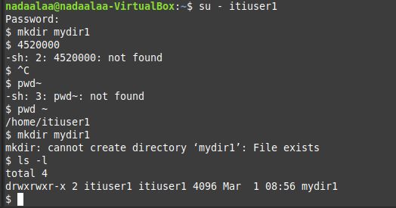

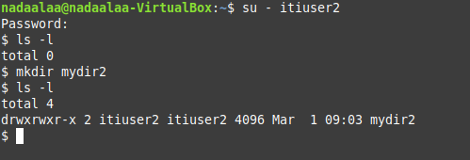

7. list directory permissions and send screenshot.

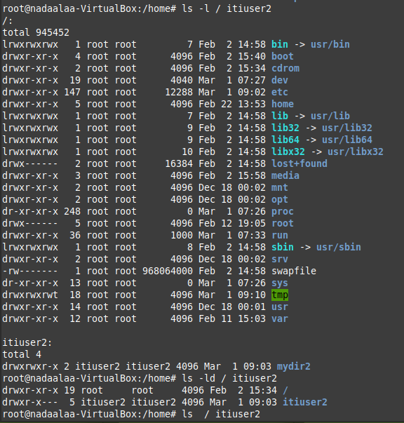

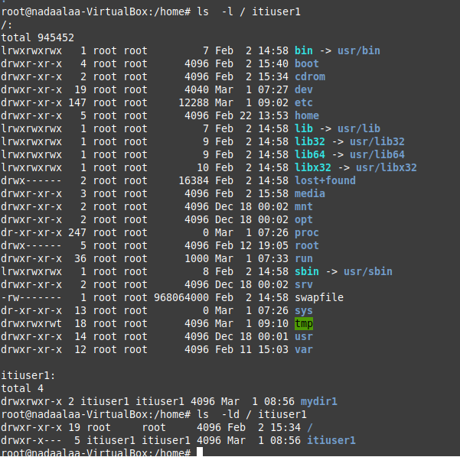

8. send screenshot of all processes in tree mod

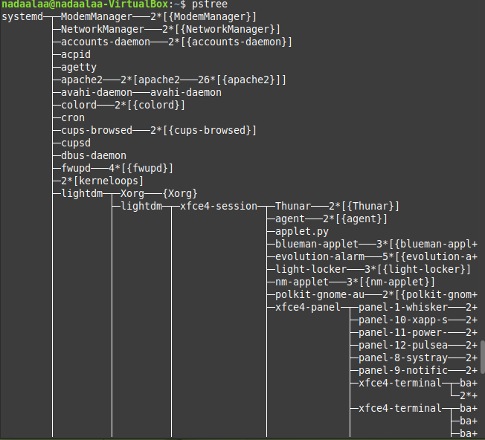

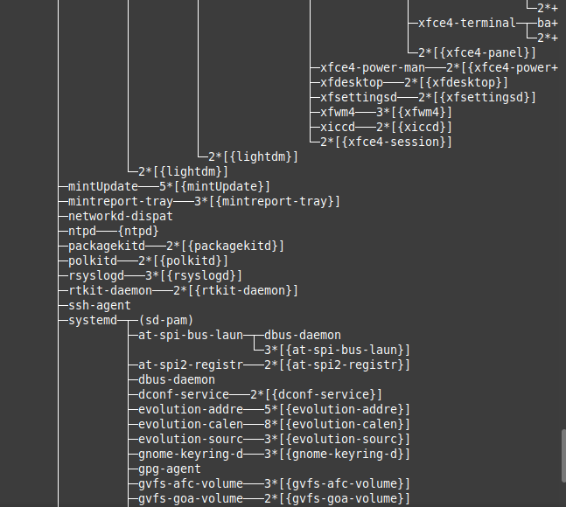

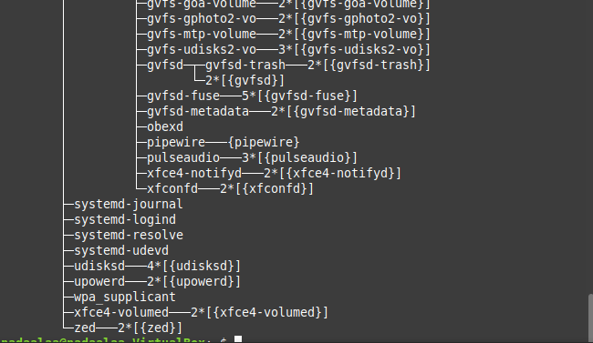

9. execute command tail -f /var/log/syslog

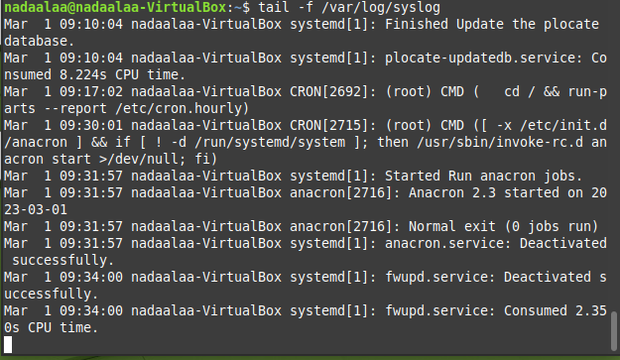

10. find the process id PID of tail process then kill it using

kill command

