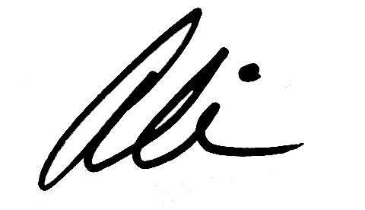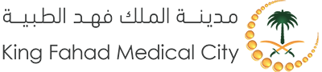

**Ali Mohamed Hanidaddin**

For his satisfactory completion of training for this course Full stack web development .

From 4/8/2022 12:00:00 AM

To 10/9/2022 12:00:00 AM

**Student Name: Nada Nazal**

**Student Id: 1**

H

**END OF TRAINING CERTIFICATE**

This certificate is presented to