Assignment 3: Agents — doit Shell Agent
Deep Learning Methods for Texts and Sequences

Overview
doit is a LLM shell agent. It accepts natural language requests, calls an LLM to produce a structured json response, sends the response type, executes shell commands when appropriate, and keeps session history and user memories.
3 model configurations are supported with ~/doit.cfg: a hosted api model (Groq / llama-3.1-8b-instant), a local instruction model without tool calling (ollama/gemma3:4b), and a local tool calling model (ollama/qwen3:4b).

Section 1: Single Command at a Time

What was implemented
_build_messages() creates the message list. _call_llm() calls LiteLLM and parses the json response (with a markdown fence stripping step and a regex fallback for models that add extra prose). _process_response() dispatches on resp["type"].
Five response types are defined in the system prompt:
command — a shell command to execute
answer — informational text without execution
impossible — request cannot be done as a shell command
clarification — llm needs more information
multi_step — ordered sequence of commands

Design decisions
json in prompt was chosen over tool or function calling so that the same code path works with all 3 model types. Dangerous command classification is embedded in the same json response (the "dangerous" boolean field), avoiding an extra LLM call.

ACDL — V1: first invocation (no history)
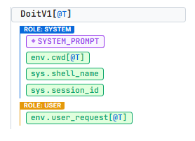

Real interactions
doit "list the files in the current directory"
$ ls
-> List files and directories in the current directory
doit "tell me a joke about shell scripting"
Why did the shell script go to therapy? Because it was feeling a little 'looped' and had a lot of 'if' issues!
doit "send an email to my boss"
[Cannot do that: I don't have the necessary information to send an email.
Please provide the recipient's email address, subject, and message.]

Limitations
"impossible" is triggered only by the llm's judgment — it sometimes can try to guess instead.

Section 2: Identifying Dangerous Commands

What was implemented
The system prompt defines two lists (dangerous vs. non commands). The llm sets the "dangerous" boolean in the same response — no extra LLM call. When dangerous=true, handle_command() prints a warning and prompts y/N before executing.

Design decisions
Keeping the classification in the same call avoids disagreement between 2 separate calls. The prompt lists concrete examples to help the llm generalise to other dangerous cases.

Real interactions
doit "delete all .log files in the current directory" (answer: n)
$ find . -type f -name '*.log' -delete
-> delete all .log files in the current directory

[!] This command modifies the system.
Execute? [y/N] n
Skipped.
Limitation found during testing: mkdir classified as dangerous=false
$ doit "create a folder called doit_test"
# LLM returned: dangerous=false
# mkdir ran immediately without confirmation.
# The system prompt lists rmdir but not mkdir explicitly;
# "anything that alters state" did not catch it.

Limitations
mkdir, touch, and other commands are sometimes misclassified as safe. The system prompt lists rmdir but not mkdir — the llm does not always generalise the dangerous scenarios.

Section 3: Model Flexibility

What was implemented
~/doit.cfg selects the model and provider. _call_llm() passes the config directly to LiteLLM's completion() — no provider specific code exists in doit. Three configurations were tested:
- API: groq/llama-3.1-8b-instant
- local_tools: ollama/qwen3:4b
- local_no_tools: ollama/gemma3:4b

doit.cfg examples
{"model":"groq/llama-3.1-8b-instant","api_key":"gsk_...","api_base":"","model_type":"api"}

{"model":"ollama/qwen3:4b","api_key":"","api_base":"http://localhost:11434","model_type":"local_tools"}

{"model":"ollama/gemma3:4b","api_key":"","api_base":"http://localhost:11434","model_type":"local_no_tools"}

Model comparison — all three tested with same request
doit "list all python files in this directory" — all three models
groq/llama-3.1-8b-instant -> {"type":"command","command":"ls *.py",...}
ollama/qwen3:4b -> {"type":"command","command":"ls *.py",...}
ollama/gemma3:4b -> {"type":"command","command":"ls *.py",...}

All three returned valid JSON.

Key difference: gemma3 vs qwen3 on JSON discipline
qwen3:4b (tool-calling trained) returns bare json with no surrounding prose.
gemma3:4b (general instruction model) sometimes wraps the json in an explanation. The regex fallback in _call_llm() handles this, but a stricter parser would break on gemma3.

Limitations
on CPU only hardware, local models take much more time per call, which is acceptable for testing of course but slow for real use.
gemma3 requires the regex fallback more often; very complex requests occasionally produce malformed json that even the fallback cannot parse.

Section 4: Multi-Turn

What was implemented
History is stored in ~/.doit/history.json. each entry saves session_id, timestamp, cwd, request, llm response, and the result. _build_messages() loads the last 10 entries for the session and injects them as alternating user/assistant turns, with execution output appended as a user message after each command.

Design decisions
Execution output is injected back so the model knows exactly what happened which enables follow ups without the user repeating context.

ACDL — V3: multi-turn with execution results
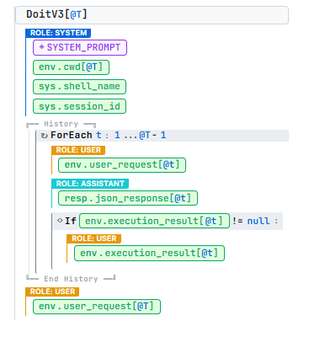

Interactions:
Turn 1: doit "how do I check which python version is installed?"
You can check which Python version is installed by running the command
`python --version` or `python3 --version`.
Turn 2: doit "execute it"
$ python --version
-> Print the version of Python installed on the system
[exit 126] <- bash detection issue on Windows; LLM correctly re-issued the command

Limitations
History is capped at 10 entries — older context is silently dropped in long sessions.

Section 5: Clarifications

What was implemented
type="clarification" is one of the standard JSON response types. handle_clarification() prints the question and options, reads the answer, then calls _call_llm() again with the answer appended. The result is processed normally — it could be a command, an answer, or another clarification. Empty input or Ctrl C aborts cleanly.

Design decisions
The mechanism requires no separate tool infrastructure — it is just another JSON type. The model decides when to clarify, the system prompt tells it to only ask when genuinely uncertain.

Real interaction
doit "list all files in home folder sorted by date, ask me which date type to use"
? Which date type would you like to use to sort the files in the home folder?
1. modified
2. accessed
3. created

Your answer: modification date

$ stat -c '%Y' *
-> Print the modification time of each file
[exit 126]

Limitations
The Groq llama-3.1-8b model rarely triggers clarification spontaneously — it tends to just guess instead. I needed to explicitly request clarification in testing.
The follow up command after clarification was incorrect in this run (stat -c rather than ls -lt) — the LLM lost track of the original goal after the clarification exchange.

Section 6: Richer Interactions

What was implemented
type="answer" handles all non command requests. The system prompt states: "When a user asks a question like how do I..., respond with type=answer, not type=command." Follow ups like "execute it" work because the full prior assistant response is in the history context.

Real interactions
Turn 1: $ doit "how do I check which python version is installed?"
You can check which Python version is installed by running
`python --version` or `python3 --version`.
Turn 2: $ doit "execute it"
$ python --version
-> check the version of Python installed
Python 3.9.10

Limitations
After many turns, the LLM may pick the wrong "it" if there are multiple commands in recent history.

Section 7: Memory

What was implemented
Memories are stored in ~/.doit/memory.json as a flat key/value dict. Any model's response can include a "memories" array to create, update, or delete entries. An empty value means "forget". Memory is injected at the top of the system message on every invocation, before conversation history.

ACDL — V4: with memory (and shell history)
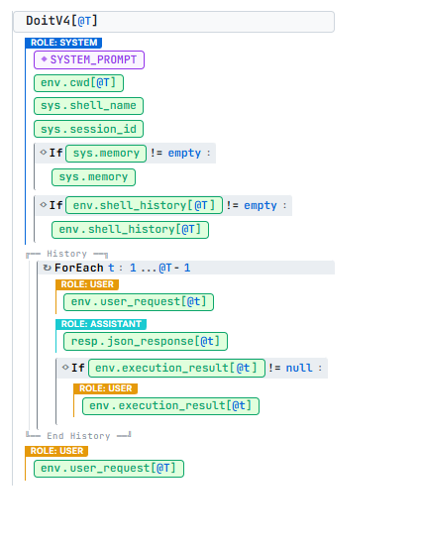

Interactions
doit "store in your memories that project_folder is ~/school/llms/ass3"
(no output — LLM returned a memories-only response with no type field)
Memory stored: {"project_folder": "~/school/llms/ass3"}
(new session) $ doit "what is my project folder"
Your project folder is ~/school/llms/ass3
$ doit --memories
Stored memories:
project_folder: ~/school/llms/ass3

Limitations
The llama-3.1-8b model often ignores the memories mechanism for natural requests like "remember my name is Nadav".
A response with only "memories" and no "type" field produces no output but still stores the memory correctly — the user will see a blank response.

Section 8: User Awareness (Shell History)

What was implemented
read_shell_history() reads ~/.bash_history or ~/.zsh_history and returns the last 15 commands. zsh extended history lines are parsed to extract just the command. The list is injected in the system message as a separate section, distinct from doit's own conversation history.

Design decisions
Two sources of "what happened before" are kept separate on purpose: doit's own commands appear in the assistant turns of the conversation history, while manual shell commands appear only in the system section. The LLM can therefore distinguish "you (doit) ran X" from "the user manually ran Y".
User manually ran: cd ~/data && python train.py --epochs 10
doit "summarize what I just did"
You navigated to ~/data and ran a Python training script (train.py) with 10 epochs.
This was a manual action outside of doit.

Limitations
Commands that run after the current doit call are not captured.
On Windows the .bash_history path may differ depending on Git Bash.

Section 9: Output Awareness

What was implemented
Each history entry stores the full execution result(stdout, stderr, returncode) . _build_messages() appends this as a "[Execution result]" user message after each assistant turn. The next model call therefore has full access to the output of the previous commands.

Real interactions
Turn 1: doit "show the sizes of all files in this directory"
$ du -h *
-> Print the sizes of all files in the current directory
[exit 126] <- command failed on Windows bash
Turn 2: $ doit "why did that command fail?"
The command failed because it encountered a directory that it couldn't access, and it returned a non-zero exit code (512). This is likely due to the presence of the `.no_exist` directories in the output, which suggests that the command was trying to access non-existent files or directories.
The LLM correctly diagnosed the failure by reading the stderr and returncode from the previous execution result in context.

Limitations
a very large stdout can inflate the context significantly.

Section 10: Multi-Tasking (Session Isolation)

What was implemented
Each doit process reads DOIT_SESSION_ID from the environment. If not set, it defaults to the parent shell PID (os.getppid()), which is unique per terminal window — so each terminal gets its own session automatically with no setup required. _build_messages() injects the last 10 entries from the current session as conversation turns, and also injects the last 5 entries from every other session into the system message — labeled with session ID and cwd. This lets the llm resolve cross-session references when the user explicitly asks for them.

Real interaction - cross-session reference
window2 session: doit "show me disk usage of this folder"
$ du -h .
-> Show disk usage of the current directory
[output: 2.3M total]
window1 session: doit "now do the same thing window2 did"
$ du -h .
-> show disk usage of the current directory
[output: 2.3M total]
window1 correctly replicated the command from the other window's history, which was injected into the system message under "History from other sessions".

Limitations
The history of other sessions is capped shortly (last 5 entries, command only) — full stdout is not shared across sessions.

Section 11: Further Extensions

Extension 1 (IMPLEMENTED): Autonomous Agentic Loop (--agentic)

Description
The user gives a goal for which the agent plans and executes commands step by step, observes output, and decides what to do next.

Implementation
A separate system prompt (_AGENTIC_SYSTEM) defines three response types:
- "agentic_step" — run a command, observe output, continue
- "agentic_done" — goal reached, stop
- "agentic_ask" — ask the user a question, then continue
run_agentic() maintains a growing messages list. After each step, the execution result is appended and the LLM is called again. Max 10 steps.

ACDL — Agentic mode (substep @I within turn @T)
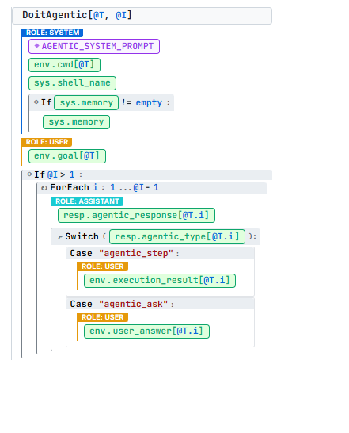

Interaction
$ doit --agentic "find all .cfg files in this folder and count the total number of lines" [Agentic mode - goal: find all .py files and count total lines]

-- Agentic step 1/10 --
$ find . -name '*.py' -print0 | xargs -0 wc -l
-> Find all .py files and count lines
[exit 126] <- bash not found on Windows

-- Agentic step 2/10 --
$ find . -name '*.py' -print0 | xargs -0 wc -l
-> Try again with correct path
[exit 126]

-- Agentic step 3/10 --
$ find . -name '*.py' -print0 | xargs -0 wc -l
-> Try again with absolute path
[exit 126]

-- Agentic step 4/10 --
[Done] Failed to count total lines in .py files due to incorrect path handling
The agent correctly applied the "stop after 3 failed attempts" rule from its system prompt, returning agentic_done with an honest summary of the failure. This demonstrates appropriate error recovery behavior.

Extension 2 (described): Context Compaction
For long sessions, history grows unboundedly. A compaction step would periodically summarise older turns to some narrative ("user navigated to ~/proj, installed dependencies, ran tests — all succeeded"), thus replacing them with a single summary entry. This directly addresses the 10-entry cap limitation without losing semantic context.

Extension 3 (described): Project Profiles
Each directory could have a .doit_profile file with project specific instructions: preferred test command, deployment pipeline, known gotchas. When doit is called, it reads any .doit_profile in the current or parent directories and injects it as [Project context], making the agent behave differently per project.

ACDL Summary: Context Evolution
The context grew incrementally as features were added:
Version | New context added | ACDL spec
V1 — single command | SYSTEM_PROMPT + cwd + shell + session_id | DoitV1[@T]
V2 — dangerous cmds | dangerous field in SYSTEM_PROMPT (same structure) | DoitV1[@T] (prompt updated)
V3 — multi-turn | + History loop with execution results injected | DoitV3[@T]
V4 — memory + shell hist | + sys.memory + env.shell_history in system block | DoitV4[@T] (final normal mode)
Agentic mode | AGENTIC_SYSTEM + goal + growing substep history | DoitAgentic[@T, @I]

Appendix: Complete System Prompts

SYSTEM_PROMPT (normal mode)
You are doit, an intelligent shell assistant. Translate user requests into shell
commands or answer questions about the shell/system.

ALWAYS respond with a single JSON object -- no markdown fences, no prose outside the JSON.

Response types:
1. {"type":"command","command":"<bash command>","description":"<what it does>","dangerous":false}
2. {"type":"command","command":"<bash command>","description":"<what it does>","dangerous":true}
3. {"type":"answer","text":"<your explanation>"}
4. {"type":"impossible","text":"<reason>"}
5. {"type":"clarification","question":"<your question>","options":["opt1","opt2"]}
6. {"type":"multi_step","description":"<goal>","steps":[{"command":"...","description":"...","dangerous":false}]}

Any type may include: "memories":[{"key":"preferred_editor","value":"vim"}]
Use empty value to forget: {"key":"old_fact","value":""}

Dangerous = true for: rm, rmdir, mv, cp (overwrite), chmod, chown, kill, pkill, sudo,
apt/pip/brew, git push/reset --hard, curl|sh, dd, mkfs, truncate, > redirects,
systemctl stop/disable, and anything else that alters state.

Dangerous = false for: ls, cat, head, tail, grep, find, ps, df, du, pwd, echo,
which, man, stat, file, wc, diff, git log/status/diff, and other read-only operations.

When user says "execute it"/"run it"/"do it": execute the last suggested command.
When user asks "how do I...": respond with type=answer, not type=command.

Current directory: {cwd}
Shell: {shell_name} | Session: {session_id}

[if memory non-empty]
User memory (persistent facts):
{key}: {value}

[if shell history non-empty]
Recent manual shell commands (for context):
$ {cmd}

AGENTIC_SYSTEM_PROMPT
You are doit running in AGENTIC mode. The user has given you a high-level goal.
You must accomplish it step by step by issuing shell commands, observing their output,
and deciding what to do next.

In each turn respond with ONE JSON object:

Continue with another command:
{"type":"agentic_step","command":"<cmd>","description":"<why>","dangerous":<bool>}

Goal achieved -- stop:
{"type":"agentic_done","summary":"<what was accomplished>"}

Need user input to continue:
{"type":"agentic_ask","question":"<your question>"}

Dangerous detection rules are the same as normal mode.
Never loop forever: if you cannot make progress after 3 attempts, use agentic_done to stop.

Current directory: {cwd}
Shell: {shell_name}

[if memory non-empty]
User memory:
{key}: {value}

