Task 1: Get public IP address using google and windows command.

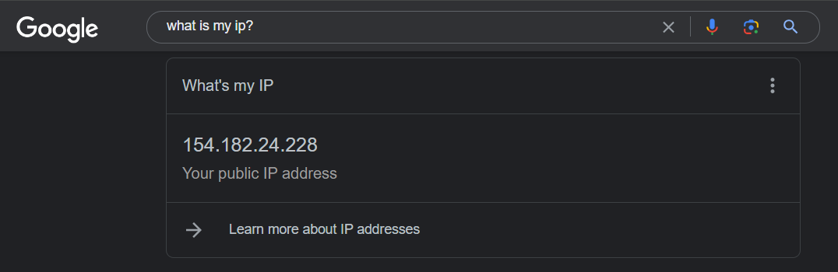

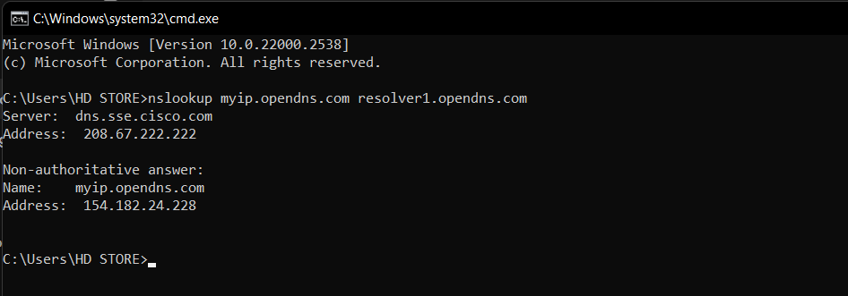

Task 2: Get private IP address (IPv4 and IPv6) using commands.

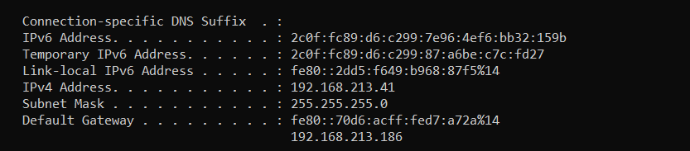

Task 3: What is the vendor code of your physical address?

Vender Code is a unique number given to each manufacturer or supplier of a specific product.

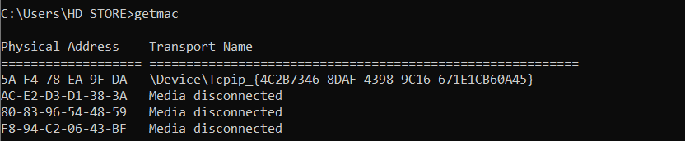

Task 4: Write your device name?

NODDY



Task 5: get the following information of your system:

a- Operating System Version

b- Processor Type

c- Model

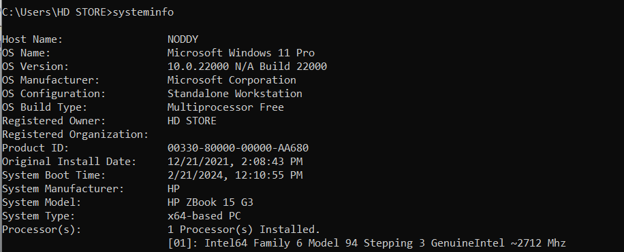

Task 6: check reachability of:

a- IP address: 100.100.100.100

b- Domain Name: swap.com

Solve A

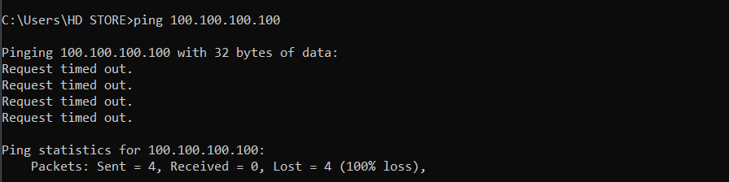

Solve B

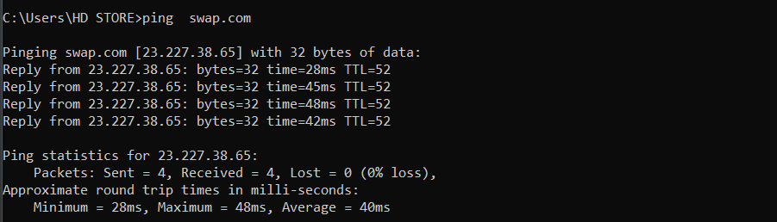

Task 7: get the domain name of IP address: 102.132.103.35

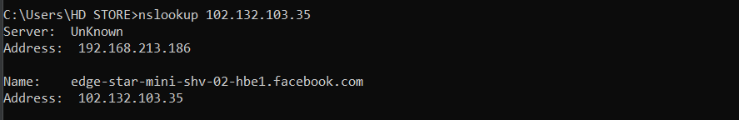

Task 8: how many hops to reach this domain: nourrahamat.com

27

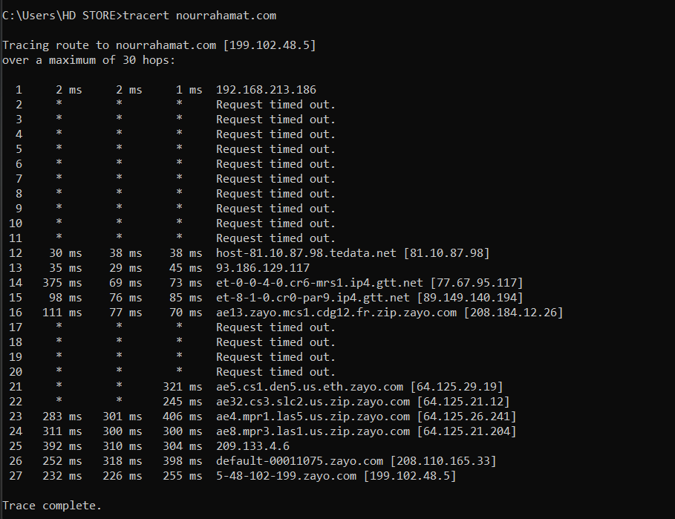

Task 9: write the address of second hop and before last hop of task 8

1-none

2- 208.110.165.33

Task 10: write the Round Trip Tiem (RTT) of first hop of task 8.

6ms

