Task 1 Design this structure in one of Network Diagram tools and take screenshot of design.

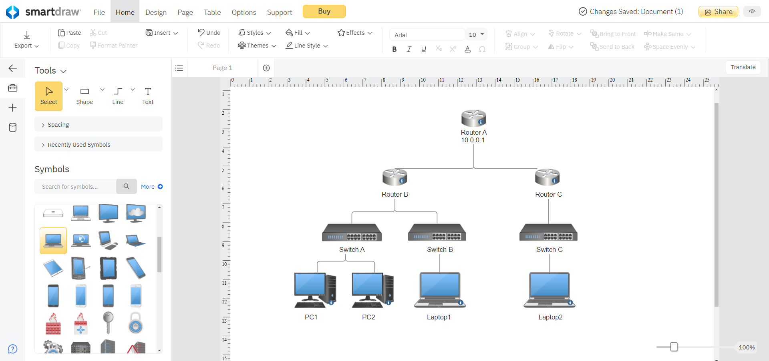

Task 2 Create this structure in CISCO Packet Tracer.

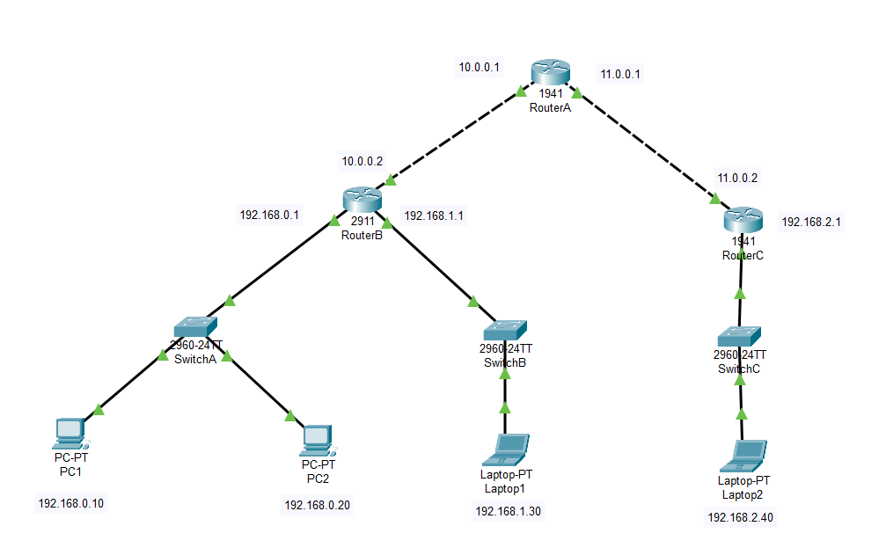

Task 3 Put suitable configuration and IP addresses of all hosts.

Done

Task 4 Make a display and host names of all hosts as shown in figure.

     

 

 

Task 5 Put all routers and switches on Privileged Exec Mode.

By enable command

  

  

Task 6 Try to ping from labtop1 to Labtop2.

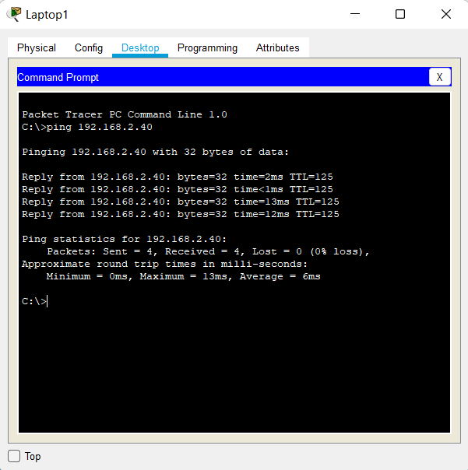

Task 7 Trace route from PC1 to Labtop2.

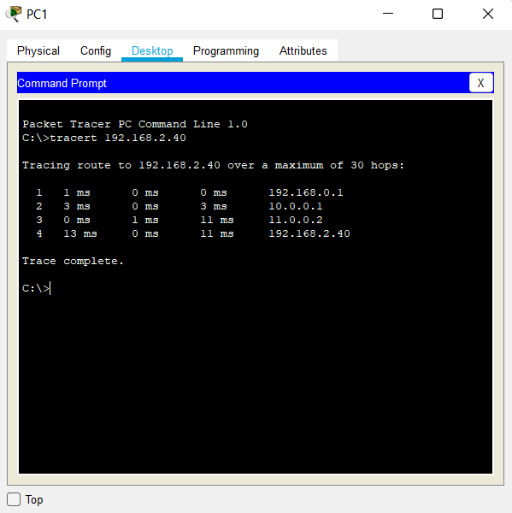

Task 8 Change all switches and routers hostname from configure terminal mode.

  