Task 1: Apply this structure of devices on CISCO Packet Tracer

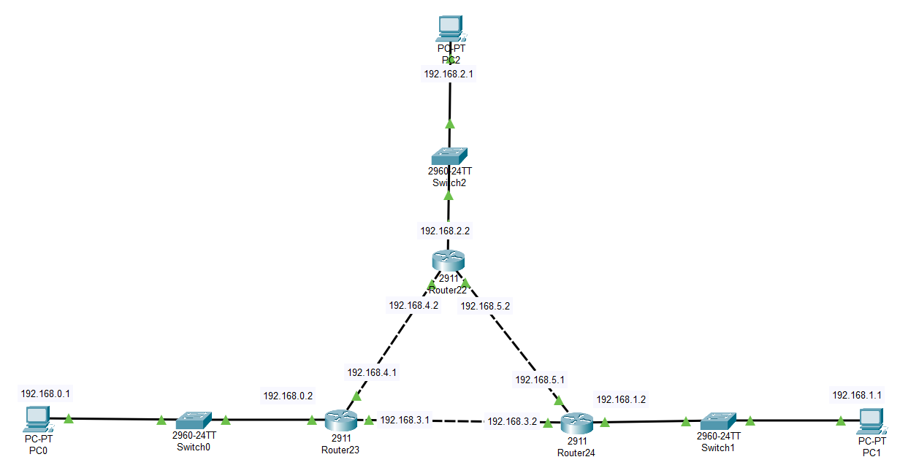

Task 2: Adjust appropriate IP Addresses of all PCs and Routers.

Done

Task 3: Make configuration settings of all routers that make them connected to each other conveniently.

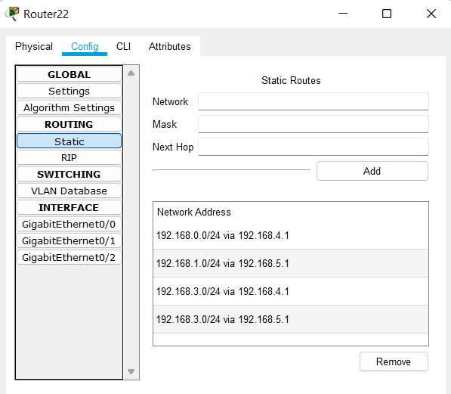

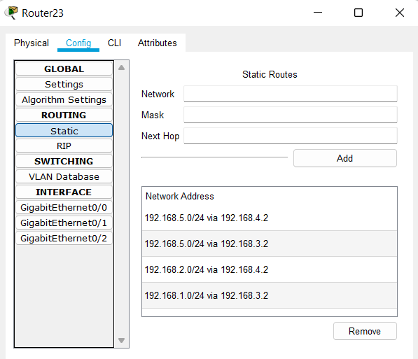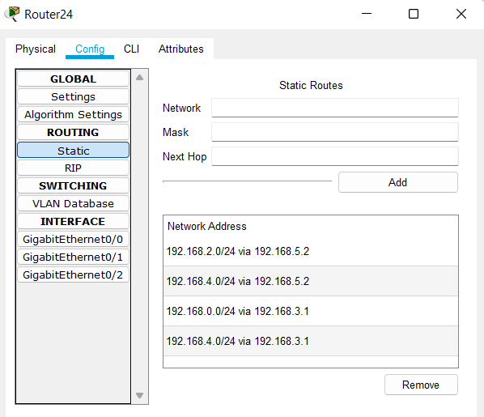

Task 4: Try to ping from any host to other hosts