Week 6: Lecture 5 Tasks

Task 1: Plot Line Encoding of following stream of bits 0001000 and 1110111 Using .

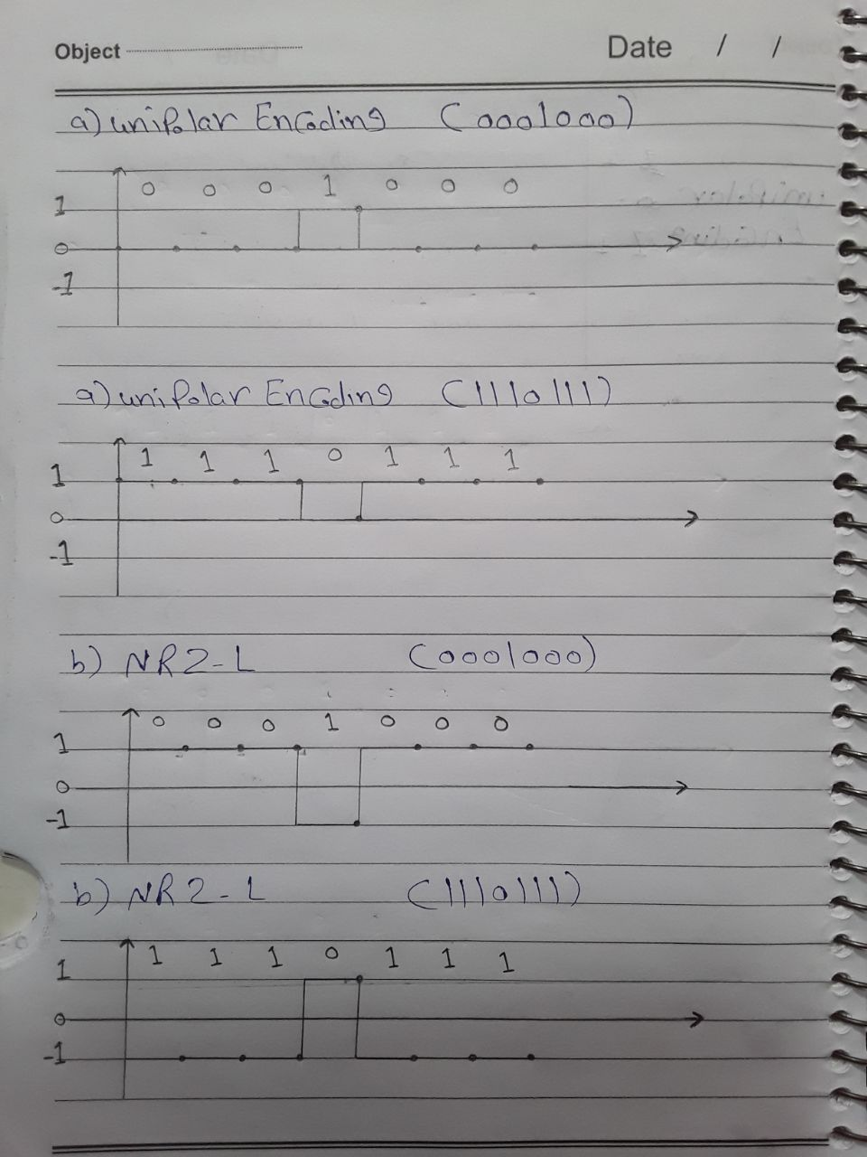

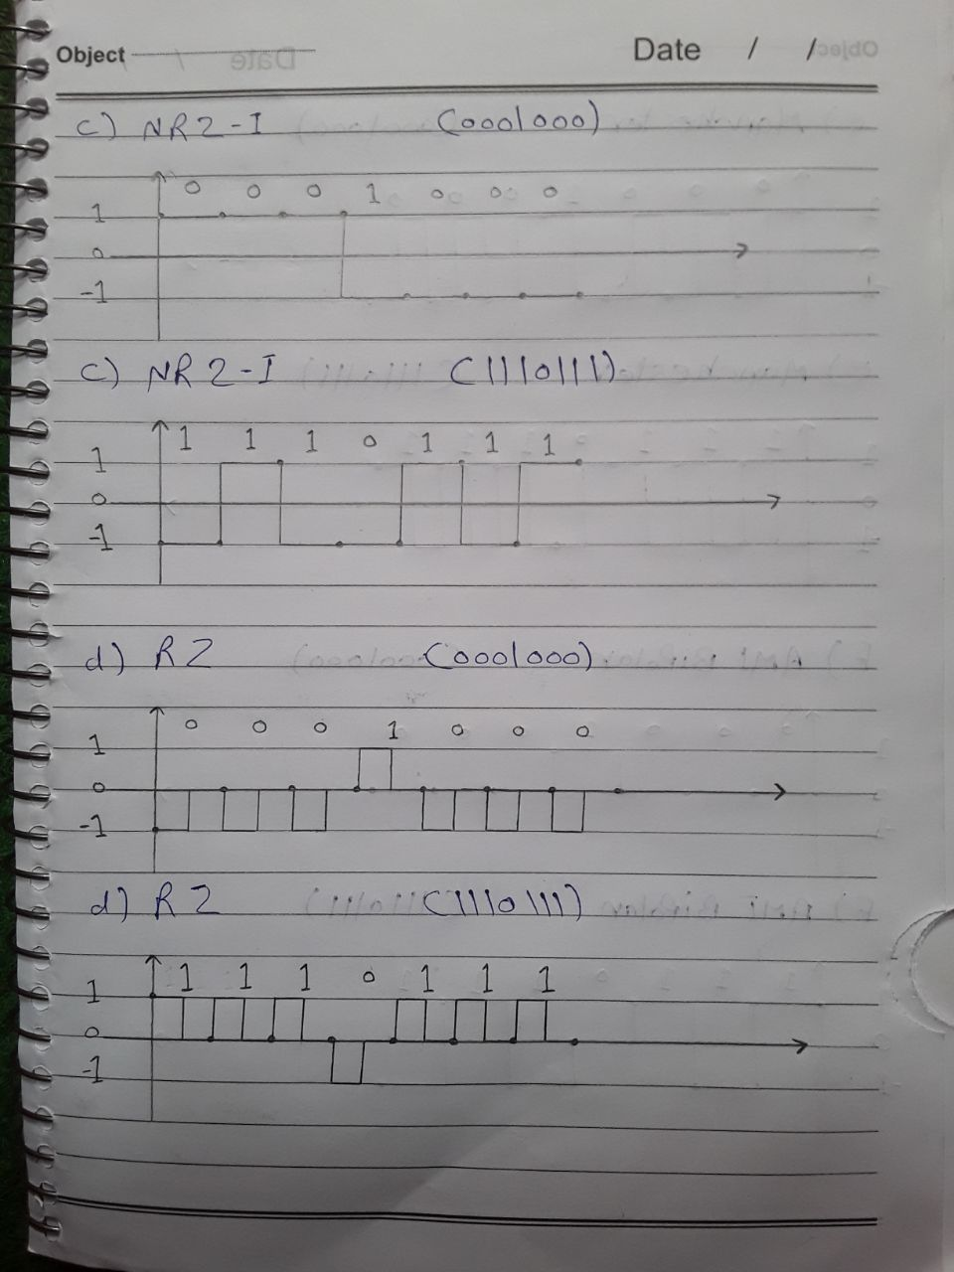

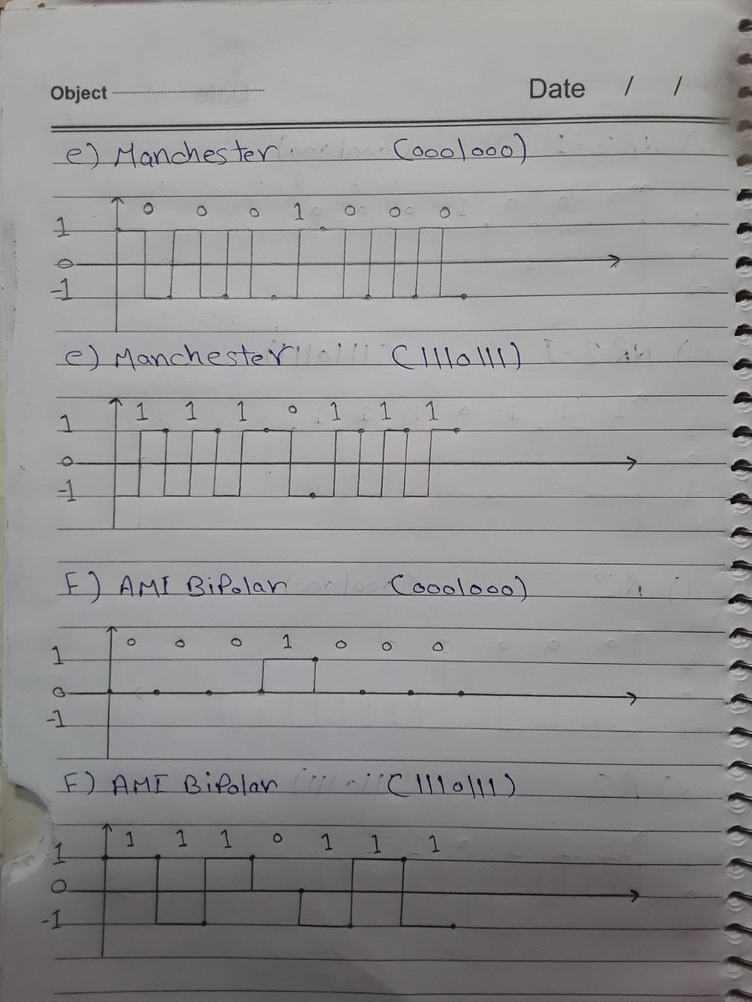

Task 2: Calculate cost and next hop of all tables using Distance Vector Routing Algorithm

|  |  |  |  |  |  |  |  |  |
| --- | --- | --- | --- | --- | --- | --- | --- | --- |
| Table For A | | | Table For B | | | Table For C | | |
| Dst | Cst | Hop | Dst | Cst | Hop | Dst | Cst | Hop |
| A | 0 | A | A | 1 | A | A | 4 | F |
| B | 1 | B | B | 0 | B | B | 4 | D |
| C | 4 | F | C | 4 | D | C | 0 | C |
| D | 4 | B | D | 3 | D | D | 1 | D |
| E | 2 | E | E | 3 | A | E | 6 | F |
| F | 3 | F | F | 4 | F | F | 1 | F |
| Table For D | | | Table For E | | | Table For F | | |
| Dst | Cst | Hop | Dst | Cst | Hop | Dst | Cst | Hop |
| A | 4 | B | A | 2 | A | A | 3 | A |
| B | 3 | B | B | 3 | A | B | 4 | B |
| C | 1 | C | C | 6 | A | C | 1 | C |
| D | 0 | D | D | 6 | A | D | 2 | C |
| E | 6 | B | E | 0 | E | E | 5 | A |
| F | 2 | C | F | 5 | A | F | 0 | F |

