Week 7: Lecture 6 Tasks

**Codes**

Server

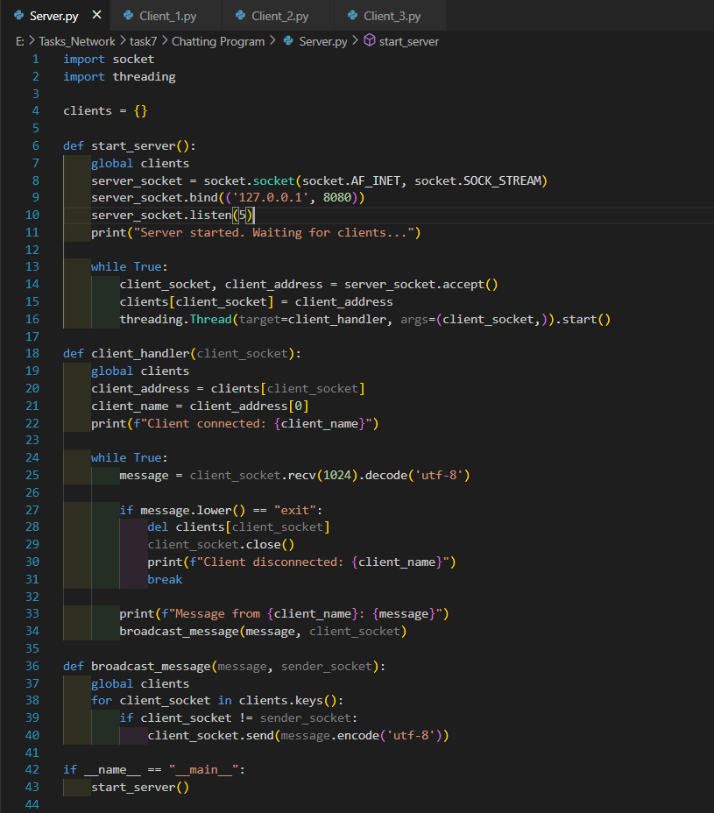

Clients

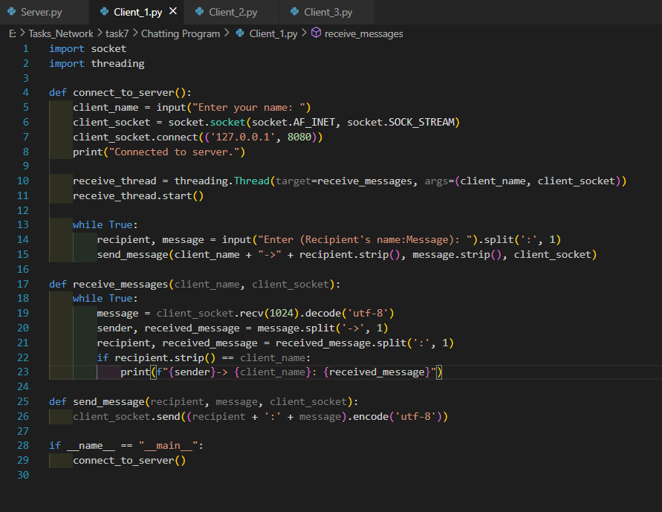

**Run**

Server

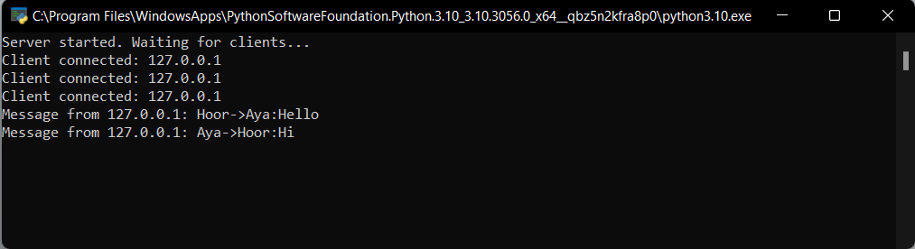

Client_1

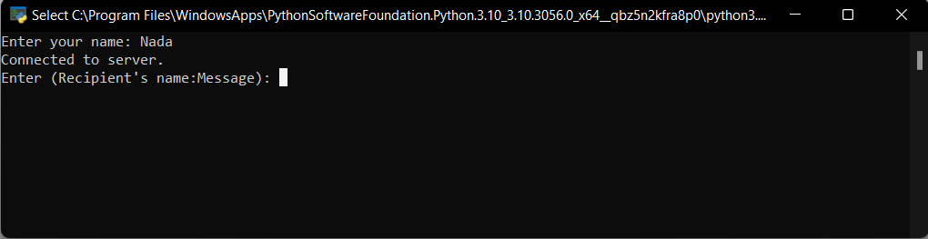

Client_2

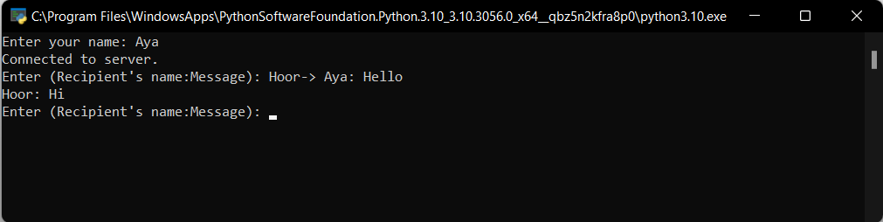

Client_3

