REPORT



trez votre adresse e-mail ici]

DATA SCIENCE PROJECT




A KNOWLEDGE BASED RECOMMENDATION SYSTEM
FOR PROJECT RISK MANAGEMENT:ONTOLGOY
LEARNING APPROACH

Realized by :

LAKHAL Abir
HMAIDI Mehdi
BELAIDI Nada
MAGHREBI Racha
CHARAABI Khaled
KHECHANA Fares

University Year : 2021 - 2022

Table des matières
Project description 2
Chapter1: Data extraction and analysis 3
1.Text segmentation: 4
2.Text-preprocessing: 4
1.1 Libraries importing : 5
1.2 Regex: 6
1.2 Stopwords : 6
1.4 Remove Header: 7
1.5 POSTAG: 7
1.6 Lemmatization: 7
1.8 TF_IDF: 8
1.9 Similarity: 9
1.10 Triplet extraction: 9
1.11 Rule based matching: 10
Chapter2: Ontology 12
1.OWL components building process 13
2. Add classes and sub-classes : 13
3.add data proporties : 14
4.Add object proporties : 14
14
4. ontology visualization with protégé du processus 6 : 15
Chapter3 : Recommendation system deployment 17
General conclusion 20

Project description
Project Risk Management (PRM), a knowledge-intensive process with processes and tools, requires effective management of risk-related knowledge that can assist in making the right decision by managers.
The premise of this work is to address the problem of OL that could be applied to text analysis as a
way to build PRM ontology which will be integrated further in an recommendation system that
predict and provide a real time personnalized recommendation with respect to user profile (project
manager, risk owner, risk action owner, etc) a targeted answer for a risk-related request. This ontology
will be learnt from an unstructured text which called “ PMBOK + PMI’s standard for PRM” as a
reference guideline that embodies a set of knowledge and recommendations respectively.
A generic framework, that is reusable and can be shared, serve as a guide to manage PRs according to PMBOK 5th 🡪 An ontology based recommendation system for PRM supporting the retrieval, representation and recommendation of knowledge!

Chapter1: Data extraction and analysis

1.Text segmentation:

We start by segmenting our text data. It is a precursor to text retrieval, automatic summarization, information retrieval ; language modeling and natural language processing . In written texts, it is the process of identifying the boundaries between words, phrases, or some other linguistic meaningful units, such as sentences or topics. The term separated from such processing is useful to help humans reading texts, and are mainly used to assist computers to do some artificial processes as fundamental units, such as NLP, and IR. We extract the PDF file by process.

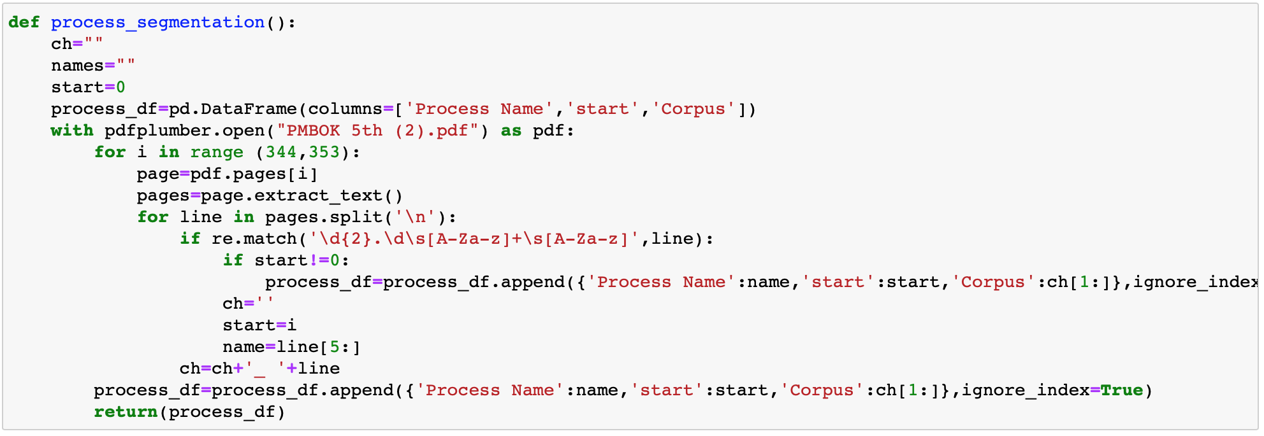
Then we extract the output, input and the techniques and tools each one in a separate dataframe with their annotation .

2.Text-preprocessing:
Since we have textual PDF data , we are in need of specific processing to be able to extract meanings and learn from this data in order to make it more useful. Thus, we proceeded by using the Natural Language Processing which is known as NLP. The techniques of the 11 preparation of NLP data covers several stages, the result of which is cleaned and formatted text data.
NLP stands for Natural Language Processing, which is a part of Computer Science, Human language, and Artificial Intelligence. It is the technology that is used by machines to understand, analyse, manipulate, and interpret human's languages. It helps developers to organize knowledge for performing tasks such as translation, automatic summarization, Named Entity Recognition (NER), speech recognition, relationship extraction, and topic segmentation

Libraries importing :

We imported the nltk library, which is a software library in Python allowing automatic language processing, so we can use WordNetLemmatizer, StopWords, word_tokenize, pos_tag..
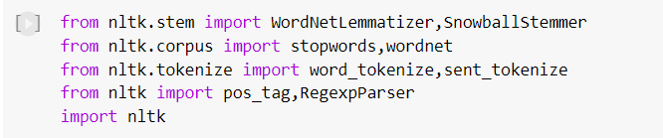
We also imported spacy, which is a Python software library for automatic language processing, to use the Matcher, os, fnmatch..
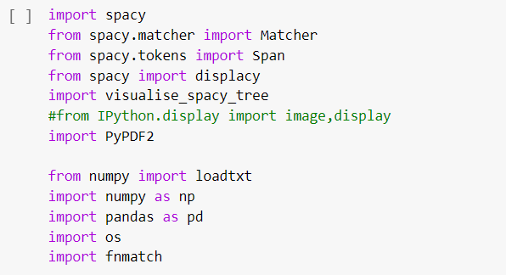

We downloaded the medium English pipeline optimized for CPU from spacy.

1.2 Regex:

We used the regular expression function to extract only the alphabetic expressions from the text (Remove all the other characters).
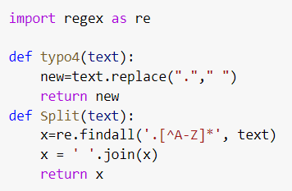

Stopwords :

Many words have little semantic interest, this is the reason for which the stop words must be deleted. Indeed, stopwords are all the most common words in a language. NLTK library has a list of stopwords for many languages and also tried removing stopwords using their POS in the sentence.

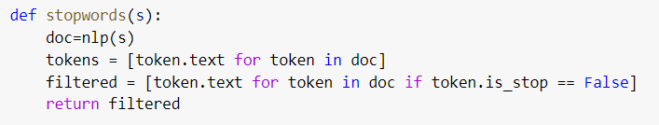

1.4 Remove Header:

This function removes the page header from the text.

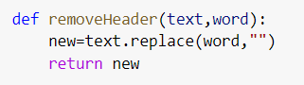

1.5 POSTAG:

It may not be possible to manually provide the correct POS tag for every word for large texts. So, instead, we will find out the correct POS tag for each word and map it.
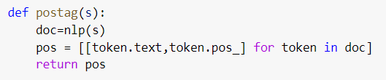

1.6 Lemmatization:

It’s a Natural Language Processing technique that is used to prepare text, words, and documents for further processing. It designates a lexical treatment given to a text with a view to its analysis. This processing consists in applying to the occurrences of lexemes subject to inflection a coding referring to their common lexical entry, which is designated under the term of lemma.

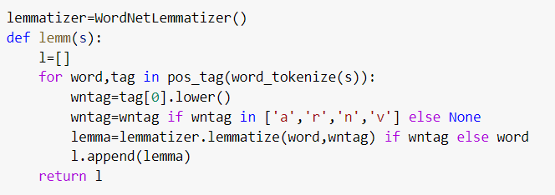

1.8 TF_IDF:

FIDF, short for term frequency–inverse document frequency, is a numerical statistic that is intended to reflect how important a word is to a document in a collection or corpus.
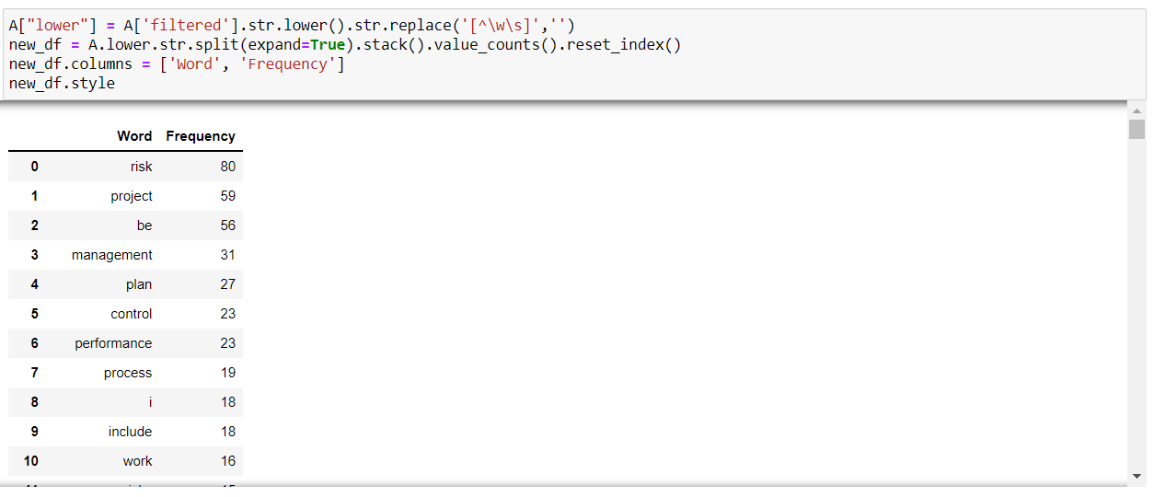

1.9 Similarity:

Text Similarity is one of the essential techniques of NLP which is being used to find the closeness between two chunks of text by it's meaning or by surfaces.
We used it in order to find out whether the text we started off with changed it’s meaning or not.
Our similarity rate was equal to 0.95.

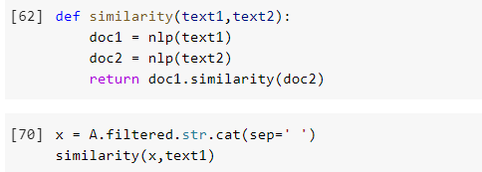

1.10 Triplet extraction:

Triples are a way to represent information from a text sentence in fewer words without losing the context. There are different techniques for getting this information before you represent it as triples, and the techniques depend on the kind of data being read as input.
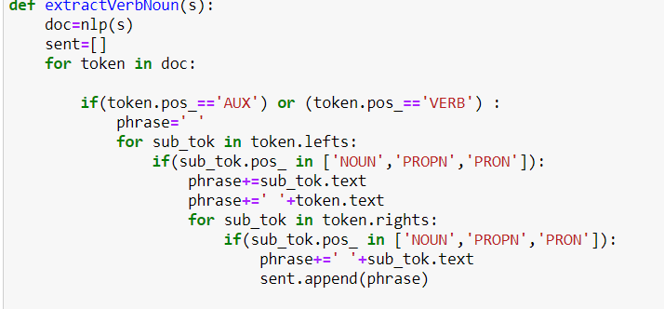

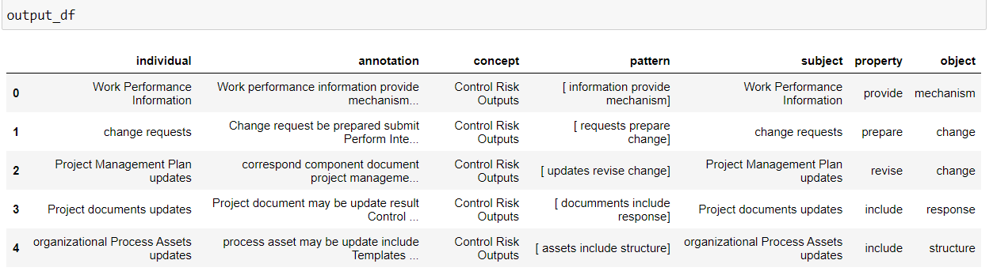

1.11 Rule based matching:

Compared to using regular expressions on raw text, spaCy’s rule-based matcher engines and components not only let you find the words and phrases you’re looking for – they also give you access to the tokens within the document and their relationships.
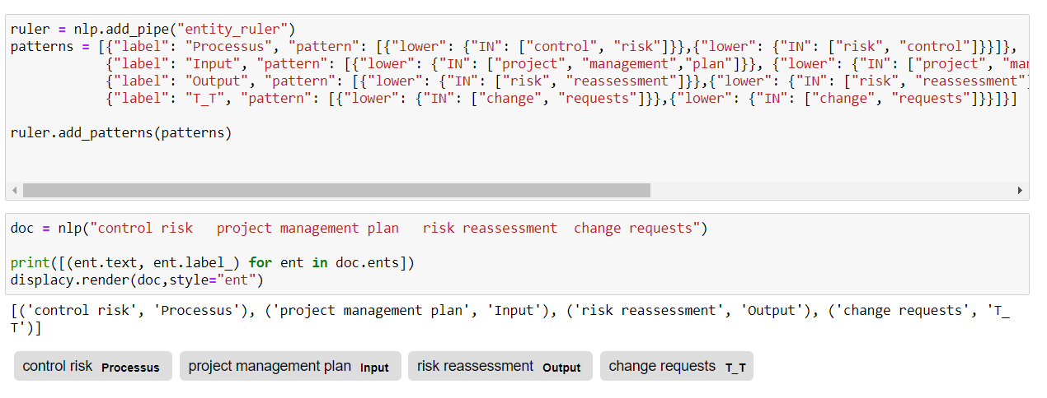

Chapter2: Ontology

1.OWL components building process

Using RDFLIB, we convert our obtained dataframes from the pre-processing process into OWL format. Then we add the properties and the classes into triples format while keeping the relationships between them. Beside we add prefixes to entities in order to differentiate between them:

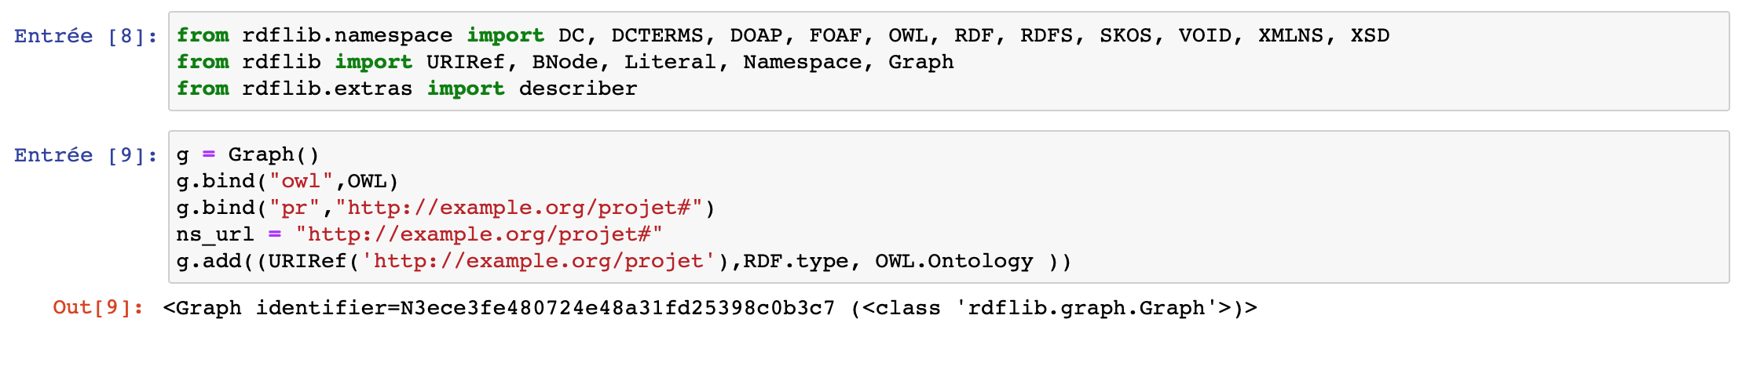

2. Add classes and sub-classes :

The ontology class attribute can be used to associate your class to the given one.
We use the top-down approach to develop the classes and subclasses hierachy . we start with creating classes for the general concepts, our six processes Then we specialize each one by its inputs,outputs and tools.

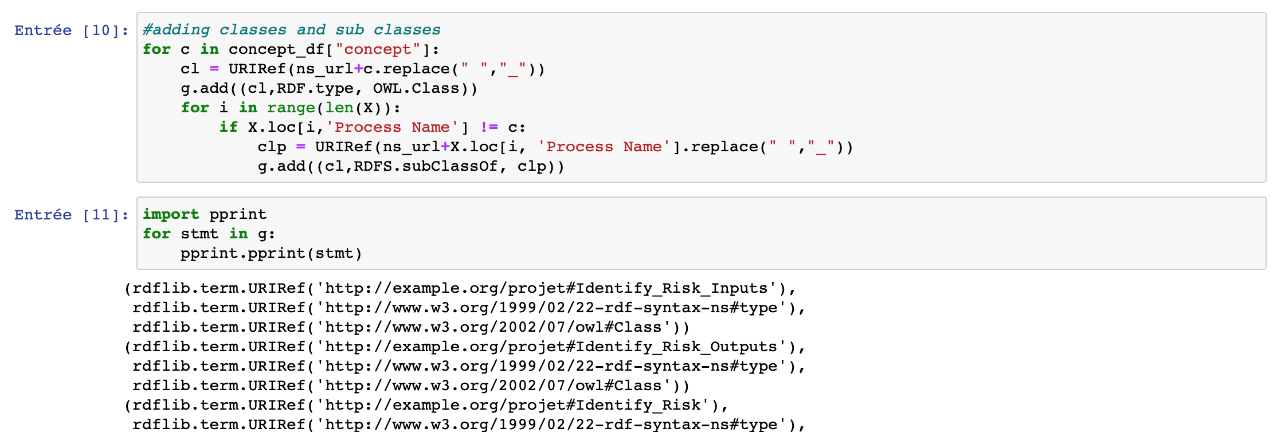

3.add data proporties :

the classes alone will not provide enough information to build our ontology. Once we have defined the classes, we must describe the internal structure of concepts.in this case we have to add data proporties for each concept

4.Add object proporties :

Object properties connect two individuals a subject and object with a predicate, while with data properties the predicate connects a single subject with some form of attribute data.
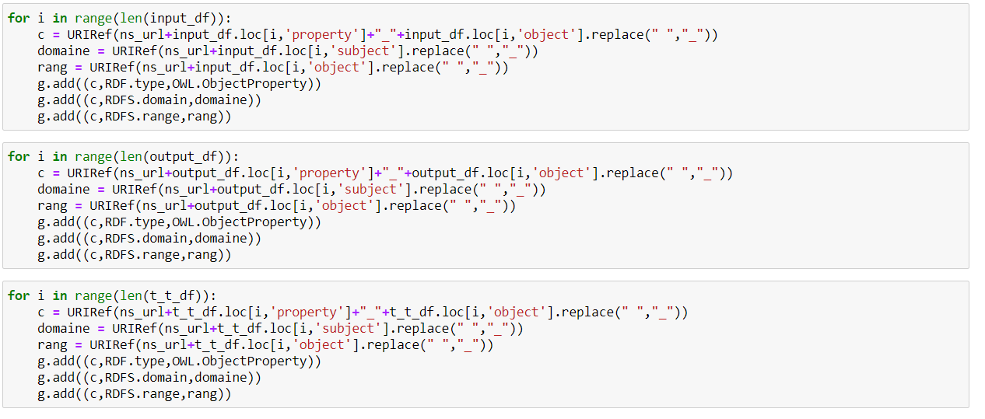
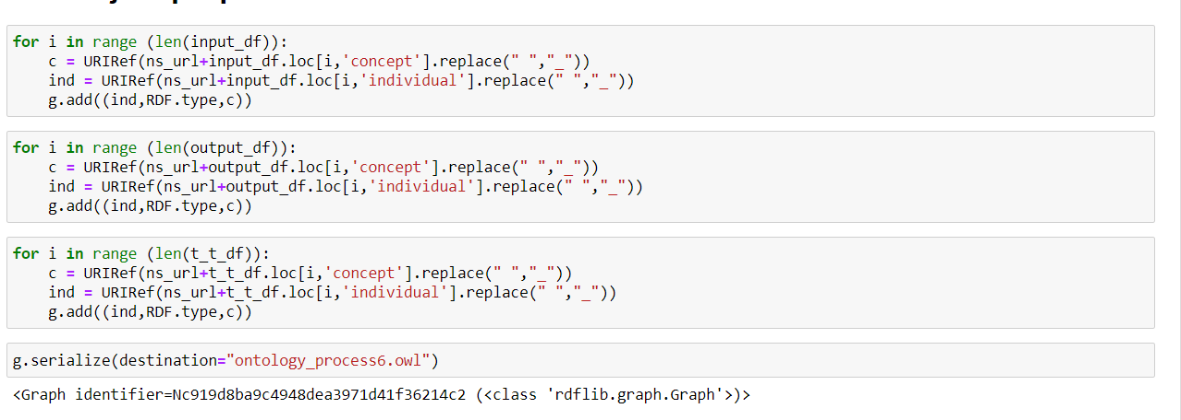

4. ontology visualization with protégé of process 6 :
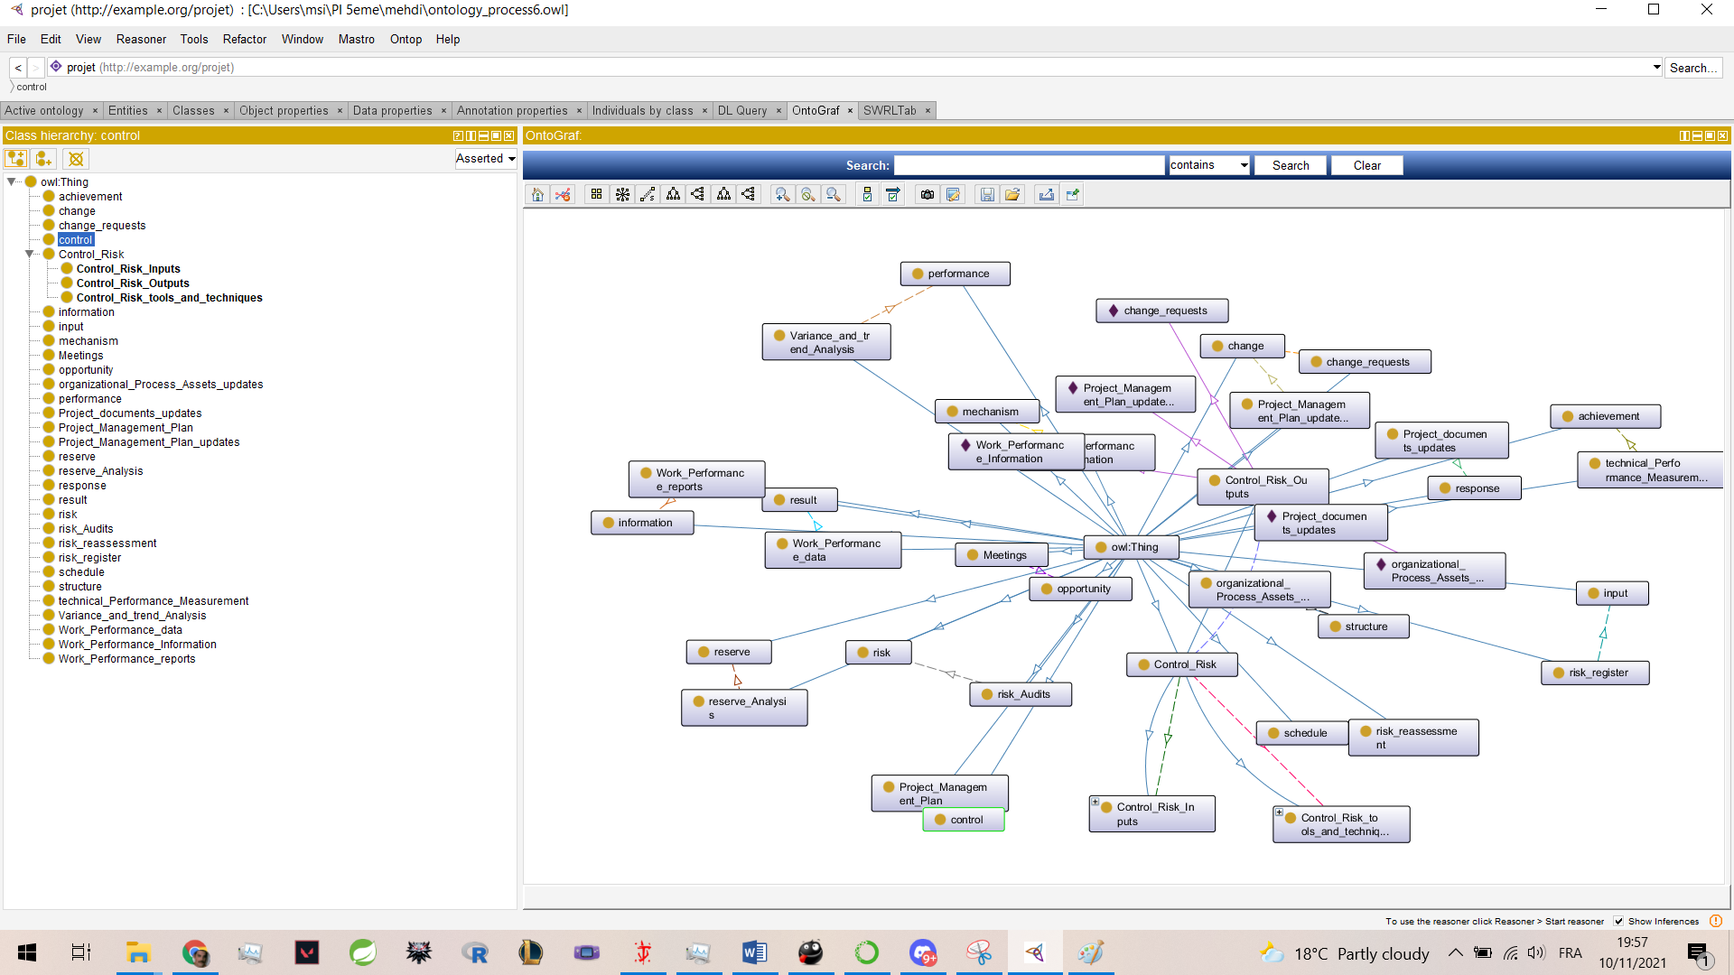
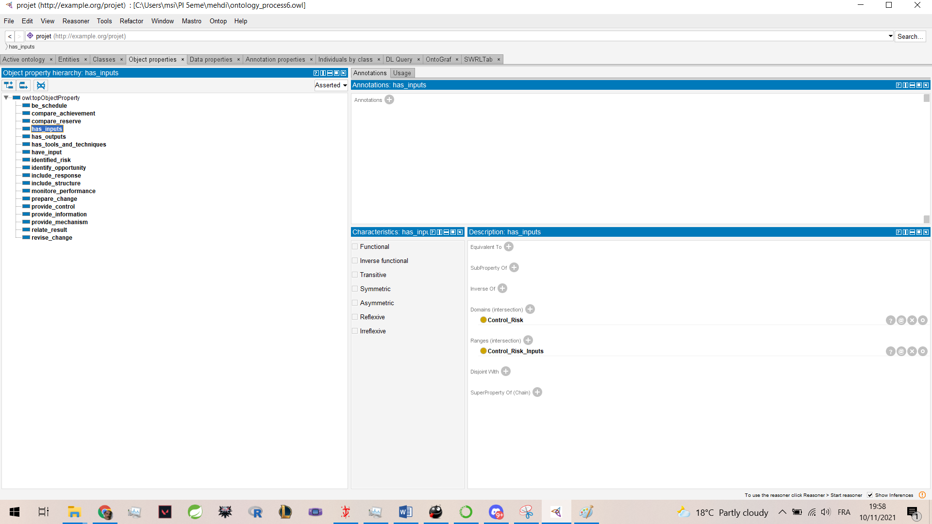

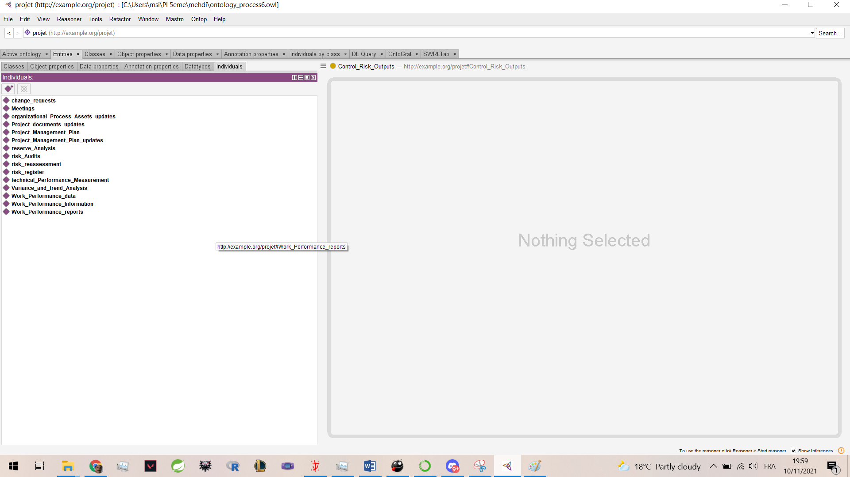

Chapter3 : Recommendation system implementation

& deployment

In this step, we will explain how we implemented and deployed our recommendation system.
Creation of the model based on TF-IDF :
We used TF-IDF to create our model to compare query with our ontology classes.

Here’s an example of similarity between our query and the ontology class with a similarity higher than 70%.
Here’s the ‘Inputs’ of ‘Plan Risk Management’ extracted from the ontology :
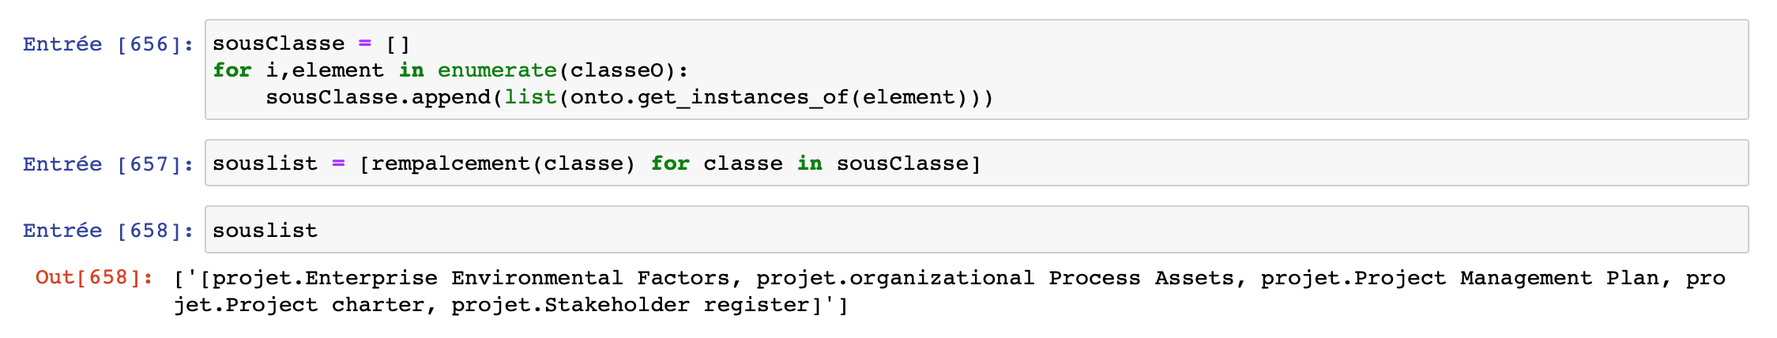

This is an example of the final output of our recommendation system :
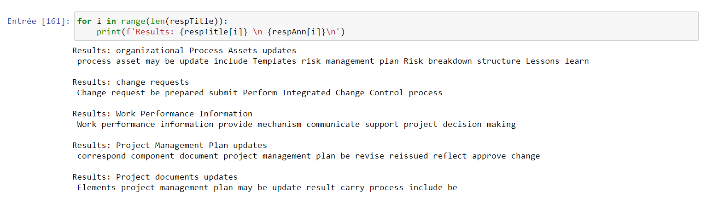

General conclusion

In this project, we used different technics and tools such as NLP for the preprocessing phase ,as well as a lot of research, to create a model that will make it easier for the client, who wants to lunch a project,to discover easily the risks that he can face .

