

**Books World**

**Online Bookstore**

**SRS**

|  |
| --- |
| **_______________________________________________________________________** |

|  |
| --- |
|  |
|  |

|  |  |  |  |  |
| --- | --- | --- | --- | --- |
| **Version** | **Written By** | **Reviewed By** | **Approved By** | **Date** |
| **1.0** | Nada Ihab Ahmad Mohamed Adb El-Gawad | | | Nov / 2018 |

|  |
| --- |
| Section: 3 |

Group: SE2018G03



Cairo, Egypt

**Table Of Contents**

|  |  |
| --- | --- |
| **Table Of Contents ……………………………………………………………………………………………………………………** | 2 |
| **1. Introduction………………………………………………………………………………………………………………………….** | 3 |
| * 1. Executive Summary **………………………………………………………………………………………………………..** | 3 |
| * 1. Document Overview**……………………………………………………………………………………………………….** | 3 |
| * 1. Abbreviations and Terminologies**…………………………………………………………………………………….** | 4 |
| * 1. References**……………………………………………………………………………………………………………………..** | 4 |
| **2. System Description……………………………………………………………………………………………………………….** | 5 |
| 2.1. Introduction**……………………………………………………………………………………………………………………** | 5 |
| 2.1.1. About BW**………………………………………………………………………………………………………………** | 5 |
| 2.1.2. System Functionalities**……………………………………………………………………………………………** | 6 |
| 2.1.3. System Facilities**……………………………………………………………………………………………………** | 7 |
| 2.2. Users**…………………………………………………………………………………………………………………………….** | 7 |
| 2.3. Modules**……………………………………………………………………………………………………………………….** | 8 |
| **3. System Users…………………………………………………………………………………………………………………………** | 9 |
| **4. System Modules……………………………………………………………………………………………………………………** | 10 |
| 4.1. Customer-Browse**………………………………………………………………………………………………………….** | 10 |
| 4.1.1. Customer-Browse Context**……….……………………………………………………………………………** | 10 |
| 4.1.2 Customer-Browse Detailed**………..…………………………………………………………………………..** | 10 |
| 4.2. Customer-Shopping Cart**……………………………………………………………………………………………….** | 11 |
| 4.2.1. Customer-Shopping Cart Context **……….…………………………………………………………………** | 11 |
| 4.2.2. Customer-Shopping Cart Detailed**……….…………………………………………………………………** | 11 |
| 4.3. Customer-Authentication Context**………...……………………………………………………………………….** | 12 |
| 4.4. Customer Purchase History **………………………………………………………………………………………….** | 12 |
| 4.5. Authenticated Customer Modify Profile**…………………………………………………………………………** | 12 |
| 4.6. Customer-Purchase**……………………………………………………………………………………………………….** | 13 |
| 4.6.1. Authenticated User-Purchase Context**……………………………………………………………………** | 13 |
| 4.6.2. Authenticated User-Purchase Detail**………………………………………………………………………** | 13 |
| 4.7. New User Registration **………..……………………………………………………………………………………….** | 14 |
| 4.8. Exchanging Books **………..………………………………………………………………………………………………** | 14 |
| 4.9. Customer-Purchase**…………………………………………………………………………………………..…………** | 14 |
| 4.9.1. Administrating Inventory Context**………..……………………………………………………………….** | 14 |
| 4.9.2. Administrating Inventory Detail**…………………………………………………………………..……….** | 14 |
| **5. System Functions……………………………………………………………………………………………………………….** | 15 |
| 5.1. Browse Catalog**…………………………………………………………………………………………………………..** | 15 |
| 5.1.1. Book Search**…………………………………………………………………………………………………………** | 15 |
| 5.1.2. Rating a Book**………………………………………………………………………………………………………** | 15 |
| 5.2. Maintain Account**…………………………………………………………………………………..……………..……** | 16 |
| 5.2.1. Register**…………………………………………………………………………………………………………..….** | 16 |
| 5.2.2. Login**…………………………………………………………………………………………………………………** | 16 |
| 5.2.3. Logout**…………………………………………………………………………………………………….…………** | 16 |
| 5.3. Manage Shopping Cart**……………………………………………………………………………………………….** | 17 |
| 5.3.1. Place an Order**…………………………………………………………………………………………………………** | 17 |
| 5.3.2. Update Shopping Cart**…………………………………………………………………………………………….** | 17 |
| 5.3.3. View Shopping Cart**…………………………………………………………………………………………………** | 17 |
| 5.3.4. Exchange Books**…………………………………………………………………………………………………….** | 17 |
| 5.4.1. Login**………………………………………………………………………………………………………………………** | 18 |
| 5.4. Administrator**…………………………………………………………………………………………………………………** | 18 |
| 5.4.1 Login **…………………………………………………………………………………………………………………....** | 18 |
| 5.4.2. Update a Book**……………..……………………………………………………………………………………….** | 19 |
| 5.4.3. Manage Order**……………………………………………………………………………………………………….** | 19 |
| 5.4.4. Logout**………………………………………………………………………………………………………………….** | 20 |
| **6. System Models……………………………………………………………………………………………………………………..** | 21 |
| 6.1. Use Case Diagram**…………………………………………………………………………………………………………** | 21 |
| 6.1.1. User & Administrator Use Case**………………………………………………………………………………** | 21 |
| 6.2. Sequence Diagrams**………………………………………………………………………………………………………** | 22 |
| 6.2.1. User Login**……………………………………………………………………………………………………………** | 22 |
| 6.2.2. Book Search**…………………………………………………………………………………………………………** | 23 |
| 6.2.3. Adding To Shopping Cart**...……………………………………………………………………………………** | 24 |
| 6.2.4. Administrator**………………………………………………………………………………………………………** | 25 |
| **7. Non-Functional Requirements………………………………………………………………………………………………** | 26 |
| 7.1. Security**…………………………………………………………………………………………………………………..…..** | 26 |
| 7.2. Usability**………………………………………………………………………………………………………………..…..…** | 26 |
| 7.2.1. Availability and Accessibility**………………………………………………………………………………….** | 26 |
| **9. System Interface…………………………………………………………………………………………………………………** | 28 |
| 9.1. User Interfaces**…………………………………………………………………………………………………………….** | 28 |

### 1. Introduction

**1.1. Executive Summary**

This software system -**B**ooks **W**orld- is an online bookstore. It is made for customers who are interested in buying or exchanging books via the Internet. This system is designed to “provide automation support” for the process of placing books for sale on the Internet and facilitating the actual sale.

**B**ooks **W**orld will allow any user to create an account to be part of our community. The system allows customers to browse, search, select, and add books to their shopping cart, add or delete books from the cart, also our unique feature which is exchanging books, the user can exchange any book he has with any book from the exchangeable section from our website. Also our customers become members of our small reading community to read other users recommendations and feedbacks and be up to date with our news field about bestselling books new releases, anticipated releases and so on…

**1.2. Document Overview**

Software Requirements Specification document is designed to document and describe the agreement between the customer and the developer regarding the specification of the software product requested. Its primary purpose is to provide a clear and descriptive “statement of user requirements” that can be used as a reference in further development of the software system. This document is broken into a number of sections used to logically separate the software requirements into easily referenced parts.

This **SRS** document aims to describe the Functionality, External Interfaces, Attributes and Design Constraints imposed on Implementation of the software system described throughout the rest of the document. Throughout the description of the software system, the languages and terminology used should unambiguous and consistent throughout the document.

This **SRS** document describes the software requirements specifications for **B**ooks **W**orld which is an online bookstore, it’s a Fast Track e-shopping Software System specifically developed for use in any bookstore that would want to automate electronically its book sales. This document includes a description of the software and its subsystems.

Throughout this document, **B**ooks **W**orld will sometimes be referred to as " **BW** " Defining and describing the functions and specifications of this online Bookstore software Requirements Specification (**SRS**). This Software Requirements Specification illustrates, in clear terms, the system’s primary uses and required functionality as specified by the customer.

**1.3. Abbreviations and Terminology**

|  |  |  |
| --- | --- | --- |
| No. | Abb. /Term. | Description |
| 1 | SRS | Software Requirements Specification |
| 2 | BW | Books World is the online bookstore application. |
| 3 | Use-Case | Oval shapes with titles that represent direct functionality within the system that must be implemented. |
| 4 | MTBF | Mean time between failure |
| 5 | TLD | Top-Level Domain |
| 6 | CDN | Content delivery network |
| 7 | SEO | [Search Engine Optimization](http://encyclopedia2.thefreedictionary.com/Search+Engine+Optimization) |
| 8 | IMA | Internet merchant account |
| 9 | PSP | Payment service provider |
| 10 | PCI SSC | [Payment Card Industry Security Standard Council](https://www.pcisecuritystandards.org/) |

**1.4. References**

This document is based on IEEE standards (IEEE Std 830-1998).

<https://standards.ieee.org/standard/830-1998.html>

### 2. System Description

**2.1. Introduction**

**2.1.1. About BW**

**B**ooks **W**orld is an online web application where customers can purchase books online. The user can search for any book by its title, author’s name or ISBN, later he can add books to the shopping cart and finally purchase those using Cash on delivery method, and the user can also exchange any of his books with any book from the exchangeable section.

The user can login using her/his account details or new customers can set up an account very quickly. They should give basic details as their name, contact number and delivery address. Books in the website are divided into categories based on their genres like Novels, arts, Education, Manga, etc…

A new feature that is included in **B**ooks **W**orld which is exchanging books between users. Users can exchange used books between one another without any costs except for the delivery fees , every registered user that has sign in and has any used book(s) can list his used books and supply information about her/his books as title, author’s name, number of pages, type of cover page, image of the book, and the book’s condition .

The Administrator will have additional functionality when compared to the common user. He can add, delete and update the book details, book categories, member information and also confirm a placed order, and manage exchanged books.

**B**ooks **W**orld is a user -friendly website that is designed with simple and friendly interface without complications.

**2.1.2. System Functionalities**

Books World has the following functionalities:-

### A Home page with product catalog

This is the page where the user will be navigated after a successful login. It will display all the book categories and will have a search keyword option to search for the required book. It also includes some special sections like top selling books, top author, recommended books etc.

### Search

A search by keyword option is provided to the user using a textbox .The keyword to be entered should be the book title. If the user would like to know details about a book user can click on the title or the image from where she/he will be directed to a Book description page. It includes the notes of the book content, the recommend book titles. Users can also comment about the book and show the commented articles.

### Shopping Cart

The user can manage a shopping cart which will include all the books selected by the user. The user can edit, delete and update her/his shopping cart. A final shopping cart summary is displayed which includes all the items the user selected and the final total cost.

### Managing user account

Each user should have an account to access all the functionalities of website. User can login using login page and logout using the logout page.

### Exchanging Books

Users can exchange used books between one another without any costs except for the delivery fees, every registered user that has sign in and has any used book(s) can list her/his used books and supply information about her/his books as title, auther, number of pages, type of cover page, image of the book, and status of the book .

### Administration

The Administrator will be provided with special functionalities like

* + - * Add or delete a book category
      * Add or delete a member.
      * Add or delete author and publisher.
      * Manage member orders.
      * Add or delete a Payment status.

**2.1.3. System Facilities**

The online bookstore **BW** system will provide facilities to the System administrator, Guest users and Registered:

### Facilities to be provided to the system administrator.

* + - * System administrator will have user friendly asynchronous GUI (Graphical User interface) system.
      * To have the details information of order, average selling rate, top selling books information, weekly selling books information etc…

### Facilities to be provided to the registered user.

* + - * User can choose and buy any kinds of books easily from this site only by registering.
      * User can search any kind of books from this website.
      * User can easily access this website
      * User can add, update or cancel his/ her shopping cart within limited time

### Facilities to be provided to the Guest user.

* + - * User can show all information of books.
      * User can search any kind of books from this website.
      * User can read review about a book.



#### Users

1. Administrator: The person who will administrate and manage **BW**.
2. Guest: The person who will operate the software product.
3. Customer: A customer is a registered user.

**2.3. Modules**

The following are four special system modules:

1. **Buying books**:

The user can select books from the different genres of books available in the website, the user can search any book he wants by typing the book’s name, author’s name or ISBN.

1. **Exchanging books**:

A unique feature that the website holds is that the user can exchange books from the exchangeable section, through simple steps, the user must fill the basic details about the book such that the book’s name, condition, brief description and upload the book’s photo.

1. **Reading community**:

The website has a small reading community which allows the users to read each other recommendations, feedbacks, book’s rating, and interact with each other.

1. **News field**:

In this section the user will be up to date with books’ news as bestselling books, new releases, and anticipated releases.

### 3. System Users

There are two main system users whom will use this online book store, Administrator of the application and internet users that will use WB as a service provider for buying books online through this ecommerce application.

Listed below is a brief description of the activities for every type of system users, those are:

|  |  |
| --- | --- |
| **System Users** | **Activity** |
| Administrator | The person who will administrate and manageBWwhich is the application of the online bookstore software product.  The administrator will have a complete control over the BWconcerning items in the e-store or concerning users of the online application. |
| Guest | The person who will operate the software product, navigate or search for a book without registering to the application and without having an account.  User is considered as a Guest User, she/he can show all information of books, search any kind of books from this website and read review about books. |
| Customer | A customer is a registered user that has an account in order to buy books or exchange her/his used book. |

### 4. System Modules

### 4.1. Customer-Browse

### 4.1.1. Customer-Browse Context

Books

Books Information

Book Review

Customer

Book Review

### 4.1.2. Customer-Browse Detailed

Books

Book Review

Book Review

Customer

Book Information

### 4.2. Customer-Shopping Cart

### 4.2.1. Customer-Shopping Cart Context

### 

Shopping Cart Items

Customer

Shopping Cart Items

Inventory

### 

### 

### 4.2.2. Customer- Shopping Cart Detailed

Shopping Cart Items

### 

Shopping Cart Items

Shopping Cart Items

Shopping Cart Items

### 

### 4.3. Customer-Authentication Context

### 

Customer

Customer

Authenticated User

Shopping Cart Items

### 4.4. Authenticated Customer Purchase History

Authenticated User

Purchase History

History Report

Inventory

### 

### 4.5. Authenticated Customer Modify Profile

Customer

Authenticated User

### 4.6. Customer-Purchase

### 4.6.1. Authenticated User-Purchase Context

Shopping Cart Items

Inventory

Customer

Order Details

Authenticated User

Purchase History

Shipping

### 4.6.2. Authenticated User-Purchase Detail

Display Cart

Shopping Cart Items

Inventory

Authenticated User

Customer

Order Details

Order Report

Inventory

Purchasing History

### 4.7. New User Registration

New account

Customer

### 4.8. Exchanging Books

Exchanged Books

Customer

### 4.9. Administration

### 4.9.1. Administrating Inventory Context

Inventory

Administrator

### 4.9.2. Administrating Inventory Details

Inventory

Administrator

### 5. System Functions

**5.1. Browse Catalog**

**5.1.1. Book Search [BS_BC_0]**

|  |  |
| --- | --- |
| Description: | A user can search for a book of his choice by writing book’s title, author’s name, or ISBN. Then a select query is used to retrieve data from the database and display the selected information. |
| Actor: | User/Customer |
| Input: | Enter book’s title in the search field. |
| Output: | The system will display the books which matches the selected search criteria. |
| Pre-conditions: | Enter the home page. |
| Post-conditions: | Required books appear on the screen. |

**5.1.2. Rating a Book [RB_BC_1]**

|  |  |
| --- | --- |
| Description: | If the user wants to give rating according to his opinion for a book he can select either Excellent, Very good, good, regular or deficient. The final rating of a book will depend on all the individual user rating. |
| Actor: | User/Customer |
| Input: | The user will select a rating based on his opinion. |
| Output: | The system will display the rating of a book and the total number of votes received.  Below is the display for various ratings:-  ***** Excellent  **** Very Good  *** Good  ** Regular  * Deficient |
| Pre-conditions: | Book to be rated must be in the view mode. |
| Post-conditions: | Book is rated. |

## 5.2. Maintain Account

**5.2.1. Register [RG_MA_0]**

|  |  |
| --- | --- |
| Description: | If the user doesn’t have an account then he will be asked to register. |
| Actor: | Customer |
| Input: | The user will enter details in the registration form according to the required fields. The fields include:   |  | | --- | | 1.First name | | 2.Last name | | 3.Password | | 4.Email | | 5.Phone | | 6.Delivery address | | 7.Governorate | | 8.City | |
| Output: | The user will be directed to the main home page. |
| Pre-conditions: | Sign up page must be opened. |
| Post-conditions: | A new account is created. |

**5.2.2. Login [LI_MA_1]**

|  |  |
| --- | --- |
| Description: | If the user wants to get access to all the functionalities of Online Book Store he should login using his username and password. |
| Actor: | Customer |
| Input: | The user will enter his username and password. |
| Output: | If it is a successful login the user will be directed to the main home page. |
| Pre-conditions: | Validation of username and password. |
| Post-conditions: | The user opens his account. |

**5.2.3. Logout [LO_MA_2]**

|  |  |
| --- | --- |
| Description: | If the user wants to end his session and sign out of the website then he can use the logout option. |
| Actor: | Customer |
| Input: | The user will click the logout button. |
| Output: | The user’s account session comes to an end. |
| Pre-conditions: | Logout button must be pressed. |
| Post-conditions: | The user is directed to Home page. |

## 5.3. Manage Shopping Cart

**5.3.1. Place an Order [PO_MSC_0]**

|  |  |
| --- | --- |
| Description: | If the user wants to purchase a book then he can place an order by selecting the add to shopping cart button and entering the quantity required under the book description. |
| Actor: | Customer |
| Input: | The user will enter the quantity required and click the add to shopping cart button. |
| Output: | The order will be added to the user’s shopping cart. |
| Pre-conditions: | The user must be logged in. |
| Post-conditions: | The selected book is added to the shopping cart. |

**5.3.2. Update Shopping Cart [USC_MSC_1]**

|  |  |
| --- | --- |
| Description: | If the user wants to change the quantity of a book or change a book then he can update his shopping cart. |
| Actor: | Customer |
| Input: | The user will click the details button in the shopping cart summary to edit and update his order details. |
| Output: | The updated order details are reflected in the shopping cart summary. |
| Pre-conditions: | There must be one or more books in the shopping cart so that the user can modify it. |
| Post-conditions: | The shopping cart is updated. |

**5.3.3. View Shopping Cart [VSC_MSC_2]**

|  |  |
| --- | --- |
| Description: | If the user wants to view the items he added to the shopping cart then he can click the shopping cart link at the top of the page. |
| Actor: | Customer |
| Input: | If the user wants to view the items he added to the shopping cart then he can click the shopping cart link at the top of the page. |
| Output: | The user’s shopping cart summary will be displayed in the form of a tabular format with all the books and their quantity. A total cost of all the items is also displayed at the bottom. |
| Pre-conditions: | My Cart button must be pressed. |
| Post-conditions: | The cart is displayed. |

**5.3.4. Exchange Books [EB_MSC_3]**

|  |  |
| --- | --- |
| Description: | If the customer has any used book that she/he wants to exchange. Then through this link she/he can exchange it with another used book from a list. |
| Actor: | Customer |
| Input: | The customer should enter some required fields that describe the used book that is required to be exchanged. |
| Output: | After the customer press the exchange button, then a list of available used books ore displayed for the customer to select one. |
| Pre-conditions: | The user must provide the book’s details, in which he’s going to exchange. |
| Post-conditions: | Exchange order is raised. |

## 5.4. Administrator

**5.4.1. Login [LI_AD_0]**

|  |  |
| --- | --- |
| Description: | If the Administrator wants to get access to all the functionalities of Online Book Store he should login using his username and password. |
| Actor: | Administrator |
| Input: | The Administrator will enter his username and password. |
| Output: | If it is a successful login the Administrator will be directed to his menu page. Else if the Administrator enters invalid information he will be asked to check the entered information. |
| Pre-conditions: | Validation of username and password. |
| Post-conditions: | The admin account is opened. |

**5.4.2. Update a Book [UB_AD_1]**

|  |  |
| --- | --- |
| Description: | If the Administrator wants to add or delete a book then he can insert or delete a book using his administration rights and the book table will be updated in the database. |
| Actor: | Administrator |
| Input: | If the Administrator wants to add or delete a book then he can insert or delete a book using his administration rights and the book table will be updated in the database.   |  | | --- | | 1.Book title | | 2.Book’s Category | | 3. Author | | 4.Publisher | | 5.Edition version | | 6.Number of pages | | 7.ISBN= [International Standard Book Number](http://www.thefreedictionary.com/International+Standard+Book+Number) | | 8. language | | 9. Cover type | | 10.Price | | 11.Discount | | 12.Image of the Book | | 13.Store Review | | 14.Number of books available |   If he wants to delete a book he can click the delete button to remove it from the database. |
| Output: | The updated books list will be displayed in the main home page under their particular category. |
| Pre-conditions: | There must be books in the website |
| Post-conditions: | Books’ stock is modified. |

**5.4.3. Manage Orders [MO_AD_2]**

|  |  |
| --- | --- |
| Description: | If the Administrator wants to add or delete an order then he can insert or delete an order using his administration rights. |
| Actor: | Administrator |
| Input: | If the Administrator wants to add an order the he should click the insert link button in the orders page else he can delete a particular selected order. |
| Output: | The updated orders list will be processed to the users. |
| Pre-conditions: | There must be one or more orders. |
| Post-conditions: | Ordered are executed. |

**5.4.4. Logout [LO_AD_3]**

|  |  |
| --- | --- |
| Description: | If the Administrator wants to end his session and sign out of the website then he can use the logout option. |
| Actor: | Administrator |
| Input: | The Administrator will click the logout button. |
| Output: | The Administrator’s account session comes to an end and he should login again if he wants to enter into the website. |
| Pre-conditions: | Logout button must be pressed. |
| Post-conditions: | Admin is directed to homepage. |

### 6. System Models

**6.1. Use-Case diagram Next**

**6.1.1. User & Administrator Use-Case**

Users and Administrator are the two actors included inBW**,** the Online Book Store.

Below is the use case diagram for this BW through the activities of both Users and Administrator.

**Admin.**

**User**

User & Administrator Use Case diagram

**6.2. Sequence Diagram **

**6.2.1. User Login**

Default.php

Login.php

User

Session manager

Get user(userpassword)

Actor-customer

User

Verify login ()

Login successfully

Login failure

**6.2.2. Book Search**

Actor-User

Search.php

Book set

Advanced search

Search (title.cat))

Getbookset()

returnbookset

Search (title.auther)

Getbookset()

returnbookset

**6.2.3. Adding to Shopping Cart**

Actor. User

Book

Book Order

Shopping Cart

Logout.php

Add cart ()

Get book ()

Delete Cart ()

Update cart ()

Place Order ()

Logout ()

**6.2.4. Administrator**

Actor..admin

Login.php

Book

Category

Logout.php

User

Add category ()

Get book ()

Delete Category ()

Add book ()

Add book ()

Add user ()

Logout

Delete user ()

### 7. Non-Functional Requirements

# Non-Functional Requirements covers the requirements that are related to the Online Bookstore System. This includes Extensibility, Legal and Regulatory requirements, Performance requirements, Reliability requirements and Security requirements, etc…

## 7.1. Security

Some key security aspects must be applied to the web application to secure transaction these are:

**7.1.1. Securing Transactions**

Security for online transactions, and maintaining confidential information security.

**7.1.2. Securing Processed Information**

Processed information must be kept secure

**7.1.3. Securing Users data**

All information gained from the end users that is processed must be kept secure.

## 7.2. Usability

Usability means user-centered design. Both the design and development process are focused around the prospective user to make sure their goals, mental models, and requirements are met and to build products that are efficient and easy to use.

The system must be easy to use with minimum training. It will be easy to navigate, search, sell and buy books. The application should be free of complications or errors.

## Usability means test, test, and test again

There are principles of good website usability, we must make sure to consider in BW.

## 7.2.2. Clarity

**7.2.2.1**. **Simplicity**

Focus on what’s important. If you don’t distract your visitors they will be more likely to do what you want them to do

**7.2.2.2. Familiarity**

Stick to what people already know. There is nothing wrong with looking at other sites for inspiration.

### 9. System Interfaces

**9.1. User Interfaces**

Before implementing the actual design of the application, a few user interface designs were constructed to visualize the user interaction with the system as they browse for books, create a shopping cart and purchase books. The user interface design will closely follow the Functional Decomposition Diagrams that show the initial designs of the web pages.

**Home page**

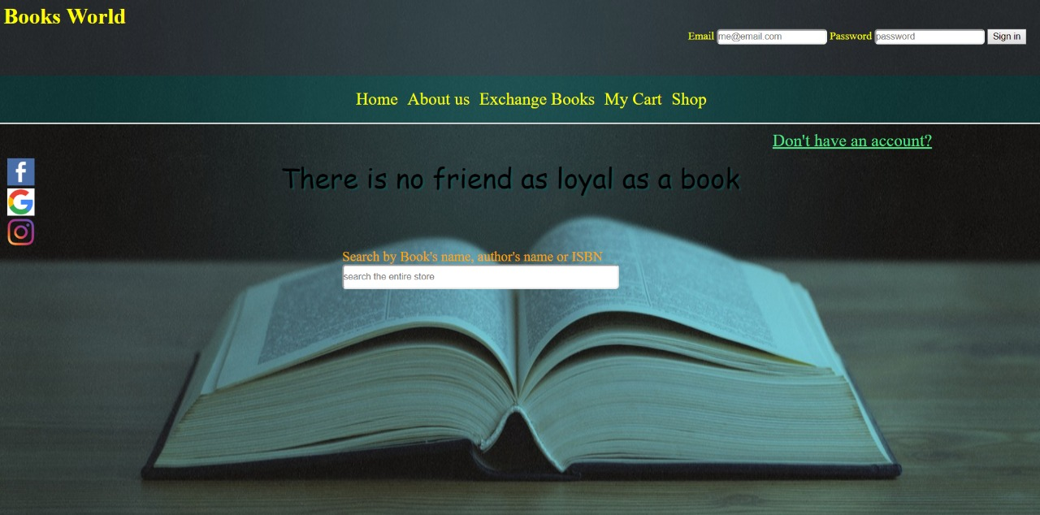

**Sign up page**



**Exchange books’ page**

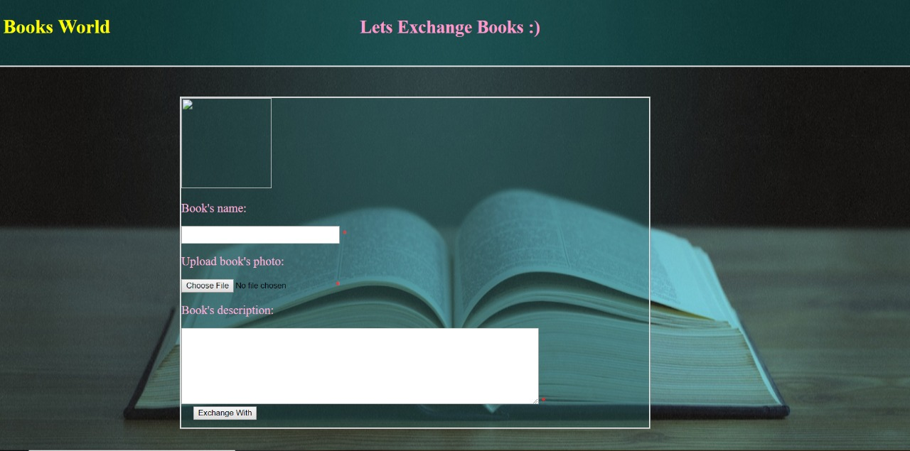

**Selection of books (under construction)**

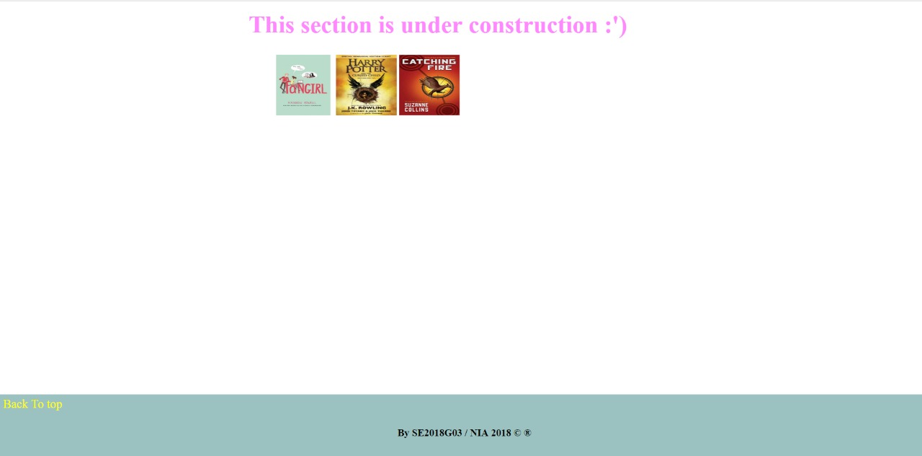

**Shopping cart**

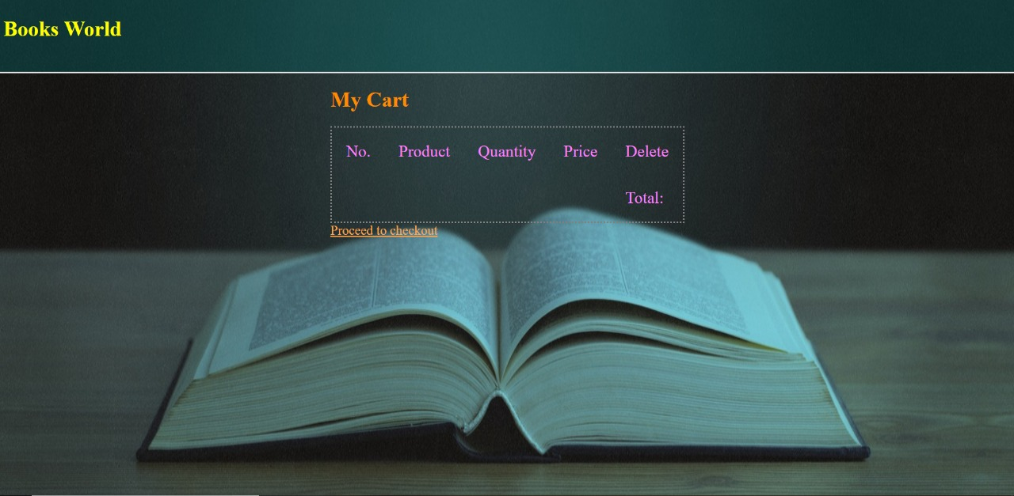

**Check out**

