CancelIQ
Hotel Booking Cancellation Intelligence Platform
Predictive Analytics · Revenue-at-Risk Modeling · Explainable AI · BI Dashboard · AI Copilot
Project Report | Data Mining & Visualization — MTC Digilians Program

Executive Summary
Hotels face revenue and planning uncertainty when bookings are cancelled. CancelIQ analyses 119,389 cleaned historical booking rows, predicts cancellation risk with a calibrated XGBoost model, estimates financial exposure, and makes the results accessible through a Power BI dashboard and a bilingual browser assistant. The project spans data cleaning, statistical analysis, temporal validation, model comparison and a booking risk calculator. An optional local data API supports free-form questions, with Gemini available when its server-side key is configured.

1. Business Problem
The hotel needed answers to six practical questions:
- Which bookings are likely to be cancelled?
- How much revenue is at risk from those cancellations?
- What factors actually drive cancellation behaviour?
- Which specific bookings or customers need proactive attention?
- What operational patterns can the hotel improve?
- How can historical booking data support better day-to-day decisions?

2. Data Understanding & Cleaning
The raw dataset (36 columns, 119,390 rows) was cleaned deliberately rather than with a blanket dropna(). Missingness itself was treated as signal where relevant, and every decision was justified against the business context:
Issue | Finding | Decision
company missing | 94.31% missing | Recoded as "No Company" — 38.22% cancel rate when missing vs 17.52% when present
agent missing | 13.69% missing | Recoded as "No Agent" — 24.66% vs 39.00% cancel rate
country missing | 0.41% missing | Recoded as "Unknown"
children missing | 4 rows | Filled with 0, based on booking context, not asserted as certain
Duplicates | 0 exact duplicates | None removed
Undefined categories | meal, market_segment, distribution_channel | Standardized to "Unknown"
Negative ADR | 1 row (adr = -6.38) | Removed as invalid
Extreme ADR | max 5,400 | Kept — no evidence of entry error
Zero-night bookings | 715 rows | Kept — legitimate for cancellations/no-shows
Outliers | thousands flagged by IQR | Investigated individually, not auto-removed
PII (name, email, phone, card) | present | Dropped entirely from the analytical dataset
Leakage (reservation_status, date) | near-perfect mapping to target | Dropped — post-outcome information

3. Feature Engineering
New features were built with business meaning, not just statistical convenience: total_guests, total_nights, estimated_revenue (ADR × nights), party_size_category, stay_type, lead_time_category, has_booking_changes, has_previous_cancellation, has_special_requests, requires_parking, room_type_changed — plus, at the modeling stage, guest_cancellation_rate, adr_per_person, and cyclical (sin/cos) encoding of arrival month.
A correlation heatmap caught redundant feature pairs that one-at-a-time testing had missed:
- requires_parking ↔ required_car_parking_spaces (r = 0.99)
- has_special_requests ↔ total_of_special_requests (r = 0.86)
- has_booking_changes ↔ booking_changes (r = 0.80)
The final analytical dataset held 44 columns, trimmed to 38 features for modeling after removing IDs, dates, and redundant pairs.

4. EDA & Statistical Validation
Every visual finding was backed by a formal test — Chi-square with Cramér's V for categorical associations, Mann-Whitney U for numeric comparisons — so no claim rests on a bar chart alone.
Variable | Cancellation-rate spread | Effect size | Verdict
Deposit type | No Deposit 28.4% · Non-Refund 99.4% · Refundable 22.2% | V = 0.4815 (strong) | Top priority
Previous cancellations | 33.9% → 91.6% | V = 0.2709 (moderate) | High priority
Market segment | Groups 61.1% · Online TA 36.7% · Direct 15.3% | V = 0.2668 (moderate) | High priority
Lead time | median 45d (kept) vs 113d (cancelled) | 0.3785 | High priority
Hotel type | City 41.7% vs Resort 27.8% | V = 0.1365 (weak) | Kept, not standalone
Customer type | Transient 40.8% vs Group 10.2% | V = 0.1364 (weak) | Kept, low priority
ADR | median 92.5 vs 96.2 | 0.0608 (very small) | Kept, low priority
All findings are reported as association, not causation, throughout the analysis.

5. Machine Learning
The train/test split was chronological (80/20), not random, because bookings have a real time order that a random split would ignore. Train covered Jul 2015 – Mar 2017 (35.85% cancel rate); test covered Mar – Aug 2017 (40.79% cancel rate).
Preprocessing: numeric features were median-imputed and standardized; low-cardinality categoricals one-hot encoded; high-cardinality fields (agent, company, country) frequency-encoded to avoid an exploding, overfit-prone feature space. All transforms were fit on train only.
Six model families were trained and tuned under the exact same evaluation regime — a small random hyper-parameter search, every candidate scored on pooled out-of-time predictions from four expanding-window temporal folds (Apr 2016 → Mar 2017), so no model gets an easier validation scheme than another: Logistic Regression, Random Forest, LightGBM, CatBoost, XGBoost, and a 2-model Blend (XGBoost + LightGBM), benchmarked against a Dummy baseline.
Model (temporal CV, train) | Accuracy | Precision | Recall | F1 | ROC-AUC | PR-AUC
Dummy baseline | 63.63% | 0.00 | 0.00 | 0.00 | 0.482 | 0.353
Logistic Regression (tuned) | 80.05% | 72.41% | 72.94% | 72.67% | 0.869 | 0.818
LightGBM (tuned) | 82.62% | 77.95% | 72.82% | 75.30% | 0.898 | 0.858
Random Forest (tuned) | 82.89% | 78.09% | 73.63% | 75.79% | 0.896 | 0.853
CatBoost (tuned) | 82.94% | 79.50% | 71.56% | 75.32% | 0.901 | 0.861
Blend XGB + LightGBM | 83.05% | 80.27% | 70.81% | 75.25% | 0.904 | 0.863
XGBoost (tuned) — WINNER | 83.05% | 80.44% | 70.56% | 75.18% | 0.904 | 0.863
XGBoost was selected programmatically — not hard-coded — as the model with the best temporal-CV accuracy, statistically tied with the Blend. It was then calibrated (Platt scaling) and evaluated once, untouched, on the held-out future test window:
XGBoost (tuned) — one-time test | Accuracy | Precision | Recall | F1 | ROC-AUC | PR-AUC
Test (Mar – Aug 2017, unseen) | 79.49% | 76.54% | 71.70% | 74.04% | 0.885 | 0.846
The gap between the 83.05% temporal-CV accuracy and the 79.49% test accuracy is expected and reported honestly: the test window has a meaningfully higher actual cancellation rate (40.8% vs 35.9% in training), which is ordinary drift when forecasting forward in time, not a bug. This test-set figure — not the higher cross-validation numbers — is the one to quote publicly.

6. Benchmark Against a Reference Project
Before building this pipeline, a reference project was used to calibrate expectations for scope and quality: a fellow capstone team's “Hotel Intelligence” dashboard (Snipers Team), covering the same brief — database engineering plus data analysis & ML on the same booking dataset. Its published modelling result was a Random Forest classifier reaching 81% accuracy, an F1 of 0.79, and an AUC of 0.86.
Metric | Reference project (Random Forest) | This project — Random Forest (tuned) | This project — Logistic Regression (tuned)
Accuracy | 81.0% | 82.89% | 80.05%
ROC-AUC | 0.860 | 0.896 | 0.869
F1-score | 0.79 | 0.758 | 0.727
In temporal cross-validation, this project’s Random Forest reached 82.89% accuracy and 0.896 ROC-AUC, compared with 81% accuracy and 0.860 AUC reported by the reference project. Logistic Regression reached 80.05% accuracy and 0.869 ROC-AUC in the same internal validation. These comparisons are informal because the reference project did not use the same train/test split or evaluation protocol. For this project’s final, later-in-time test, the selected XGBoost achieved 79.49% accuracy and 0.885 ROC-AUC.
The reference result helped set an informal benchmark. The strongest evidence for the model is the one-time chronological holdout test reported above, with precision, recall and F1 shown alongside accuracy.

7. Power BI Dashboard
Three pages sit on top of the model's outputs.
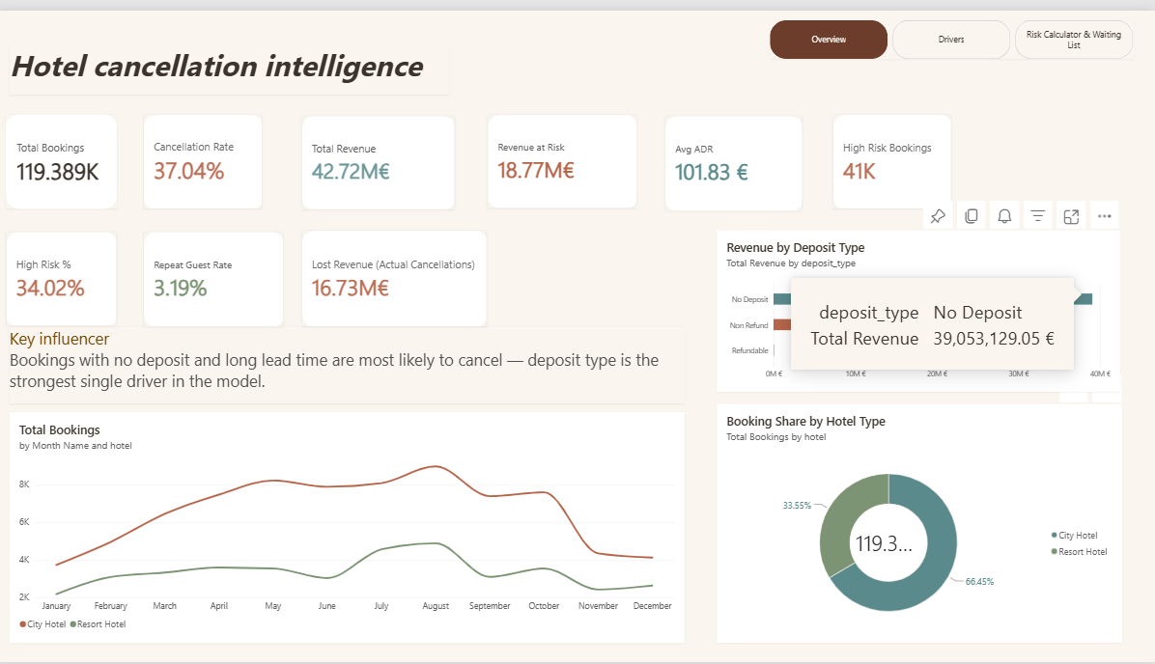
Overview — KPIs, revenue by deposit type, booking share by hotel type.
119,389 cleaned bookings, 37.04% cancelled, €42.72M gross booked value (including cancelled bookings), €16.73M estimated value of cancelled bookings, €16.81M model-expected exposure, €101.83 average ADR, and 40,453 high-risk bookings at the 50% risk threshold.
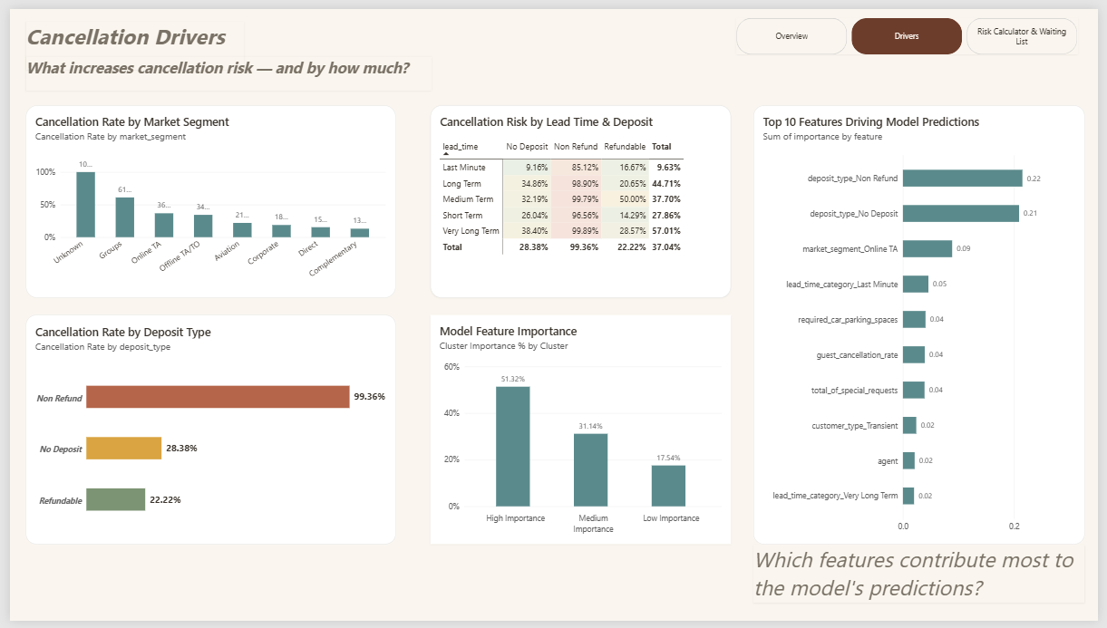
Cancellation Drivers — segment/deposit breakdowns and top model feature importances.
The updated SHAP feature summary ranks guest country, deposit type, agent, total special requests, lead time and market segment among the leading signals. Feature importance measures contribution to predictions; it does not establish a causal effect or, by itself, the direction of an effect.
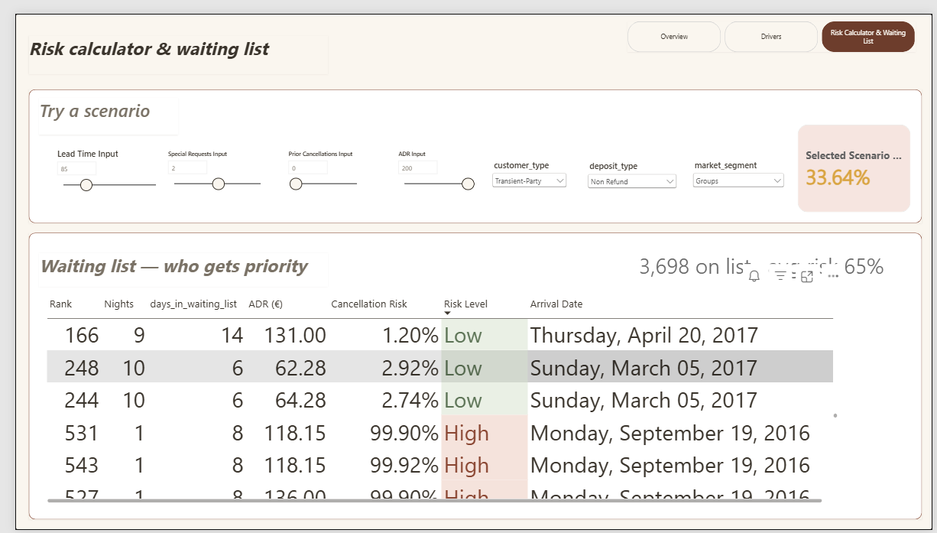
Risk Calculator & Waiting List — browser-based what-if scenarios and a waiting-list example ranked by expected realised value.
The calculator lets a manager vary booking inputs and see the calibrated model risk update. The historical waiting-list file ranks positive-value bookings by expected realised value = (1 − predicted cancellation risk) × ADR × nights. It demonstrates prioritisation logic, not a live queue.

8. Chatbot
The bilingual assistant uses updated facts from the 119,389-row scored booking file and the new model metadata. Its offline answers cover selected dashboard questions; its browser-based calculator evaluates the embedded XGBoost trees and displays risk plus one-variable what-if changes. When the supplied local Python API is running, a Data API mode offers free-form questions grounded in aggregates calculated from bookings_scored.csv. Gemini can optionally help interpret and phrase those answers when GEMINI_API_KEY is configured on the server; the model continues to calculate booking risk.

Hotel Cancellation Assistant — the original bilingual HTML interface updated with the current XGBoost model, preprocessing statistics, calibration and 50% high-risk threshold. The accompanying local API supports additional data questions; it is optional and requires a Python server.
Answers are limited by the historical data and available fields. The assistant presents probabilities and estimated exposure for decision support; the hotel remains responsible for any operational action. The Gemini connection requires a valid API key and has not been verified with a live key for this report.

9. Conclusion
CancelIQ brings together cleaning, leakage checks, feature engineering, statistical analysis, temporal model validation, a Power BI dashboard and a bilingual assistant. The reported test performance is 79.49% accuracy and 0.885 ROC-AUC; the assistant provides updated, data-grounded summaries and browser-based risk scenarios, with optional Gemini wording through the local API. Historical data and informal external benchmarking remain important limits on operational claims.

