**Analog IC**

**Lab 2**

|  |  |
| --- | --- |
| Name | ID |
| Nada Tarek Mowafi | 20012094 |
| Salma Hamdy Mohammed | 20010677 |

**The Characteristics of Integrators and Differentiators Circuits:**

* Integrator:
* The circuit:

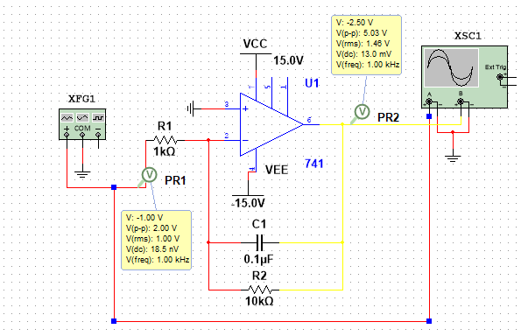

Function generator settings for all:

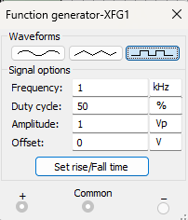

1. **Sinusoidal wave input:**

* **Output from multisim:**

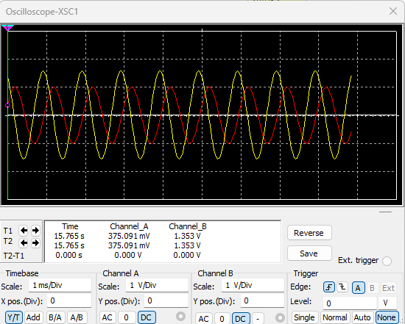

* **Output in the lab:**

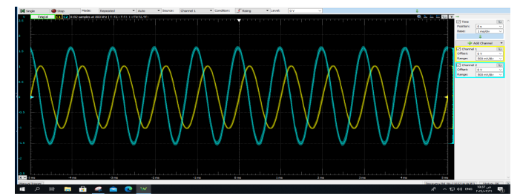

1. **Square wave input:**

* **Output from multisim:**

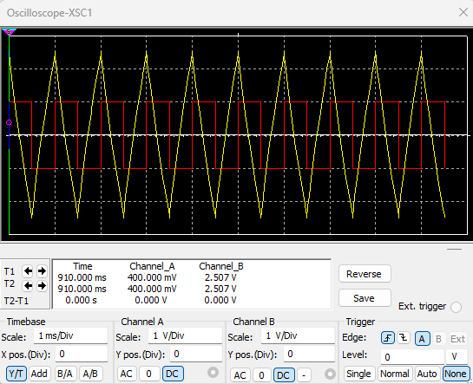

* 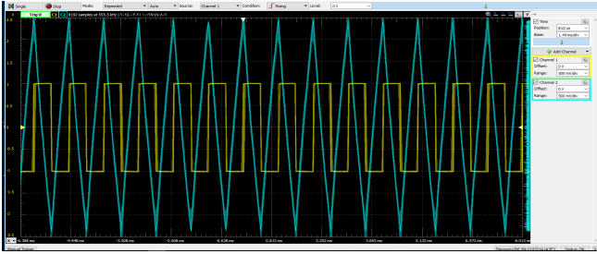**Output in the lab:**

Comment: If the square wave is applied to Integrator Amplifier, the produced output will be a triangular wave or saw tooth wave as the op-amp integrator produces an output voltage which is proportional to the integral of the input voltage.

1. **Triangular wave input:**

* **Output from multisim:**

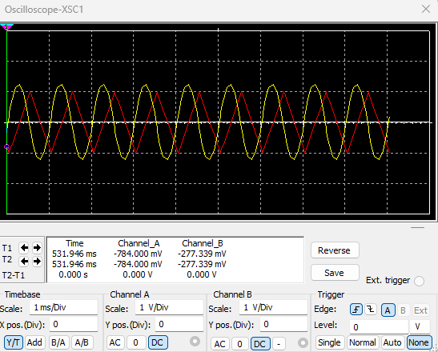

* **Output in the lab:**

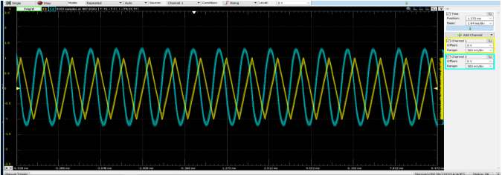

* **The frequency response:**

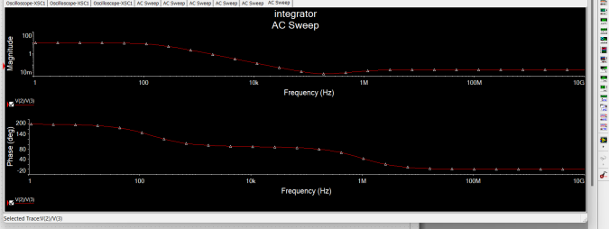

* **The differentiator circuit:**

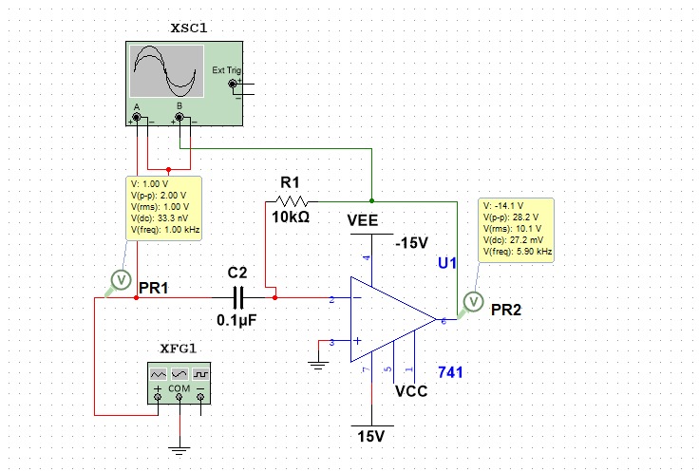

* Function generator settings for all:



1. **Sinusoidal wave input:**

**Output from multisim:**

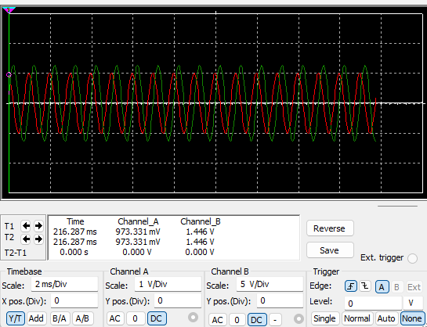

**Output in the lab:**

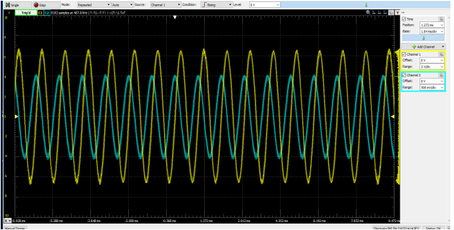

1. **Square wave input:**

**Output from multisim:**

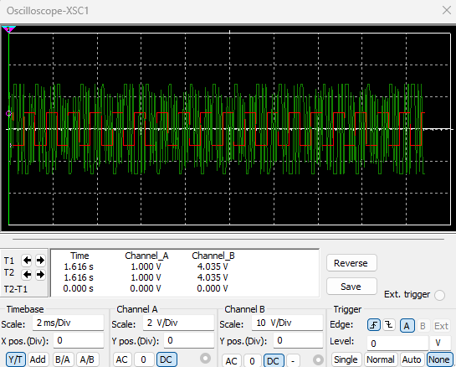

**Output in the lab:**

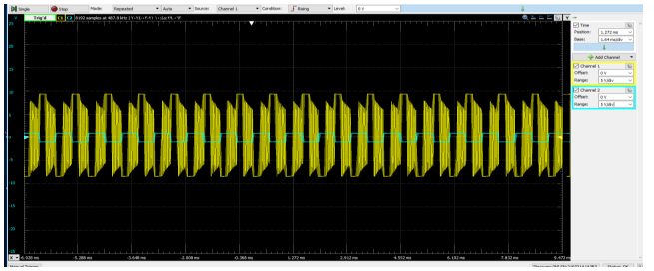

Comment:

If a rectangular wave is applied to a differentiator amplifier, the output will be a series of pulses. And if a square wave is applied, the output will be delta as the op-amp differentiator produces an output voltage which is proportional to the rate of change of the input voltage.

1. **Triangular wave input:**

**Output from multisim:**

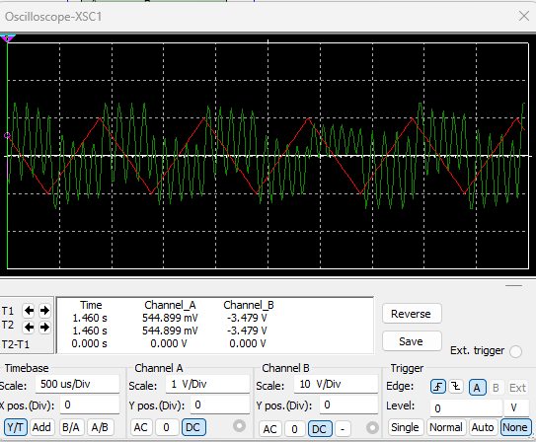

**Output in the lab:**

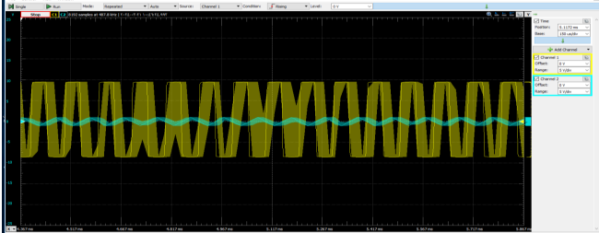

**Frequency response:**

