Operational Amplifier (Op-Amp)

Audio Amplifier

|  |  |
| --- | --- |
| Names | IDS |
| Nada Tarek Mowafi | 20012094 |
| Salma Hamdy Mohamed | 20010677 |
| Mohamed Khamis Awad | 20011560 |
| Rowan Tarek Elsayed | 20010586 |

***Operational Amplifier (Op-Amp):***

* ***Introduction:***

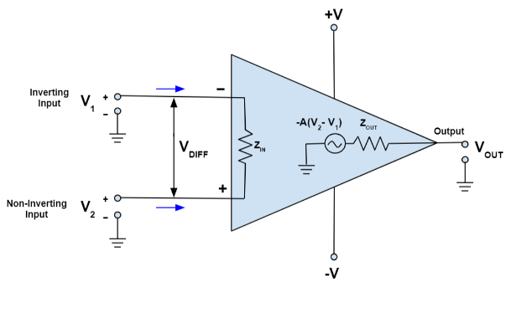Operational amplifiers (op-amps) are fundamental building blocks in analog electronic circuits. They are highly versatile and widely used due to their ability to amplify signals, perform mathematical operations, and maintain precise outputs.

1. *Basic Functionality:*

Op-amps are differential amplifiers with high gain, typically used to amplify the voltage difference between two input terminals. They have a non-inverting input (+), an inverting input (-), and an output.

1. *Ideal Characteristics:*

In theory, op-amps have infinite input impedance, infinite open-loop gain, zero output impedance, infinite bandwidth, and zero offset voltage. In practice, real op-amps have limitations due to factors like power supply constraints and imperfections in manufacturing.

* ***Common Configurations:***

1. 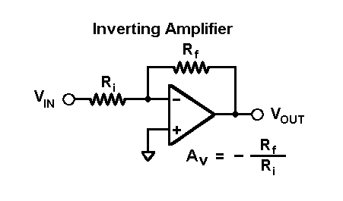**Inverting Amplifier:**

Amplifies the voltage difference between the input terminals with a gain determined by the ratio of feedback resistor to input resistor.

1. 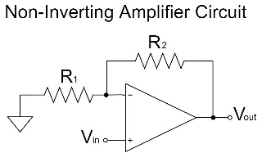**Non-Inverting Amplifier:**

Amplifies the voltage at the non-inverting input with a gain determined by the ratio of feedback resistor to input resistor.

1. **Summing Amplifier:**

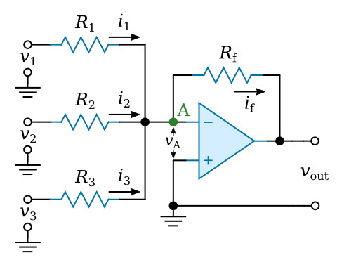 Adds multiple input voltages weighted by their respective resistor values.

1. **Difference Amplifier:**

Subtracts one input voltage from another.

1. **Integrator and Differentiator:**

Performs mathematical integration and differentiation of input voltages.

* ***Modern Applications:***

1. Audio Amplification:

Used in audio equipment for amplifying and shaping audio signals.

1. Signal Processing:

In digital-to-analog converters (DACs) and analog-to-digital converters (ADCs) for signal conversion.

1. Control Systems:

In feedback loops for control and automation systems.

1. Communications:

In modulators, demodulators, and signal conditioning circuits in communication systems.

* ***The application:***

***Audio amplifier:***

* 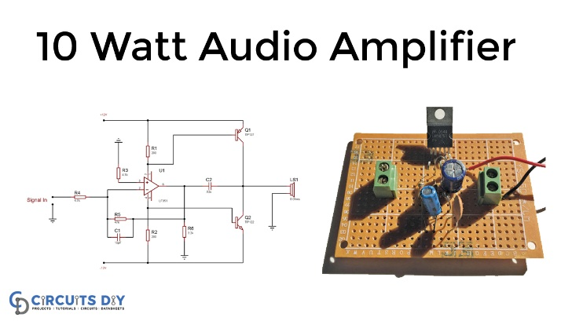An audio amplifier utilizing operational amplifiers (op-amps) is engineered to enhance the strength and fidelity of audio signals. Typically consisting of pre-amplification, main amplification, tone control, and output stages, these amplifiers utilize op-amps for their ability to precisely amplify signals with minimal distortion. Op-amps are employed in each stage, leveraging their high gain, low noise, and versatile configuration options. Additionally, op-amps facilitate the implementation of feedback loops for stability and linearity, as well as protective features to safeguard against overloads and short circuits. Ultimately, audio amplifiers employing op-amps deliver clean, powerful, and accurate sound reproduction, making them indispensable components in a wide range of audio systems, from home stereos to professional audio setups.
* A computer screen shot of a computer program

  Description automatically generated with low confidenceSchematic Diagram:
* ***The schematic diagram of the audio amplifier circuit consists of two main components:***

1. **pre-amplifier stage:**

* The pre-amplifier stage is a noninverting op-amp with a negative feedback loop to reduce nonlinearity.
* The introduction of negative feedback reduces the effective input to the amplifier, which brings the device back to the linear region of operation. With negative feedback, the level of non-linear distortions in the amplifier is reduced.
* This stage amplifies the input signal from the audio source and prepares it for further amplification in the power amplifier stage.

1. **power amplifier stage:**

* The power amplifier stage is a push-pull power stage that takes the amplified signal from the pre-amplifier and drives it through the speaker. This stage is responsible for providing enough power to drive the speaker and produce high-quality sound.
* Where a push–pull amplifier is a type of electronic circuit that uses a pair of active devices that alternately supply current to, or absorb current from, a connected load. This kind of amplifier can enhance both the load capacity and switching speed.
* **Capacitors:**
* the usage of capcitor in circuit In the audio amplifier circuit, capacitors are used for several purposes. One of the main purposes is to block DC voltage and allow only AC voltage to pass through. as coupling capacitors
* This is important because DC voltage can damage the speaker and other components in the circuit.
* Capacitors are also used for coupling signals between different stages of the amplifier, allowing the amplified signal to be passed from one stage to another while blocking any DC offset.
* **Transistors:**
* Transistors transforms a small input current into a bigger output current. As a switch, it can be in one of two distinct states -- on or off -- to control the flow of electronic signals through an electrical circuit or electronic device.
* they are often used in power amplifier stages to provide high current gain and drive speakers with high power output.
* ***After analysing the circuit, several key aspects emerge***:

1. **Fidelity and Low Distortion:**

The amplifier's use of operational amplifiers (op-amps) throughout the signal chain emphasizes a focus on maintaining fidelity and minimizing distortion. Op-amps, with their high gain and low noise characteristics, contribute to achieving faithful reproduction of the input audio signal with minimal added noise or distortion.

1. **Versatility and Configurability:**

The inclusion of various stages such as pre-amplification, tone control, main amplification, and output driving highlights the amplifier's versatility and adaptability to different audio sources and output devices. Op-amps offer flexibility in configuration, allowing for adjustable gain settings and tone control parameters to tailor the audio output to specific preferences or requirements.

1. **Feedback and Stability:**

The utilization of feedback loops, made possible by op-amps, enhances the amplifier's stability, linearity, and overall performance. Feedback mechanisms help to mitigate distortion, regulate gain, and ensure consistent output characteristics across different operating conditions, contributing to reliable and predictable audio reproduction.

1. **Protection and Reliability:**

Incorporating protective features to safeguard against overloads, short circuits, and other potentially damaging conditions demonstrates a commitment to reliability and longevity. Op-amps enable the implementation of monitoring circuits that can detect abnormal operating conditions and trigger protective measures to prevent damage to the amplifier and connected devices.

1. **Efficiency and Power Regulation:**

While not explicitly mentioned, efficient power regulation is crucial for stable and clean audio amplification. Op-amps can be employed in voltage regulation circuits to maintain a steady output voltage despite fluctuations in the input power supply, ensuring consistent performance and minimizing the risk of power-related issues such as clipping or distortion.

* ***Some calculations:***
* Some fundamental equations commonly used to describe its behaviour include:

1. Voltage Gain Equation:

The voltage gain () of the amplifier is typically calculated based on the feedback resistor () and input resistor () in the circuit. For a non-inverting amplifier configuration, it can be approximated as:

This equation describes how much the input voltage is amplified by the amplifier.

1. Output Voltage Equation:

The output voltage () of the amplifier can be calculated using the input voltage () and the voltage gain ():

This equation illustrates the relationship between the input and output voltages of the amplifier.

1. Power Equation:

The power delivered to the load (𝑃𝑜𝑢𝑡) by the amplifier can be calculated using the output voltage (𝑉𝑜𝑢𝑡) and the load impedance (𝑅𝐿):

This equation quantifies the amount of power transferred from the amplifier to the connected load, which is crucial for determining the amplifier's performance and efficiency.

1. Frequency Response Equation:

The frequency response of the amplifier describes how its gain varies with frequency. It can be characterized by equations such as the gain-bandwidth product (GBP):

GBP = . BW

BW is the bandwidth of the amplifier.

* ***Simulation***:
* voltages with the oscilloscope:

input signal:

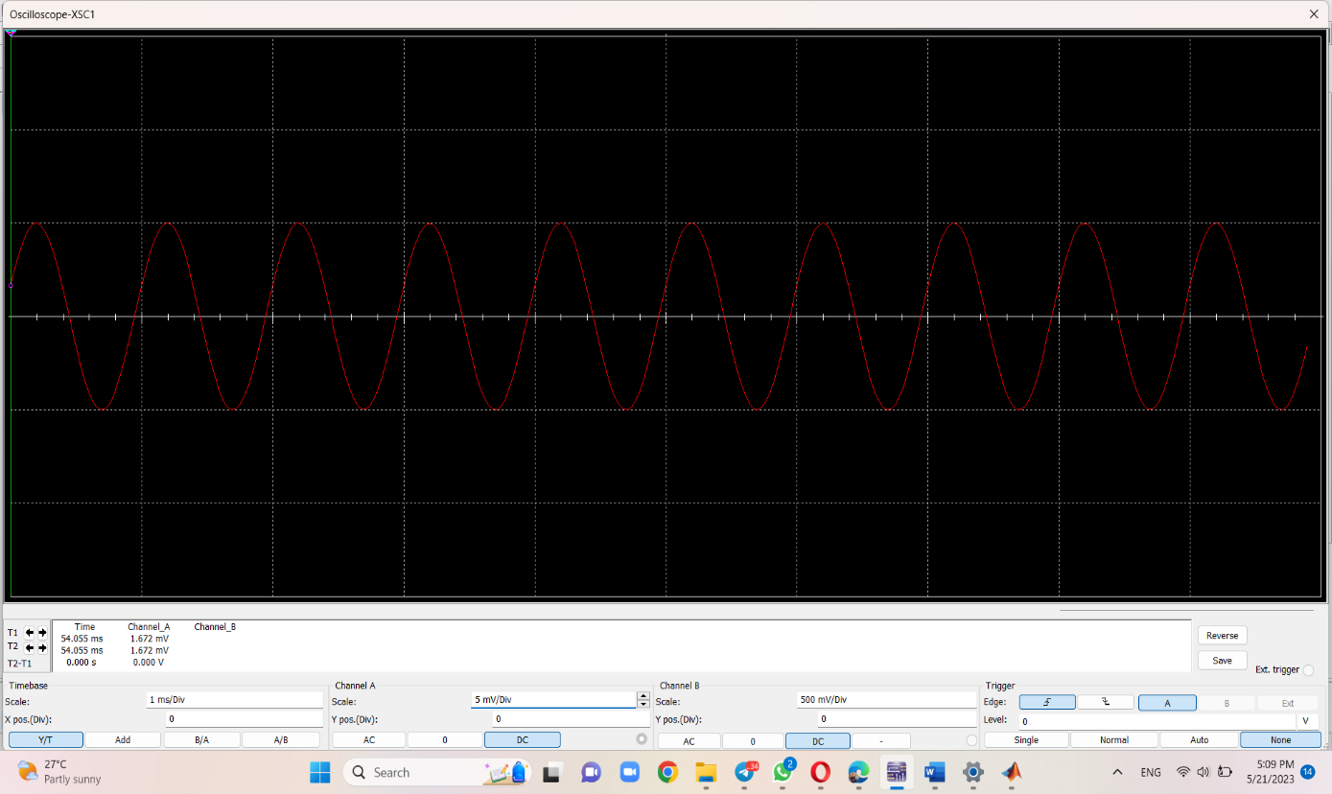

Output signal: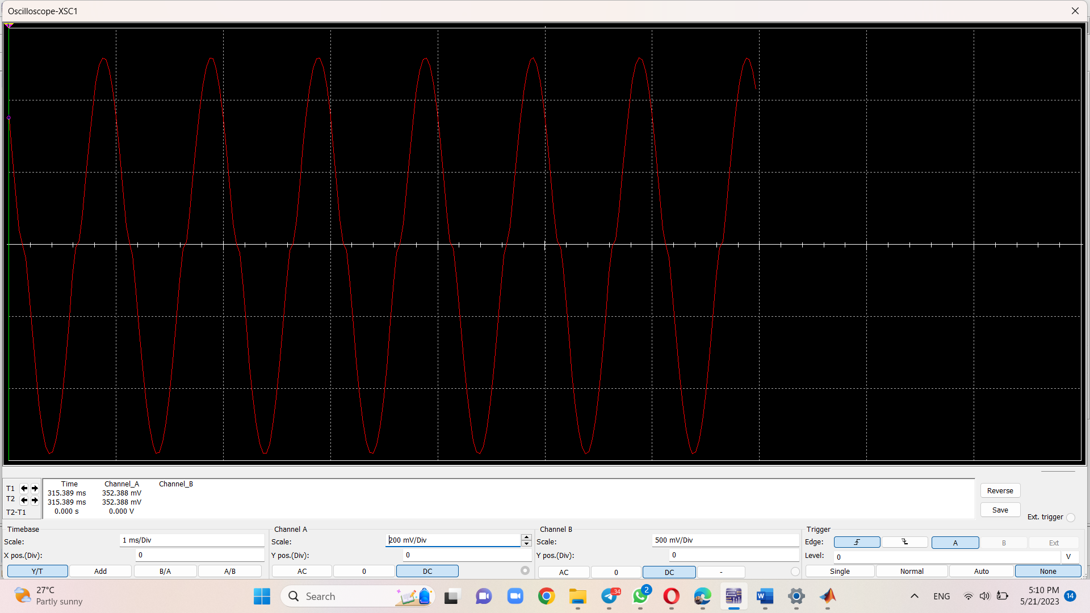

* voltage gain of the op-amp stage:

* voltage gain of the op-amp stage:

gain = ) =45.25db

* overall voltage gain:

gain = ) = 43.6db

* ***conclusion***:

an audio amplifier utilizing operational amplifiers (op-amps) offers a versatile and effective solution for amplifying audio signals with fidelity and precision. By leveraging op-amps' characteristics such as high gain, low noise, and precise control, the amplifier achieves faithful reproduction of input audio signals while minimizing distortion and noise. The amplifier's design typically incorporates stages for pre-amplification, main amplification, tone control, and output driving, providing flexibility and adaptability to different audio sources and output devices. Feedback mechanisms ensure stability, linearity, and consistent performance across varying operating conditions, while protective features safeguard against potential damage to the amplifier and connected devices. Through the application of mathematical equations and design principles, engineers can analyse, optimize, and tailor the amplifier's performance to meet specific requirements, making it a fundamental component in a wide range of audio systems, from consumer electronics to professional audio setups.