**Image annotation:**

Image annotation is the process of **labeling images** in a given dataset to train machine learning model

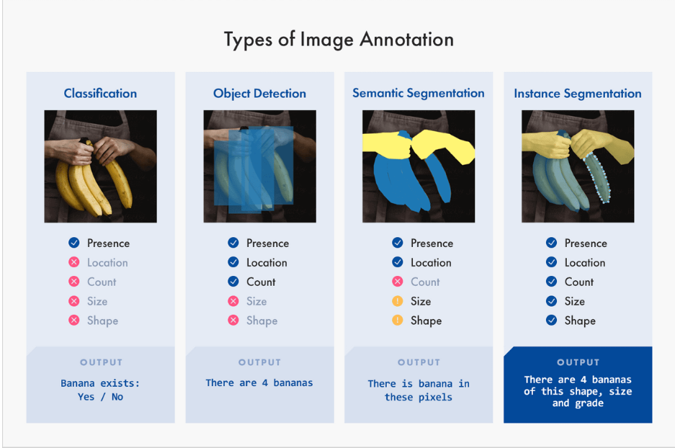

**Masking images:**

Masked Image in machine learning is a way to hide data. It helps in telling the prediction model that certain timesteps in the sequence-processing layer are missing, and the model does not need to handle them

**How to do masking in image processing?**

Mask is a type of filter which performs operation directly on the image. The filter mask is also known as convolution mask. To apply a mask on an image, filter mask is moved point to point on the image. In the original image, at each point(X, Y), filter is calculated by using a predefined relationship.

**Docker:**

Too much libraries and modules

Lama bn2l el application mn environment mn el tanya lazem a3ml intsalling l kol 7aga el application mo3tmd 3aleeha

Fa el docker hygm3 ko, 7aga ana me7taga fy container fa a2dar an2l mn mkan l mkan tany bsholaa

Bylm kol el dependancies w y7otha fy container a5od el container w a7otha fy el environment ely ana 3aizha a3ml deployment bkol shola

W kaman by5leeny a2dra agrb el application bta3y b kol el versions ely ana 3aizaha