Task 1

1-username:nadaabdelrahman

2-

The cat command is all well and good for small files. The more command displays the contents of the file one screen at a time for large files

3-rm -r removes a directory and all its contents; rmdir will only remove a directory if the directory is empty

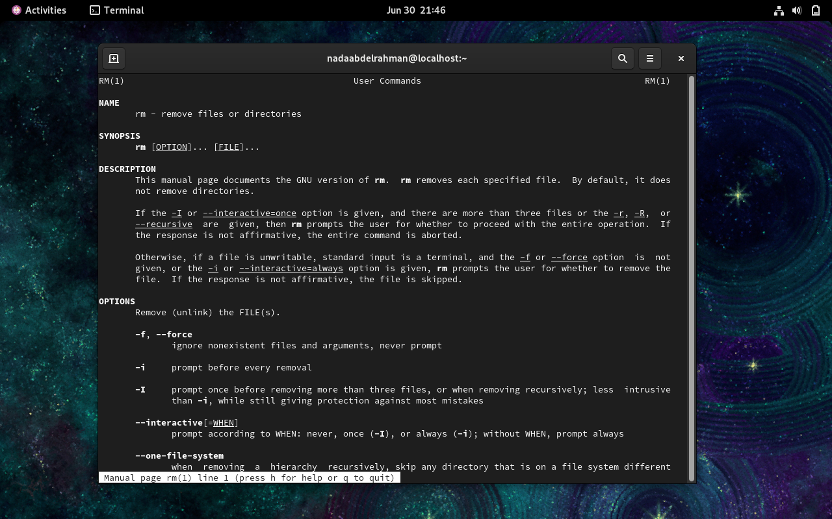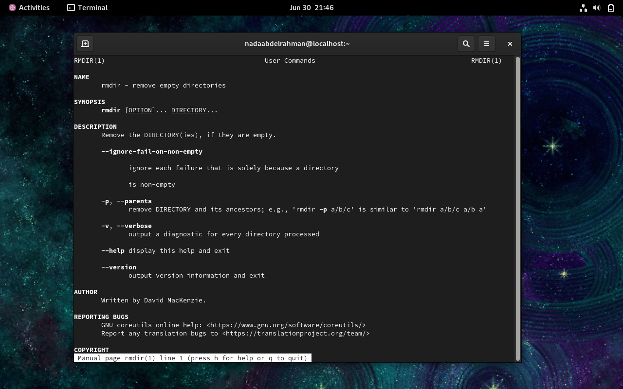

4-

9-

