Arbeidskrav DS3103 Webutvikling

General Information
- Assessment: Godkjent / Ikke godkjent.
- Can be solved individually, or group of 2, or group of 3
- The arbeidskrav consists of 2 parts:
  - A technical solution
  - Giving and receiving feedback from other groups and delivering the feedback
- If in group: the one who delivers includes a file called “group-members.txt” including full name of all the group members. Only one in the group should deliver!
- You are to solve the arbeidskrav in the attached project folder.
- Zip the project before upload to Canvas.
- You may ask the student assistants for guidance (but not direct solutions) in the lab exercises.
- Have fun!!!

Technologies
- HTML5, CSS3, and JavaScript (ES6+).

Techniques and resources
- Semantic coding
- BEM
- Diverse CSS code for styling content
- Grid system with CSS3 Grid
- Media Queries
- FontAwesome
- JavaScript (main points):
  - ES6+ techniques such as arrow functions, forEach() and filter()
  - Array with objects
  - localStorage
  - Module

Tips / things to reflect over.
- Is the code tidy and structured?
- Are the variables and functions named properly?
- Is the code easy to read for other developers?
- Is the HTML semantic?
- Do I have unnecessary code repetition?
- Should I add a comment (HTML, CSS, and/or JavaScript) to mark and/or explain certain codes or sections?

Case: Armies of Zondor

Web application for a medieval army
Note that all screen shots below are to exemplify the pages and functionality, and do not represent the complete functionality or design. You can decide freely on design according to what you think will be/look best.

Quick overview of web pages

Page 1. Resource shop.
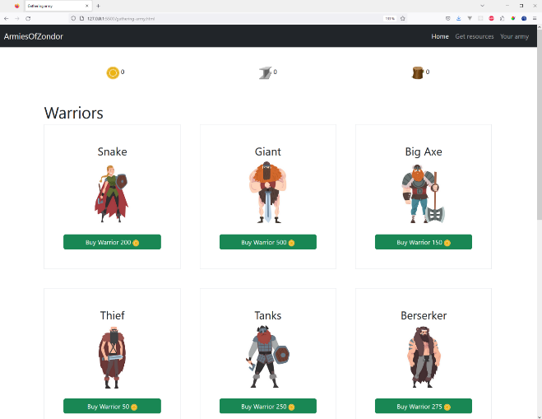

Page 2. Getting resources.
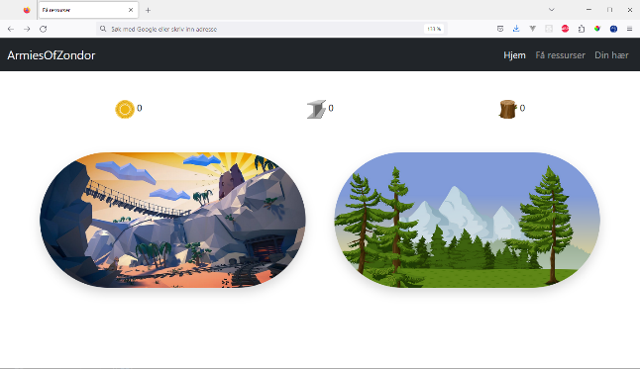

Page 3. Your army.
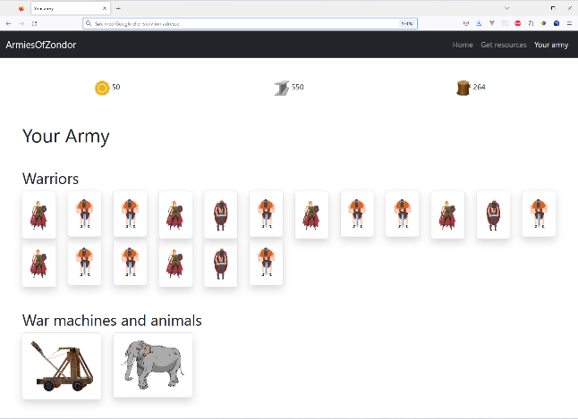

Page 1. Resource shop.
Page where you buy army resources (warriors, animals, and war machines). PS! You are free to design the entire solution as you wish when it comes to layout, colors, font-family, icons etc. The screen shots are only to exemplify the functionality!
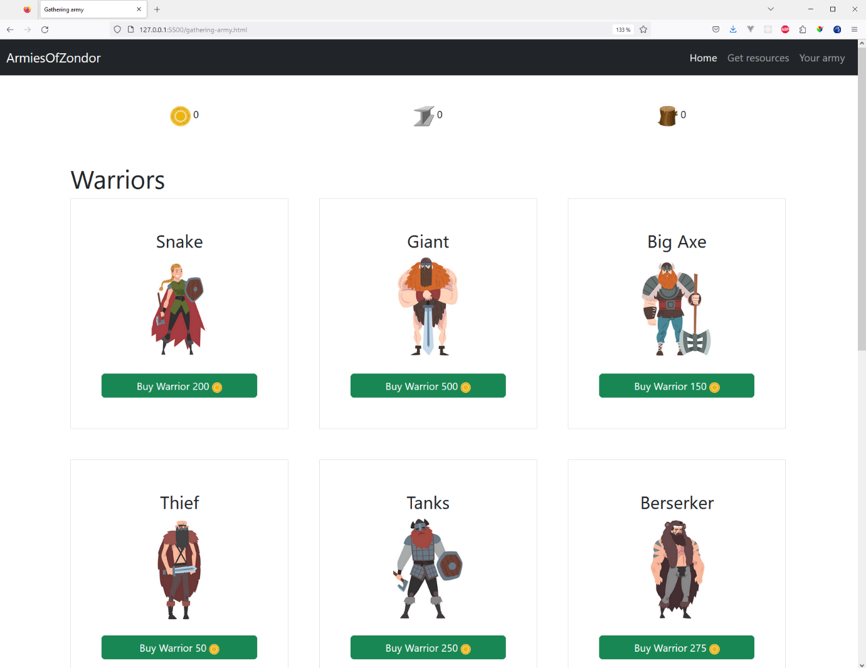
- The warriors should have the upper part of the page, while the animals and war machines have the lower part. They are all shown with category name (for example a “Snake” type warrior, image, and price.
- You should make 2 (or 3) separate Modules for the information:
  - Warriors
  - Other (animals and war machines)
- Each warrior to buy has (at least):
  - categoryName
  - priceGold
  - image
- A war machine costs gold, metal, and wood to buy.

Page 2. Getting resources.
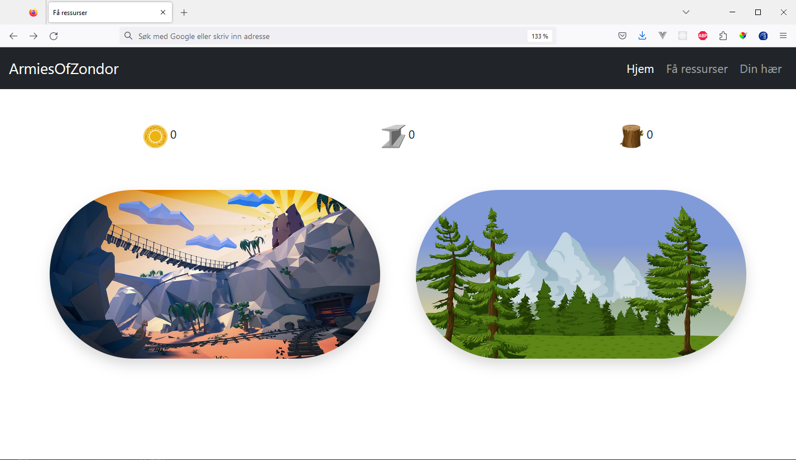
Page where you have to cut wood and mine metal and gold.
- When you click on the mine picture you will get a random amount of either gold or metal. There is a 75% chance of getting metal; thus 25% chance of getting gold.
- When you click on the woods picture you will get a random amount of wood.
- The numbers beside the gold, metal and wood pictures get updated as you get more gold, metal and wood. These resources need to be saved in localStorage.
- When you hover over the mines you should get the cursor of pickaxe-cursor.png
- When you hover over the woods you should get the cursor of axe-cursor.png

Page 3. Your army
Page where you see your bought army resources.
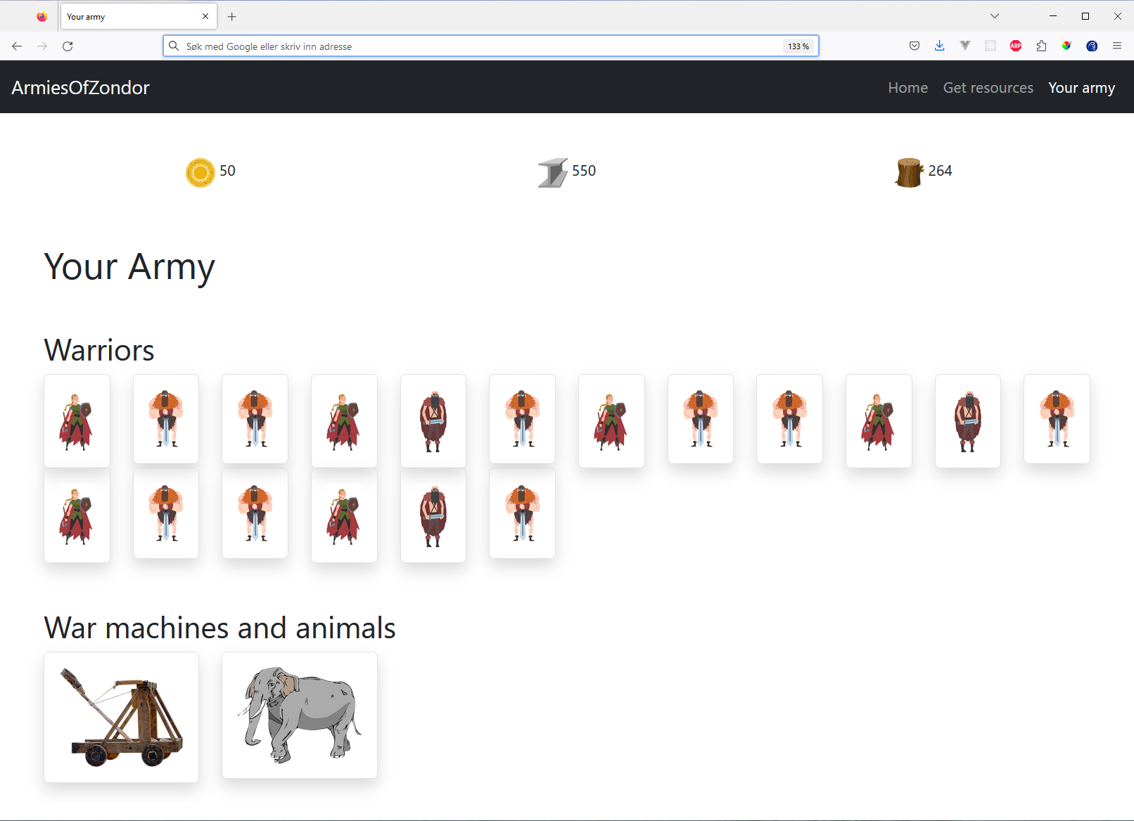

Other requirements and specification (for the entire solution)
- When something is bought, information will have to be stored to localStorage so that it can be shown in the “your army” page.
- Note that all warriors, war machines, and animals on all pages are generated with JS
- The solution is to be responsive
- All 3 pages will need access to localStorage regarding how much gold, metal, and wood you have.
- You are expected to add as much as possible different CSS properties to get as much experience with coding CSS / CSS framework
- Should make use of favicon
- Add search functionality with filter()

Additional things (not mandatory)
- Add functionality (on a new page for example) for summing up how much you have of each thing, how much you have spent on warriors, animals, war machines, etc.
- Other things you think may be nice/fun in the application.
- Write 200-300 words about Usability and Universal Design in context of the solution.

Collaboration task (mandatory)
- Give your project (either all or parts of your code) to 1-2 other groups in your class, and get the code from 1-2 other groups. Then write and 3-5 points about what is good, and 3-5 points about what can be improved to the other group(s) – see template below.
- “Part of your code” can for example be “gathering-army.html”, “gathering-army.js”, and “WarriorModule.js”.
- You will deliver both the feedback you have given, and the feedback you have gotten.
- This task should/can be done in one of the lab exercises before the delivery date.

Template for feedback

3-5 good things in the solution code
- X
- Y
- Z
- A
- B

3-5 things that can be improved, and/or tips etc.
- X
- Y
- Z
- A
- B

Examples of things that one can give feedback on
- Variable, and function names
- Tidyness
- Structure
- Code repetition
- Code improvements
- …other things

