

Django is a Python web framework that encourages rapid development.

It takes care of much of the hassle of web development, so you can focus on writing your app without needing to reinvent the wheel. It’s free and open source.

We’ll write out backend with Django.

Setup venv

pip install virtualenvwrapper-win

mkvirtualenv habit-tracker

deactivate

workon habit-tracker

---

**Virtual Environment** [<https://pypi.org/project/virtualenvwrapper-win/>]

A tool for creating isolated Python virtual environments, each with their own libraries and site-packages.

---

Django installation

pip install django

Start a new Django project

django-admin startproject habit_tracker

---

**django-admin** [<https://docs.djangoproject.com/en/4.1/ref/django-admin/>]

django-admin is Django’s command-line utility for administrative tasks

manage.py is automatically created in each Django project. It does the same thing as django-admin but also sets the DJANGO_SETTINGS_MODULE environment variable so that it points to your project’s settings.py file.

---

# URL Routing and Django Apps

Start the Django application

python ./habit_tracker\manage.py startapp habit_tracker_app

Explanation about some files

* C:\Code\git\habit-tracker\backend\habit_tracker\**habit_tracker_app\urls.py**

This file contains urls that will be used in our app.

* C:\Code\git\habit-tracker\backend\habit_tracker\**habit_tracker_app\views.py**

This file contains functions that will be used when the pages are viewed

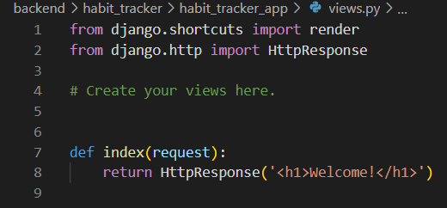

And when starting the app with python .\habit_tracker\manage.py runserver, we get:

# Django Template Language

# Sending Data to Template File

# Building a Word Counter in Django