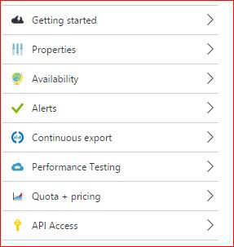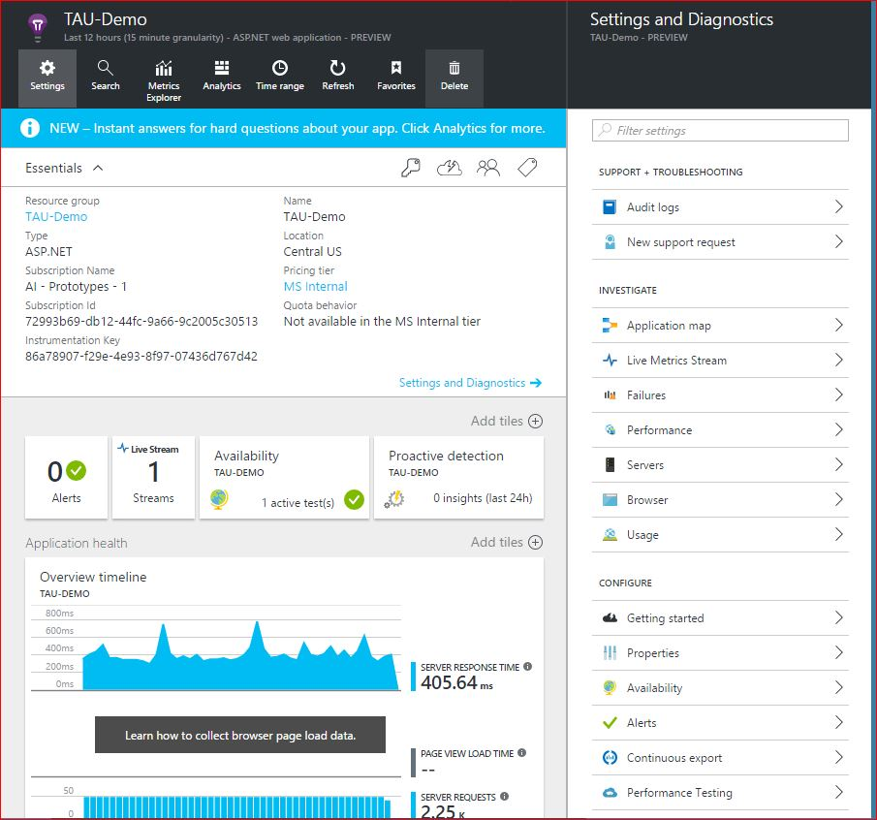

Settings-> Performance -> SegmentationSummaryQuery

Settings-> servers-> RequestSeriesandSummaryQuery

Settings->Availability->WebTestMetricQuery

Settings->Alert->’choose one’->AlertQuery,WebTestMetricQuery,WebTests

Settings->Quota+Pricing-> BillingPlanQuery,SegmentationQuery,EventsLastMonthQuery

Settings->Usage-> SegmentationSummaryQuery, RequestSummary, NoRequestsEverQuery,

NoPageViewsEverQuery, NoRemoteDependencies

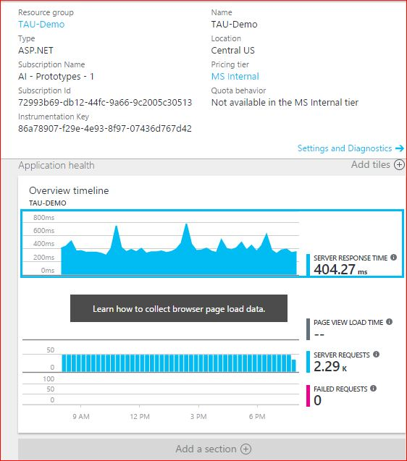

לחיצה על אחד הגרפים למטה:

RequestSeriesAndSummaryQuery, SegmentationQuery, searchResultsQuery

Other:

Search-> ‘choose one’ -> SearchResultsQuery

Search->filters->’choosefilter’->SegmentationSummaryQuery

Refresh-> ComponentAggregateMetricsQuery,WebTestsQuery,AlertQuery,AggregateQuery,RequestsSummaryQuery,

**Every click on a graph-> SearchTimelineQuery**