CS236781: Final Project

1. Abstract
2. Intro

## Problem Domain

Atrial fibrillation (AF) is one of the most common types of arrhythmias, which are irregular heart rhythms [1]. AF occurs when the upper chambers of the heart (atria) beat out of rhythm and as a result, blood is not pumped efficiently to the rest of the body, causing an unusually fast heart rate, quivering, or thumping sensations in the heart [2]. Often episodes of AF are asymptomatic [3]. AF is the most common sustained cardiac arrhythmia and as of 2020, 33 million people are affected by this disease worldwide [4]. AF patients are at moderate-to-high risk of stroke and the disease is a common factor of heart failure [5]. As such, establishing an effective monitoring system for early AF detection along with an effective approach to treating AF is essential [5].

AF is often transient or paroxysmal in nature, and the correct diagnosis of AF can be challenging in patients with paroxysmal AF [6]. The main characteristic of AF disorder is the irregular rhythm of the heartbeat or more specifically when a varying period is observed in Electrocardiogram (ECG) signal between R–R peaks [7]. The disease is hard to diagnose, since patients suffering from AF may not have symptoms at early onset, and there is spontaneous termination of arrhythmia. Thus using machine learning to detect AF can be very beneficial.

Heart disease prediction using machine learning has become common in the last few decades. There are numerous studies using deep learning techniques to detect heart arrhythmias in general and AF in particular. Machine learning algorithms have the potential to improve patient outcomes and reduce the workload of clinicians particularly where diagnoses are made from large volumes or complex patterns of data such as in AF.

## Existing approaches and drawbacks

We based our project on a study that aims to detect Atrial Fibrillation using long short-term memory network (LSTM) with RR interval signals [8]. Their proposed Computer-Aided Diagnoses (CAD) system can be used for long-term monitoring of the human heart. The system achieved 98.5% accuracy with 10-fold cross-validation (20 subjects) and 99.77% accuracy with blindfold validation (3 subjects).

We plan to address and improve the proposed system's architecture by modifying the model's layers and adding an attention layer to our system (further explained in section 3.2)

1. Methods

This section introduces the approach used by the paper we rely on [8] and our modifications and improvements.

## Original Approach

The model implemented in the study [8] is based on Recurrent Neural Network (RNN). To identify RR intervals as AF it is necessary to examine each RR interval in relation to other intervals over time. So, in order to classify AF it is crucial to be able to put an RR interval in its context. RNNs allow the network to retain and utilize state information, meaning information on what has happened in previous time steps. The RNNs have a "memory" that captures information about all elements of the same input sequence.

LSTMs are an improvement on standard RNNs since they incorporate a gating mechanism and are able to deal with the [vanishing gradient problem](https://en.wikipedia.org/wiki/Vanishing_gradient_problem) that can be encountered when training traditional RNNs. An LSTM has the ability to control which information is remembered and which is forgotten. The model from the study [8] used a Bidirectional LSTM, which utilizes past and future data from the input sequence. This enables the network to make a more accurate prediction because it is given a wider context.

A global max pooling in one dimension was used in the study's [8] model, after the bidirectional LSTM layers. The goal of a max pooling layer is to down sample the input representation by reducing its dimensionality and allowing for assumptions to be made according to the features with the max values.

## Modifications and Improvements

The main modification that was made was changing the one-dimension max pooling layer to an attention layer. The attention mechanism is widely used in deep learning networks, in fields such as Natural Language Processing (NLP) and Computer Vision, and is inspired by the ability of the human brain to direct our focus and pay greater attention to certain factors when processing data.

Since paroxysmal AF occurs as sporadic periods of AF between normal heart rhythms, a soft attention mechanism can put more emphasis (attention) on beats with higher prevalence of AF. Our proposed modification is changing the max pooling layer which chooses the max values, and replacing it with a soft attention layer that its output will be a combination from all the values, with bigger emphasis on relevant values, and not only the maximum.

## Data used

The experiments conducted by the study [8] and by us were based on data from the MIT-BIH Atrial Fibrillation Database [9][10]. The database includes 23 long-term ECG recordings of human subjects with atrial fibrillation (mostly paroxysmal). The individual recordings are each 10 hours in duration and contain two ECG signals each sampled at 250 samples per second. The R peaks are labeled and the RR intervals were extracted according to these labels.

1. Implementation and Experiments

## Data Preprocessing

The data preprocess is based on the preprocessing methods described in the study [8]. The relevant data from the 23 ECG recording files is represented in the p_signals. The p_signals are read and split into RR intervals according to the R peaks from the file record. Each interval is labeled as negative or positive for AF according to the ".atr" file. Then samples are created by splitting RR interval sequences into overlapping sequences of 100 beats for each HR trace, where there are 99 beats overlapping with the adjacent sample. A beat sequenced is labeled as AF if it contains one or more beats that were classified as showing signs of atrial fibrillation. The other sequences are labelled as normal, i.e. negative.

Since we encountered memory limit problems when trying to save all the samples created into one dataset, data processed from each file is saved into a subset dataset and then the final dataset is created by concating all the subset datasets.

Another problem we encountered was the imbalance of the dataset produced. Although the MIT BIH AF database is heavily weighted with AF patients compared to a real patient population, the amount of beats labeled as AF is sparse compared to the other beats, since AF occurs in intermittent periods between normal beats. To overcome the imbalance of the data we used a weighted data loader on the training set. The weighted data loader oversamples the rare class – meaning the sequences labeled with AF.

## Model Architecture

The system architecture we used is based on the study [8] with some improvements made by us. The details of the architecture of the study are shown in Figure 1. According to the study's approach the sequences of 100 beats are sampled into the bidirectional LSTM. The number of cells in each of the layers of the bidirectional LSTM was set to twice the input sequence length. This section of the model architecture is implemented with the same structure as the study's.

In our model architecture an attention layer is used between the bidirectional LSTM layers and a fully connected layer as opposed to a max pooling layer that is used in the study's architecture. Both techniques, the attention and max pooling, reduce the dimension of the sequence size from 100 to 1.

The output of this layer is then inserted into two fully connected layers that are used to produce the final classification. These fully connected layers are implemented with the same structure as the study's.

The bidirectional LSTM analyzes and extracts the features which are passed to the fully connected layers that classify whether the sequence holds AF beats or not. The model was implemented using PyTorch.

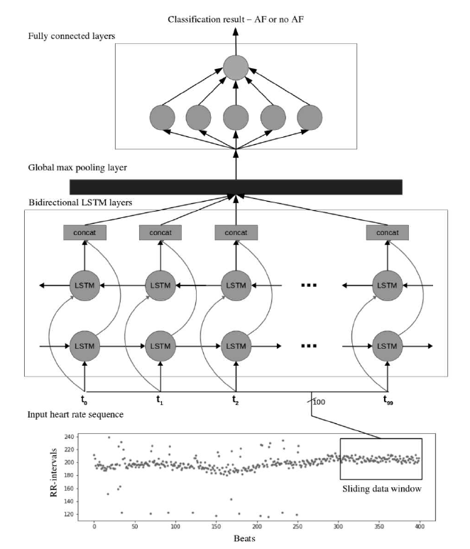

Figure 1: The bidirectional LSTM architecture used in the paper [8]

להוסיף תרשים של הארכיטקטורה שלנו? זה מאוד דומה לתרשים שלהם

## Training Methods (and hyperparamter values)

## Experiments and configuration

What was compare , the evaluation metrics used

1. Results and discussion

## Results

כאשר אנחנו מאמנים ובודקים על אותם קבצים אז המפות אט' תואמות (נותנות תוצאות טובות) אבל שאנחנו מאמנים ובודקים על קבצים נפרדים כלומר על מטופלים שונים, המפות אט' לא בהכרח רלוונטיות למטופלים של הבדיקה ולכן מקבלים תוצאות פחות טובות

## Analyze and explain results

## Compare to previous works

**Acronyms**

AF Atrial Fibrillation

CAD Computer-Aided Diagnosis

ECG Electrocardiogram

LSTM Long Short-Term Memory

NLP Natural Language Processing

RNN Recurrent Neural Network

**References**

[1] - <https://www.nhlbi.nih.gov/health-topics/atrial-fibrillation>

[2] - <https://www.medtronic.com/us-en/patients/conditions/atrial-fibrillation-afib.html>

[3] - Munger, TM; Wu, LQ; Shen, WK (January 2014). ["Atrial fibrillation"](https://www.ncbi.nlm.nih.gov/pmc/articles/PMC3904170). *Journal of Biomedical Research*.

[4] - Chung, MK; Eckhardt, LL; Chen, LY; Ahmed, HM; Gopinathannair, R; Joglar, JA; Noseworthy, PA; Pack, QR; Sanders, P; Trulock, KM; American Heart Association Electrocardiography and Arrhythmias Committee and Exercise Cardiac Rehabilitation, and Secondary Prevention; Committee of the Council on Clinical Cardiology; Council on Arteriosclerosis, Thrombosis and Vascular Biology; Council on Cardiovascular and Stroke Nursing; Council on Lifestyle and Cardiometabolic Health (March 2020). ["Lifestyle and Risk Factor Modification for Reduction of Atrial Fibrillation: A Scientific Statement From the American Heart Association"](https://doi.org/10.1161/CIR.0000000000000748).

[5] [- Atrial Fibrillation Recurrence and Peri-Procedural Complication Rates in nMARQ vs. Conventional Ablation Techniques: A Systematic Review and Meta-Analysis](https://www.frontiersin.org/articles/10.3389/fphys.2018.00544/full)

Ka H. C. Li1,2,3†, [Mei Dong](https://loop.frontiersin.org/people/537180/overview)4†, [Mengqi Gong](http://www.frontiersin.org/people/u/528268)5, George Bazoukis6, Ishan Lakhani2,3, Yan Y. Ting2,3, [Sunny H. Wong](http://www.frontiersin.org/people/u/468199)2,3, Guangping Li7, William K. K. Wu8, Vassilios S. Vassiliou8, Martin C. S. Wong10, [Konstantinos Letsas](http://www.frontiersin.org/people/u/19580)5, [Yimei Du](http://www.frontiersin.org/people/u/292862)11, [Victoria Laxton](http://www.frontiersin.org/people/u/377563)12, Bryan P. Yan1, Yat S. Chan1, [Yunlong Xia](http://www.frontiersin.org/people/u/501745)12, [Tong Liu](http://www.frontiersin.org/people/u/282803)2*, [Gary Tse](http://www.frontiersin.org/people/u/335924)2,3* and International Health Informatics Study (IHIS) Network

[6] - [Improved Detection of Silent Atrial Fibrillation Using 72-Hour Holter ECG in Patients With Ischemic Stroke](https://www.ahajournals.org/doi/full/10.1161/STROKEAHA.113.001884)

[Martin Grond](https://www.ahajournals.org/doi/full/10.1161/STROKEAHA.113.001884), [Marek Jauss](https://www.ahajournals.org/doi/full/10.1161/STROKEAHA.113.001884), [Gerhard Hamann](https://www.ahajournals.org/doi/full/10.1161/STROKEAHA.113.001884), [Erwin Stark](https://www.ahajournals.org/doi/full/10.1161/STROKEAHA.113.001884), [Roland Veltkamp](https://www.ahajournals.org/doi/full/10.1161/STROKEAHA.113.001884), [Darius Nabavi](https://www.ahajournals.org/doi/full/10.1161/STROKEAHA.113.001884), [Markus Horn](https://www.ahajournals.org/doi/full/10.1161/STROKEAHA.113.001884), [Christian Weimar](https://www.ahajournals.org/doi/full/10.1161/STROKEAHA.113.001884), [Martin Köhrmann](https://www.ahajournals.org/doi/full/10.1161/STROKEAHA.113.001884), [Rolf Wachter](https://www.ahajournals.org/doi/full/10.1161/STROKEAHA.113.001884), [Ludger Rosin](https://www.ahajournals.org/doi/full/10.1161/STROKEAHA.113.001884), and [Paulus Kirchhof](https://www.ahajournals.org/doi/full/10.1161/STROKEAHA.113.001884) (Oct 2013)

[7]  **-** [Early Detection of Atrial Fibrillation Based on ECG Signals](https://dx.doi.org/10.3390%2Fbioengineering7010016)

[Nuzhat Ahmed](https://www.ncbi.nlm.nih.gov/pubmed/?term=Ahmed%20N%5BAuthor%5D&cauthor=true&cauthor_uid=32069949)1 and [Yong Zhu](https://www.ncbi.nlm.nih.gov/pubmed/?term=Zhu%20Y%5BAuthor%5D&cauthor=true&cauthor_uid=32069949)2,* (March 2020)

[8] - [Automated detection of atrial fibrillation using long short-term memory network with RR interval signals](https://www.sciencedirect.com/science/article/abs/pii/S0010482518301847)

[OliverFaust1](https://www.sciencedirect.com/science/article/abs/pii/S0010482518301847" \l "!),[AlexShenfield1](https://www.sciencedirect.com/science/article/abs/pii/S0010482518301847#!),[MurtadhaKareema](https://www.sciencedirect.com/science/article/abs/pii/S0010482518301847#!),[Tan RuSanb](https://www.sciencedirect.com/science/article/abs/pii/S0010482518301847#!),[HamidoFujitac](https://www.sciencedirect.com/science/article/abs/pii/S0010482518301847#!),[U. RajendraAcharyadef](https://www.sciencedirect.com/science/article/abs/pii/S0010482518301847#!)

[9] [Moody GB, Mark RG. A new method for detecting atrial fibrillation using R-R intervals. Computers in Cardiology. 10:227-230 (1983).](http://ecg.mit.edu/george/publications/afib-cinc-1983.pdf)

[10] Goldberger, A., Amaral, L., Glass, L., Hausdorff, J., Ivanov, P. C., Mark, R., ... & Stanley, H. E. (2000).