Linear models
2D classification problem
non-linear separation

Logistic regression
to predict probability we will use output of linear model and logistic function
cross-entropy minimization
train our model with gradient descent
to train our classifier using stochastic gradient descent(SGD)
hyperparameters like batch size, learning rate

Mini-batch SGD

SGD with momentum

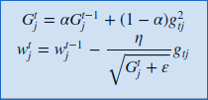
RMSprop

MLP

