בס"ד

**קובץ פתרונות מטלה 1 במסדי נתונים:**

**שאלה 1:**

השאילתה תשלוף :

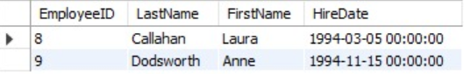

**שאלה 2:**

select OrderID from orders join customers on (orders.CustomerID = customers.CustomerID)

join employees on (customers.City = employees.City)

where orders.EmployeeID = employees.EmployeeID

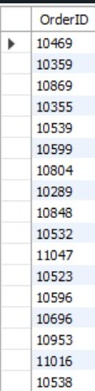

**שאלה 3:**

select ProductName, count(distinct orders.CustomerID) as `number customers` from products

join `order details` on (products.ProductID = `order details`.ProductID)

join orders on (`order details`.OrderID = orders.OrderID)

group by `order details`.ProductID

having count(distinct orders.CustomerID) > 1

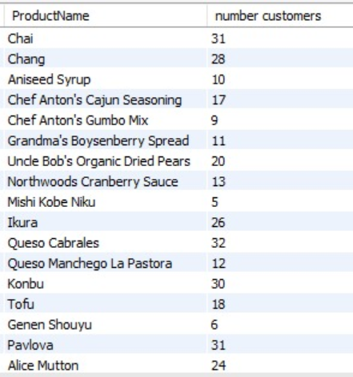

**שאלה 4:**

select cat.CategoryID, count(p.ProductID) as `number of produts` from categories cat

join products p on (cat.CategoryID = p.CategoryID)

join `order details` od on (p.ProductID = od.ProductID)

join orders o on (od.OrderID = o.OrderID)

join customers cus on (o.CustomerID = cus.CustomerID)

where cus.ContactName like '%Sommer'

group by cat.CategoryID

order by cat.CategoryID

