CASE 1 : Normal

SJF-Preemptive. –
Inputs
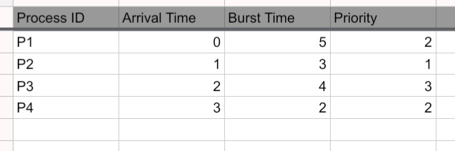

Outputs

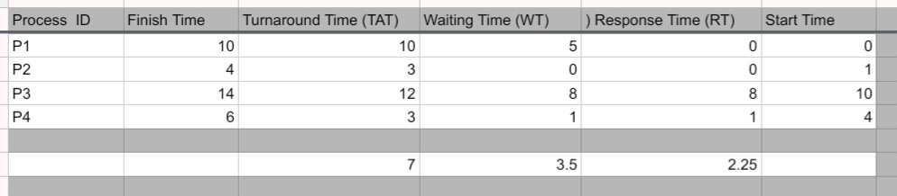
Finish Time:from Gantt Chart
( The last moment the process left the CPU and finished its work).

Turnaround Time (TAT)= Finish Time-Arrival Time
Waiting Time = Turnaround Time- Burst Time
Response Time = Start Time-Arrival Time
_______________
TAT1=10-0=10
TAT2=4-1=3
TAT3=14-2=12
TAT4=6-3=3

Average Turnaround Time (ATAT)=(Summation Values of TAT ) / number of Processes
=(10+3+12+3)/4=7

WT1=10-5=5
WT2=3-3=0
WT3=13-4=8
WT4=3-2=1

Aaverage Waiting Time (AWT)= (Summation Values of WT)/number of processes

=(5+0+8+1)/4=3.5

RT1=0-0=0
RT2=1-1=0
RT3=10-2=8
RT4=4-3=1

Average Response Time = (0+0+8+1)/4=2.25
-----------------------------
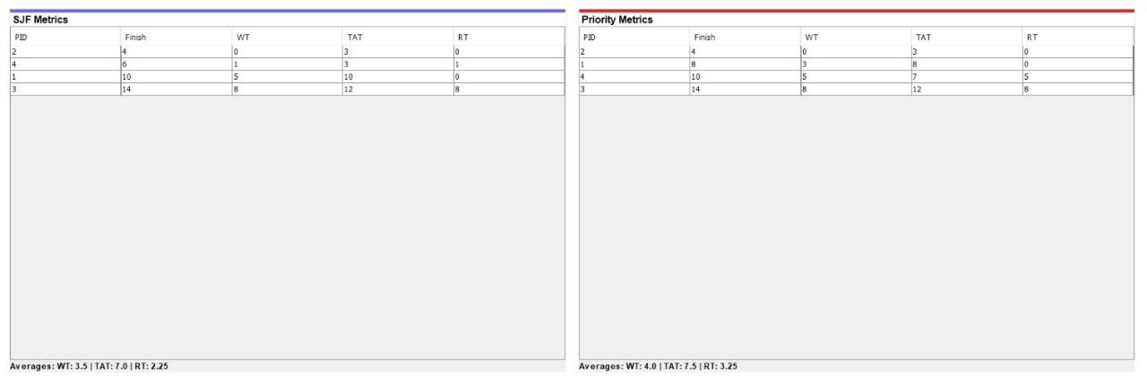

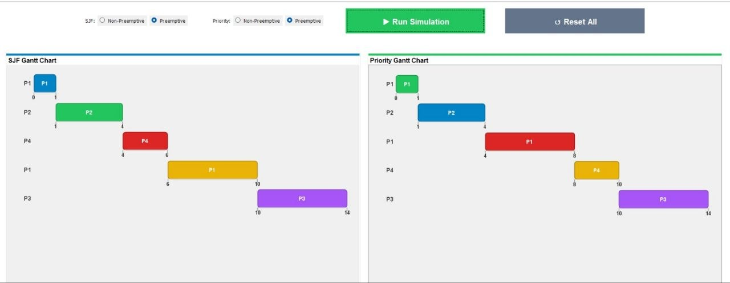
-SJF-Non Preemptive
Inputs



Outputs

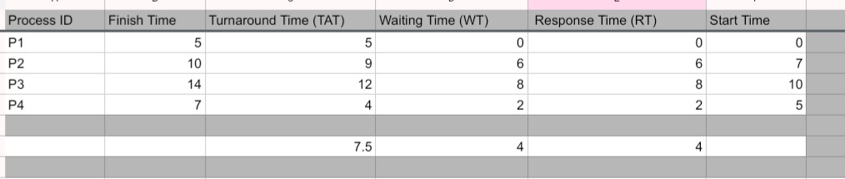

TAT1=5-0=5
TAT2=10-1=9
TAT3=14-2=12
TAT4=7-3=4
Average TAT= (5+9+12+4)/4=7.5

WT1=5-5=0
WT2=9-3=6
WT3=12-4=8
WT4=4-2=2

Average WT=(0+6+8+2)/4=4

RT1=0-0=0
RT2=7-1=6
RT3=10-2=8
RT4=5-3=2

Average RT=(0+6+8+2)/4=4

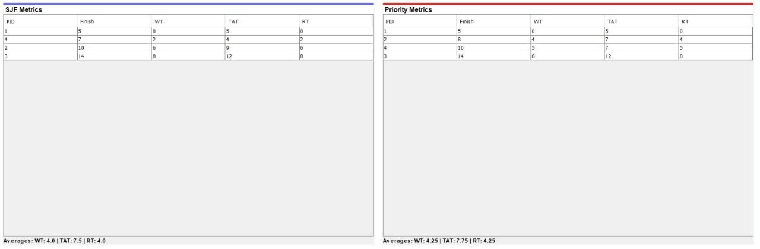

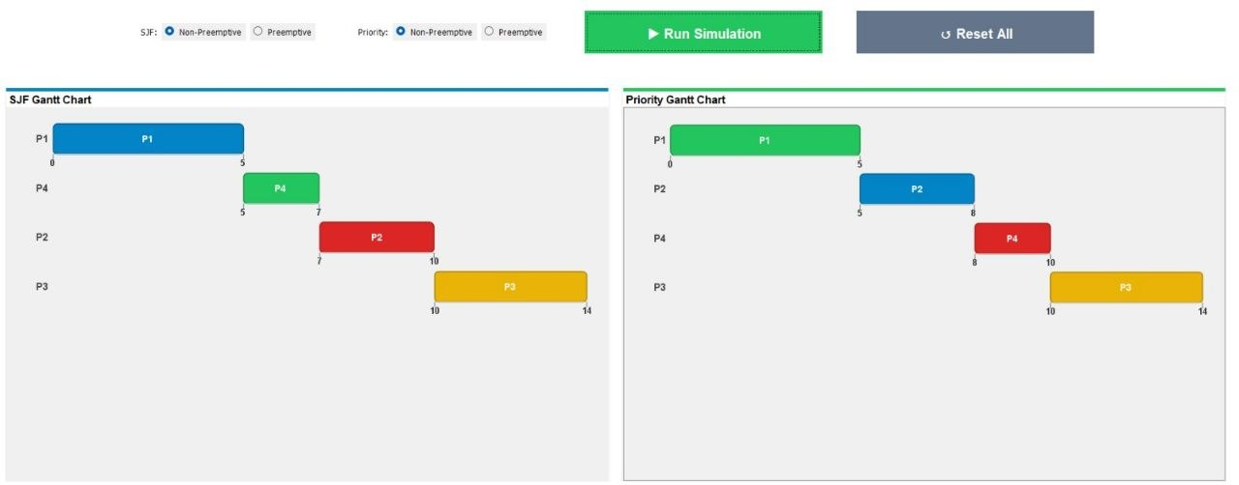

Priority Preemptive



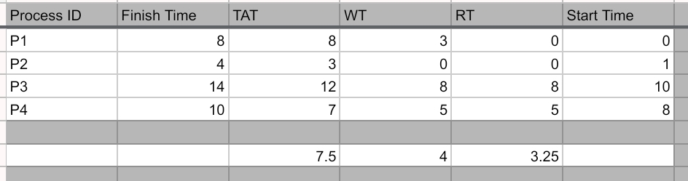

TAT1=8-0=8
TAT2=4-1=3
TAT3=14-2=12
TAT4=10-3=7

Average TAT=(8+3+12+7)/4=7.5

WT1=8-5=3
WT2=3-3=0
WT3=12-4=8
WT4=7-2=5

Average WT=(3+0+8+5)/4=4

RT1=0-0=0
RT2=1-1=0
RT3=10-2=8
RT4=8-3=5

Average RT=(0+0+8+5)/4=3.25





Priority Non Preemptive.



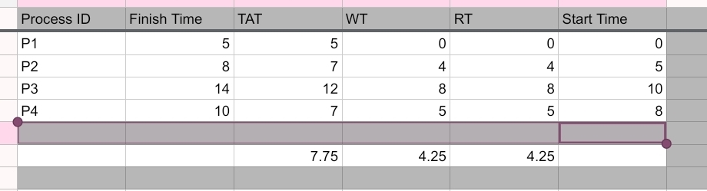

TAT1=5-0=5
TAT2=8-1=7
TAT3=14-2=12
TAT4=10-3=7

Average TAT=(5+7+12+7)/4=7.75

WT1=5-5=0
WT2=7-3=4
WT3=12-4=8
WT4=7-2=5

Average WT=(0+4+8+5)/4=4.25

RT1=0-0=0
RT2=5-1=4
RT3=10-2=8
RT4=8-3=5

Average RT=(0+4+8+5)/4=4.25





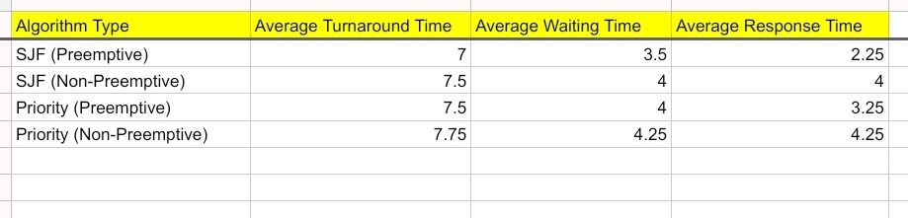

Upon comparing the results of Case 1, the SJF (Preemptive) algorithm demonstrates the highest efficiency, achieving the minimum Average Waiting Time (3.5), Turnaround Time (7.0), and Response Time (2.25) among all tested scheduling methods.

