In this case, we tested the system’s ability to handle incorrect data entry. The goal is to ensure that the application remains stable and provides clear feedback to the user when invalid inputs are provided.

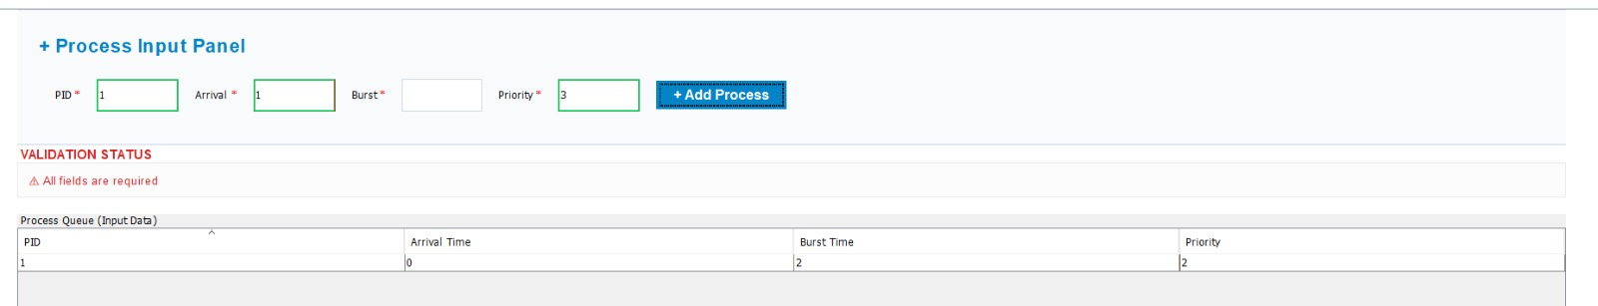

The execution was halted because of missing data. All input fields must be populated before starting the simulation.
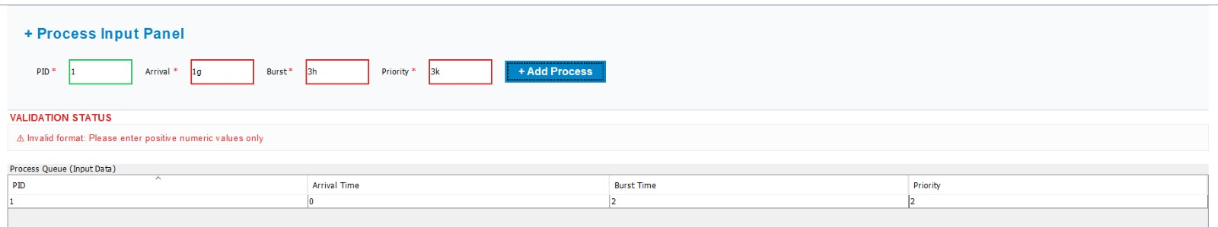

Non-numeric characters were blocked to prevent calculation errors. The system only accepts Integer values for process metrics.

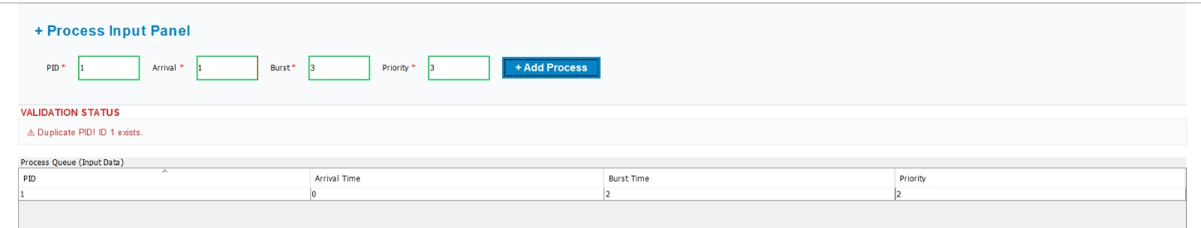

Duplicate Process IDs are not allowed to avoid Identification conflicts within the ready queue.
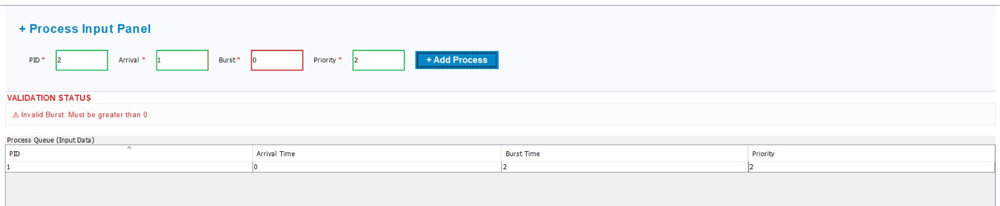

Invalid priority levels were detected. The system ensures that priority values fall within the predefined acceptable range.

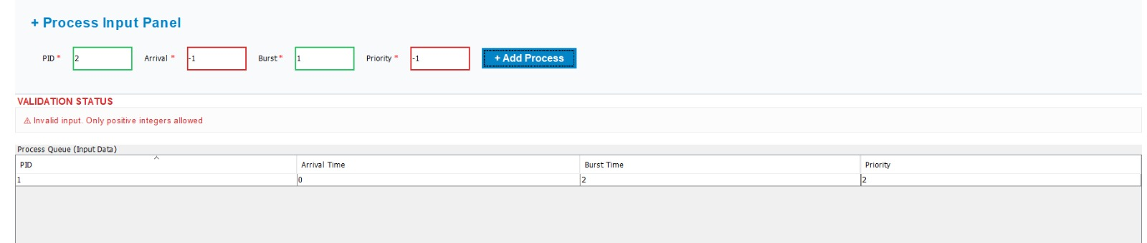
The system rejected the negative input because Arrival and Burst times must be non-negative integers to ensure logical scheduling

