- What is Web & App Development?
- What is Mern Stack?
MERN is a popular technology stack used to develop full-stack web applications.
MERN
- M → MongoDB — Database
- E → Express.js — Backend framework
- R → React.js — Frontend library
- N → Node.js — JavaScript runtime/backend
It allows developers to use JavaScript for both frontend and backend development.
- What is HTML5?
HTML5 is the modern version of HTML (HyperText Markup Language).
- Why not new Version Appear?
- How to make a File and Folder?
- How to save notepad file?
- .html extension?
- Why index name is mandatory for home page?
index.html is not technically mandatory, but it is the standard/default filename used for a website's main page.
- What is browser?
Browserek software/application hai jo humeinwebsites aur web pages ko internet par open aur usekarnedetahai.
- Google Chrome
- Microsoft Edge
- Mozilla Firefox
- Safari
- How to change default browser?
Chrome meinaapapni HTML website ko easily test karsakte ho.
- Open Settings.
- Go to Apps.
- Select Default apps.
- Find your preferred browser, such as Chrome, Edge, or Firefox.
- Select it.
- Set it as the default browser.
- Basic Structure of HTML?
<HTML>
<head><title>This is class1</title></head>
<body>

</body
</HTML>
- What is tag?
Tag HTML ka ek keyword hotahai jo webpage kekisi part ko define kartahai.
- What is element?
Element opening tag, content aur closing tag se mil karbantahai.
- Difference between Opening and Closing Tag?
Opening Tag: Element ko start kartahai.
Closing Tag: Element ko end kartahai. Is mein/hotahai.
- Boiler plate
Boiler Plate ka matlabhotahaipehle se likhahua basic code, jise hum baarbaar use kartehain.
Boilerplate ek ready-made structure hotahaijisse hum apna project jaldi start karsaktehain.
Short cut: shift !

- What HTML tag contain?
HTML tags keandarcontent yadoosre HTML elements ho saktehain.
<html>
<Head>
<body></body>
</head>
</html>
- What is head tag contain?
<head> tag mein webpage ki important information/settingshotihain jo normally webpage par directly shownahihoti.
- <title>Website ka naam jo browser ke tab mein show hotahai.
- <meta>Text aur special characters ko properly show kartahai.Website ko mobile aur different screen sizes par adjust kartahai.
- <link>
- <style>
- <script>
- What Body Tag contain?
<body> tag mein webpage ka visible contenthotahai jo user ko browser meinnazaraatahai.
- Headings
- Paragraphs
- Images
- Links
- Buttons
- Videos
- Lists
- Heading?
<h1></h1>
<h2></h2>
<h3></h3>
<h4></h4>
<h5></h5>
<h6></h6>
- Paragraph tag?
Paragraph tag HTML mein text ko paragraph ki form meinlikhnekeliye use hotahai.

- Bold tag?
Ye srf word ko bold kre ga.
Is ka use paragraph meinkiya ja sktahaiagrkisi word ko heighlightkerna ho to.
<b></b>
- Italic?
Kisi book ka name movie name apnibaat per zoor dene keliye.
<i></i>
- SubScript tag?
Footnote keliyejese h2o
<sub></sub>
- SuperScript tag?
Power dene keliye
<sup></sup>
- White Space?
Ap jitnibhi space de deinlkn html mein wo single space hi count ho gi.

- &nbsp?
Agr ap ko extra space dena ho to us keliye use krei.

- Block Level Element?
Wo elements jo full width letehain.
Agr us ke bad code mein kuch likho bhi to wobhi new line se hi show ho ga.
<div>,<p>,<h1> to <h6>,<section>,<article>,
<header>,<footer>,<nav>,<aside>,<main>,<form>,<ul>, <ol>

- Inline Element?
Inline elements wo hotehain jo srfuitni space letehainjitni space required hotihai .
<span>, <a>, <b>, <i>, <em>, <strong>

- SelfClosing tage?
Wo tag jis ka closing tag alg se nhi hota.
Is mein / slash lgana optional ai….

<br> → line break, <hr> → horizontal line, <input> → form input, <meta> → metadata ,<link> → CSS link, <base>, <source>, <track>, <area>
- Line Break?
Agar aik hi paragraph (<p>) keandarrehtehuay new line chahiye, to hum <br> ka hi use kartehain.
<br/>
- Horizontal Rule?
Page meine horizontal line draw kartahai
<hr/>
- Semantic markup?
Semantic markup ka matlab _{hai} HTML tags ka use unke meaning kehisaab sekarna, nakesirf style keliye.
Besst SEO (search Engine Understanded content), Clean and more Readable coad, Meaningful
<header> → introductory content or page header, <nav> → navigation links, <main> → main content of the page, <section> → a thematic group of content, <article> → a self-contained piece (blog post, news item), <footer> → footer information, <em> → emphasized text, <strong> → strong importance, <blockquote> → a quotation, <address> → contact information., <Cite>→ reference ka title btatahai author ka name nhi <dfn> → definition
- Strong?
Test ko bold kerta hai. Lkn srf styling is ko use kerne ka purpose nhi hota….
Lkn ye meaning fulhai. Semantic tag hai. Ye browser to btata hai ke ye word important hai.
- Why <strong></strong> and <b></bold are the part of HTML5?
<p><b>Name:</b> Ali</p><!--sirf label -->
<p><strong>Warning!</strong> File delete ho jayegi.</p>
- Emphaise?
Kisi word ya text per zoor dena.
Help me .please help me.
Please per zoor diya gaya hai.

- <blockquote>
text kisi aur source se liya gaya quotation hai.
Complete para…
Ye indent (left/right space) ho jatahai
- <q>
Chhoti quote (sentence keandar)
short inline quotes keliye (browser automatically quotation marks add kartahai).
- <Cite>
Kisi book, article, movie, website ka title show karne ke liye
Text usually italic ho jatahai
jb koi text kisi reference se liye jata hai to us ka title define kerty hain.
- Attribute?
Extra informationya property about tagjis information se ye modify hotahai…
Ye tag ka opening part meinlikhajatahai…
Is mein do chezihain name and value

- <abbr>
Kisi bhiabbrivationya short form dikhanekeliye
Full form batanekeliye (mostly title attribute kesath)
- <acronym>
Same as <abbr>lekin ab use nhi hota….
- <dfn>
Kisi bhi word ki definition ko define kern eke liye use hota hai…
Jb bhi kisi cheez ko define krein us ke name per ye laga dein.
Jis word per lgao wo itelic ho jatahai….
- <address>
Iss ka use author ya owner ka address dikhane ke liye kerty hain…
Isme, email, phone,postal address website ko show kerta hai…
Ye hmesha body ya article ke ander ata hai…….

- <ins>
Insert text is ka kaam hai ke new text ko show kerna .jis bhi text per lgade in us ke niche underline lgadetahai…
- <del>
Delete text ka kaam hai ke jb ap koi new value add krein aur puri value ko change kerdein.. jis value ko delete kerdein us per cut ki form meinek line aa jjatihai……

- <s>
Old version hai
Out dated
Is ka use tb hota hai jb ap ko ye btana ho ke ab ye exist nhi kerti ya abhi available nhi hai..
- List?
Numbered list/ order list. (Ol)
Bullet list. unorder list (ul)
Definition list. (dl)
- Order list
Is ko number list bhikehtyhain.
Jab order / sequence important ho
By default is ka style numbers hotahai.
Attribute is meinuse hosktyhain…
Type , start, revered
Number, uppercase, lowercase, roman
- Unorderlist
Is ka use unorder list keliyehotahai .
Jab order important na ho
Type attribute is mein deprecated hainyanifilhal ho sktahaikaamkrelkn bad mein future mein ho skt hikaamnhakre.
Circle disc square
Browser abhi bhi kaam karta hai
Modern way = CSS
- Description/ Definition list
3 tags use hotyhain<dl>
<dt> Definition
<dd>Definition description/ Description Details
Explanation dnekeliye

- Link (Hyperlink)
n HTML, links (also called hyperlinks) are used to move from one webpage to another, or to another section of the same page, or to files like PDFs, images, emails, etc.
Ek page se dosre page per move kernna.
Link hamesha ap ko file per le kerjaye ga kunke us ki extension hai.
- Unvisited links are underlined and blue
- Visited links are underlined and purple
- Active links (during click) are underlined and red

- Anchor tag <a>
- Href
(Hyper-text REference)
ek attribute hai
jis mein link ka address hota hai.

- Target
Ye bhi ek attribute hai jo a mein use hotahai
Ye batata haike lick hone wala linkkahan open honahai
_self = same tab mein open ho ga.
_target = new window ya tab mein open kro.
_parent, _top in ka use iframe meinhotahai.
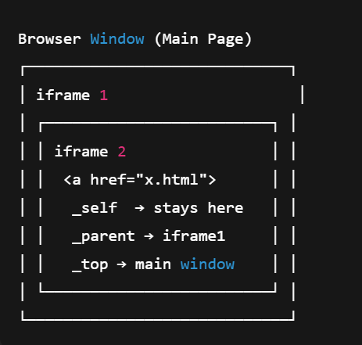

- Absolute Url
Apni web se kisidosri website per move kerna
- Relative Url
Apni hi web keek pagesedusre page per move kerna..

- Email link
<a href="mailto:abc@example.com">Send Email</a>
- Phone link
<a href="tel:+923001234567">Call Us</a>

- On image link
<a href=” link of the website”><imgsrc=”logo.jpg” alt=” value” /></a>

- Sibling
Ek sibling se dosre per jane keliye use kreinge. Hrefmein same name ka

- Child
Age ap ko apnesiplingke folder keanderkisi file meinjanahai to
Pehle sibling ka name phir forward slash phir child ka name

- Reverse back
Age ap ko apne parent ke sibling ke passjanahai to us keliyepehle folder se baharaeinge.
Us keliye ..lgy ga phir forward slash phirfile ka name
- ID
Ye ek attribute haijis ka use hum kertyhainek hi page meinek section se dosre section per jane keliye….

- Image
Imgek inline element hai

- Extension
Jis wo jisformatemeinimg save ho gi…
- <img>
Ye ek self-closing tag hai
- Src
Srcek attribute hai jo imgmein use kiyajatahaijis ka kaamhaiimg a path btana.
ka purpose ye haikeaapek image ke multiple versions browser ko de do, har version ka width ya densityalag ho saktahai.
Browser phirautomatically decide kartahaikaunsa image load karnahai, based on screen size.
- Srcset
Ekse zadaimges ka path dennekeliyeagr ye nachle to ye
W width kisibhiimgki .pixcelsmein….
- Alt (Alternative text)
Ye bhiek attribute hai ..
Jbimg load nhihoti t ye text show hotahai..
SEO google ranking keliye important.

- Title
Ek aur attribute haijis ka use hum imgmeinkersktyhain..
- UNIT
Img ko width aur height dene keliye unit detehain….
Html mein hum abhikeliye do units study kreinge.

- Pixcel
Agr value is meindetehain to value her screen per fix hotihai
- %
I mein value ko dene se img screen ke according adjust hotihai.
Ye apne parent ke according % mein value letahai…..
- Figure
Ye bhiek semantic tag hai
Ye ek parent element haijis ko imgmein use kiyajatahai
bas apne content keliyeek container banatahai..

- Figcaption
Semantic tag
Image ka caption, title, description
Image ke bare mein detail detehainis mein
Image keneeche us ka short description
- Loading
Browser ko batata haiimage kab load karnihai.
- Lazy
Sirfvisible content load hotahai
Neechewali images load nahihoti
- Decode
Encode hotahaijb hum device mein koi img save kerwatyhain wo cod formmein ja ker save hotihai.
ab wo image jb browser per show hogi to us ko decode kehtyhain ye code form se digital form mein..

- Async
Ye deode ki value haijismeinimgfst load hotihai..
- Sync
Pehle image decode hotihai, phir page show hotahai — is liye page slow ho saktahai.
Agar browser image ko pehle decode kare aur us waqt page render ko rok de, to isaykehtehainsynchronous (sync) loading / decoding.
- Auto
Browser khud decide kartahaikaunsatareeqa best hai.

- Srcset
Different screen sizes keliyedifferent images load karwanekeliye.
- Sizes
Browser ko batata haiimage ki width kitnihonichahiye.
Imge ka size controlkertaahai

- Img width
- Img height
- Fetchpriority
Browser ko batata haikaunsi image pehle load honichahiye.

- Link with img
- <ahref="https://www.karachiflora.com/Home/Index">
- <imgsrc="images/flower(4).jpg"alt="Flower4"width="20%">
- </a>

- Table
Is tag keandarhum poora table ka contentlikhtehain.
Use
Student record
Result sheet
Employee list
Timetable
Price list
Reports
- Tag table…
<table> →Jismein hum sara content daltehain…
Parent tag.
- Tr<tr>
Table rowbananekeliye use hotahai.
Ismeek complete row ke columns (<th>ya<td>) likhtehain.Th<th>
Table heading / header cellkeliyehotahai.
Usually bold aur centerhotahai.Td
- Td <td>
Table data / normal cellkeliyehotahai.
- Border (Deprecated)
Table ko border dene keliye.
Html5 mein CSS use hotahai….
- Cellpadding
Deprecated
Cell keander padding dene keliye
Cell keandar space (padding) dene keliyehotahai.
- Spanning column
Ye merge nahikarte, balkayextra space le rahehain.
- Colspan
Do column ki jgalenekeliye use hotahai…
- Spanning Rowsphelahuwa
rowspan tab use hotahai jab ek cell ko multiple rows meinphailana ho
Ye donomerge nahikarte, balkayextra space le rahehain..
- Rowspan
Do row ki jaga lenekeliye
- <caption>
Caption ka use table tag keanderkiyajatahai
Caption ka behavior bilkultitle jaisahotahai .
Isi liye ye table ke bahr show hotahai….
Lkn top per
- Table sementic tags
Table create karneke semantic tags:
table, caption, thead, tbody, tfoot, tr, th, td
- Scope
Scope eksemantic attributehai.
Ye headings ko define kartahai, batata haikeye heading kis row ya column keliye apply hotihai.
“Ye heading yahan se yahantakkaamkaregi.”

- Value of scope col
Har column heading per lagatehain.
Meaning: Ye heading poore column keliye apply hotihai.
- Value of scope Row
Har row heading per lagatehain.
Meaning: Ye heading poore row keliye apply hotihai.
- Thead
Head ka itnabhi content hai us meinlikh do…

- Tbody
Body ka sara content tbodymeinlikh do
- Tfoot
Last line foot meinlikhdena
- Nested table

- Cellspacing (deprecated)

- bordercolor="red" (Deprecated)nhikaamkerta

- color (property bhikaamnhikerti)

- Form
Form ek box haijahan user apni information type kartahai. Submit button dabane se ye data kisi address (action) par send hotahai.
Is ka use user se input lenekeliyekiyajatahai.
- Login karwanekeliye
- Account banwanekeliye (Signup / Register)
- Contact karnekeliye
- Search karnekeliye
- Order place karnekeliye
- Feedback aur surveys keliye
- Real-life Examples:
- Facebook / Instagram Login
→ Email + Password input
- Google Search
→ Search box mein text input
- Daraz / Amazon Order
→ Address, phone number, payment details
- Website Contact Form
→ Name, email, message

- Server?
Server ek powerful computer hai jo websites aur apps ko run kartahai aur user se aayi hui information ko process kartahai.

Real-Life Analogy
- Form = Aapka letter / application
- Server = Post office ya school office jo letter receivekarke action letahai
- Response = Reply ya action jo aapkomiltahai

- Form
Parent element jismein hum sare components dalnege form ke
- Action (Attribute)
Form keaction attribute mein hum woh address daltehainjahanhumein user ka data send karnahotahai, jaise server ya file.
- Method (Attribute)
Method attribute batata haike form ka data kaisebhejajayega.
Method attribute decide kartahaike form ka data URL ke through (GET)yasecretly (POST)bhejnahai.
Is mein do value hotihain:
Get:
Jbhmein data chahyehotahai .jese search engins se.
Post :jbhmein data send kernahotahai bs ek verification chahyehotihaike data mil gayahaiyanhi.
- Input
Input element form ka wo part haijahan user apna data type kartahai.
element form ka wo part haijahan user apna data type kartahai.
Input element single-linehotahai
- Type (attribute)
Ye btatahaike input meinkis type ka data aye ga.
Input ka type, jaise text, email, password, number
- Text
Normal single-line textkeliye.
Default input type hai.
- Number
Type number dene se srf number hi de sktehain.
Aur input field keandder spinner show hotahai.
- min="1"max="100"
- Min Max
min / max attribute typing ko block nahikarta, balkaysirf form submit ke time validation kartahai.
Use with:
- number,
- range,
- date,
- time,
- month,
- week,
- datetime-local
- Tel
Is ka use phone number keliyekertyhainke use mein + ya – wghera hot hai.

- Password
Hidden inputkeliye, jo dots ya asterisks show kartahai.
Eye icon se toggle password visibility possible hai using JS.
- Email
Email address input keliye.
Browser basic validation automatically kartahai.
Example: <input type="email" required>

- Size
Ka use hum text meinkertyhain . input ki width controle kern eke liye.
Ye kuch type ki value ko support kertahai…
- Text
- Password
- Email
- Search
- Tel
- url
- number ⚠️ Limited / browser dependent

- Maxlength
Input field keanderkitna text likhsktyhain us kelieyhai.
- Text
- Password
- Email
- Search
- Tel
- url

- Month
Month select karnekeliye, format: YYYY-MM
Example: <input type="month">
- Date
Date selectkeliye, format: YYYY-MM-DD
Example: <input type="date">

- Time
Time selectkeliye, format: hh:mm
Example: <input type="time">

- Datetime-local
Date + Time local select karnekeliye, format: YYYY-MM-DDThh:mm
Timezoneignorehotahai, local time use hotahai.
Example: <input type="datetime-local">

- Week
Week select karnekeliye, format: YYYY-Www
Example: <input type="week">

- Color
Color picker input keliye.
Browser ekcolor paletteshowkartahai.
Example: <input type="color">

- Placeholder
Field keandarhint ya example textdikhatahai jab user kuch type nahikarta.

- name
Jab form submit hotihai, browser input ki value kesathnamebhejtahai server par.
Without name, input field ki value server ko nahimilegi.
- Range
Slider input keliye use hotahai.
Use:
- volume,
- brightness,
- zoom,
- price filter etc.
- required
form submit hone se pehleuser must fillkare.
required is an attribute used to make a form field mandatory. The form will not submit unless the user fills in that field.
- Readonly
User value change nahikarsakta, lekindekhsaktahai.
HTML meinreadonly ka use form fields ko view-only bananekeliyehotahai
User value edit nahikarsakta
<input type="text" value="Pakistan" readonly>
- Disabled
Field disable ho jatahai — value submit nahihoti.
<inputtype="text"disabled>
- Autocomplete
Browser suggestion ON / OFF karnekeliye.
Is ki do values hotihain
- On
- off
- <labelfor="">Autocomplete</label>
- <inputtype="text"autocomplete="on">

- Pattern
Pattern attribute form fields me custom input validation keliyehotahai.
- User input kartahai
- Form submit par browser input check kartahai
- Agar input pattern se match nakare → form submit block ho jatahai
- title attribute me diyagayaerror message show hotahai
- patternsirftext, email, search, tel, url, password par kaamkartahai
- type="number" par pattern kaamnahikarta
Syntax:
- Patterm=”[0-9]{10}” ya
- Pattern= “[A-Z]{3,10}”
- Pattern=”[A-Za-z]{2,15}”
[] btatihaikekonsa number yak is type ka alphabet use kernahai…
{} btatihaikekitne number ya alphabet likhskty ho
- {6} only 6 digit
- {6,} minimum 6
- {6,10} 6 se 10 kedermiyan
- Perfect matching keliye
- ^ start
- $ end
- Syntax
- Pattern=”^[0-9]{10}$”
- poora input sirf10 digit ho
- code
- <inputtype="text"pattern="[A-Za-z]{3,10}"title="3 to 10 letters only">
- <input type="tel" pattern="[0-9]{11}" title="Enter 11 digit phone number">
- <input type="text" pattern="\d{5}" title="5 digit postal code">
- <input type="password" pattern="(?=.*[A-Za-z])(?=.*\d)[A-Za-z\d]{6,12}" title="6-12 chars, at least 1 letter & 1 number">

- Step
- Name
1. Jab form submit hotihai, har input field ka name aur uski value server kepaasjatihai.
Server name ke basis par identifykartahaike ye data kis field se aayahai.
2. uses
- radio button
- checkbox
- text
- number
- File
- Value
  - Input field ka default value.
  - Agr ap chahtyhainke default value rahe to is ko input mein add kersktyhain.pehe se

- Textarea
Multi line text keliye
Is mein type attribute us enhihota.
Attributes.
- Cols
- Rows
Ye do attributes ki help se width aur height set kersktyhain.

- Radio button
Is ka use limited value keliyeek value ko select kern eke liyekiyajathai.
Group kern keliye name(atrbue) use hotahai….
- Gender Selection
- Yes / No Questions
- Payment Method
- Marital Status
Attribute:
- Name
- Value
- Checked (bydefault value pehle se selected)
- Checkbox
Agrek se zada value select kerwani hon to Is ka use kreinge.

- Dropdown
- Select
Parent element ksikeander option likhtyhain
- Option
Option ek element hai jo slect ka child hai.
Is mein hum option daltehain
- Selected value
- File
User apnidevice se file upload kersktahai.
Ye file inputkesath use hotahai — multiple files select karnekeliye.
Attributes
- Multiple =>eksathek se zada files select kersktyhain…..
- Accept
- Image/jpeg, Image/png, Imgage/* (Only All type images)
- .zip
- video/* accept="video/mp4", accept="video/webm"
- audio/* (accept="audio/mp3" ,accept="audio/wav"
- .txt
- accept=".ppt,.pptx"
- accept=".xls,.xlsx"
- accept=".doc,.docx"
- accept="application/pdf"
- FieldSet
fieldset form ke related fields ko ek group me dikhanekeliye use hotahai.
Form organizedlagtahai
Fields clear aur readable ho jatehain

- Legend
legendfieldset ka title / heading hotahai.

- Extra Markups
wo tags jin ko hum styling, layout ya information keliye hon content keliyenhi, extra markups hain...
- Example:
- div aur span
- Meta tag
- iframe
- Comment
- Block-level Elements (<div>, <p>, <h1> to <h6>, <section>, <article>, <header>, <footer>)
- Inline Elements ( <span>, <a>, <b>, <i>, <strong>, <em>)
- Sementic markups
- div
Divek block-level container (box) hotahai, jiska use hum content ko alag boxes meinrakhne, layout banane, aur inline elements ko block-level bananekeliyekartehain.
- Layout means:
Page par cheezon ko sahijagah par arrange karna — jaise:
- Header (upar)
- Sidebar (left/right)
- Main content (center)
- Footer (neeche)

- Span
Span ek inline element haijiska use hum text kekisi specific part ko style aur control karnekeliyekartehain.
- Meta tag
Meta tag ka use web page ki important information browser aur search engines ko dene keliyehotahai.
- <meta>tag HTML ke<head> sectionkeandarhotahai aur:
- SEO (Search Engine Optimization)mein help kartahai
- Browser ko instructionsdetahai..
Use:
- Character Encoding batata hai:
<metacharset="UTF-8">
UTF-8 ka matlabhaike hum duniya ki almost tamam languages ke characters support karsaktehain.
Yani agar hum apni website mein
English (A–Z), Urdu (ا ب ت), Arabic (ع ر ب), Hindi (अआइ), Chinese (你好), ya Emojis 😃
use karnachahen, to UTF-8 ki wajah se ye sab sahitarah display hotehain.
- SEO keliye (Description & Keywords)
<metaname="description"content="Best web design services in Pakistan">
<metaname="keywords"content="web design, html, css, pakistan">
<meta name="viewport" content="width=device-width, initial-scale=1.0">
Viewport: browser ka visible area jahan page show hotahai
Content=: page ki width device screen kebarabar ho
initial-scale=1.0: Page ka initial zoom level set kartahai
- Page ke author ka naam
<metaname="author"content="Ali Ahmed">
- Iframe:
Iframe ka use hum kisi aur website ya external content ko apni website keandar embed (show)karnekeliyekartehain — uploadkarnekeliyenahi.
Example
- YouTube video apni website par lagana
- Google Maps apni website par show karna.
- Kisi aur website ka page apni site keandar open karna

Kuch websites security reasons ki wajah se iframe mein open hone ki ijazatnahi detin.
Example:
src → jis website ko show karnahai.
- Audio
Autoplay
Controle
- Head tag mein
<link href="image.jpg">
- Video
<video> tag ka use web pages par videos dikhanekeliyehotahai. Lekin directly manage karnamushkil ho saktahai, isliyekabhikabhi<iframe> use kiyajatahai (especially YouTube/Vimeo videos keliye).
Syntax
<video src=””></video>
- Src video ka path
- Controls se tamam controls user ke hath mein aa jatehain
- Autoplay khud hi play ho ga
- Loop video end hone ke bad dubara start ho jatihai.

- Sementic tags

tructural / Layout Tags
- <header> – Represents introductory content or a group of navigational links.
- <nav> – Defines a section with navigation links.
- <main> – Main content of the document; only one per page.
- <footer> – Footer of a page or section.
- <section> – Defines a standalone section of content.
- <article> – Represents independent, self-contained content (e.g., blog post).
- <aside> – Content tangentially related to main content (e.g., sidebar, ads).
- <figure> – Encapsulates media content like images or diagrams.
- <figcaption> – Caption for a <figure>.
- <details> – Widget to show/hide additional details.
- <summary> – Summary/title of <details> content.
- <dialog> – Represents a dialog box or interactive component.

Text Content Tags
- <h1> to <h6> – Headings, semantic importance from highest to lowest.
- <p> – Paragraph.
- <blockquote> – Quoted block of text from another source.
- <q> – Short inline quote.
- <cite> – Reference to a creative work (book, article, song).
- <address> – Contact information of author/owner.
- <time> – Represents a date or time.

3. Media / Embedded Content Tags
- <audio> – Embed audio content.
- <video> – Embed video content.
- <source> – Specifies media source for <audio> or <video>.
- <picture> – Contains multiple image sources for responsive images.
- <img> – Image (can be semantic with alt text).
- <map> – Image map with clickable areas.
- <area> – Defines clickable area inside <map>.
- <iframe> – Embed external content (videos, maps, etc.)

. Form & Input Tags
- <form> – Defines a form for user input.
- <label> – Label for form input elements.
- <input> – Input field.
- <textarea> – Multiline text input.
- <button> – Clickable button.
- <fieldset> – Groups related form elements.
- <legend> – Caption for <fieldset>.
- <select> – Drop-down list.
- <option> – Item in a drop-down list.

Table Tags
- <table> – Table.
- <caption> – Table title/caption.
- <thead> – Header section of a table.
- <tbody> – Body section of a table.
- <tfoot> – Footer section of a table.
- <tr> – Table row.
- <th> – Table header cell.
- <td> – Table data cell.

Other Semantic Tags
- <mark> – Highlighted text for reference or emphasis.
- <strong> – Important text (usually bold).
- <em> – Emphasized text (usually italic).
- <code> – Inline code snippet.
- <pre> – Preformatted text.
- <small> – Side comments or fine print.
- <del> – Deleted text.
- <ins> – Inserted text.

Github
- Github
GitHub is an online web-based platform where people can store, manage, and collaborate on code.
It is based on Git, which is a system that tracks and records every change in the code.

- Repository (repo) Repository ek folder/project hotahaijahancode aur uski history store hotihai.
- Commit Commit codemeinkiyegayechanges ko save karne ka recordhotahai.
- Push / Pull Push ka matlabhailocal computer se code ko GitHub par upload karna.
Pull ka matlabhaiGitHub se latest code ko apne computer par download/update karna

- Git
- Git is a Version Control System (VCS).
- VCS: Git aapke files aur code mein hone wale changes ko track kartahai, taakeaapprevious versions dekhsakenyazarurat par wapas ja saken.
- Track: Track ka matlabhaikisicheez ko follow ya monitor karna.

- Git &Github

- Git: Ektool (auzar)hai jo aapke computer par code ke changes trackkartahai.
- Github: Ekwebsite / cloud serverhaijahanaapGit tool ka use karkeapna code:
  - Managekarsakte ho
  - Sharekarsakte ho
  - Updatekarsakte ho
  - Aur team kesath collaboratekarsakte ho

Real-Life Example: School Notebook Analogy
- Git (local tool)
  - Sochoaapkepaasek personal notebookhai.
  - Ismeaapdaily homework likhte ho aur changes track karte ho.
  - Agar aapgaltikarte ho, to pichle din ka page dekhke correct karsakte ho.
  - Matlab: local changes track karna aur revert karna = Git.
- GitHub (online cloud server)
  - Ab aapchahte ho keaapke dost bhiaapka notebook dekhsaken aur apni pages add karsaken.
  - Aapnotebook ka copy online locker (cloud) me rakhte ho.
  - Ab koi bhi dost online login karkeaapka notebook dekhsaktahai, update karsaktahai aur new pages add karsaktahai.
  - Matlab: sharing, collaboration, aur backup = GitHub.

Cloud aur Server ka matlab
- Server
  - Serverekpowerful computerhotahai jo data ko store aur managekartahai.
  - Ye 24/7 online rehtahai, taakeusers internet ke through data access karsaken.
  - Example: Jab aap YouTube par video dekhte ho to video YouTubeke server se stream hotahai, aapke computer mein permanently store nahihota.
Server ki need:
Server is liye use kiyajatahaikyunke hum bohatzyada data apne personal computer mein store nahikarsakte aur na hi usay 24/7 online rakhsaktehain. Is liye companies apnepowerful servers use kartihainjahan data store hotahai aur users internet kezariye access kartehain.
- Cloud
- Cloud ka matlabhaionline storage ya services jo internet par available hotihain.
- Companies cloud servers provide kartihainjahanaapapna data store aur managekarsakte ho.
- Aapfree ya paid accountkesaath cloud services use karsakte ho.
- Aapka data aapke computer ki storage occupy nahikarta, balki internet ke through access hotahai.
Server | Cloud server
Serverekphysical powerful computerhotahai jo data store kartahai aur users ko internet ya network ke through provide kartahai.  Ye usually ek specific location (data center)meinhotahai.  Example: Website ka data kisi company ke server machine par store hotahai. | Cloud Serverekvirtual serverhotahai jo internet par multiple physical servers ki help se run kartahai.  Isayaaponline create, scale aur managekarsakte ho.  Ye cloud platforms par miltahai.  Examples:  - Amazon Web Services  - Google Cloud  - Microsoft Azure

CSS
- What is css?
- Full form of Css? Cascading style sheet
- How many ways to apply css on html? 3 ways
- Name the methods?
- Inline css
- Internal css
- External css
- External Css how to connect?
By giving link of the file in the .html file in the head tag
<Link>
- Ye HTML tag hai.
- Iskakaam external file ko HTML page se connect karnahotahai.
- Iska closing tag nahihota.
Rel relationship
- Browser ko batata haike ye file kis type ki hai.
- CSS file keliye value hotihai:
href="style.css"
href ka matlabfile ka path ya locationhotahai.
- How to get the element in external aur internal style sheet?
We use selectors
- By character name
- Class
- Id
- Syntax
Slector :declaratioon
p {
font-family: Arial;
}

- Selector (select element to apply css)
- Declaration {}curly brackets=>Under curly brackets we write the styling
- Decleartionkeanderbhi 2 chezeinhotihain
- Property : “value”;
- Declaration mein hum ek se zada properties bhi de sktyhain;
- Selectors
- Universal selector
- Type selector
- Class selector
- Id selector
- Child selector
- Descendant selector
- Adjacent selector
- General sibling selector
- Universal selector
Symbol *
Agar aap is par koi style apply karte ho, to wo poore page kehar HTML element par apply ho jatahai
- Type Selector
Symbol:element name
Is selector ka use HTML element ke naam se style apply karnekeliyehotahai.
- Class Selector
Symbol:.
Class selector ka use class attribute wale elements par style apply karnekeliyehota ha
- ID Selector
Symbol:#
id selector ka use kisiek unique element par style applykarnekeliyehotahai.
- Child Selector
Symbol:>
div>p

Child selector ka use sirf direct child elements ko select karnekeliyehotahai
- Descendant Selector
Symbol:(space)
divp
Descendant selector ka use parent element keandarmojoodtamam child elements ko select karnekeliyehota ha
Direct child + nested
- Adjacent sibling Selector
Symbol:+
div+p

Direct first sibling
Adjacent selector ka use kisi element keturantbaadaane wale sibling element ko select karnekeliyehotahai.
- General Sibling Selector
Symbol:~
div~a

General sibling selector ka use kisi element kebaadaane wale tamam sibling elements ko select karnekeliyehotahai at a time only 1

How Css Rules Cascade
Cascade means:ekkebaadeklagataarhona.

- Rule of cascade:
CSS meincascade ka matlabhotahaike jab ek hi element par multiple styles lag rahi hon, to wohrules kemutabiqekkebaadek decide hotihainkekaunsa style apply hoga.
- Order of rule of cascade
4. inheritance
Kuch properties parent se set per apply ho jatihain.agr child per explicity(directly bataya)apply na ho to.
3. Source Order (Last rule wins)
Agrekelemnt per ek se zada value apply ki gai hon to to last value apply hotihai.
2. specificity
Specificity meinhamare per order hain.
Order of specificity (strongest → weakest):
Inline style > #id > .class ,> element tag
    - Inline style (strongest)
Agr ap ne ek element per external internal aur inline style app lykiyahai to inline strong hai is liyewahi apply ho ga.
    - # ID
Second number
    - .class
Third number
    - Element name
Least priority
4. Importance (Priority)
!important wale rules sab se zyada priority rakhtehain.
Color
There are three ways.
- By Name
Total 147 predefined color namesbrowsers recognize kartehain
- Hex code
Hexadecimal
Format: #RRGGBB
6 characters hotehain (0–9, A–F)
- RGB
0-255 range
Red Green Blue 256 *256*256 = 16777216
Rgba a= alpha transparency ya opacity
Value 0-1
0 complete transparent and 1 complete visible
- HSL
H= hue color range
Color wheel 0 to 360
- Ye ekcolor wheelhotahai:
0° → Red 🔴
120° → Green 🟢
240° → Blue 🔵
- Matlab jo number doge, us angle ka color milega
S= saturation btatahaike color kitnastrong ho ga.
- 0 to 100 percent
- Range: 0% se 100%
0% → bilkul grey (no color)
100% → full strong/vibrant color

L= lightness 0 to 100 percent
- For text we use keyword:
color
- For background we use:
Background-color
Opacity:

how inspect element in chrome?
Inspect Element in Google Chrome ka use karna easy hai. Ye web page ke HTML, CSS, aur JavaScript ko check ya modify karnekeliyehotahai.
- Quick Methods to Open Inspect Element

- Right click.
- Page me kisibhi element (text, image, button) par right-clickkarei
- Choose Inspect
- Developer Tools panel open ho jayega
- Keyboard Shortcut
- Windows / Linux:Ctrl + Shift + I
- Chrome Menu
- Top-right corner → 3 dots (⋮)
- More Tools → Developer Tools

Developer Tools Overview
- Element tab: HTML aur CSS dekho aur edit karo
- Console tab: JavaScript errors aur logs
- Network tab: Page loading aur API requests
- Sources tab: JS aur CSS files check karo
- Application tab: Storage, cookies, local storage

Text
Font style
- Font family (link in head of html and font family)
- Font-face (@fontface in css)
- Font family (@impot)

- Font family:
Property font-family: “”;
- By defalt vs code meinkuch fonts mojoodhain.
- Google font se bhi embed kersktyhain.
- Font family
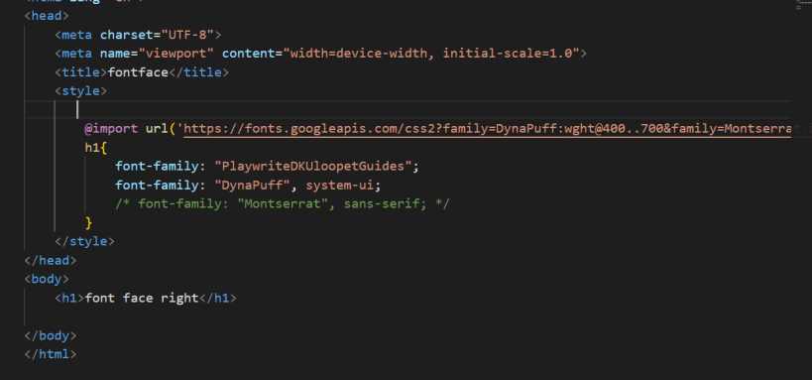
- Font Face

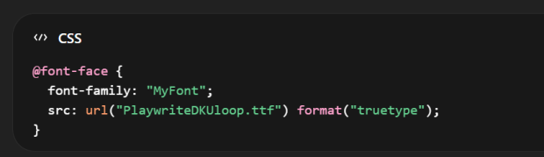

Google font se download kerneke bad apne project ke folder mein us font ko le aein.
Phircss ki style sheet mein sb se upper @fontface apply krein.
Font-family mein “font neme”
Srcmein do chezein .
- url Jahan ap ka font rakhahai.
- Formate =>format() browser ko batata haike font kis type ka hai

Units
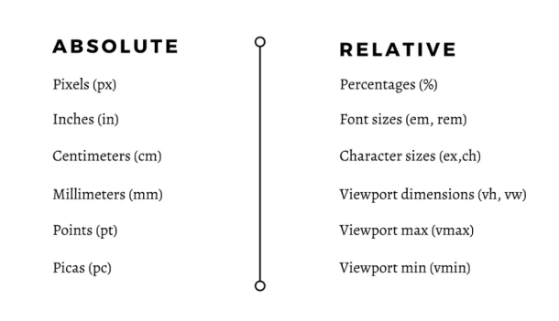

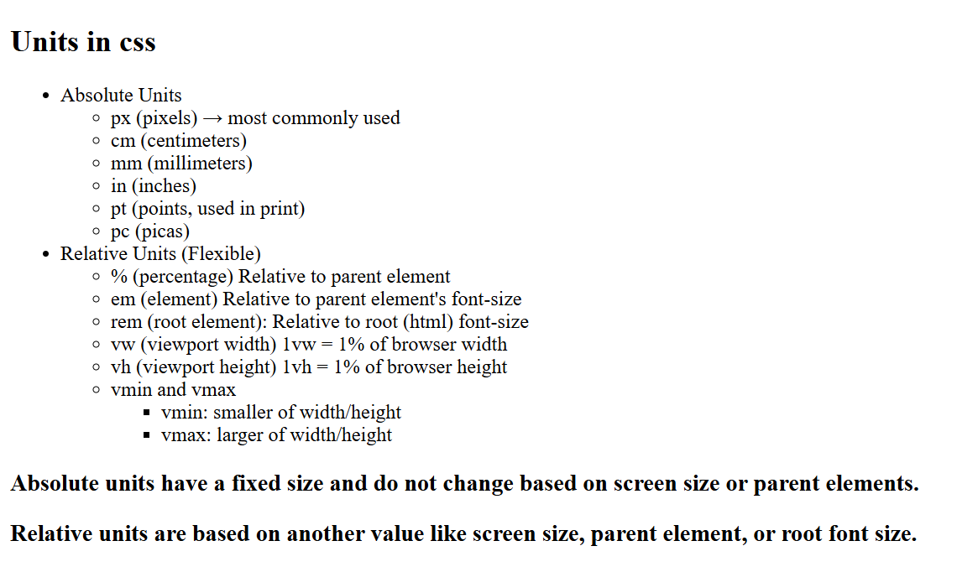

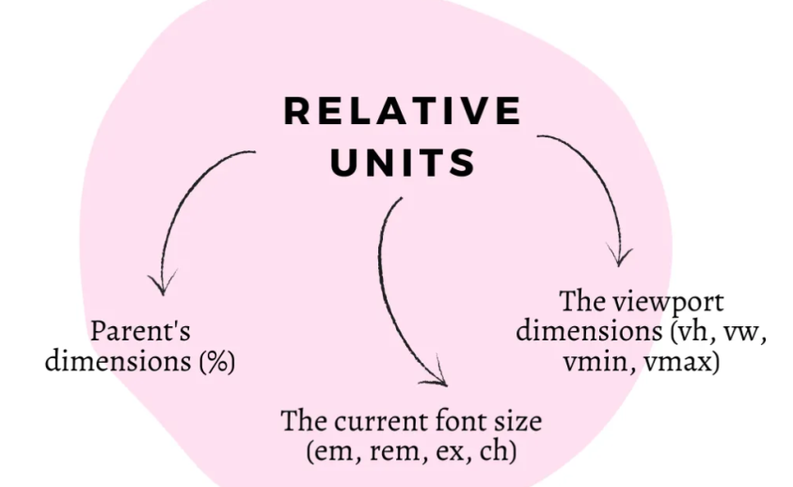

- Percent%
- %parentke relative hotahai
- Height % ka tricky behavior:
Agr parent ki height given na ho. To child ki height: 90%kaamnahikaregi
- Nested Percentage
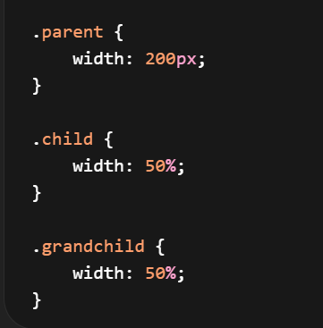
👉 Result:
- child = 100px
- grandchild = 50px
agr font-size apply kro to child parent ke according mange kregilknagr parent box ho ga to wo apne parent ke pass jayegi body. body ka default font-size nhihai is liye wo apne parent html se font size le ga.
Html ka default font size 16px
Aap technically 4.8px ya 6px banasakte ho, lekin browsers itnichoti font ko properly render nahikarte.
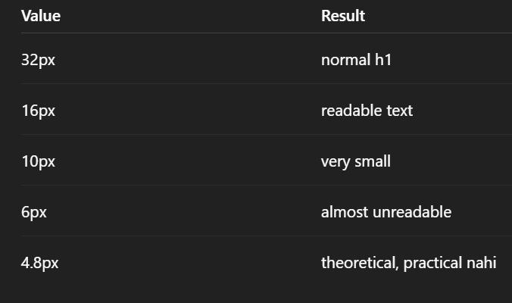
Heading
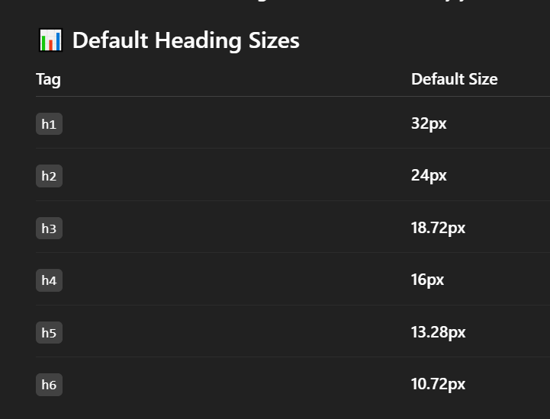

- EmEmek relative unit hai.
👉 Ye font-size ke basis par calculate hotihai

Super Important Twist
👉 Agar property font-size ho:
➡em = parent ka font-size
👉 Agar property padding/margin ho/height/width :
➡em = apne khud ke font-size😮
• Browser dekhtahai → is element ka font-size kyahai?
• Agar defined hai → wahi use karega
• Agar defined nahi → parent se lega
- Agar parent bhinahi → default (16px)

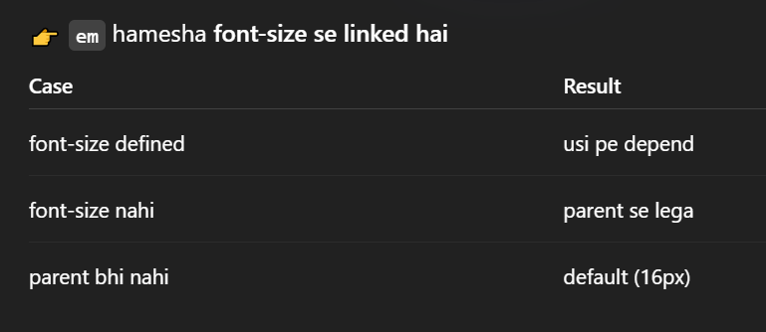

- Rem
Yeh ek CSS unit hai jo root element (<html>) ke font-sizeke base par kaamkartahai.
1rem = html (root) ka font-size
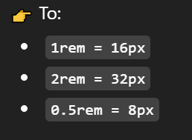
- Responsive design
- Agar tum root font-size change karo:
- Poora layout automatically scale ho jayega
- 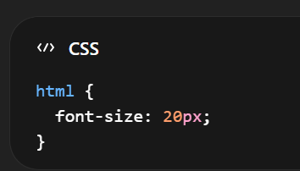
- Consistency
- Accessibility

- Pixcel
Pixcel screen ka sb se visible dot hotahai.
Px ka use kerke hum size exact kersktyhain
Pixcelfixed unit hai is se size change nhihota.
Pixcel fixed haiis liyembl screen per ap ka layout break ho sktahai is liye is ki jga %, em rem vhvw use kertyhain.
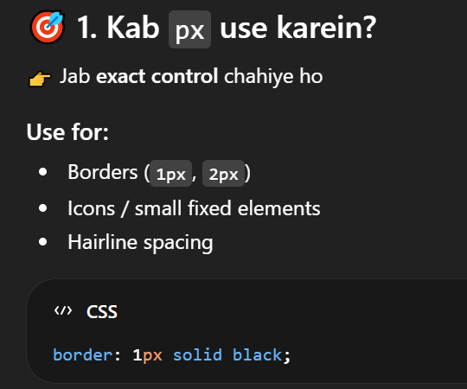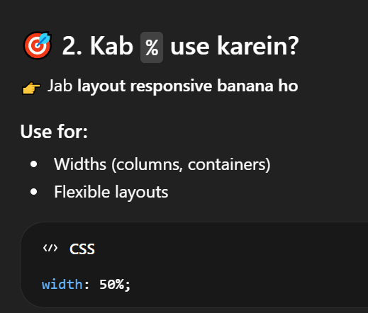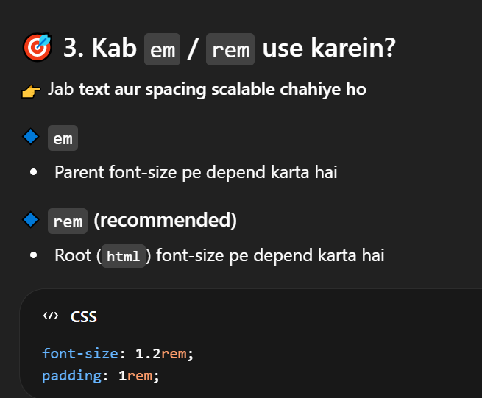

- Font size
font-size text ka size (bara yachhota) control kartahai.
Common units
- Pixcel
- Em
- Rem
- %
- Font-weight
Ye CSS property text ki boldness (motapan) control kartihai.
Normally keywords use kartehain:
Bold, bolder, normal, light, lighter
Ya numeric values use karsaktehain for more control:
100 to 900
400 => normal
600 => semi bold
700 =>bold

- Font style
font-style is used to make text normal, italic, or oblique.
Itelic “”
Normale “normale test”
Oblique “rarely used agritelic available na ho”

- Text transform
  - Uppercase (saara text CAPITAL letters mein)
  - Lowercase (saara text small letters mein)
  - Capitalize (har word ka pehla letter capital)
  - none (default (koi change nahi)
- text decoration => Short hand
text-decoration: underline dashed pink;
text-decoration: line-through dotted brown;
text-decoration: underline dashed red ;
  - none
  - underline (by default text keneeche line)
  - line-throught (cuts the text)
  - overline
- text-decoration-color
color change kern eke liye jo line text kesathatihai us ka
- text-decoration-line
  - none
  - underline (by default text keneeche line)
  - line-throught (cuts the text)
  - overline

- leading
Typography meinleading (ledd-ing) ka matlabhotahai:
👉do lines kedarmiyan vertical space (gap)
CSS meindirect “leading” property nahihoti,line-height
- Typography
Typography ka matlabhotahai text ko is tarah design karnakewohreadable, attractive aur effectivelage.
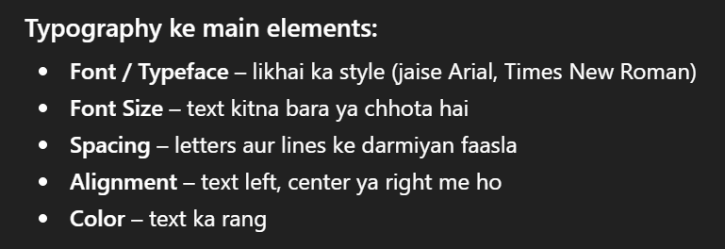
- Letter -spacing
Har letter (character)kedarmiyan space control kartahai
Positive, Negative value both
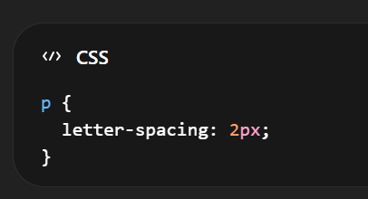
- Word-spacing
Value can be positive or negative
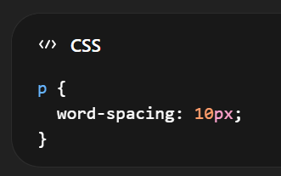
- Line height
Value positive

- Alignment
Image, text, box, element, ko sahi position mein set kerna (center right left bottom)
- Text-align
- Text ko position kernekeliye text-align ka use kertyhain
  - Center,
  - left,
  - right,
  - justify
- ye sirfinline content (text, inline elements) ko box keandar set kartahai
srf text move ho ga. box nhi
- text-alignblock-level parent element par lagtahai (like div, section, body)
- inline per kaamnhikertakunke in ki width utnihotihaijitni us ki width

- Vertical align
vertical-alignelements ko vertical direction (upar–neeche)mein align kartahai, lekinharjagahkaamnahikarta❗
top
bottom
middle
baseline
use
- Navbar icons
- List items (menu)
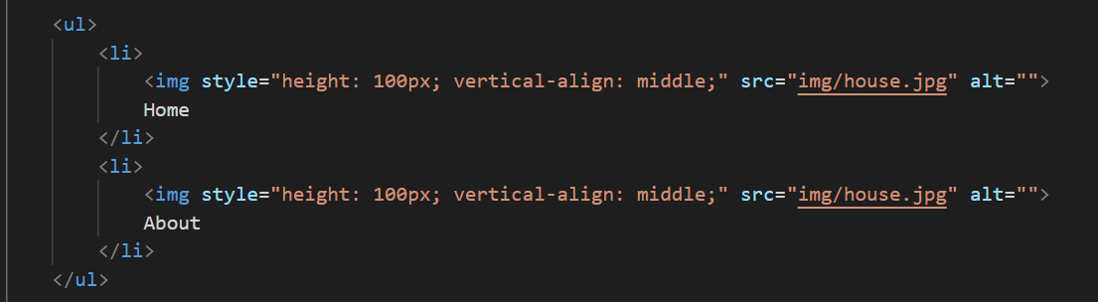
- Buttons kesath icons
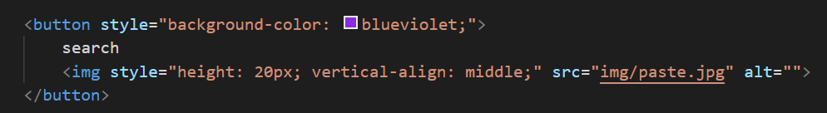
- Table cells (td, th)
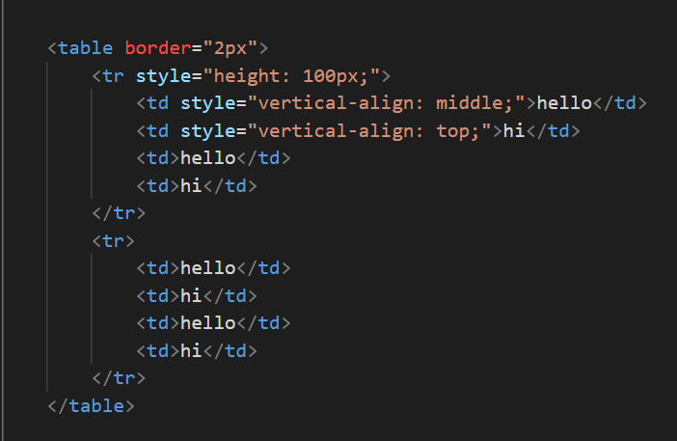
- Baseline kyahotihai?
Baseline wo imaginary line hotihaijis par text “baithta” hai

- 👉Div (block element) pe directly kaamnahikarta
- Aajkal developers kam use kartehainvertical-align
- ❌Kyun?
- Limited hai (sirf inline / table pe kaamkartahai)
- Text-indent

- Text shadow
Firstvaluesshows right or left +ve right and negative -ve
Second value iss for top and bottom +ve top and bottom -ve
Thirdvalueblur
- First letter-line
::first-letter aur ::first-line CSS ke pseudo-elements hotehain jo text ke specific parts ko style karnekekaamaatehain.
- Pseudo elements
Pseudo-elements CSS ke special keywords hotehain jo kisi element kespecific part ko style karnekeliye use hotehain — bina HTML change kiye.
Pseudo-elements inline style (style="") mein use nahihote:
- :first-letter,

::first-letter

Kisi element kesirfpehle letter ko style kartahai.
- color
- font-size
- font-weight
- font-family
- text-shadow
- background-color
- text-transform
- float
- margin
- padding
- border

- :first-line
::first-line
Kisi element ki pehli line ko style kartahai (screen size kehisaab se change ho saktihai)
- color
- font
- word-spacing
- background-color
- letter-spacing
- text-transform
- Ye kaamnhikerta
- margin
- padding
- border
- width / height
- Pseudo-classes aur pseudo-elements ka difference
Pseudo-class element ki state (condition) ko target kartihai.
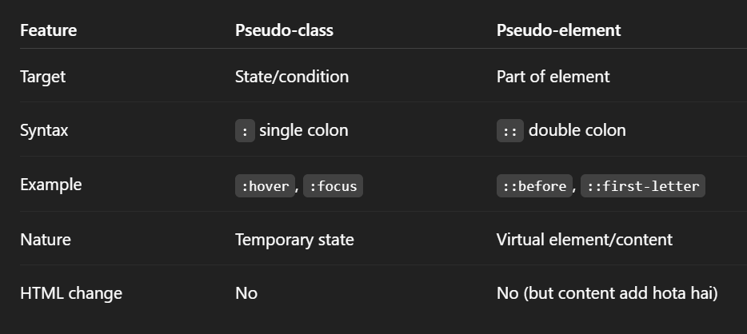
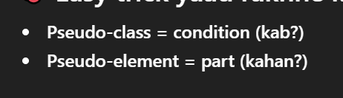

- Psecudo-classes
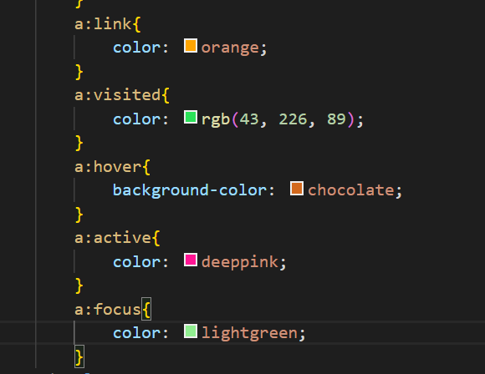

- Link
::link
- Unwanted / new
- Abhitk visit nhikiya
- Hover (MOST USED 🔥)
:hover
Jb user mouse link ke upper le aye to
- User interaction show kartahai
- UX improve kartahai (button feel aatahai)
Kahan use hotahai?
- Buttons
- Navigation menus
- Cards
- Images
- Links

- Focus Second most important
:focus

Kahan use hotahai?
- Input fields (forms)
- Login/signup pages
- Search bars

Jab user click karrahahotahai (mouse press)
Click feedback detahai
- Visited
Jab tum kisi link ko pehle open karchukehote ho, to woh “visited” ho jatahai.
• History based state
• Permanent change (jab tak history hai)
Use:
- Only links (a)
- Buttons click effect
- Mobile tap feedback
- Active
Jab tum kisi element ko abhi select/active karte ho
- Current active state
- Temporary (jab tak focus hai)
Use:
Inputs, buttons, links

CSS Box Concept
Box sizing
Box sizing CSS ka ek important concept hai jo decide kartahaikekisi element ka width aur height kaise calculate hogi.
- Cssmein her page ko browser ek box samjhtahai.
- Box ke parts: ise hi Box Modelkehtyhain
- Content
- Padding
- margin
- border
Jab tum kisi box (div) ko width dete ho, to us width keandarpadding aur border include hongeyanahi — yeh box-sizing decide kartahai.
Box-sizing ke 2 types
- Content box
- Border box

content Box(default)
Width/height sirf content ko apply hotihai. Padding aur border alag se add hotehain, jis se total size barhjatahai.Sirfandar ka data (content).
- Padding + border extra add hotayhain
- Problem:
Layout big ya uneven ho jatahai
Border Box (most used)

Width/height keandar content, padding aur border sab include hotehain, is liye total size change nahihota.
• Width keandar hi content + padding + border sab includehotahai
• Size fixed rehtahai

Min-Width Max-width
•min-width: Box ki minimum width set kartahai (issechhotanahihoga).
•max-width: Box ki maximum width set kartahai (issezyadabadanahihoga).

use kartehain?
- Responsive design mein help kartahai (screen chhotiyabadi ho to layout adjust ho).
- Text ko readable banatahai:
  - Bohatwide lines → read karnamushkil
  - Bohatnarrow lines → bhi read karnamushkil

Min-height Max-height
Border
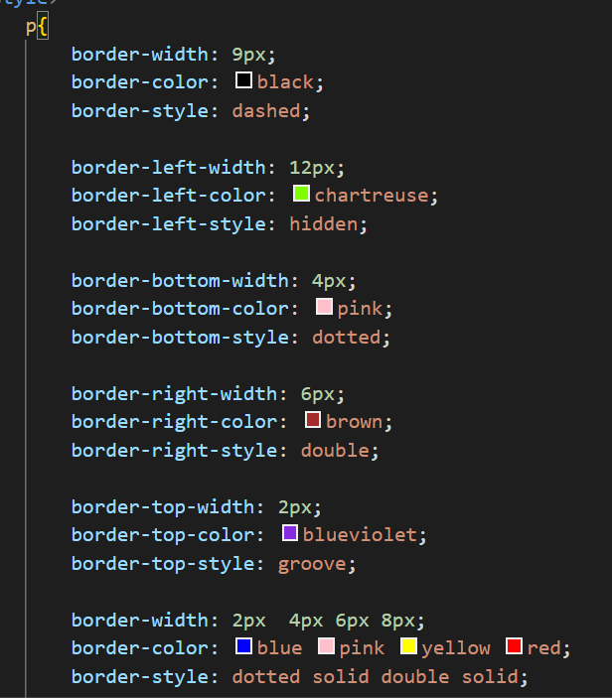
Radius
Border image
MarginPadding
margin % aur padding %width ke relative hotahai (height kenahi)
margin: 10px;
margin: 10px 20px 30px 40px;
margin: 2px 10px; top-bottom, left-right
margin : 0px auto; center from right left

padding:10px;
padding: 10px 20px 30px 40px;
padding: 2px 10px; top-bottom, left-right
overflow
Display
Is ka use block level elemnt ko inline banae aur inline ko block level banaekeliyejiyajat ahi
Display: inline
- Inline elements width/height ignore karte.
- top/bottom margin properly work nahikarta
- Width aur height content jitni space letahai.
- Use kabkarein?
  - Jab sirf text keandar small cheez ho
  - Example: <span>, <a>

Display: block

display: block
- Block full width letahai
- width/height kaamkartihai.

display: inline-block

inline-blockdono ka mix hai (best case)
- inline bhihotahai (side by side)
- width/height bhikaamkartihai.

Box shadow
https://getcssscan.com/css-box-shadow-examples
A shadow effect around an element’s border to make it look raised or floating.
box-shadow: x-offset y-offset blur spread color;
x-offset = if + then right if- then left
y-offset if + then bottom if – then left
spred of shadow
color
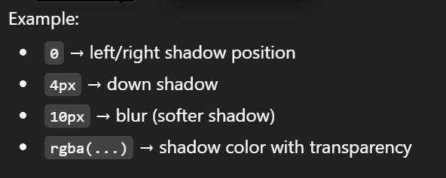
Image:
Background image
CSS me background-image tab use hotihai jab aapkisi element kepeeche (background me) image laganachahte ho — nake directly content ketaur par.
Background size:
Value:
- contain
- cover

Background cover
• Container poora fill kartahai
• Aspect ratio maintain
•Image crop ho saktihai
•Empty space nahihota

Background-contain
- Puri image visible hotihai
- Aspect ratio maintain
- Empty space aa saktahai
- Crop nahihoti
👉 Websites mein90% cases meincover use hotahai
👉contain mostly logos aur small elements keliyehotahai
Box ka koi hissakhalinahirehta — lekin image ka kuch part cut ho saktahai
Background repeat
Agar image chhotihai aur container badahai → browser us image ko repeat kartahai by default.
Is behaviour ko control kern ekeliye background-repeat use hotahai.
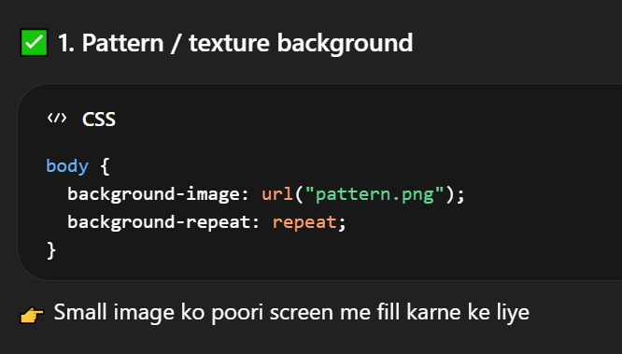
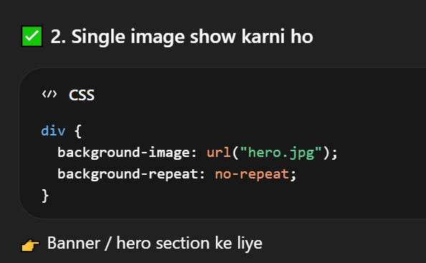
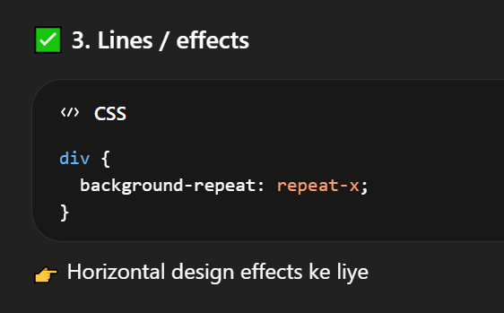
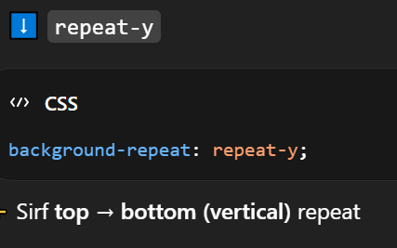

Background-position
Ye sirfimage kekaunse part ko dikhanahai wo control kartihai
- Top
- bottom
- center
- right
- left
Background-attachment
- Fixed scrollimage screen pe fixed rehtihai (parallax effect)
- Scroll(default)default (image scroll hotihai page kesath)
Background
background: colorimagerepeatposition / size;
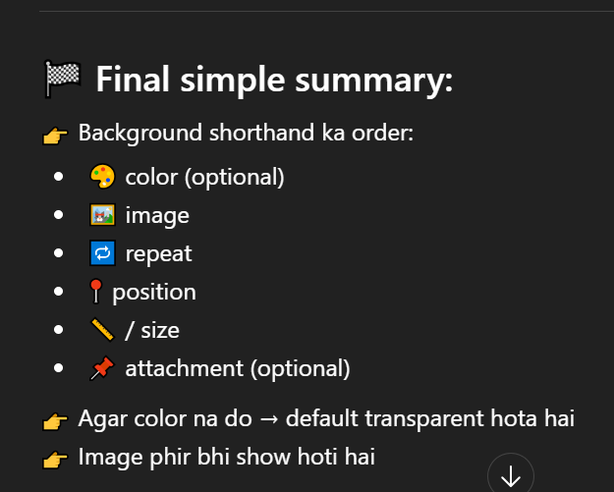
Gradient + image combine karna
- Matlabektransparent color sheet upar lag jatihai
- background: linear-gradient(rgba(0,0,0,0.6), rgba(0,0,0,0.6)),url("hero.jpg") center/cover no-repeat;
- Jo color tum dete ho (gradient me), wo image keupar overlay ki tarahaatahai
- Top layer:
Gradient (color overlay)
- Bottom layer:
Image

Gradient kyahotahai?
- Gradient ka matlabhotahai: “rangon ka smooth transition”
- Matlabek color se doosre color me gradually change hona

Multiple backgrounds

MUST ADD:
👉 “First image = top layer, last image = bottom layer”

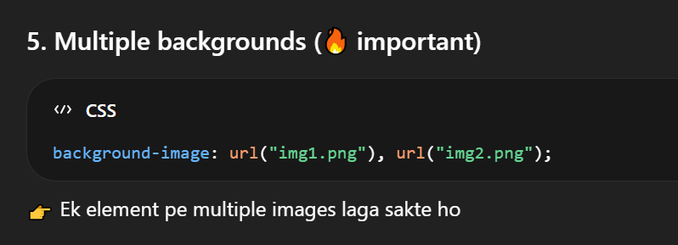
background-blend-mode
Image + color ko mix karnekeliye
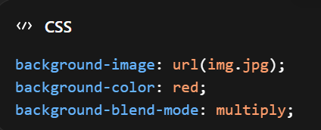

Use:
- dark overlay effect
- cinematic look
- image + color mix
- text readable bananekeliye
- hero section dark karnekeliye
backdrop filter
List
List style type

Unordered Lists (<ul>)
- disc sab se zyada use hotahai (default bullet ●)
- none jab custom design ya icons use karne ho
- circlekabhikabhi use hotahai (○)

🔹 Ordered Lists (<ol>)
- decimal sab se common (1, 2, 3)
- lower-alpha (a, b, c) — forms ya sub-points me
- lower-roman (i, ii, iii) — academic ya outlines me
list style image

list style position
list-style-position CSS property decide kartahaikelist marker (bullet ya number) text keandaraayeyabahar.
- Outside (default)
Bullet text kebaharhotahai
Bullet left side pe hotahai, text neatly align hotahai

Outside (most common)
- websites menus
- articles
- blogs

- Inside
Bullet text keandar aa jatahai
Agar line wrap ho, to text bullet keneeche shift ho jatahai

Inside
- cards
- boxes
- sidebars
- colored backgrounds wali lists

- ::marker (pseudo element)
Ye pseudo-element list ke bullet ya number ko stylekarnekeliyehotahai.
sirf color, font-size

- ::beforekyakartahai?
- ::after
Short hand
list-style: typepositionimage;

Table
- Border:
- Width for complete table
- Text decoration
- Text transform
- Letter spacing
- Padding
- Font size
- Background color
- Hover
- Extra styling in css
- Empty-cell
empty cells (jinmein koi content nahihota) ko show ya hide karna
- Hide
- Show
- Inherit inheritsirf value copy kartahai, koi naya behavior nahibanata
- Border-spacing
- CSS property use hotihaitable ke cells kedarmiyan gap (space) dene keliye.
- Har cell ke beech 10px ka gaphoga
- Agar tum border-collapse: collapse; use karte ho
👉 to border-spacingkaamnahikarega

- Border-collapse
border-collapse CSS property table keborders ko control kartihai — yanicells ke borders alag-alagrahengeya merge ho jayenge.
- Separate
- collapse
- table layout
- fixed
- fixe kesth word wrap use kersktyhain

Form
- input
- font-size
- font-family
- color
- background-color
- border “none”
- border radius
- box-shadow
- text-shadow
- padding margin
- cursor
- :hover
- :active
- :disabled (attribute)
:disabled (yanijb tag disable ho us time ye properties apply hon tb keliye)
- :focus “When click”
  - outline”none”
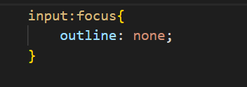

Important correction:

:active → sirfmouse press (click dabatewaqt 1 second)hotahai

:focus → jab input select ho jatahai aur cursor andar aa jatahai
- Input (Type: image)
  - Jab image ko button banana ho
  - Submit button ko image banana ho
  - Fancy button design chahiye ho (icon/photo button)
  - <input type="image" src="logo.jpg">
- Form layout (alignment)
- Labels different length ki hotihainisliye alignment bigarjatahai
- <div> use karna (each field new line)
- same width inputs
- right aligned labels (simple forms)
- spans for alignment help
Jab form complex ho (radio buttons, extra text etc.)

- Fieldset& legend
- form ko group kartahai (box banatahai)
- legend → group ka title hotahai

Css variables
- :root selector
    - Ye global scopehotahai
    - Yaniyahan define ki gayi variables poori website mein available hotihain
- Variable name (custom property)
  - Variable name mein do hyphens (--) zaroorihain,sirfek dash (-) nahi
  - Iskebaad tum apnimarzi ka meaningful name rakhte ho
- Value
Ye koi bhi valid CSS value ho saktihai:
    - Color
    - Px
    - Background color
    - Font etc
- Use karna (var() function)
h1 {
color: var(--primary-color);
}
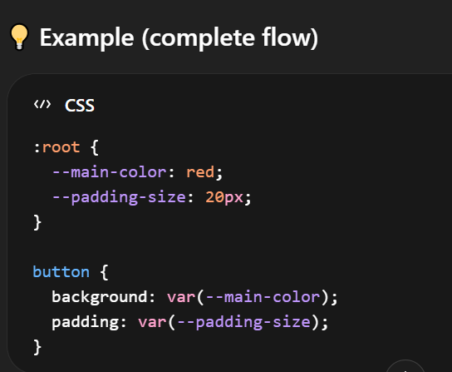

Position
Position decide kartahaike koi cheez screen par kahannazaraayegi.
- Normal
- Relative
- Absolute
- Fixed
- Float
- Normal (Static)
Normal default behavior. Yaniekke bad ek element.
- Relative
Element apni original jaga se move kertahai right, left, top, bottom lekinuskiasaljagahwahirehtihai.
- Phiraapuskotop, left, right, yabottom se move kardete ho.
- Lekinbaqi elements apnijagahnahibadalte.

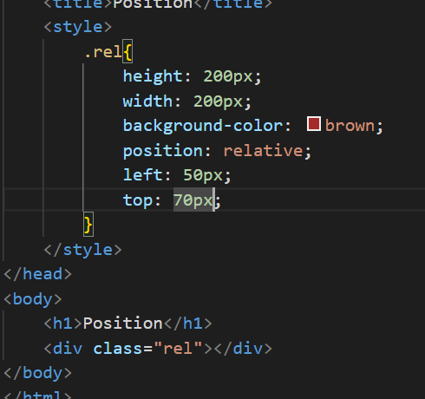
Use:
- Choti Adjustment keliye.
- Jab tum kisi child element ko absolutekarte ho
toh parent ko relative
- Buttons, icons, labels ko thoda adjust karnekeliye

- Absolute Position
- Tb use kertyhainjbkisi element ko complete control kerna ho.
- Aur us ko normal flow se hatadetahai.
- Wo apne parent kehisab se ( jis ki position relative ho ) us kehisab se adjust hotahai.
- Agr parent ki position relative na ho. To puri screen ( body ) kehisab se position letahai.
Use:
- Exact placement keliye. (Jaisekisi box ko top-right ya center meinrakhna)
- Overlapping elements (image ke upper text lijhna)
- Button ko image keupar show karna
- Popups / dropdowns
- Badges / iconsJaise notification bell par red dot
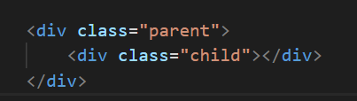
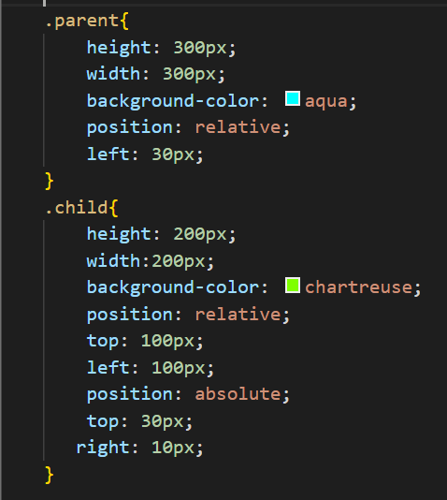

- Fixed
Element stick ho jata
User
- Navbar ko fixed kern eke liye jo scroll nhikerta
- Chat button
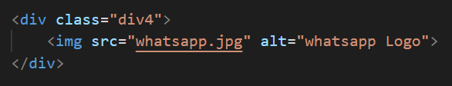

- Float (Reading Assignment)
kisi element ko left ya right side par le jana aur baqi content ko uske around flow karnedena.
ek element (image) ko left ya right side par push karna
• aur baqi text ko uske around flow karwana
- Element ko left ya right pushkartahai
- Images ke around text
- Baqi text / elements uskearound aa jatehain
- Element normal flow se thodabahar ho jatahai
- Layout bananekeliye (purani websites)
- Sidebar bananekeliye (old method)
- Boxes ko side by side lane keliye
- z-index
- Sochotumhare pass do box hain jo overlap ho rahehain.
- z-index decide kartahaikaunsa box upardikhega
- Agar positionnahidiya → z-index ignore ho jatahai

- 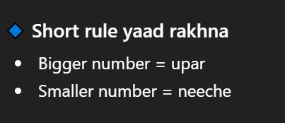

- -ve +vedono values de sktyhain.

- Jo zadavluegigiwahi di upper aye ga

uses
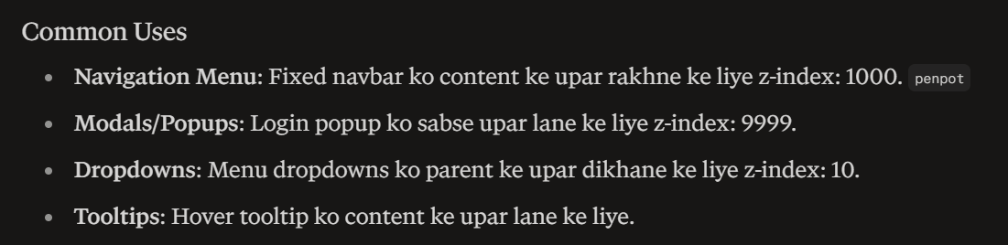

Flex Box
Flexboxek CSS layout model hai jo elements ko row ya column mein arrangekarnekeliye use hotahai — aur sabse important:
- Alignment and spacing automatically handle kertahai.
- Manually margins ya positioning se fight nahikarnapadta.
Kun use hotahai?
- Item ko center kern ekeliye.
- Equal spacing chahye ho.
- Dynamic content ho (size change hotarehtahai.
- Responsive layout banana ho.
- Old CSS (float , inline-block)

Kb use hotahai
- Navbar bananne
- Button ko align kerna
- Cards ko row mein arrange kerna
- Centering (perfect center)

Flex box kese use hotahai
Step 1 = parent ko flex banao
Step 2 = Direction control kro
Step 3 = Alignment samjhao
Step 4 = Space control kro

- Display
Flex
- Flex-direction
- Row (left to right) default mein
Main -axis horizontal hai.
- Justify-content => left to right
- Align-item => top to bottom
- Row-reverse (right to left)
- Column (top to bottom)
Main– axis verticle
- Justify-content => top to bottom
- Align-item=>right to left
- Column-reverse(bottom to top)
- Flex-wrap
- Wrap
- Nowrap(default)
- Wrap-reverse

- Justify-content
- Flex-start
- Flex-end
- Flex-center
- Space-between
- Space-around
- Space-evenly
- Align-item
align-itemscross axis pe kaamkartahai
Aur uskokaamkarnekeliyecontainer mein extra space honazaroorihai
- Strech
- Items ko automatically container ki full height (ya width) takphailadetahai
(lekinsirfcross axismein)
- align-items: stretchtabhikaamkartahai jab child ki width auto ho.
- Flex-start
- Flex-end
- Center
- baseline
- align-self
align-self Flexbox ka property hai jo single item ko controlkartahai — yanialign-items poori line pe apply hotahai, lekinalign-selfsirfek item pe.
- Ek specific flex item ko cross axis mein alignkartahai
- auto (default) Parent (align-items) ko follow kartahai
- Order
- Yeh flex items ki position change kartahai
- HTML change kiyebina items ka order change karsakte ho
- Sab items ka default order = 0hotahai
- Jiska order chhotahoga → wohpehleaayega
- Jiska order badahoga → wohbaadmeinaayega

- Gap
Margin ki jagah use hotahai
- align-content (multi-line keliye)
Sirf tab kaamkartahai jab flex-wrap: wrap ho
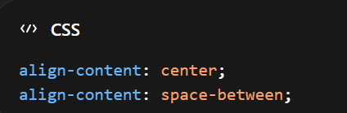

- flex
Yeh = flex-grow + flex-shrink + flex-basis
- flex-grow
flex-grow: 1;
Extra space ko fill kartahai
- flex-shrink
flex-shrink: 1;
Space kam ho to shrink hotahai
- flex-basis
flex-basis: 200px;
Initial size definekartahai
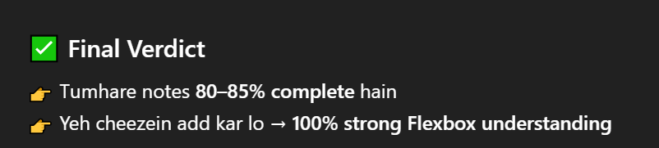
- margin: autotrick (pro level)

- Transform
transform element ko change kartahai:
move (translate) px mein
rotate degree mein
scal 1, 2, 3 + - both
skew degree mein
- Move (translate)
- Translate
transform: translate(100px);
- translatY
transform: translateY(200px);
- translateX
transform: translateX(200px);
- translateZ
perspective CSS me ek property hai jo batatihaike 3D elements ko viewer ki nazar se kitnidoori se dekhnahai, jisse depth aur distance ka effect createhotahai.
perspective nahi ho, to kuchkhasnahidikhega.
•translateZ(+) → object window se bahar aa rahahai
•translateZ(-) → object window keandar door ja rahahai
- Rotate
- Rotate()
transform: rotate(40deg);
- RotateX
transform: rotateX(60deg);
- RatateY
transform: rotateY(70deg);
- Rotate3d
transform: rotate3d(x, y, z, angle);
transform: rotate3d(6, 3, 1, 60deg);

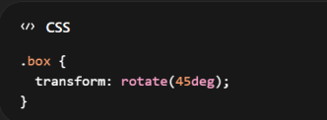
- Scale
scale()element ka size change karnekeliye use hotahai — yaniusay bara yachhotakartahai, bina actual width/height change kiye.
Px use nhihota
Positive value
- Scale(1) = normal
- scale(1+) = zoom in
- scale(0.x) = zoom out

- Scale()
transform: scale(2);
- scaleX() width stretch
transform: scaleX(3);

- scaleY()height stretch
transform: scaleY(2);

- scale3d()
transform: scale3d(1,2,2);
negative Vaue
- element flip ulta
transform: scale(-1);
transform: scaleY(-1);
transform: scaleX(-1);

- Skew
skew() ka use element ko tircha (slanted / tilted)karnekeliyehotahai — yani shape ko diagonally distort kartahai.
- transform: skew(30deg);
- transform: skewX(20deg);
- transform: skewY(20deg);
- transform: skewX(20deg) skewY(20deg);
- transform: skew(20deg, 30deg);

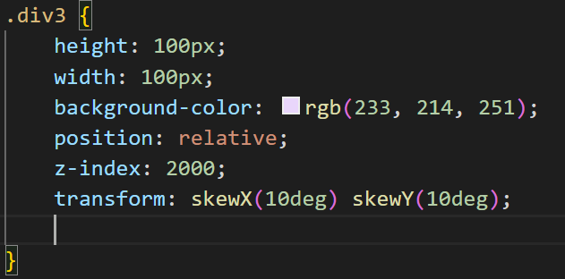

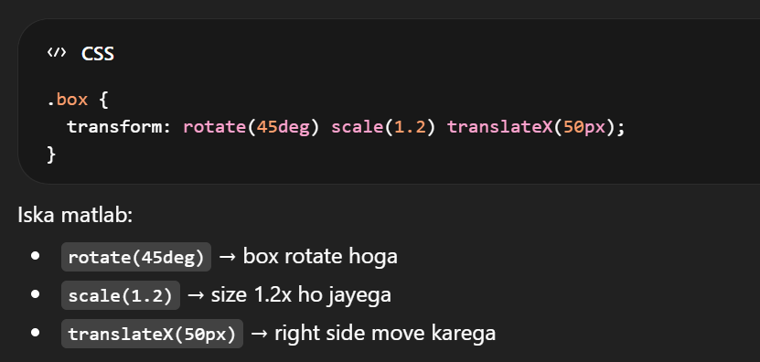

- Transition
- Jab kisi element ki property smoothly change hotihai, usay transition kehtehain.
- Transition sirf change ko animate kartahai
- kisibhi state change par applyhotihai.:hover, :focus, :active
- Transition change ko smooth banatihai

Syntax:
Transform / all time (s / milisecound ) timing function Delay

  - Property
transition-property:
•all → sab properties animate hongi
  - Duration
transition-duration: 0.5s;
•0.5s → animation 0.5 second chalegi
  - Time function
transition-timing-function: ease-in-out;
•ease → timing function (speed style)
- ease → smooth start & end
- linear → same speed
- ease-in → slow start
- ease-out → slow end
  - Delay
transition-delay: 0.2s;
•0.2s → 0.2 second baad animation start hogi

Uses:
- button hover → color slowly change
- box size smooth increase

short hand

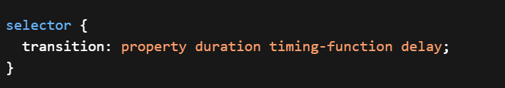

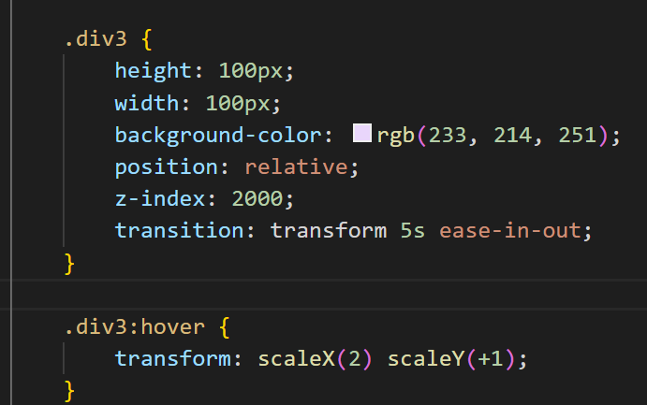

Animation
Animation aisi CSS technique hai jo automatically run hotihai, bina hover ya click ke.
Yeh full control detahai:
  - multiple steps
  - loop
  - delay
  - direction
  - repeat
@keyframes
Yeh animation ka “timeline” hotahai.
Jismein hum define kertyhain
- Animation start meinkesi ho.
- Dermiyanmeinkesi ho.
- Aur end meinkesi ho.
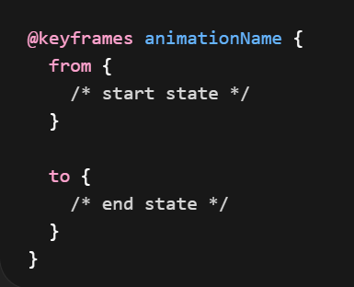

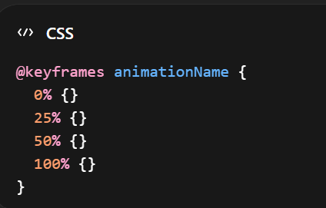

Step1: apply @keyfram
Step2: Apply Animation to Element

FULL CONTROL PROPERTIES
- animation-duration
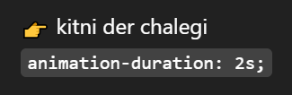
- animation-delay
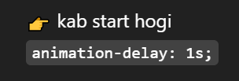
- animation-iteration-count
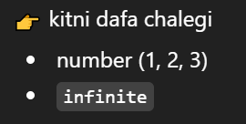
- animation-direction
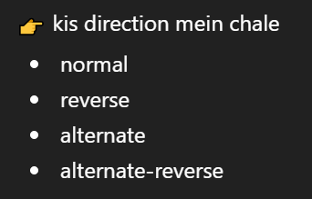
- animation-timing-function
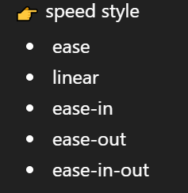
- animation-fill-mode
end kebaadkya ho
- none
  - forwards
  - backwards
  - both

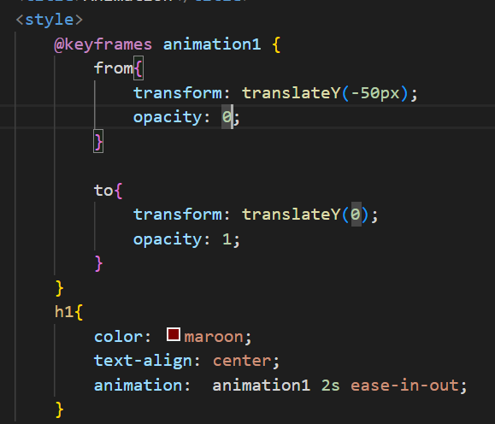
Text ka size bara ho ga y axis mein smoothly

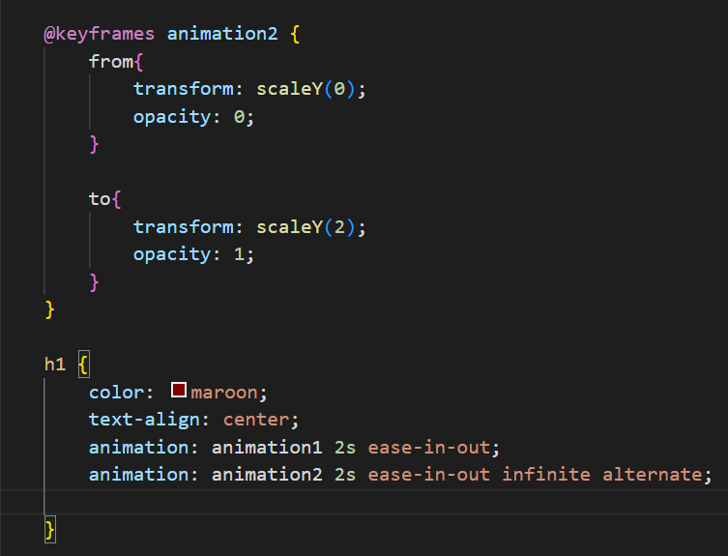
Color change

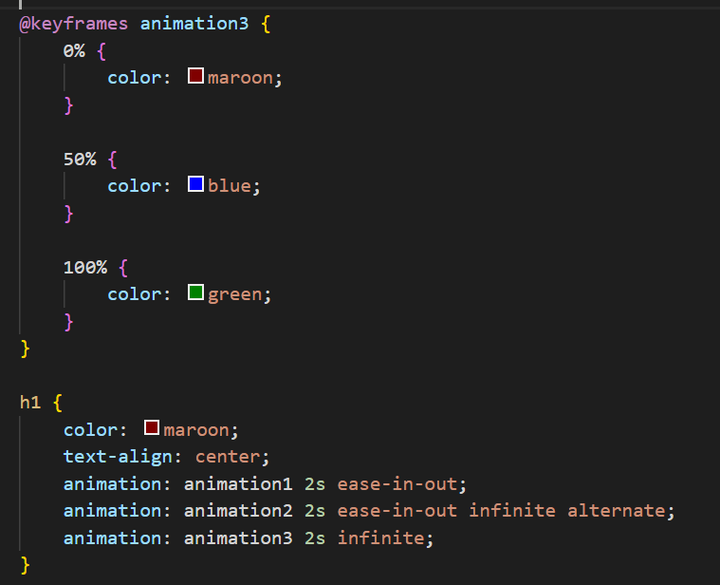

Zoom
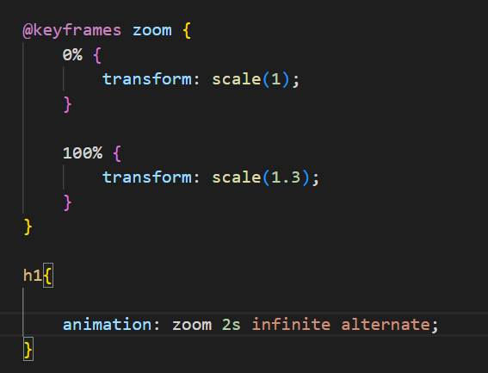

- Loop
Key word use
Infinite
- Alternate reverse
key word used
alternate
- Properties
- fade in
- slide
- bounce
- zoom
- color change
- glow
- rotate
- typing effect (advanced)

Media Query
Media queries CSS ka feature hai jo allow kartahaikeaap different screen sizes, devices ya conditions kehisaab se styling change karsaken.

Responsive ka maqsad:
- Better UX (User Experience)
- Har screen par readable content
- Buttons easily click ho saken
- Layout adjust ho jaye automatically

Kun use kertyhain?
User different screen keliyekertyhainjese

/* Extra small devices (phones, 600px and down) */
@media only screen and (max-width: 600px) {...}
/* Small devices (portrait tablets and large phones, 600px and up) */
@media only screen and (min-width: 600px) {...}
/* Medium devices (landscape tablets, 768px and up) */
@media only screen and (min-width: 768px) {...}
/* Large devices (laptops/desktops, 992px and up) */
@media only screen and (min-width: 992px) {...}
/* Extra large devices (large laptops and desktops, 1200px and up) */
@media only screen and (min-width: 1200px) {...}

Mobile parzoomkarnapadega
Layout toot jatahai
User experience kharabhotahai

Syntax
@media (max-width: 768px) {
body {
background-color: lightblue;
}
}

max-width ka matlab:
"is value se chhotiyabarabar screen"

min-width ka matlab:
👉"is value se badiyabarabar screen"

- @media → rule start kartahai
- (max-width: 768px) → jab screen 768px ya us se chhoti ho
- {} → andar styling apply hogi

- For Mobile
@media (max-width: 480px) { }

- Tablet keliye
@media (max-width: 768px) { }
- Desktop keliye
@media (min-width: 1024px) { }

Avoid:
- Fixed width avoid karo
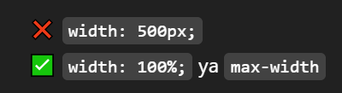

- Flexible Layout use karo
• Flexbox
• Grid

- Images responsive karo
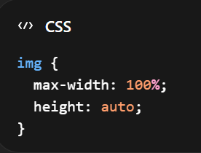

- Kin cheezon ko responsive kartehain?
- Layout
• Columns → mobile par single column
• Desktop par multi-column

- Typography
Font size adjust hotahai

- Navigation
• Desktop → navbar
• Mobile → hamburger menu

- Images & media
Resize hotihain

- Buttons
Mobile par bade aur clickable

Kaise implement kartehain?
- Width-based
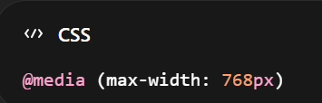
- Device orientation
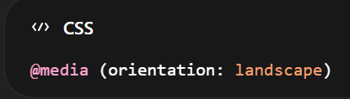
- Combination
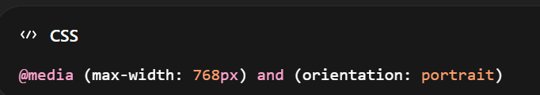

Navbar responsive
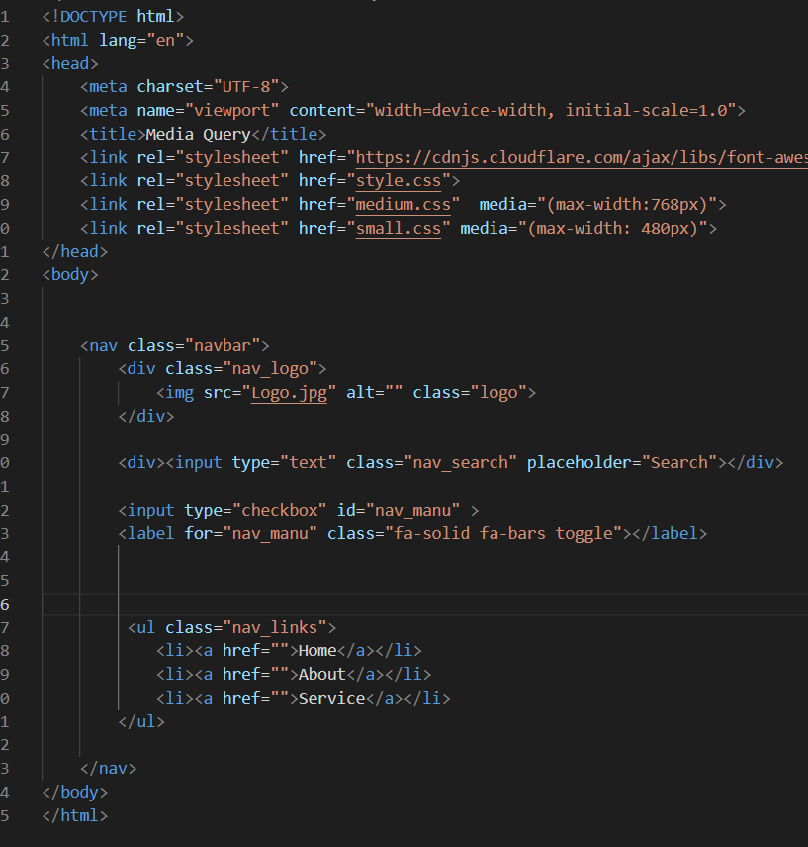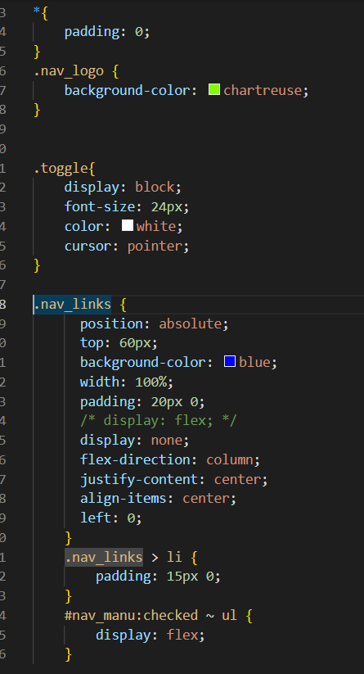

Grid
- CSS Grid eklayout systemhai.
- Ye 2D system (rows + columns) par kaamkartahai.
- Isme hum container define kartehain aur uskeandar items place kartehain
Grid kun Use hotahai
• complex layouts bananekeliye
• responsive design (mobile + desktop)
• elements ko perfectly align karnekeliye
Grid kese use kertyhain.
Step1# Container ko Grid banao
•display: grid
Step2# column define kerna
•grid-template-columns
Step3# Gap (spacing)
•gap
Step4# Row define kerna (optional)
•grid-template-rows
Step5# item control kerna
•justify-items
•align-items
Step6# Shortcut
•place-items
Important Concepts
- Grid Container
Parent element jismein grid hotahai.
- Grid Item
Jo elements container keandarhotehain
- Grid cell
Sab se chhota unit (1 row + 1 column ka box)
- Grid Lines
Invisible lines jo grid ko divide kartihain
Numbering hotihai (1, 2, 3...)
- Grid Track
2 lines kedarmiyan space (row ya column)
- Grid Area
Multiple cells ka group
Jab ek item multiple rows/columns cover kare.

Properties
Column And Rows
- Grid-template-column
Columns ko define kernekeliye
- Is mein hum px mein value de sktyhain.
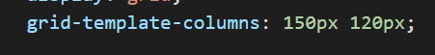
- Is meinauto ka use kersktyhain.
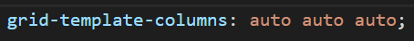
- Frequency define kerke de sktyhain
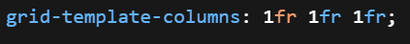

- Grid-templete-row
Row define kern eke liya
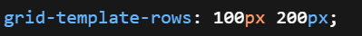

Item placement
- Grid-column
Apnimerzi se columns ko adjust kern eke liye use kertyhain.
Shortcut
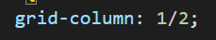
- Grid-column Start
- Grid-column-end
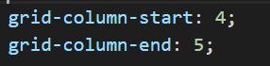

- Grid-row
Apnimerzike row define kern eke liye use hotihai.
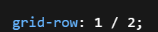

- Grid Areas
Her row me same number of columns hone chahiye.
- Gap

- gap
- Row gap
- Column gap
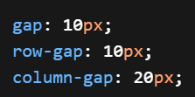
Alignment
- Justify-content
- Parent (grid container) par apply kertyhai.
- Pura grid move kartahai (horizontal).
- align content
Pura grid vertically move kartahai
Parent per lagatyhain.
- Justify item
- Items ko horizontal align kartahai (cell keandar)
- Lagaty parent per hi hain
- Har grid item apnebox (cell)keandarhotahai
Value
- start→ left align
- center→ center
- end→ right align
- stretch
- align item
Items ko vertical align kartahai (cell keandar)
- justify-self
- Single item ko horizontally align kartahai (cell keandar)
Child ko deinge
justify-self: start | center | end | stretch;
- align-self
Single item ko vertically align kartahai
Child ko dein ga
- Place content
- place-self
shortcut (align-self + justify-self)
- Place item
shorthand (align + justify items)

- fr unit
- fr ka matlabhotahai“fraction of available space”
- Ye unit CSS Grid me use hotahaitaake available space ko columns ya rows ke beech proportionally dividekiya ja sake.
- fr unit available space ko flexible way me divide kartahai instead of fixed pixels.
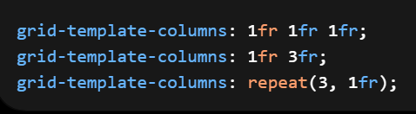
- Repeat() function
Same cheez bar barlikhne se behtarhai.
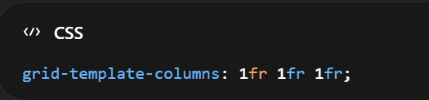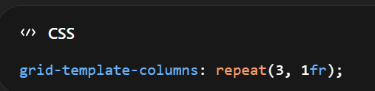
Mixed Pattern
Do column 1 frke Ur bkiremaing space 2fr
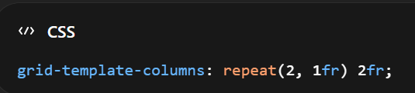
- fit-content()
content ke size kehisaab se column adjust kartahai
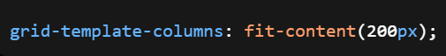
- auto-fill / auto-fit
responsive grids ke king concepts
- auto-fill = empty spaces leave kartahai

- auto-fit = space stretch kardetahai

MinMax
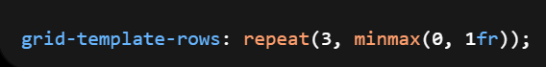
Row ki height 0 se start ho saktihai, aur maximum available space (1 fraction)tak grow karsaktihai.”

3 rows banao aur har row ko equal available space do, lekinwoh collapse na ho (minimum 0 height).

subgrid (advanced)

child grid parent ke grid ko inherit kartahai

Grid-template-areas:
layout kehisson ko naam detehain. (jaise header, sidebar, content, footer), phir un names ko grid mein arrange kartehain.

Bootstrap
Bootstrap ek popular front-end framework hai jo websites aur web apps bananekeliye use hotahai. Ye HTML, CSS aur JavaScript par based hai.

Frame-work
Framework ek structured platform hai jo:
- Pre-written code, tools aur rules provide kartahai.
- Developers ko applications efficiently develop karnemeinmadadkartahai.

Framework = ready-made setup
•Tumhe sab kuch khud se banane ki zaruratnahihoti
• Bas us setup ko use karkeapnicheezbanalete ho.

How to Add Bootstrap in your file

CDN (Recommended - Fast)

Download (Slow, Offline Works)

From Docs second option dowload

<link href="https://cdn.jsdelivr.net/npm/bootstrap@5.3.8/dist/css/bootstrap.min.css" rel="stylesheet" integrity="sha384-sRIl4kxILFvY47J16cr9ZwB07vP4J8+LH7qKQnuqkuIAvNWLzeN8tE5YBujZqJLB" crossorigin="anonymous">
<script src="https://cdn.jsdelivr.net/npm/bootstrap@5.3.8/dist/js/bootstrap.bundle.min.js" integrity="sha384-FKyoEForCGlyvwx9Hj09JcYn3nv7wiPVlz7YYwJrWVcXK/BmnVDxM+D2scQbITxI" crossorigin="anonymous"></script>

- Variable color
- Navbars in Bootstrap
- Cards carosole
- forms

Common Utility Classes

- Background color bg-primary, bg-Success, bg-danger

- Border radius rounded, rounded-end, rounded-circle

  - Bootstrap

  - Container&Container-fluid

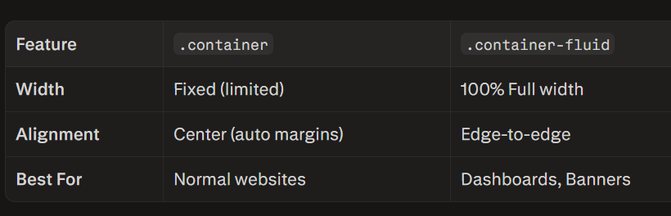
ye dono layout ki width control kartehain, lekin behave different kartehain.

Row & column (12-Column Grid)
Bootstrap 12 equal columns mein screen divide kartahai:

12 column = equal width
6+6 = 2equal parts
4+4+4+4 = 4 equal parts
3+9= sidebar + content

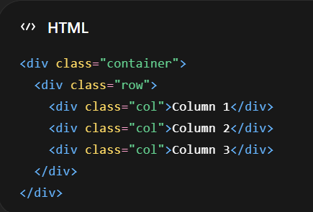

Break points (Responsive Magic!)
Breakpoints wo screen widths hainjahan par Bootstrap apni styling change kartahai.

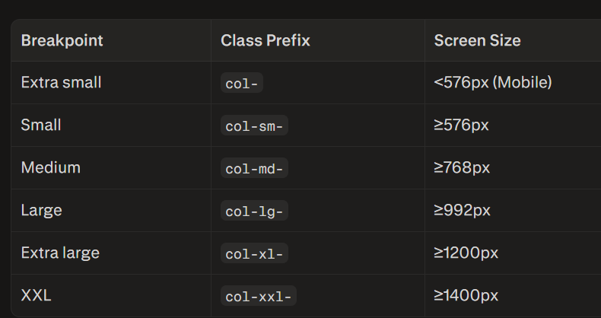

- Responsive Classes formate
[property]-[breakpoint]-[value]
Example - Mobile pe stacked, Tablet pe side-by-side:
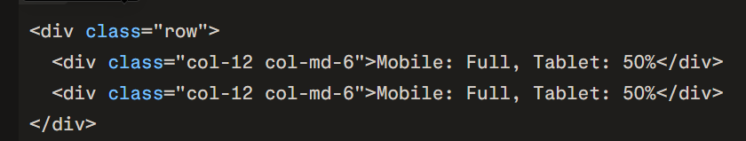

Pro tips which help in responsive design
  - Box-sizing
box-sizing: border-box;
  - Width
- Width 100% and
- max-width: 1200px;
desktop layout ko control kartahai side padding mobile/tablet pe content ko chipaknenahideta

  - Pixels ka usekam,krein relative units kazyada
- rem → fonts / spacing
- % → widths
- vw/vh → hero sections
- fr → grid
Always set root font size:
html {
font-size: 16px;
}
  - Flexbox aur Grid usekrein. (must)
flex-wrap: wrap; (must use )
  - Heights fixed mat karein
Avoid: height
Use: min-height: 500px;
  - Images ko responsive krein
max-width: 100%;
height: auto;
display: block; bonus
  - Media queries organized rakhein
max-width
Common breakpoints:
- 1200px
- 1024px
- 768px
- 480px
Har component keneecheuski media query likhein….
  - Debug trick
outline: 1pxsolidred; Kabhi kabhi koi element pura layout toddetahai ye kerne se asani se samjh aa jayega..

