Git Install Karne ka Step-by-Step Guide (Windows ke liye)
- Download Git:
- Open this link: (https://git-scm.com/install/windows)
- Wahan “Git for Windows (x64 Setup)” pe click karein.
- Install Git:
- Download hone ke baad, setup file ko open karein.
- Screen ke instructions follow karty huwe install karein.
- Mostly default settings theek hoti hain.
- Check Installation:
- CMD (Command Prompt) ya Terminal open karein.
- Type karein: git
- Agar Git install ho gaya hai, to aapko Git commands ka list dikh jaayega.
- Extra Help (Optional):
- YouTube tutorial: https://youtu.be/TT8ktVp5j-k?si=6mmSqD-MYVlwgaTh
Tip: Install karte waqt “PATH” option ko default rehne do, nahi to command prompt Git ko recognize nahi karega.

Github Install
- Download Github: Open this link: https://github.com

- Github
GitHub is an online web-based platform where people can store, manage, and collaborate on code.
It is based on Git, which is a system that tracks and records every change in the code.

Repository (repo) | Repository ek folder/project hota hai jahan code aur uski history store hoti hai.
Commit | Commit code mein kiye gaye changes ko save karne ka record hota hai.
Push / Pull | Push ka matlab hai local computer se code ko GitHub par upload karna.  Pull ka matlab hai GitHub se latest code ko apne computer par download/update karna

- Git:
Git is a Version Control System (VCS).
VCS: Git aapke files aur code mein hone wale changes ko track karta hai, taake aap previous versions dekh saken ya zarurat par wapas ja saken.
Track: Track ka matlab hai kisi cheez ko follow ya monitor karna.

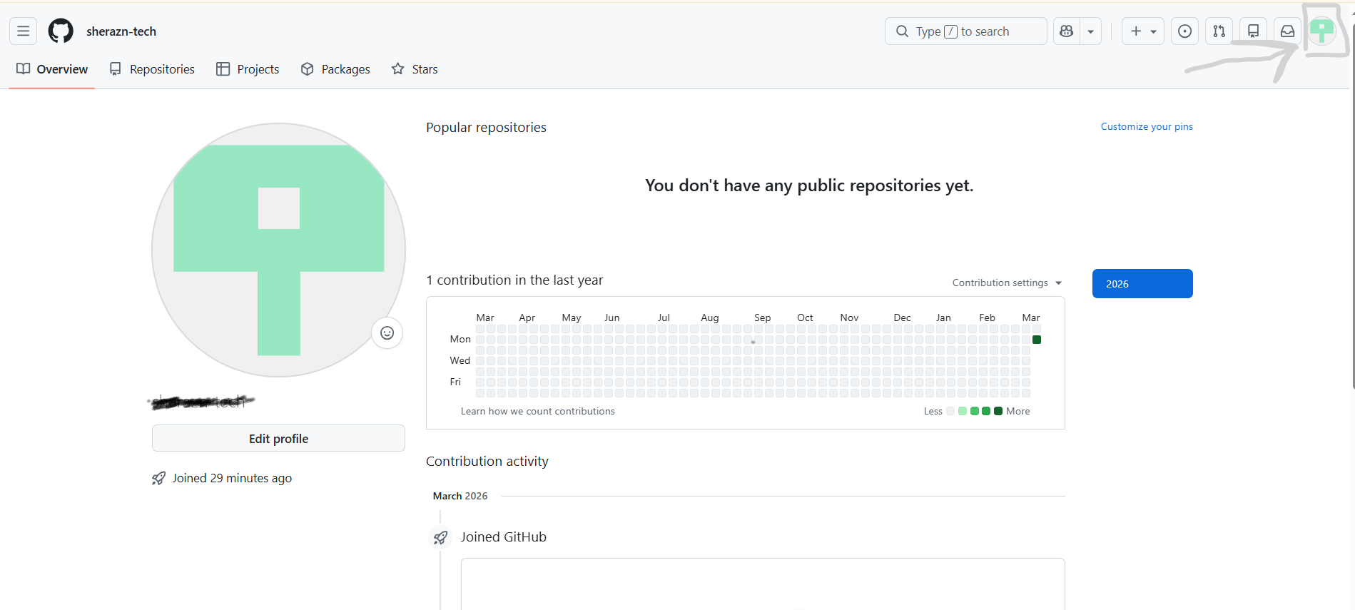
Click on repositories
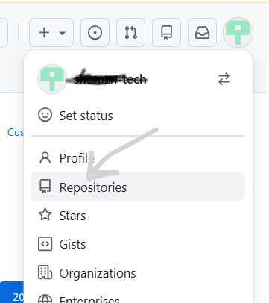

Click new
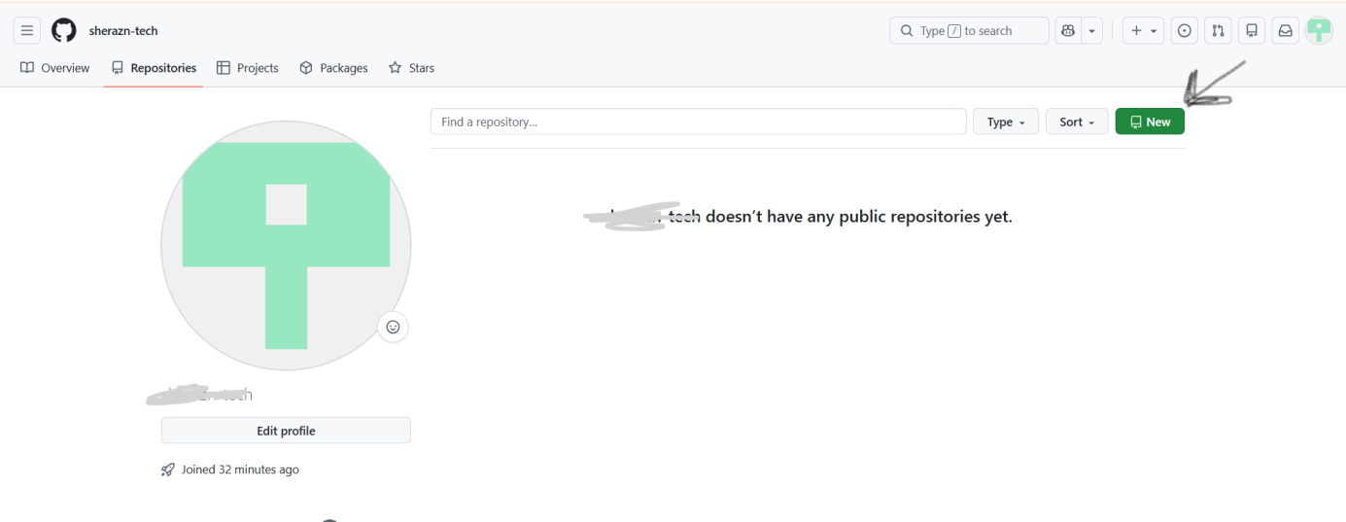
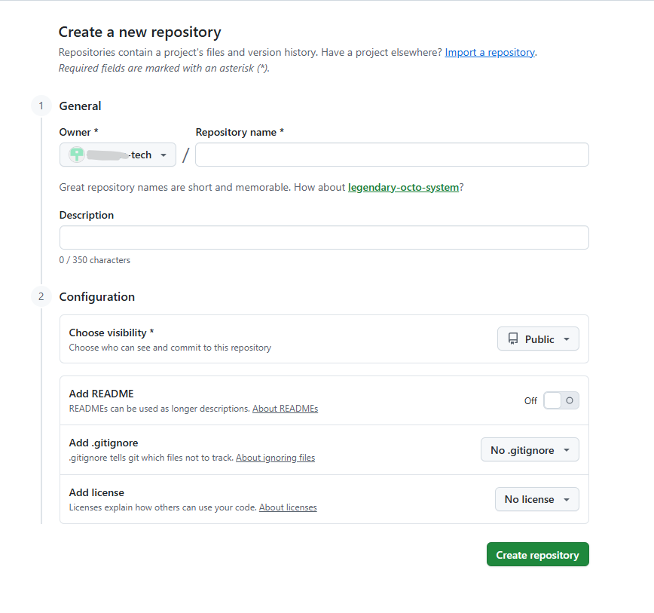
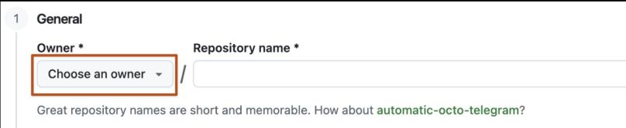

- Owner jis ka account hai
…..Matlab repo iss account ke andar banegi.
- Repository Name
Yahan project ka naam likhte hain.
GitHub repos ka standard style lowercase hota hai.
- Description
Yahan project ka short description likhte hain.
- Configuration Section
- Public
- Private
- Add README
Agar ON karte ho to GitHub ek README.md file bana deta hai.
- Add.gitignore
Ye file un files ko ignore karti hai jo GitHub par push nahi karni.
tells Git which files/folders not to track or push. For example, temporary files, passwords, or notes.txt.
notes.txt → push nahi hogi
- Add License
Log aapka code use kar sakte hain ya nahi. 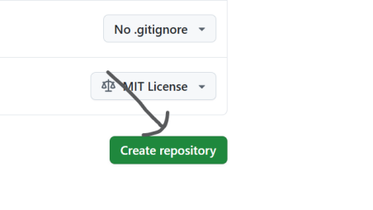

Commands To Push Code To Github For The First Time
- Step 1 — Folder open you foder in VS
Open terminal ya Gitbash
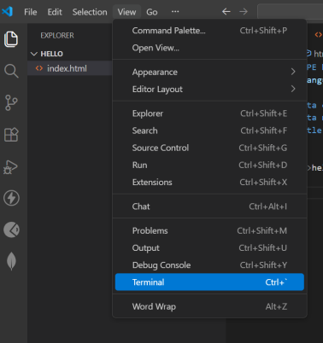
Ctrl+j
- Step 2 — Git initialize
git init
Ye folder ko git repository bana deta hai.
- Step 3 — Files add karo
git add .
. ka matlab saari files add karo.
- Sets your Git username globally on your computer
git config --global user.email "yourEmail"
- Sets your Git email globally on your computer
git config --global user.email "yourEmail"
- Step 4 — Commit karo
git commit -m "your commit”
- Step 6 — Branch set karo
git branch -M main
- Step 5 — GitHub repo connect karo
GitHub repo banane ke baad ye command use hoti hai:
git remote add origin “path”
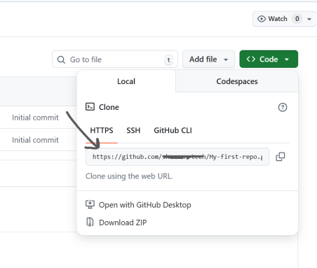
- Step 7 — Push code to GitHub

