Technical Evidence & Working Solution
Multimodal Clinical Decision Support for Pulmonary Pathology — SIC AI Track
Current submission: 28 October 2026. All primary results below belong to 0.2.0-team29-47e281fc. This replaces the previous technical evidence document's current-model narrative; historical v1 records remain separately available. Source: SIC handbook, page 17, “The complete submission package”.

1. System, Data Assets and Reproduction
Property | Current value
Model bundle | artifacts/team_bundle/manifest.json
Classifier | ResNet50 + DenseNet121 image ensemble, TF-IDF Logistic Regression
Fusion | 70% image ensemble + 30% text
Decision threshold | 0.49; selected by validation balanced accuracy
Evaluation unit | Study mean across available views; UI input is one image
Default report | Rule-based evidence summary; clinician verification required
Source modules | team_classification.py, team_features.py, team_inference.py

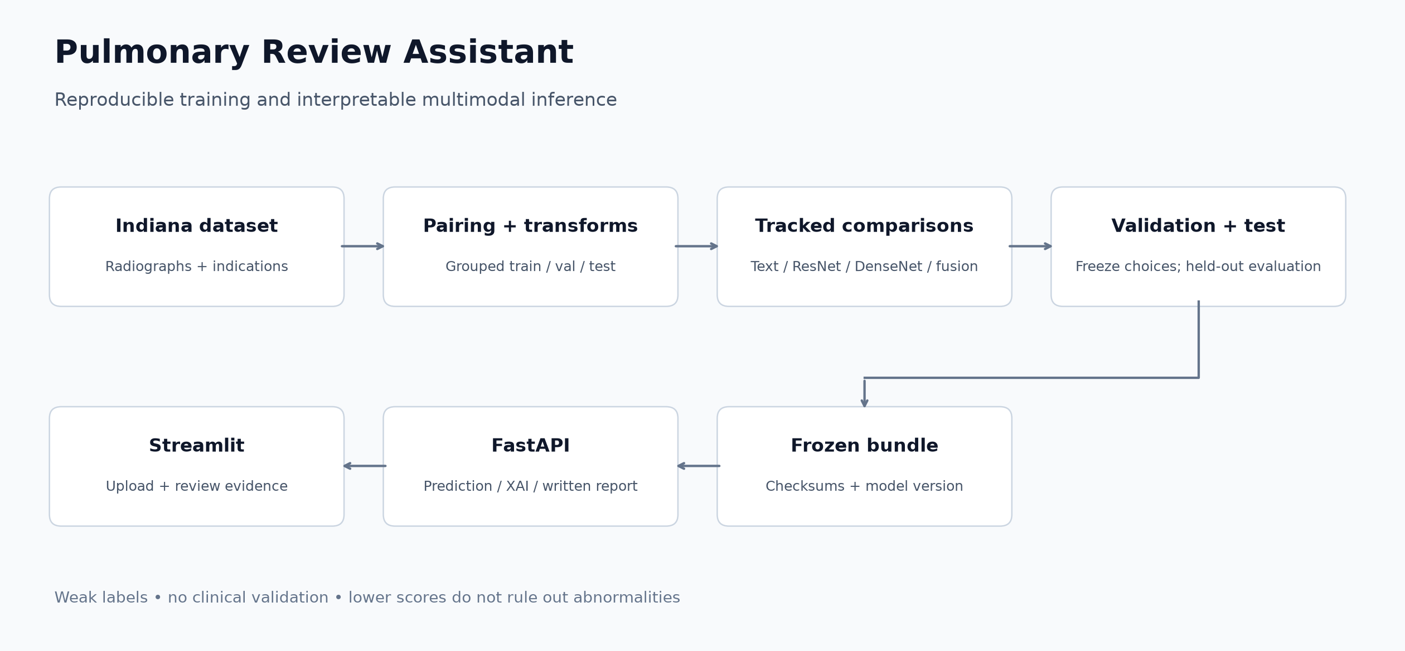
Current training and serving architecture
The Indiana University collection is distributed through NLM Open-i; this project uses the raddar/chest-xrays-indiana-university Kaggle mirror. The local source has 3,851 reports and 7,466 image records. The selected cohort requires a frontal view, retains at most one frontal and one lateral image and excludes uncertain and poor-quality cases. It contains 2,371 studies and 4,543 image rows.
Split | Studies | Image rows
Train | 1,660 | 3,179
Validation | 355 | 683
Held-out test | 356 | 681

Field | Definition / permitted use
uid | Report/study identifier; not a verified patient identifier
filename / projection | Image pairing and frontal/lateral view metadata
indication | Pre-examination clinical context; classifier input
comparison | Prior-study context; optional classifier input
findings / impression | Current interpretation; excluded from classifier predictors
Problems / MeSH | Structured weak-label sources; never classifier features
target | Normal=0, Abnormal=1; uncertain cases excluded

Normal requires the exclusive Normal problem tag with no core abnormal tag. Abnormal uses ten core groups, including cardiomegaly and fractures as well as pulmonary findings. Contradictory cases are uncertain. A strict labeling rule moves 57 chronic-only cases with a first-sentence “no acute” impression to uncertain. That impression is used for cohort labeling, not as a predictor. The target is a broad weak thoracic proxy, not an adjudicated pathology diagnosis.
Both views of a UID stay together. The selected cohort's SHA-256 audit found no exact duplicated image rows and required no split reassignment. Near duplicates and true patient independence are not established. Shared preprocessing uses grayscale, aspect-preserving Lanczos padding to 384 × 384, RGB conversion and ImageNet normalization. Data dictionary and both experiment profiles are in docs/data_assets.md; source hashes are in the cohort manifest.

2. Experiment Tracking & Tuning
Training component | Recorded configuration
Image training | 3 head + up to 15 fine-tuning epochs; batch size 8
Optimization | AdamW; ReduceLROnPlateau; class-weighted cross-entropy
Early stopping | Patience 2 on validation loss; frozen BatchNorm statistics
Retained checkpoints | ResNet50 epoch 7; DenseNet121 epoch 10
Completed image epochs | ResNet50 10; DenseNet121 12
Text search | 6 C values × 2 class-weight settings = 12 validation comparisons
Fusion search | 21 image weights; validation ROC-AUC objective
Threshold search | Validation balanced accuracy; test not used for selection
Tracking | Separate artifacts/team_classification/mlflow.db

TF-IDF word/character vocabularies and metadata scaling are fitted on training data only. Indication/comparison are cleaned and label terms masked. Final selection is frozen in selection.json before the test evaluation lock is written. Image training and final evaluations are tracked with manifests, hashes, metrics and plots. The test results were not used to select the deployed weight or cutoff.
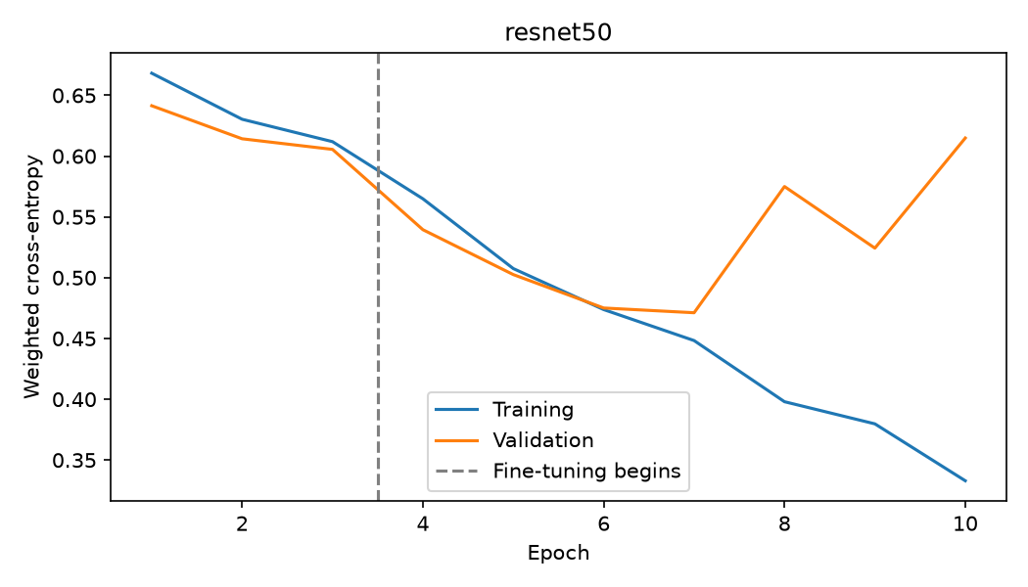
ResNet50 training and validation loss
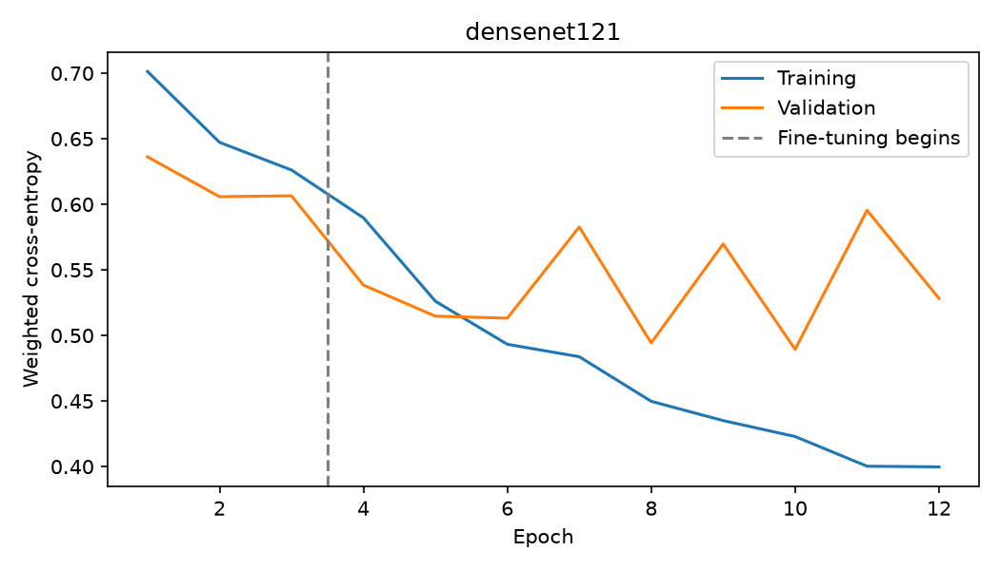
DenseNet121 training and validation loss
The GTX 1660 SUPER run uses AMP with a tested legacy-cuDNN benchmark configuration. Deterministic cuDNN FP16 returned NaNs; invalid forward passes were recomputed in FP32. Backend correction and a disk-exhaustion interruption required checkpoint restarts and optimizer reinitialization. Interrupted MLflow runs retain their failure/cancellation statuses. Seeds are recorded, but bitwise reproducibility is not promised with benchmark-selected GPU algorithms. This is a local reproduction of the team's approach, not their unavailable classification weights.
Historical v1 Optuna tuning completed 20 trials and is retained as development evidence. It belongs to a different cohort/text pipeline and is not claimed as new tuning for this model. Its linear/tree/CNN comparisons remain historical.

MLflow experiment tracking and Optuna optimization history
The current database contains 10 runs in team29-classification-reproduction: 7 FINISHED, 2 KILLED and 1 FAILED. Five finished runs log frozen test evaluations; the other two finished runs are CNN training. Interrupted attempts remain visible rather than being discarded. MLflow records parameters, epoch training/validation losses, final test metrics, selection manifests, checkpoint hashes and saved plots. Training runs record the seed and source digest; final evaluation runs link the cohort/selection manifests.
Model family / representative | MLflow run prefix | Test accuracy | Test F1 | Test ROC-AUC
Text-only | e23dfcb3 | 66.29% | 0.5652 | 0.7203
ResNet50 | 1c3b1b62 | 82.30% | 0.7961 | 0.8784
Multimodal Fusion | 92fa3596 | 82.87% | 0.7918 | 0.8816

These metrics are read directly from the three frozen-evaluation MLflow runs, covering text-only, image-only and multimodal families on the same 356 test studies. Full run IDs, statuses, parameters and metrics are in reports/evidence/team29/mlflow_tracking_snapshot.json.
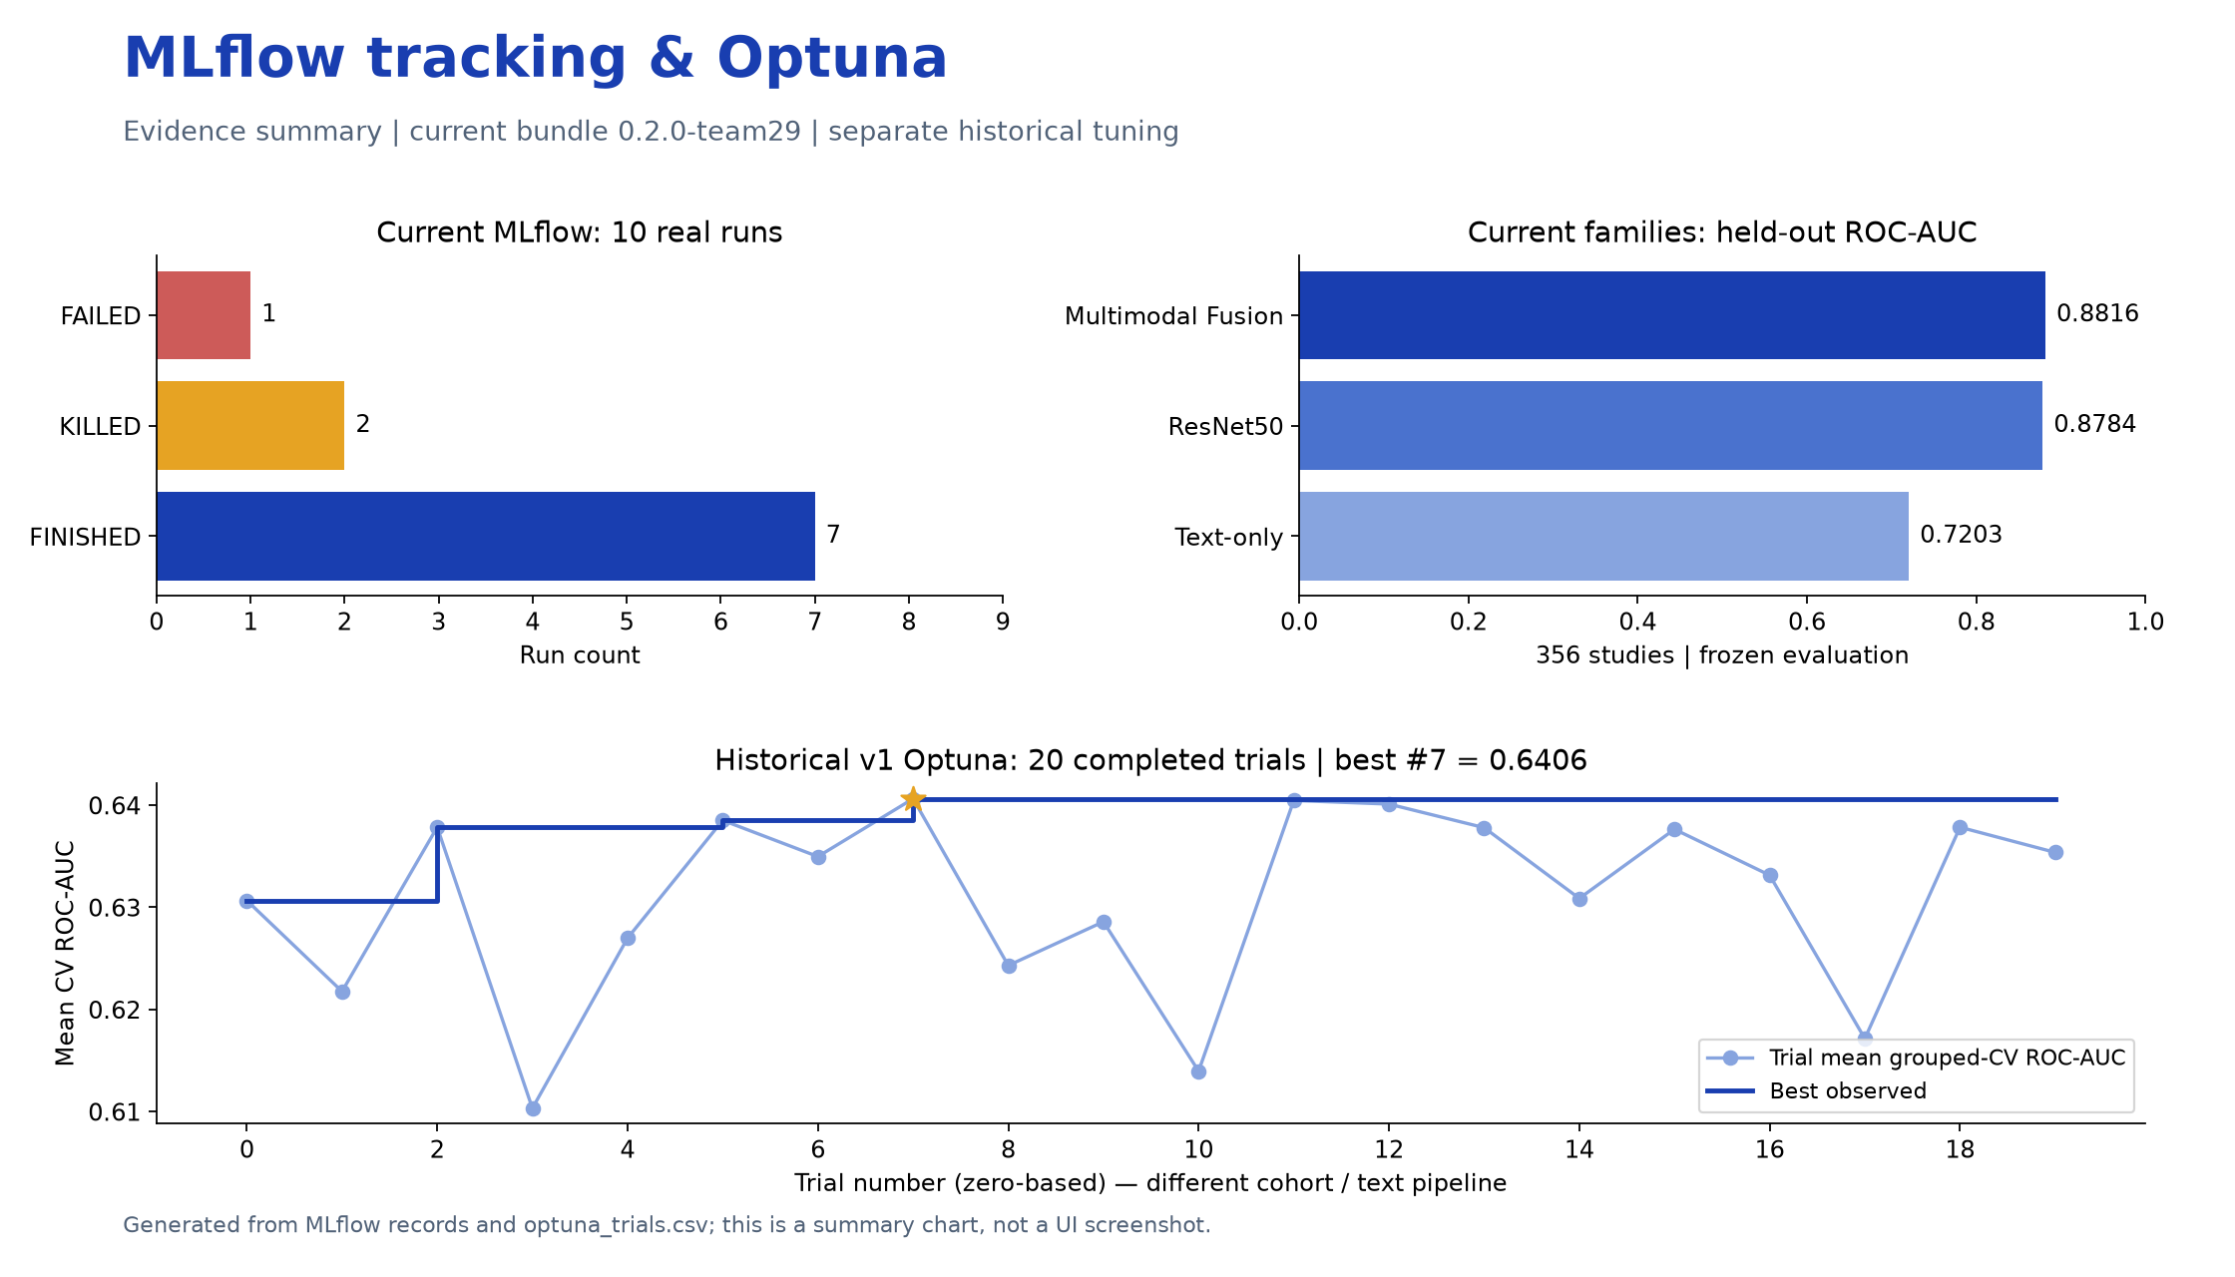
MLflow and Optuna evidence summary — generated from saved records, not a dashboard screenshot
Current validation search. The text model compares 12 settings (six C values, two class-weight settings). Its selected C is 0.3, class weighting is None, solver is liblinear, and validation ROC-AUC is 0.6726. Fusion compares 21 image weights using validation ROC-AUC and selects 70% image / 30% text. Balanced-accuracy threshold selection on validation gives 0.49 for fusion. CNN early stopping uses patience 2; retained checkpoints are ResNet50 epoch 7 and DenseNet121 epoch 10. This current search is not an Optuna study.
Historical Optuna study — separate cohort and feature pipeline. tracking_snapshot.json records 37 historical MLflow runs. optuna_trials.csv records 20 completed trials, numbered 0–19, using seeded TPE to maximize mean grouped training-fold ROC-AUC. TF-IDF is refitted within each fold. Search bounds are C in [0.001, 100] (log scale) and max_features in {500, 1000, 2000}. The best trial is 7, with mean CV ROC-AUC 0.6406, C = 0.9163741809 and max_features = 1000. The classifier uses balanced class weights. These are historical development results, not the deployed text model's settings or new test-set tuning.
Historical trial (zero-based) | Trial mean CV ROC-AUC | Best observed through this trial
0 | 0.6307 | 0.6307
4 | 0.6270 | 0.6378
9 | 0.6286 | 0.6406
19 | 0.6354 | 0.6406

The chart includes every trial and its cumulative best; the full CSV preserves parameters, states, timestamps and duration. Current threshold and fusion choices were frozen on validation before final test evaluation. No test metric is used as a tuning objective.
Inspect the local MLflow dashboard. Run from the project root:
.\.venv\Scripts\python.exe -m mlflow ui --backend-store-uri sqlite:///artifacts/team_classification/mlflow.db --host 127.0.0.1 --port 5000
Open http://127.0.0.1:5000 and select team29-classification-reproduction. Compare the five *-frozen-evaluation runs using test_accuracy, test_f1 and test_roc_auc; inspect CNN runs for loss histories. The historical database can be viewed separately with --backend-store-uri sqlite:///artifacts/mlflow.db on port 5001. Databases/artifact directories are excluded from Git; restore the separate tracking archive before opening the current dashboard on a fresh checkout. The summary chart remains viewable without either database.

3. Held-out Model Comparisons
All rows below use the same current test cohort, 356 studies / 681 source images. Accuracy and F1 use each model's own validation-selected threshold. F1 is for the Abnormal weak-label class.
Model | Accuracy | F1 | ROC-AUC | Threshold
Text-only — Logistic Regression | 66.29% | 0.5652 | 0.7203 | 0.49
ResNet50 | 82.30% | 0.7961 | 0.8784 | 0.44
DenseNet121 | 79.21% | 0.7658 | 0.8644 | 0.46
Image ensemble | 81.74% | 0.7855 | 0.8757 | 0.48
Multimodal Fusion | 82.87% | 0.7918 | 0.8816 | 0.49

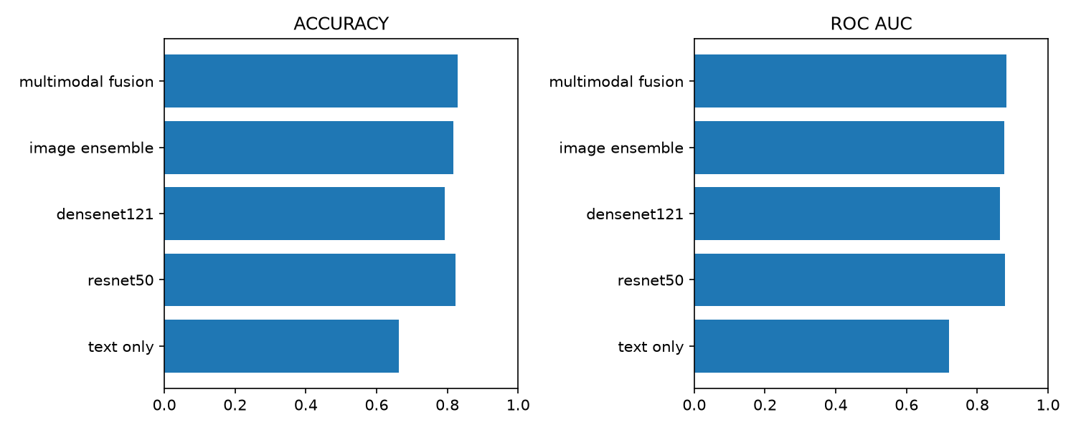
Current held-out ablation comparison
The deployed fusion achieves precision 83.45%, recall 75.32% and average precision 0.8516. It slightly improves accuracy and ROC-AUC over ResNet50, while ResNet50 has the higher F1. No statistical superiority or clinical effectiveness is established. The old 10:1 cost policy is not used in this model. Its earlier, high-recall v1 scores used a different cohort and are not directly comparable.
Model | True negative | False positive | False negative | True positive
Text-only — Logistic Regression | 158 | 44 | 76 | 78
ResNet50 | 170 | 32 | 31 | 123
DenseNet121 | 161 | 41 | 33 | 121
Image ensemble | 172 | 30 | 35 | 119
Multimodal Fusion | 179 | 23 | 38 | 116

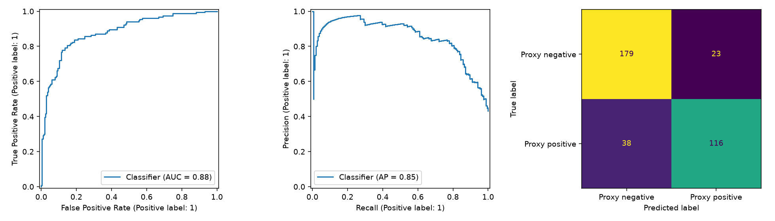
Deployed fusion ROC, precision-recall and confusion matrix
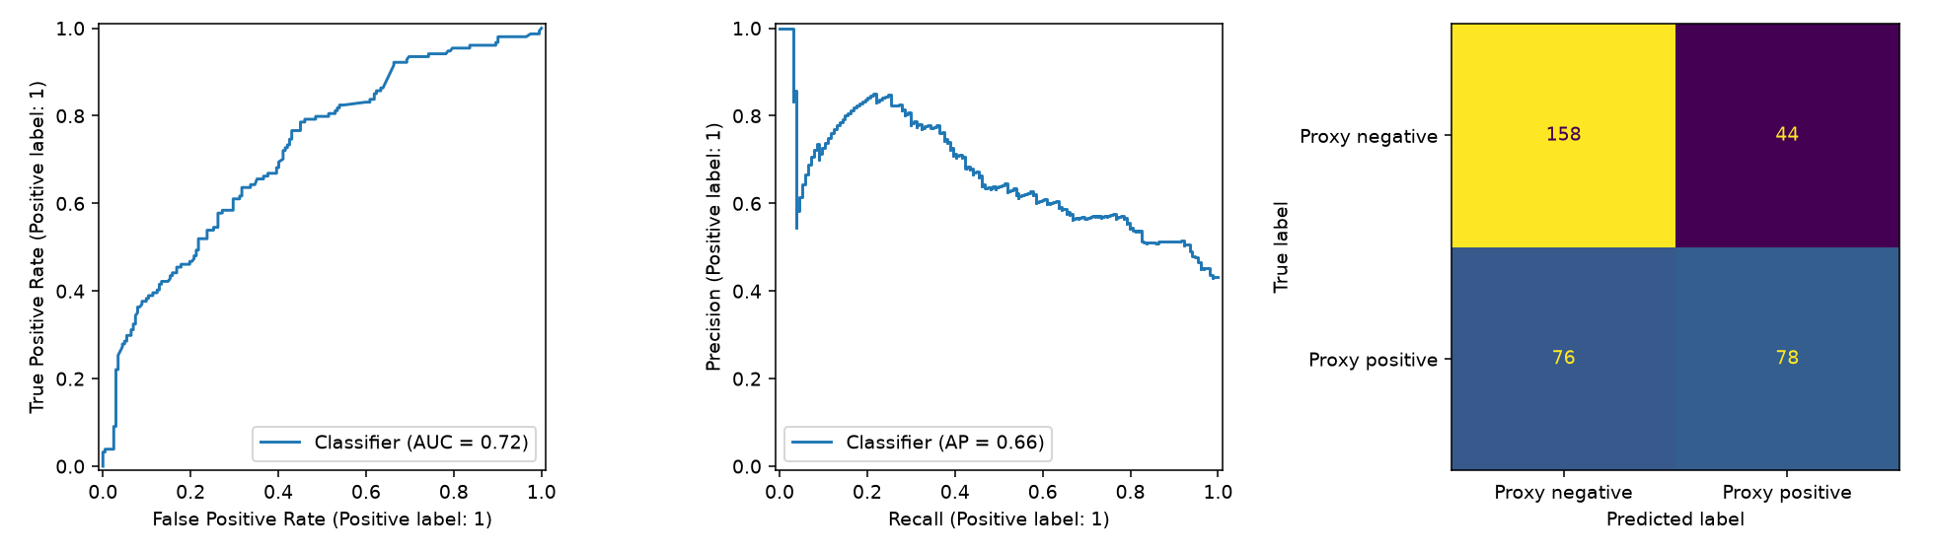
Text-only ROC, precision-recall and confusion matrix
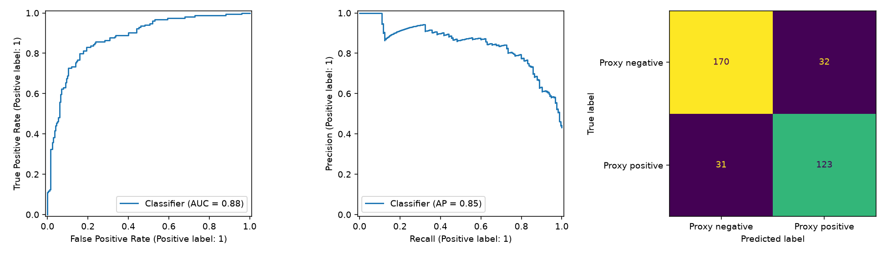
ResNet50 ROC, precision-recall and confusion matrix
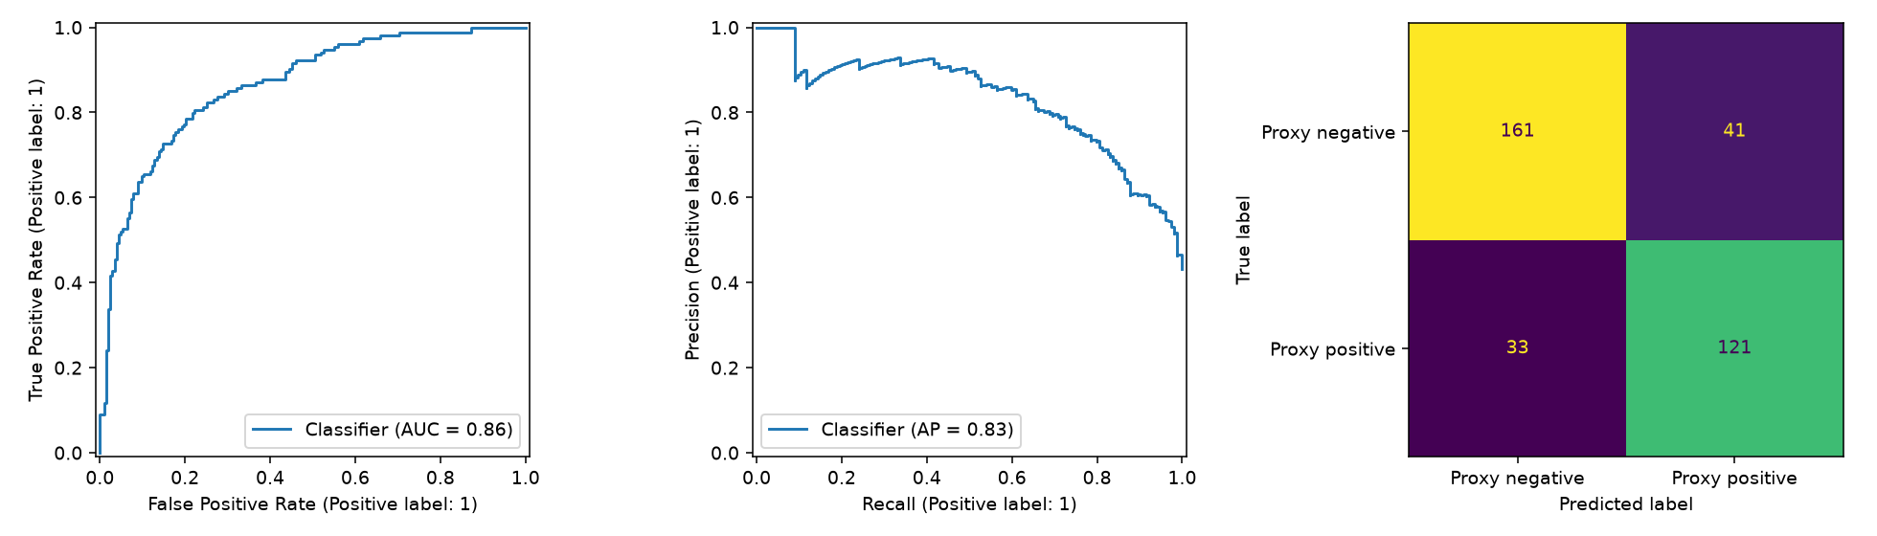
DenseNet121 ROC, precision-recall and confusion matrix
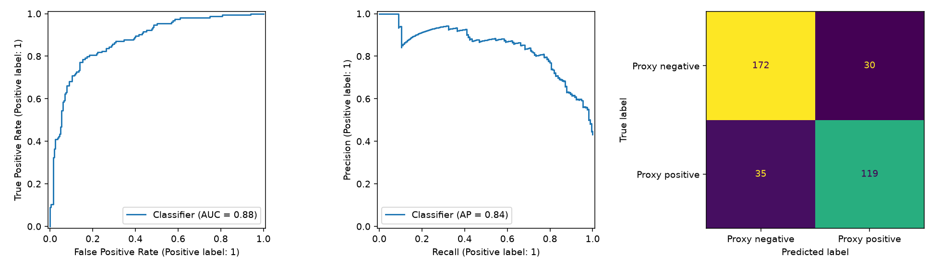
Image ensemble ROC, precision-recall and confusion matrix
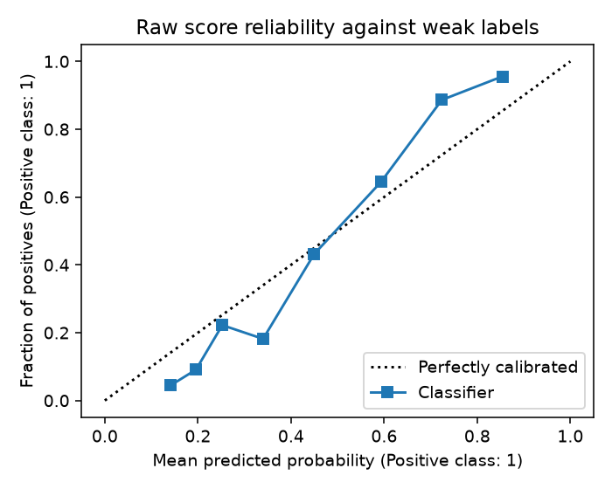
Raw fusion-score reliability against weak labels
The reliability plot is descriptive; no probability calibrator was fitted. Scores remain uncalibrated and must not be interpreted as disease probabilities.

4. Explanation Plots and Written Reports
Grad-CAM differentiates the final fused score at the ResNet50 branch. It explains that branch's contribution, not a combined anatomical map of both CNNs. Token occlusion removes one raw token and measures the change in the final score with image scores fixed. This is token occlusion, not SHAP. Changes are not additive causal effects. Image coordinates do not establish anatomy or patient laterality.
Selected test example | Weak label | Model outcome | Single-image score
UID 3212 | Normal | True negative | 21.34%
UID 2348 | Abnormal | True positive | 90.79%
UID 2829 | Normal | False positive | 71.06%

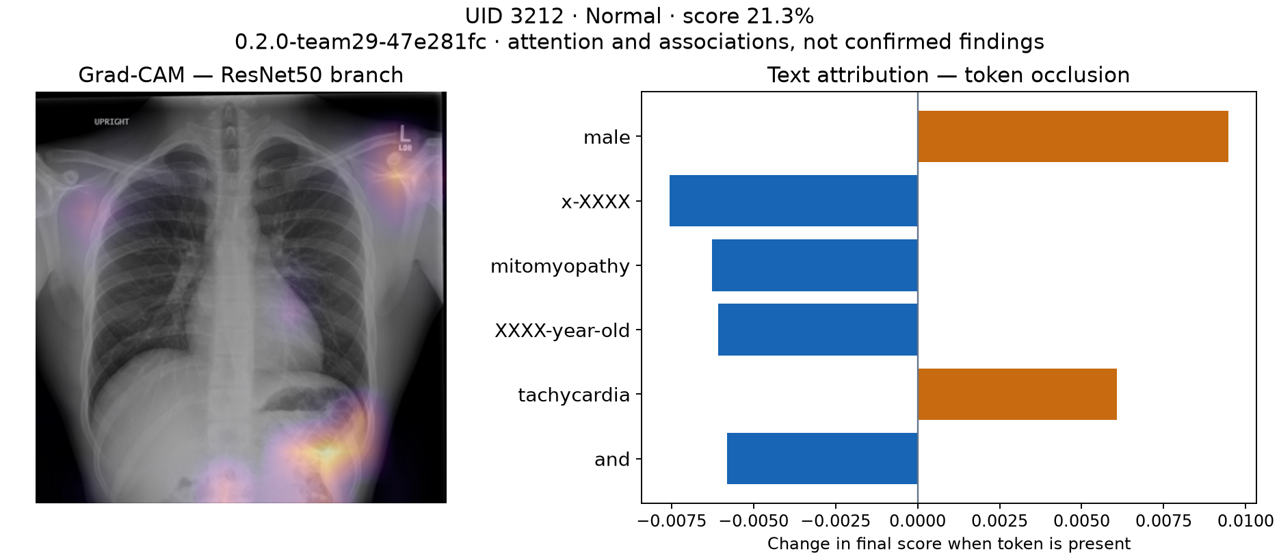
Normal example — actual deployed-model image and text attribution
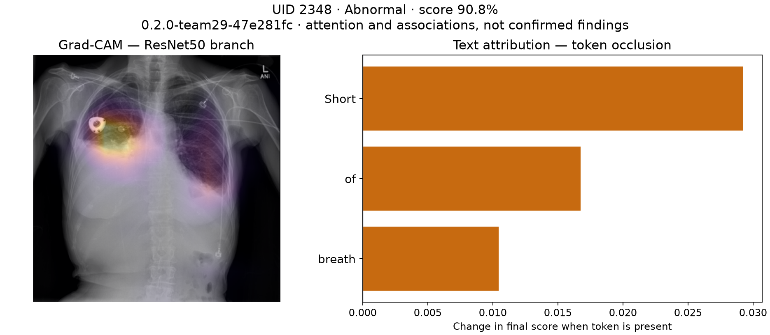
Abnormal example — actual deployed-model image and text attribution
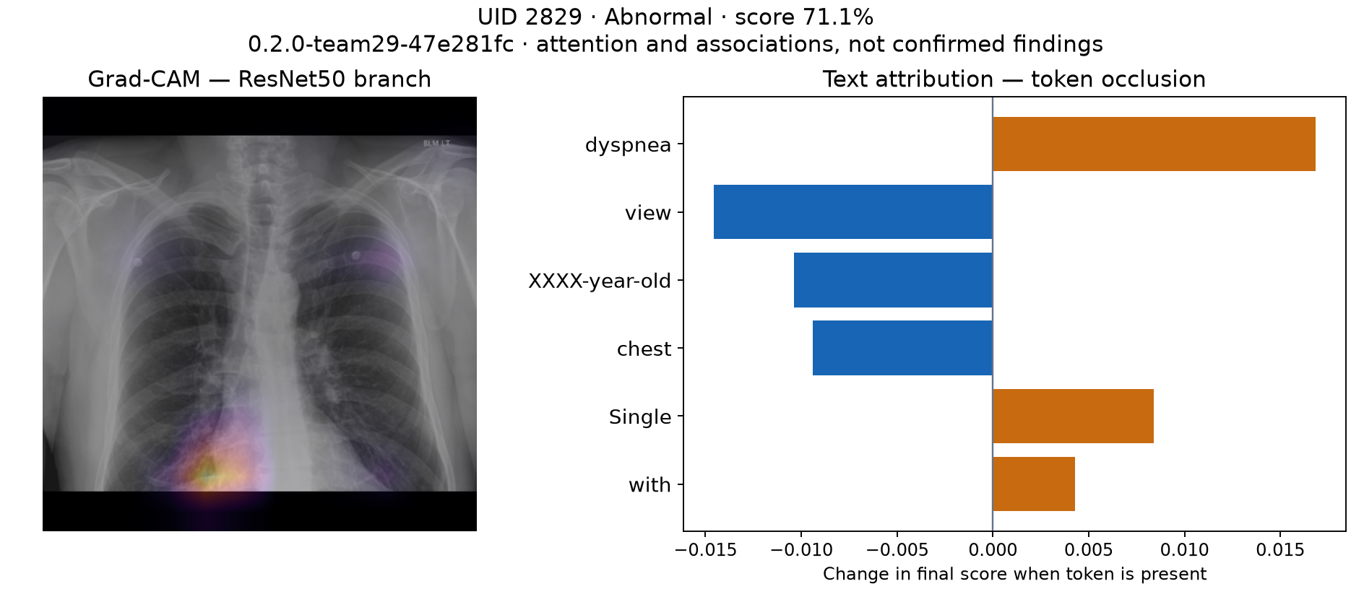
False-positive example — actual deployed-model image and text attribution
The cases were selected after evaluation to demonstrate behavior, not to estimate performance. Study metrics average views; these interface scores use one image. Exact indication/comparison fields are in demo_images/demo_cases.csv.
The rule-based report contains Predicted Class, Impression, Visual Findings, Clinical Context and Recommendation. It describes scores and attribution rather than asserting that attention proves a lesion. Every report retains “Clinician verification is required.”
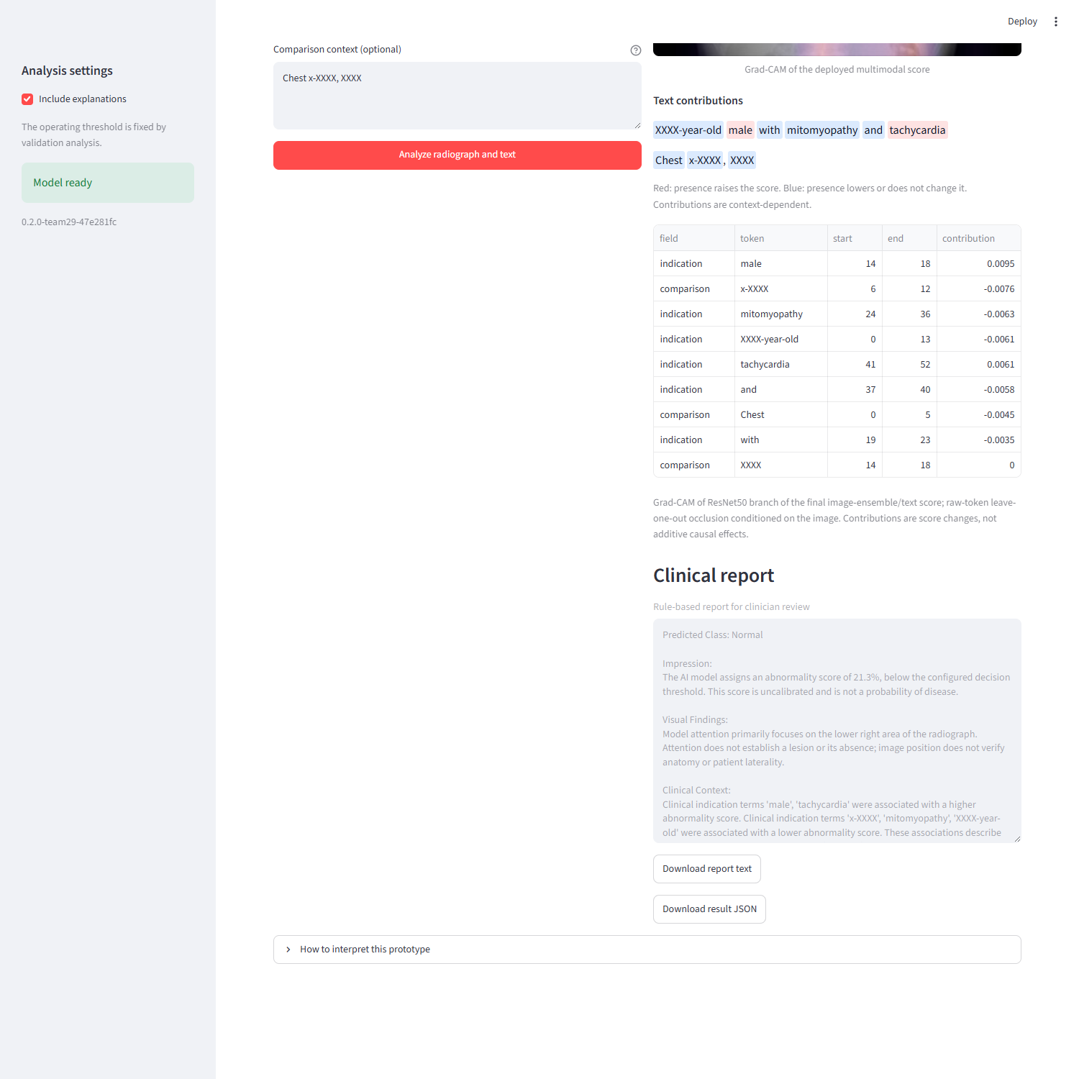
Current Streamlit written report

5. Team Notebook Analysis & Data Leakage Prevention
The team's classification notebook was inspected and ported into source modules. Missing trained classification exports required local retraining. Image/text alignment, permitted predictors, train-only fitting and grouped evaluation were checked. Ambiguous image names/conflicting UIDs are rejected, exact-image hashes are audited, and thresholds/fusion choices are selected on validation only.
The team's first report generator used FLAN-T5-small with ResNet18 visual tokens and XRV pathology tags. Its XRV densenet121-res224-all configuration explicitly lists OpenI among pretraining sources, and Indiana IU radiographs come from the OpenI/NLMCXR collection. This documents dataset-source pretraining overlap. Without the upstream per-image training manifest, it does not prove that a particular local test image or patient was seen; it is not accurate to claim proven image-level test leakage or quantify its effect from the available files.
Sources: XRV model definition and XRV OpenI dataset implementation. The deployed classifier uses ImageNet weights and does not use this XRV component.
The final notebook, notebooks/Team29_Report_Generation_Final.ipynb, removes that tagger. Tags come from a linear classifier trained on IU training studies only, on 1024-D features from the CheXpert-only densenet121-res224-chex weights; training tags are out-of-fold. After generation, a fixed finding sentence is added when the classifier is confident, using thresholds that reach 60% out-of-fold training precision. src/pulmonary/learned_reports.py loads this export and rejects exports built with the OpenI-trained weights.
Reporting option | Evidence | Decision
Rule-based evidence summary | Deterministic, faithful to classifier/XAI inputs; not a learned radiology report | Default in API/UI
Team learned FLAN-T5 draft (final notebook) | Notebook reload verified prompts, classifier probabilities and forced findings; fluent text with omission risks | Experimental adapter only

The notebook's supplied test results (362 studies) for the final model are BLEU 18.5 / ROUGE-L 0.391 / METEOR 0.339. Lexical finding checks found cardiomegaly in 7/23 reference cases (14 mentions), atelectasis in 2/45 (7) and opacity in 15/70 (53); granuloma was dropped because its classifier was too weak. The superseded OpenI-tagger run had BLEU 17.30 / ROUGE-L 0.377 / METEOR 0.326 with cardiomegaly 7/23, atelectasis 1/45 and opacity 9/70. These are limited lexical checks and language-similarity metrics, not clinician-adjudicated diagnostic accuracy, and they were not re-run in this repository. The test split was evaluated four times during notebook development, so these are not untouched-holdout results. Splits are by study, not patient. Image swaps move both visual tokens and tags, so they do not isolate the visual-token branch. The full notebook analysis and reporting decision are consolidated in this report.

6. Functional Tests and Working Solution
Check | Saved evidence | Result
Focused regression tests | reports/evidence/team29/pytest.txt | 13 passed
Export/software parity | Team bundle checksums, direct-vs-fused score tests | Passed
API prediction/explanation | deployment_verification.json | HTTP 200; matching version/scores
Invalid missing image | Same deployment verification | HTTP 422
Three real demo predictions | demo_prediction_verification.json | All matched local export
Container UI report rendering | Same deployment verification | Passed
Real browser upload/report/download | automated_demo.json | Passed
Both Compose services | Saved Docker evidence and live /ready | Healthy

The 13 tests cover predictor exclusion, aspect-preserving padding, study-label consistency, validation thresholds, import checksum rejection, real fusion parity, Grad-CAM/report generation, API validation/readiness and Streamlit rendering. Artificial test weights are software fixtures and are not the source of quality metrics. Real model quality comes from the frozen held-out outputs above.
............. [100%]
13 passed in 24.75s
Runtime component | Configuration
API | FastAPI, CPU inference, localhost:8080
UI | Streamlit, localhost:8501; internal API URL http://api:8080
Model mount | artifacts/team_bundle → /models, read-only
Model version | 0.2.0-team29-47e281fc
Recorded /predict latency | 3.57 seconds for selected case; not a benchmark
Failure behavior | Unavailable model → readiness/inference 503; no invented scores

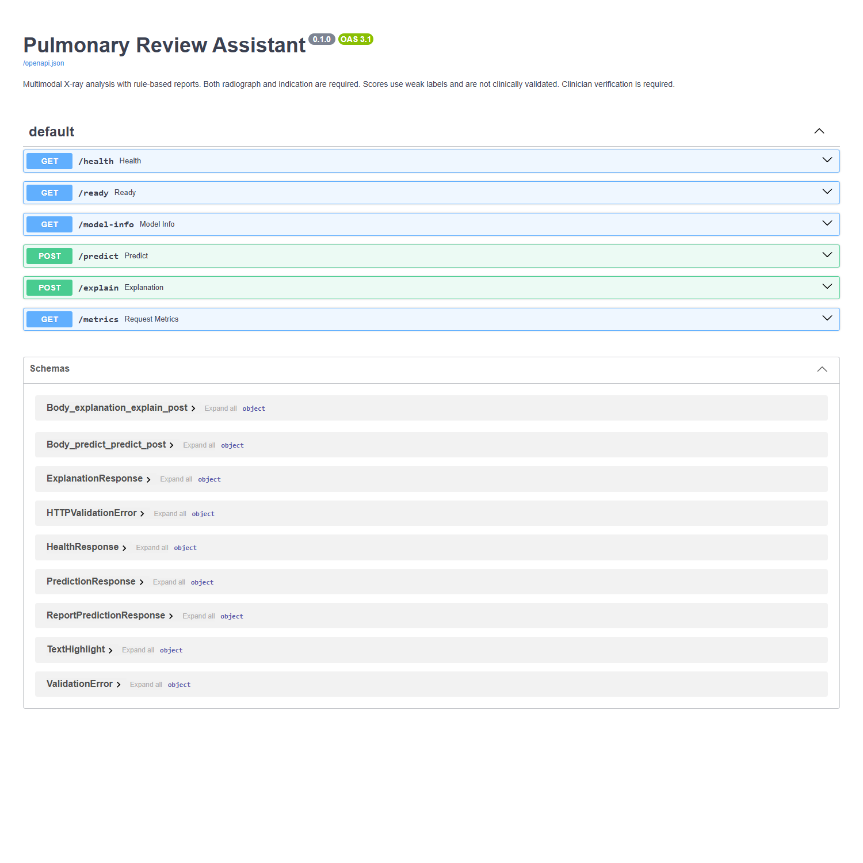
Actual current FastAPI Swagger UI
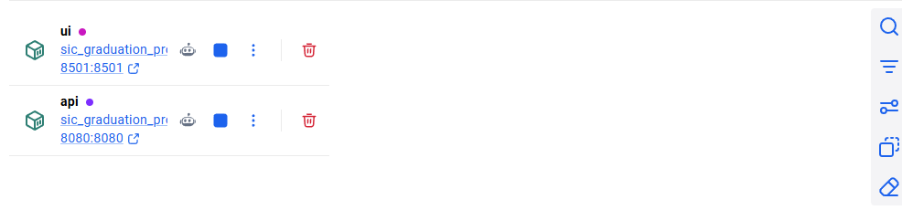
Docker Desktop container list — header omitted for privacy
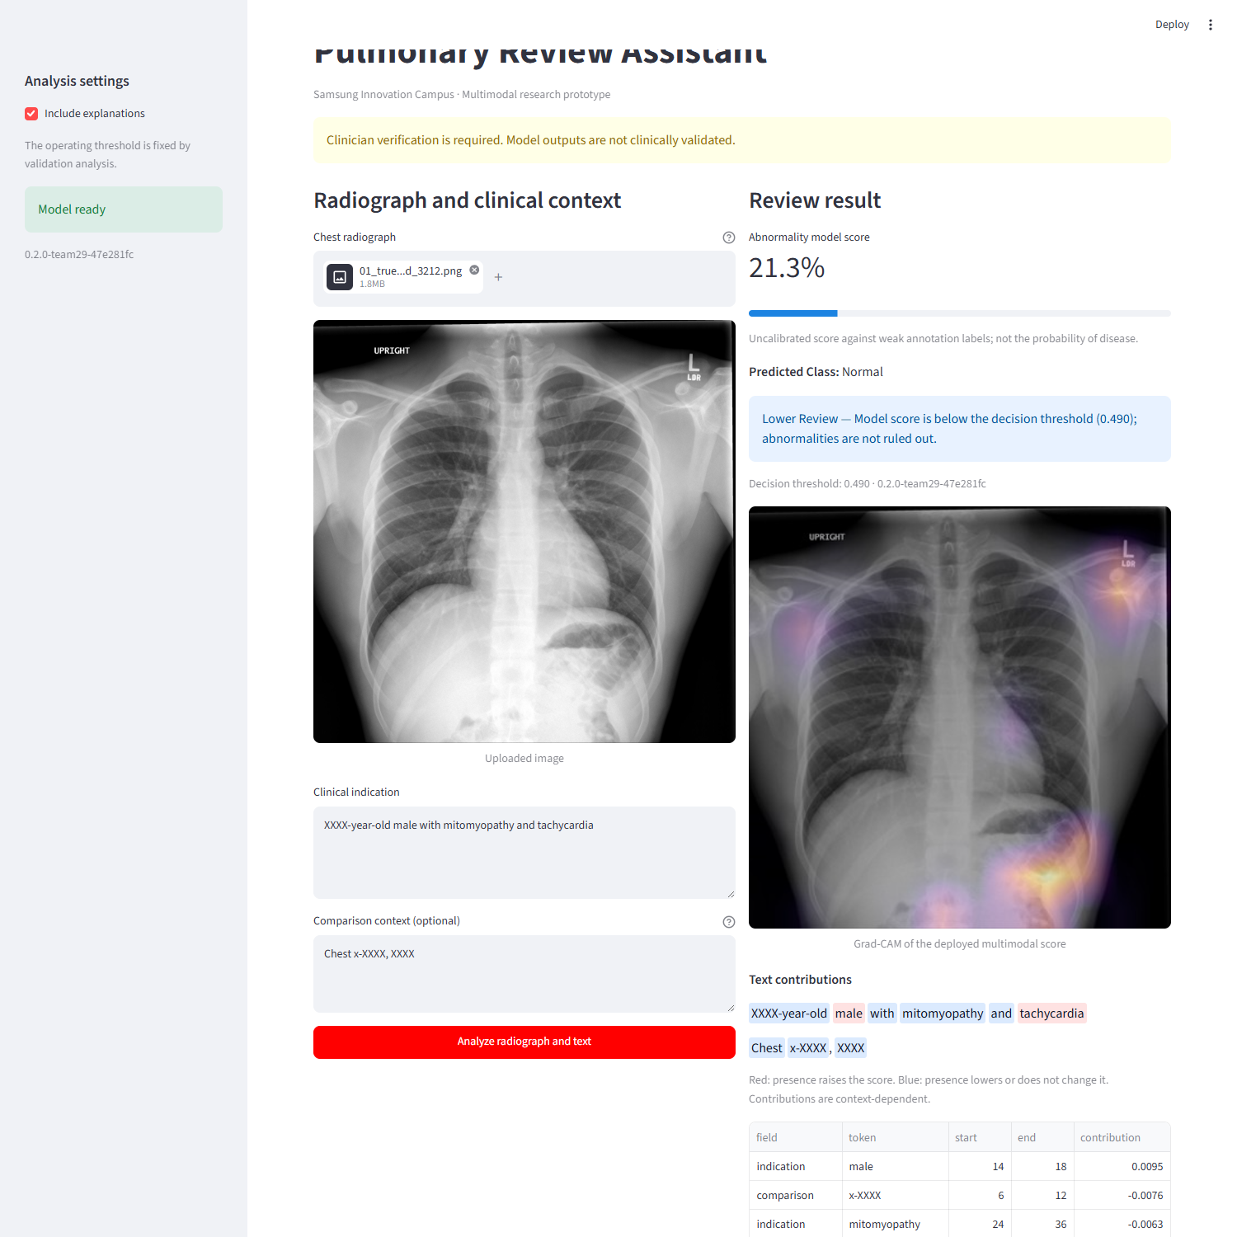
Actual current Streamlit interface
Start from the project root:
docker compose up -d --no-build --wait --wait-timeout 180
docker compose ps
Invoke-RestMethod http://localhost:8080/ready
Invoke-RestMethod http://localhost:8080/model-info
A fresh checkout needs a trusted complete model bundle first. Model binaries and raw data are excluded from Git. The offline bundle archive is packaged separately under dist/; restore its files into artifacts/team_bundle/. A clean dependency build uses docker compose build; an existing trusted image supports the smaller code-only Dockerfile.update build. See README and docs/demo_runbook.md.

7. Submission Package and Limits
SIC item | Artifact / evidence
01 Source code | src/, app/, ui/, scripts/, tests/
02 Technical documentation | README, architecture, dependencies and execution guides
03 Data assets | docs/data_assets.md, provenance, dictionary, split manifest
04 Technical evidence | This report, tracked searches, comparison/XAI plots and tests
05 Working solution | Versioned model bundle, offline archive and verified Compose stack
06 Presentation | docs/SIC_Final_Presentation.pptx, current notes and inserted assets
07 Demonstration | docs/demo_runbook.md, automation and recorded fallback
08 Team contribution summary | team_contributions.md

The exact checklist is recorded in docs/final_submission_checklist.md. Technical package checks do not substitute for each member's rehearsal or understanding. There is no external clinical validation, verified patient grouping or prospective workflow-benefit measurement. Historical test results were already visible during project development; this is not a new independent external validation study. Clinician verification is required.

