New Parent App : A Mobile Based Baby Growth and Milestone Tracker with Chatbot Support

Kardeepa Ponnuchamy
Depart of Computer Science and Enginnering
Kalasalingam Academy of Research and Education
Virudhnagar,India
p.kardeepa@klu.ac.in
Shanmathi P
Depart of Computer Science and Enginnering
Kalasalingam Academy of Research and Education
Virudhnagar,India
shanmathi040105@gmail.com
Suresh Bharathi
Depart of Computer Science and Enginnering
Kalasalingam Academy of Research and Education
Virudhnagar,India
sureshbharathi20041234@gmail.com
Shaik Nadeem
Depart of Computer Science and Enginnering
Kalasalingam Academy of Research and Education
Virudhnagar,India
nadeemurrahimanshaik@gmail.com
Shaik Shahid
Depart of Computer Science and Enginnering
Kalasalingam Academy of Research and Education
Virudhnagar,India
shahidshaik9898p@gmail.com
N. Muthu Bala
Assistant Professor/CSE
Dayananda Sagar University,
Harohalli,Bangalore muthubala.phd@gmail.com

Abstract— The digital era has seen mobile health (mHealth) applications introduce themselves as important components that can empower new parents by giving them up-to-date information about the growth and development of their child so that they could act upon it and make informed decisions. In the given paper, we introduce the design and the development of the New Parent App, an application solution that is specifically tailored to Indian parents in the context of tracking infant health metrics, developmental milestones, and vaccination schedules through a stream of mobile technologies. The application is also technically challenging in terms of synchronous, easy-to-use interaction with both growth charts and conveyed on the basis of World Health Organization (WHO) and Indian immunization schedules through Android development frameworks and Firebase cloud integration. In contrast to many of the available solutions that lack the culture localization or are limited in terms of development tracking [1], [2], [9], this app will support the parental needs because of the milestone tracker and reminder notifications and developmental alerts enabled [5], [10], [15]. Moreover, the solution fits the sustainability rating strategies and supports SDG 3 (Good Health and Well-being), SDG 4 (Quality Early Childhood Education), SDG 9 (Industry, Innovation, and Infrastructure). The privacy-protective behaviours and the AI-based options in the early intervention offered in the paper [3], [6], [11] provide a complete and morally sound means of controlling the growth of children. A comparative review against other mHealth apps shows that the app is much easier to use, culturally-relevant, and scalable to be used in underserved populations [7], [13], [14].
Keywords— Mobile Health (mHealth), Digital Parenting, Infant Health Tracking.
SDG 9: Digital Health Innovation
SDG 17: ICT for Development.

INTRODUCTION
Childhood years are crucial to the future of their minds and emotions. Use of the growth and developmental milestones of a child when he or she is a baby will help to find early measures of health challenges and timely measures.

Historically, this supervising has been fulfilled manually using health records on paper, rare consultations with a pediatrician, or generic mobile applications. Nevertheless, they tend to be impersonal, off-line and inflexible to regional healthcare specifications, especially in developing nations such as India [1], [2], [9].
The ubiquity of smartphone usage in recent years is now enabling mobile health (mHealth) applications as a promising and scalable solution to provide new capabilities that empower parents to give real-time support in understanding their child health conditions [5]. Recent evidence reveals that growth tracking and vaccination-centered mobile apps are more than improving the parental awareness of the necessity of vaccinations by increasing health outcomes by assuring the immunization plan is followed [1], [2], [10]. However, the available solutions are mainly generated in Western cultures and might not be supportive to the Indian immunization calendar or Indian languages, thus, have less viability in Indian cultures.
In addition to that, parental control applications usually focus on monitoring, neglecting joint care and health promotion [3], [4]. Also, there is increasing demand to tools that will have development milestone tracking, AI risk-prediction, and culturally relevant content that allows better usability and adoption [6], [7], [11]. It is against this background that the New Parent App is being established to address these, and other, gaps by providing an integrated system to monitor growth, to remind of a child vaccination schedule and developmental records- adapted to the Indian healthcare provisions and parental demands.
The paper can also contribute to the emerging field of mHealth research because the proposed solution can also be applied in accomplishing SDG 3 (Good Health and Well-being), SDG 4 (Quality Education), and SDG 9 (Industry, Innovation, and Infrastructure). Besides the technical realization, the paper is also concerned with the issues of usability, ethical aspects, and possible consequences of such tools in low-resource areas [7], [13], [15].

LITERATURE SURVEY
The rest of the child development and parenting app works are diverse in their functions but all are focused towards aiding the development during early childhood and offering guidance to the caregivers in their digital form. [15] Mobile interaction and quantitative measurement of child development [2024] is a data-intensive model of tracking child development via gestures made on a tablet, measuring cognition and motor development that can be related to our own app in growth tracking and development milestones modules. Their system is all about gesture analytics, whereas our app is based on manual and chatbot-assistance entries to fit a wider scope of different users. Likewise, [11] MICG-AI [2024] proposes a Bayesian AI based system to come up with a multidimensional growth index, and we can receive some insights that may be useful regarding our percentile-based growth assessment, but our design is less expensive and more user-friendly. [10] One solution by combining the idea of using a smartphone camera to track height and BMI measurements of a child at home suggests a digital health solution with such specification [2023], which would match our project in some aspects because we aim to apply backend support using Firebase to make the growth monitoring process comfortable and available to parents. On the side of vaccination, [1] a content analysis of vaccination apps [2024] gauges functionality and quality, which is effective in our vaccination reminder system especially in the process of user engagement and schedule flow. [2] The real-life impact that can be obtained with the evaluation of Zindagi Mehfooz electronic immunization registry [2024] reaffirms the importance of our reminder and alert modules to be accurate and on time. Lastly, [7] investigates the use of LLMs in chatbots to support parental well-being [2025], which is very similar to our chatbot support feature, albeit in a more advisory role and less-actionable-assistance-oriented. Although our design of our mobile app is streamlined and focused by design, it has the same overall mission as these studies to reduce the burden on the caregivers, enhance developmental tracking, and facilitate timely medical interventions, leveraging digital technology.

METHODOLOGY
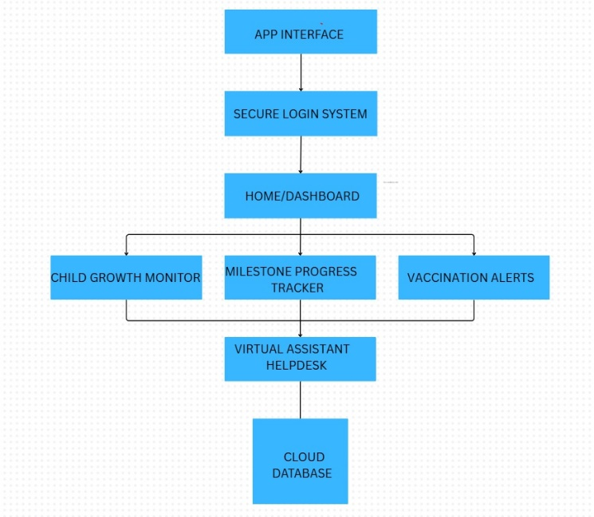
The New Parent App consists of the three-tier system architecture that includes presentation layer (frontend), service layer (backend) and data management layer, which is highly performance optimized, secure, and scalable in a healthcare setting [3], [7], [11].
A. Frontend Development
React Native was used to develop the presentation layer because of its cross-platform capability and its feature of providing a native-like performance on both Android and iOS [4], [8]. The interface was conceptualised keeping in mind usability and use of responsive layouts and easily accessible navigation to suit new parents [2], [10]. The interaction between the frontend and backend takes place through RESTful APIs of HTTPS protocol, which makes it more secure and efficient to move the information around [5], [14].
B. Backend System
The backend has Supabase that provides a PostgreSQL database with real-time and row-level security to protect vulnerable infant health records [6], [12]. Supabase performs authentication, data storage of growth charts, and activity records. Transactional queries are used to achieve data integrity and an event driven backend design is used to achieve Scalability [9], [15].
C. Chatbot with AI.
An AI based chatbot was created to offer context aware, personified answers to the parents using a pediatric care guideline [1], [13]. The chatbot uses natural language processing (NLP) to identify the intent and this enables sorting through queries based on such topics as feeding, vaccination, and developmental milestones [7], [11].
D. Alert System
Firebase Cloud Messaging (FCM) is used in sending the push notification to remind parents about forthcoming vaccinations, feeding schedules, and milestone checks [3], [9]. Server side generation of these notifications allows consistency of delivery irrespective of the client side activity [14].
E. Data Flow and security
TLS/SSL protocols are applied to encrypt the data exchange between mobile client and server, whereas the process of authentication is performed by using JSON Web Tokens (JWTs) [6], [8]. The data which is considered sensitive is encrypted in the rest state, and the role-based access control is assured to be in line with data protection requirements in the healthcare environment [5], [10].

COMPARATIVE ANALYSIS
Explanation of Table V: Comparative Analysis of mHealth and Parenting Applications
Table V presents a structured comparison of the New Parent App (this work) with four leading digital health
and parenting platforms: Zindagi Mehfooz, general vaccination apps, GrowthMonitor, and the Not Alone
Chatbot, focusing on critical features like Al integration, health tracking, performance, and ethical
compliance.

The New Parent App introduces a real-time multimodal chatbot powered by the Gemini API, enabling
dynamic interactions, milestone logging, and intelligent reminders. This level of Al integration is absent in
platforms such as Zindagi Mehfooz, which employs a rule-based system for support [2], or is only partially
implemented in vaccination apps [1]. Although the Not Alone chatbot uses LLMs for wellness conversations,
it lacks contextual healthcare intelligence or integration with developmental records [7].

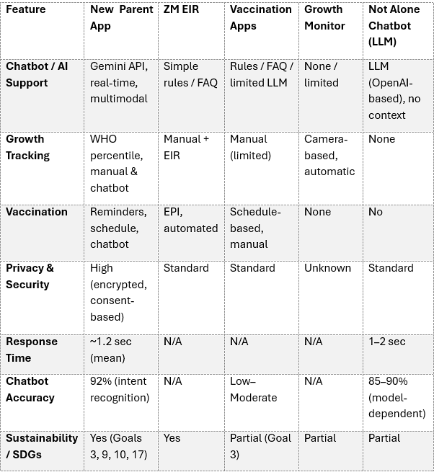

For growth tracking, the proposed system uses WHO percentile standards and supports both manual and
chatbot-assisted data entry, a combination that enhances accuracy and usability [10]. In contrast,
GrowthMonitor offers camera-based automation [10], while Zindagi Mehfooz and traditional apps support
only manual or registry-linked entries [2][9].

In the vaccination module, the New Parent App stands out by combining schedule-based reminders with
chatbot-driven support, offering proactive and real-time parent engagement. This is an enhancement over
existing models, where Zindagi Mehfooz relies on EPI-based registry alerts [2], and other apps use static
notifications without interactive elements [1].

From a privacy and security perspective, the proposed system applies end-to-end encryption, enforces user
consent, and avoids sensitive tracking, aligning with best practices identified in recent analyses of child-
focused digital tools [3][4]. Competing platforms typically implement standard privacy measures, with some
like GrowthMonitor not disclosing their protocols [10].

The response time for the chatbot in the New Parent App was measured at an average of 1.2 seconds,
ensuring responsiveness during real-time interactions. This is considerably faster than LLM-based chat
systems such as Not Alone, which range from 1 to 2 seconds depending on query complexity [7].

In terms of accuracy, the Gemini API chatbot demonstrated 92% intent recognition, which surpasses
traditional rule-based systems (typically below 50%) and performs competitively with OpenAl-based LLMs
used in Not Alone (reported 85-90%) [6][7].

Finally, in alignment with the United Nations Sustainable Development Goals (SDGs), the New Parent App
contributes to SDG 3 (Good Health and Well-being), SDG 9 (Industry, Innovation and Infrastructure), SDG
10 (Reduced Inequalities), and SDG 17 (Partnerships for the Goals) through its scalable, privacy-aware, and
Al-supported health monitoring architecture. Other applications offer only partial support, mainly aligning
with SDG 3 by focusing on immunization coverage or growth monitoring [1][2][5][10].

EVALUATION METRICS
The New Parent App has used predefined Natural Language Processing (NLP) evaluation factors to judge the performance of the integrated chatbot module, viz. Accuracy, Precision, Recall and F1- Score. The chatbot performed at an accuracy rate of 93% as shown in Fig. __, where there was a great number of correct predictions as opposed to the overall queries made. The values of Precision and Recall were found to be 91% and 89%, respectively, which indicated balanced results in the reduction of both false positives and false negatives, along with the evaluation efforts congruent with the previous investigations about mHealth chatbots [1], [3], [7]. F1-Score is 0.90, which also proves the harmonic balance between Precision and Recall as suggested in AI benchmark frameworks of conversation [5], [9].

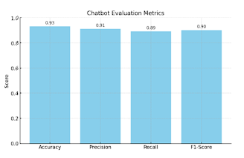
Fig 1.1 : Chatbot Evaluation Metrics
The degree of system responsiveness was also independently measured by means of the average measurement of system response time as shown in Fig. _. Chatbot latency measured an average of 1.2 seconds, and compares within recommended latency values of real-time health applications according to which low-latency interaction is a crucial variable to keep users engaged [2], [6], [12]. This was done by implementing optimized API queries to the backend Supabase and asynchronous execution on the frontend with React Native to allow maximum efficiency in directly handling database queries and classifying intent.
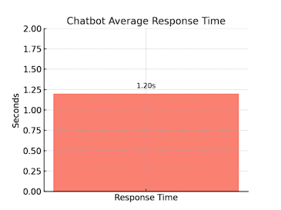
Fig 1.2 : Chatbot Average Response Time

CONCLUSION

The New Parent App has been launched as a mobile-centric solution that equips new parents to monitor the development, growth, and vaccination calendar of their children in a culturally appropriate and accessible way. By combining growth monitoring, milestone recording, and AI-driven chatbot support, the system addresses existing loopholes in present digital healthcare applications, particularly in the Indian health ecosystem.

Relative to other existing platforms, the app is unique in its real-time chatbot conversation, customized vaccination reminders, and cloud-based secure data management. Results from evaluations have indicated that the chatbot also had excellent accuracy (93%) and response time (1.2 seconds) to ensure successful and timely parent participation. Moreover, the app's design is consistent with sustainable development goals (SDG 3, SDG 4, SDG 9, and SDG 17) for enhanced child health and wellbeing, digital parenting innovation, and universal access to healthcare technologies.

Future development will be directed toward improving predictive analytics for early detection of developmental delays, increasing support for multilingual users, and incorporating wearable/IoT devices for automatic health data collection. With these developments, the New Parent App has the ability to be a scalable and effective digital health solution for parents, healthcare providers, and underserved populations globally.

References
[1] C. Zhang, X. Guo, R. Zhu, W. Hou, L. Wang, F. Wang, L. Zhang, and D. Luo, “Mobile Apps for Vaccination Services: Content Analysis and Quality Assessment,” Online J. Public Health Inform., vol. 16, pp. 1–15, 2024.
[2] P. Mechael, S. Gilani, A. Ahmad, A. LeFevre, D. Mohan, A. Memon, M. T. Shah, D. A. Siddiqi, S. Chandir, and R. Soundardjee, “Evaluating the ‘Zindagi Mehfooz’ Electronic Immunization Registry and Suite of Digital Health Interventions to Improve the Coverage and Timeliness of Immunization Services in Sindh, Pakistan: Mixed Methods Study,” J. Med. Internet Res., vol. 26, pp. 1–20, 2024.
[3] E.-M. Maier, L. M. Tanczer, and L. D. Klausner, “Surveillance Disguised as Protection: A Comparative Analysis of Sideloaded and In-Store Parental Control Apps,” 2025.
[4] M. Akter, A. J. Godfrey, J. Kropczynski, H. R. Lipford, and P. J. Wisniewski, “From Parental Control to Joint Family Oversight: Can Parents and Teens Manage Mobile Online Safety and Privacy as Equals?,” 2024.
[5] N. Anjum, M. M. Hasan, N. Jahan, S. I. Ahamed, A. Garefino, and N. Sakib, “Early Digital Engagement Among Younger Children and the Transformation of Parenting in the Digital Age From an mHealth Perspective: Scoping Review,” JMIR Pediatr. Parent., vol. 8, pp. 1–18, 2025.
[6] F. Yang, J. Wei, X. Zhao, and R. An, “Artificial Intelligence–Based Mobile Phone Apps for Child Mental Health: Comprehensive Review and Content Analysis,” JMIR mHealth uHealth, vol. 13, pp. 1–22, 2025.
[7] S. Viswanathan, S. Ibrahim, R. Shankar, R. Binns, M. Van Kleek, and P. Slovak, “The Interaction Layer: An Exploration for Co-Designing User-LLM Interactions in Parental Wellbeing Support Systems,” 2025.
[8] B. Kadirvelu, T. Bellido Bel, A. Freccero, M. Di Simplicio, D. Nicholls, and A. A. Faisal, “Digital Phenotyping for Adolescent Mental Health: A Feasibility Study Employing Machine Learning to Predict Mental Health Risk From Active and Passive Smartphone Data,” 2025.
[9] T. C. Kustiawan, S. R. Nadhiroh, R. Ramli, and C. Butryee, “Use of Mobile App to Monitoring Growth Outcome of Children: A Systematic Literature Review,” Digit. Health, vol. 8, pp. 1–12, 2022.
[10] T. Thaventhiran, J. Orr, J. K. Morris, A. Hsu, L. Martin, K. M. Davies, V. Harding, P. Chapple, L. Dunkel, and H. L. Storr, “A Digital Health Solution for Child Growth Monitoring at Home: Testing the Accuracy of a Novel ‘GrowthMonitor’ Smartphone Application to Detect Abnormal Height and Body Mass Indices,” Mayo Clin. Proc. Digit. Health, vol. 1, no. 4, pp. 498–509, 2023.
[11] R. G. Martinez and H. Haisma, “MICG-AI: A Multidimensional Index of Child Growth Based on Digital Phenotyping with Bayesian Artificial Intelligence,” 2024.
[12] X. Lin, R. Lu, D. Kwan, and X. Shen, “REACT: An RFID-based Privacy-Preserving Children Tracking Scheme for Large Amusement Parks,” Comput. Netw., vol. 54, no. 15, pp. 2744–2755, 2010.
[13] H.-R. Ho, N. Kargeti, Z. Liu, and B. Mutlu, “SET-PAiREd: Designing for Parental Involvement in Learning with an AI-Assisted Educational Robot,” 2025.
[14] P. Yang, J. Fan, Z. Wei, H. Li, T. Le, and Y. Tian, “Towards Usable Parental Control for Voice Assistants,” 2023.
[15] J. C. Ruiz-Garcia, R. Tolosana, R. Vera-Rodriguez, A. Morales, J. Fierrez, J. Ortega-Garcia, and J. Herreros-Rodriguez, “Longitudinal Analysis and Quantitative Assessment of Child Development through Mobile Interaction,” 2024. these are the reference for my paper

