1. Creating and Renaming Files/Directories
Create a directory named test_dir using mkdir.
Inside test_dir, create an empty file called example.txt.
Rename example.txt to renamed_example.txt using mv
Sol’n:
vboxuser@Ubuntu:~/tutedude$ mkdir LinuxBasic
vboxuser@Ubuntu:~/tutedude$ ls
LinuxBasic
vboxuser@Ubuntu:~/tutedude$ cd LinuxBasic/
vboxuser@Ubuntu:~/tutedude/LinuxBasic$ mkdir test_dir
vboxuser@Ubuntu:~/tutedude/LinuxBasic$ ls
test_dir
vboxuser@Ubuntu:~/tutedude/LinuxBasic$ touch test_dir/example.txt
vboxuser@Ubuntu:~/tutedude/LinuxBasic$ cd test_dir/
vboxuser@Ubuntu:~/tutedude/LinuxBasic/test_dir$ ls
example.txt
vboxuser@Ubuntu:~/tutedude/LinuxBasic/test_dir$ mv example.txt renamed_example.txt
vboxuser@Ubuntu:~/tutedude/LinuxBasic/test_dir$ ls
renamed_example.txt
vboxuser@Ubuntu:~/tutedude/LinuxBasic/test_dir$

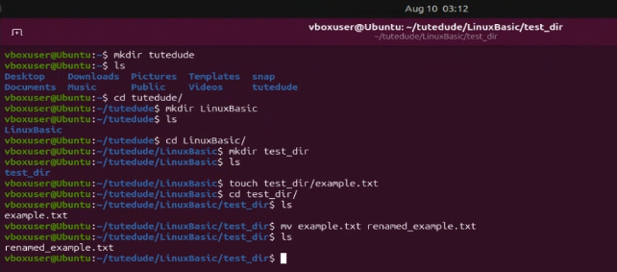
2. Viewing File Contents
Use cat to display the contents of /etc/passwd.
Display only the first 5 lines of /etc/passwd using head.
Display only the last 5 lines of /etc/passwd using tail.
Sol’n:
vboxuser@Ubuntu:~$ cat /etc/passwd
root:x:0:0:root:/root:/bin/bash
daemon:x:1:1:daemon:/usr/sbin:/usr/sbin/nologin
bin:x:2:2:bin:/bin:/usr/sbin/nologin
sys:x:3:3:sys:/dev:/usr/sbin/nologin
sync:x:4:65534:sync:/bin:/bin/sync
games:x:5:60:games:/usr/games:/usr/sbin/nologin
man:x:6:12:man:/var/cache/man:/usr/sbin/nologin
lp:x:7:7:lp:/var/spool/lpd:/usr/sbin/nologin
mail:x:8:8:mail:/var/mail:/usr/sbin/nologin
news:x:9:9:news:/var/spool/news:/usr/sbin/nologin
uucp:x:10:10:uucp:/var/spool/uucp:/usr/sbin/nologin
proxy:x:13:13:proxy:/bin:/usr/sbin/nologin
www-data:x:33:33:www-data:/var/www:/usr/sbin/nologin
backup:x:34:34:backup:/var/backups:/usr/sbin/nologin
list:x:38:38:Mailing List Manager:/var/list:/usr/sbin/nologin
irc:x:39:39:ircd:/run/ircd:/usr/sbin/nologin
_apt:x:42:65534::/nonexistent:/usr/sbin/nologin
nobody:x:65534:65534:nobody:/nonexistent:/usr/sbin/nologin
systemd-network:x:998:998:systemd Network Management:/:/usr/sbin/nologin
dhcpcd:x:996:996:DHCP Client Daemon:/usr/lib/dhcpcd:/bin/false
messagebus:x:995:995:System Message Bus:/nonexistent:/usr/sbin/nologin
syslog:x:100:101::/nonexistent:/usr/sbin/nologin
systemd-resolve:x:989:989:systemd Resolver:/:/usr/sbin/nologin
_chrony:x:988:988:Chrony Daemon:/var/lib/chrony:/usr/sbin/nologin
tss:x:987:987:tss user for tpm2:/:/usr/sbin/nologin
uuidd:x:101:105::/run/uuidd:/usr/sbin/nologin
systemd-oom:x:986:986:systemd Userspace OOM Killer:/:/usr/sbin/nologin
whoopsie:x:102:108::/nonexistent:/bin/false
dnsmasq:x:999:65534:dnsmasq:/var/lib/misc:/usr/sbin/nologin
avahi:x:103:109:Avahi mDNS daemon:/run/avahi-daemon:/usr/sbin/nologin
nm-openvpn:x:984:984:NetworkManager OpenVPN:/var/lib/openvpn/chroot:/usr/sbin/nologin
tcpdump:x:983:983:tcpdump:/nonexistent:/usr/sbin/nologin
sssd:x:104:110:SSSD system user:/var/lib/sss:/usr/sbin/nologin
speech-dispatcher:x:105:29:Speech Dispatcher:/run/speech-dispatcher:/bin/false
usbmux:x:106:46:usbmux daemon:/var/lib/usbmux:/usr/sbin/nologin
cups-pk-helper:x:107:111:user for cups-pk-helper service:/nonexistent:/usr/sbin/nologin
fwupd-refresh:x:982:982:Firmware update daemon:/var/lib/fwupd:/usr/sbin/nologin
saned:x:108:112::/var/lib/saned:/usr/sbin/nologin
geoclue:x:109:113::/var/lib/geoclue:/usr/sbin/nologin
cups-browsed:x:110:111::/nonexistent:/usr/sbin/nologin
pipewire:x:981:981:system user for pipewire:/nonexistent:/usr/sbin/nologin
hplip:x:111:7:HPLIP system user:/run/hplip:/bin/false
gnome-remote-desktop:x:980:980:GNOME Remote Desktop:/var/lib/gnome-remote-desktop:/usr/sbin/nologin
polkitd:x:979:979:User for polkitd:/:/usr/sbin/nologin
rtkit:x:978:978:RealtimeKit:/proc:/usr/sbin/nologin
colord:x:977:977:colord colour management daemon:/var/lib/colord:/usr/sbin/nologin
gdm:x:975:975:Gnome Display Manager:/var/lib/gdm3:/bin/false
vboxuser:x:1000:1000:vboxuser:/home/vboxuser:/bin/bash
vboxuser@Ubuntu:~$ head -n 5 /etc/passwd
root:x:0:0:root:/root:/bin/bash
daemon:x:1:1:daemon:/usr/sbin:/usr/sbin/nologin
bin:x:2:2:bin:/bin:/usr/sbin/nologin
sys:x:3:3:sys:/dev:/usr/sbin/nologin
sync:x:4:65534:sync:/bin:/bin/sync
vboxuser@Ubuntu:~$ tail -n 5 /etc/passswd
tail: cannot open '/etc/passswd' for reading: No such file or directory
vboxuser@Ubuntu:~$ tail -n 5 /etc/passwd
polkitd:x:979:979:User for polkitd:/:/usr/sbin/nologin
rtkit:x:978:978:RealtimeKit:/proc:/usr/sbin/nologin
colord:x:977:977:colord colour management daemon:/var/lib/colord:/usr/sbin/nologin
gdm:x:975:975:Gnome Display Manager:/var/lib/gdm3:/bin/false
vboxuser:x:1000:1000:vboxuser:/home/vboxuser:/bin/bash
vboxuser@Ubuntu:~$

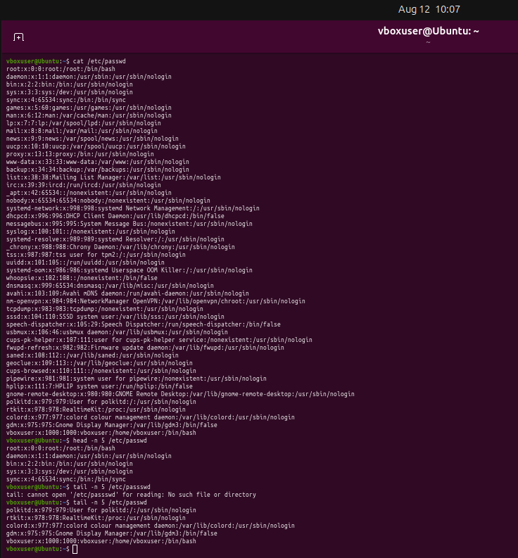

3.Searching for Patterns
Use grep to find all lines containing the word "root" in /etc/passwd.
Sol’n:
vboxuser@Ubuntu:~$ cat /etc/passwd | grep root
root:x:0:0:root:/root:/bin/bash
nm-openvpn:x:984:984:NetworkManager OpenVPN:/var/lib/openvpn/chroot:/usr/sbin/nologin
vboxuser@Ubuntu:~$
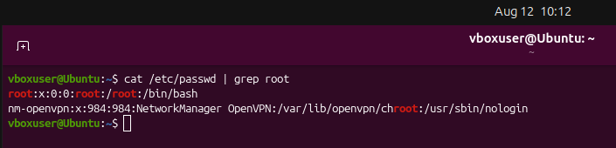

4. Zipping and Unzipping
Compress the test_dir directory into a file named test_dir.zip using zip.
Unzip test_dir.zip into a new directory named unzipped_dir.
Sol’n:
vboxuser@Ubuntu:~/tutedude/LinuxBasic$ sudo apt install zip
[sudo: authenticate] Password:
zip is already the newest version (3.0-15ubuntu3).
zip set to manually installed.
Summary:
Upgrading: 0, Installing: 0, Removing: 0, Not Upgrading: 129
vboxuser@Ubuntu:~/tutedude/LinuxBasic$ zip test_dir.zip test_dir
adding: test_dir/ (stored 0%)
vboxuser@Ubuntu:~/tutedude/LinuxBasic$ ls
test_dir test_dir.zip
vboxuser@Ubuntu:~/tutedude/LinuxBasic$ unzip test_dir.zip -d unzipped_dir
Archive: test_dir.zip
creating: unzipped_dir/test_dir/
vboxuser@Ubuntu:~/tutedude/LinuxBasic$ ls
test_dir test_dir.zip unzipped_dir
vboxuser@Ubuntu:~/tutedude/LinuxBasic$ cd unzipped_dir/
vboxuser@Ubuntu:~/tutedude/LinuxBasic/unzipped_dir$ ls
test_dir
vboxuser@Ubuntu:~/tutedude/LinuxBasic/unzipped_dir$
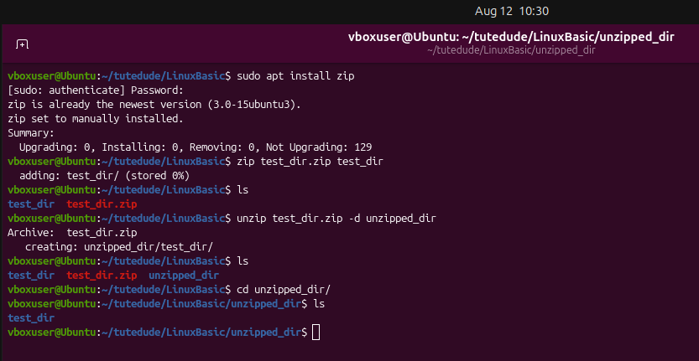

5. Downloading Files
Use wget to download a file from a URL (e.g., https://example.com/sample.txt).
Sol’n:
vboxuser@Ubuntu:~/tutedude/LinuxBasic$ wget https://sample-files.com/documents/txt/#google_vignette
--2026-08-12 10:51:21-- https://sample-files.com/documents/txt/
Resolving sample-files.com (sample-files.com)... 15.235.219.232
Connecting to sample-files.com (sample-files.com)|15.235.219.232|:443... connected.
HTTP request sent, awaiting response... 200 OK
Length: unspecified [text/html]
Saving to: ‘index.html’

index.html [ <=> ] 79.91K 443KB/s in 0.2s

2026-08-12 10:51:23 (443 KB/s) - ‘index.html’ saved [81830]

vboxuser@Ubuntu:~/tutedude/LinuxBasic$ ls
index.html test_dir test_dir.zip unzipped_dir
vboxuser@Ubuntu:~/tutedude/LinuxBasic$
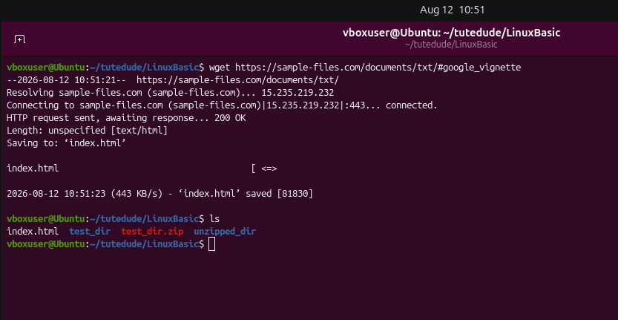

6. Changing Permissions
Create a file named secure.txt and change its permissions to read-only for everyone using chmod.
Sol’n:
vboxuser@Ubuntu:~/tutedude/LinuxBasic$ touch secure.txt
vboxuser@Ubuntu:~/tutedude/LinuxBasic$ ls
index.html secure.txt test_dir test_dir.zip unzipped_dir
vboxuser@Ubuntu:~/tutedude/LinuxBasic$ chmod a=r secure.txt
vboxuser@Ubuntu:~/tutedude/LinuxBasic$ ls
index.html secure.txt test_dir test_dir.zip unzipped_dir
vboxuser@Ubuntu:~/tutedude/LinuxBasic$ ls -l
total 92
-rw-rw-r-- 1 vboxuser vboxuser 81830 Aug 12 10:51 index.html
-r--r--r-- 1 vboxuser vboxuser 0 Aug 12 10:54 secure.txt
drwxrwxr-x 2 vboxuser vboxuser 4096 Aug 10 03:11 test_dir
-rw-rw-r-- 1 vboxuser vboxuser 168 Aug 12 10:27 test_dir.zip
drwxrwxr-x 3 vboxuser vboxuser 4096 Aug 12 10:29 unzipped_dir
vboxuser@Ubuntu:~/tutedude/LinuxBasic$
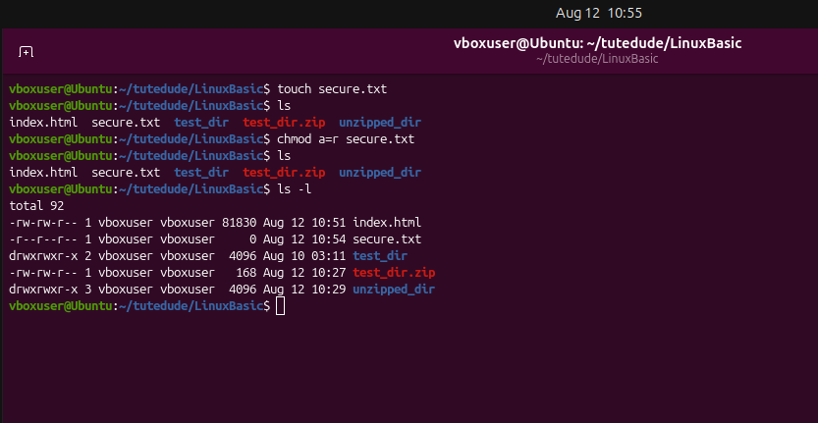

7. Working with Environment Variables
Use export to set a new environment variable called MY_VAR with the value "Hello, Linux!".
Sol’n:
vboxuser@Ubuntu:~/tutedude/LinuxBasic$ export MY_VAR="Hello, Linux!"
vboxuser@Ubuntu:~/tutedude/LinuxBasic$ echo $MY_VAR
Hello, Linux!
vboxuser@Ubuntu:~/tutedude/LinuxBasic$
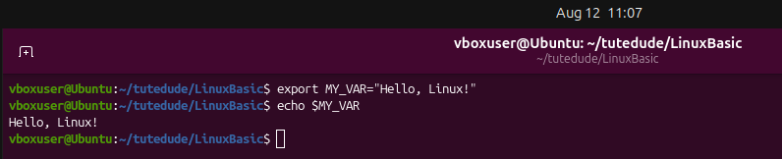

GitHub Repo Link: https://github.com/Nadeem-edu/tutedude-Devops/tree/main/Assignment1

