1. Grade Checker
Take a score as input and print the grade based on the following:
90+ : "A"
80-89 : "B"
70-79 : "C"
60-69 : "D"
Below 60 : "F", here we used a basic if else statement to carry out marks and all.
Sol’n:
# Q1. Grade Checker
score = int(input("Enter the Marks: \n"))

if score >=90:
grade = "A"

elif score >= 80:
grade = "B"

elif score >= 70:
grade = "C"

elif score >= 60:
grade = "D"

else:
grade = "F"

print("Your grade is:", grade)

Output:
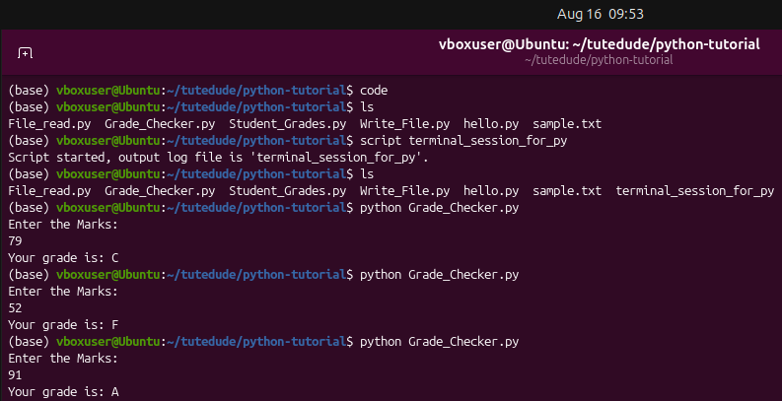
2 Student Grades
Create a dictionary where the keys are student names and the values are their grades. Allow the user to:
Add a new student and grade.
Update an existing student’s grade.
Print all student grades. Used dictionary and basic operations. Using if else:
Sol’n:
# Q2. Student Grades
SG = {'Tom':'B', 'Dick':'A', 'Harry':'C'}

choice = int(input("Type 1 - To Add New Student and Grade \nType 2 - To Update an Existing student's grade \nType 3 - To print all student's grade \n"))

if choice==1:
print("Enter Name and Grade of new student \n")
new_stdName = (input("Enter new student Value: \n"))
new_stdGrade = (input("Enter new student Grade: \n"))
SG[new_stdName]=new_stdGrade
print("List of Students after adding New Record: \n",SG)

if choice==2:
stdName = input ("Enter the student name to Update grade\n")
if stdName in SG:
upd_grade = input("Enter new grade: \n")
SG[stdName] = upd_grade
print(SG)
else:
print("Student Not found.,,")

if choice==3:
print("All Students with Grades are below: \n",SG)

Output:
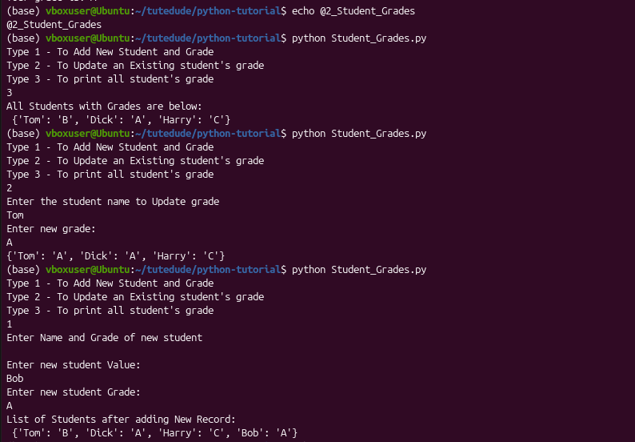
3.Write to a File
Write a program to create a text file and write some content to it.
Using file functions like write and open.
Sol’n:
# Q3. Program to Create a text file and write some content to it
filename = "sample.txt"

file = open(filename, "w")

user_input = input("Enter the content you want to add in the file: \n")
file.write(user_input)

file.close()
print("file saved...")

file = open(filename, "r")

content = file.read()
print ("\n The content of file is displayed below: \n")
print(content)

file.close()

Output:
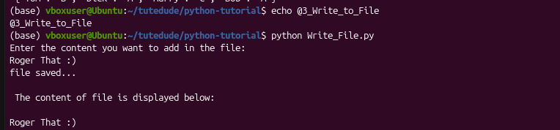
4. Read from a File
We used open in read mode and file.read to read and print to display.
Sol’n:
# Q4. Open a file in read mode using file.read() to dispaly its content
filename = "sample.txt"

file = open(filename, "r")

content = file.read()
print ("\n The content of file is displayed below: \n")
print(content)

file.close()

Output:
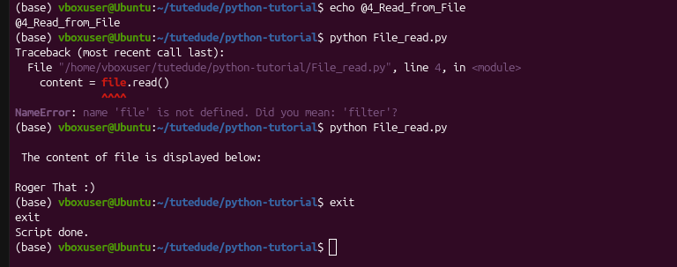

Submission Guidelines -: Attach Screenshots or command along with explanation and submit in doc(google doc or microsoft doc) format or share github link

Github Link: https://github.com/Nadeem-edu/tutedude-Devops.git >> Python

