Task 2: Frontend Form with MongoDB Atlas
- Create a form on the frontend that, when submitted, inserts data into MongoDB Atlas.
- On success: the user should be redirected to another page displaying the message “Data submitted successfully”.
- On error: display the error on the same page without redirection.
Sol’n:
#Q2. Task-2: Frontend Form with MongoDB Atlas
from flask import Flask, request, render_template, jsonify, url_for
from dotenv import load_dotenv
import os
import pymongo
from pymongo.errors import ConnectionFailure, PyMongoError

load_dotenv()

MONGO_URI = os.getenv('MONGO_URI')

try:
client = pymongo.MongoClient(MONGO_URI)
db = client.test
collection = db['flaskDB']

client.server_info()

except (ConnectionFailure, PyMongoError):
collection = None

app = Flask(__name__)

@app.route('/')
def home():
return render_template('index.html')

@app.route('/submit', methods=['POST'])
def submit():

if collection is None:
return jsonify({"error": "DB connection failed."}), 503

form_data = dict(request.form)

if not form_data or not any(form_data.values()):
return 'No data provided', 400

try:
collection.insert_one(form_data)
return render_template('success.html'), 200

except PyMongoError as e:
return jsonify({"error":f"Failed to save data to DB: {str(e)}"}), 500

@app.route('/success')
def success():
return render_template('success.html')

@app.route('/view')
def view():

data = collection.find()

data = list(data)

for i in data:
print(i)
del i['_id']

data = {
'data':data
}
return data

if __name__=='__main__':
app.run(debug=True)

Output:
Error Displayed on same screen when user is passing a null value “Please fill out this field” without redirecting to another page
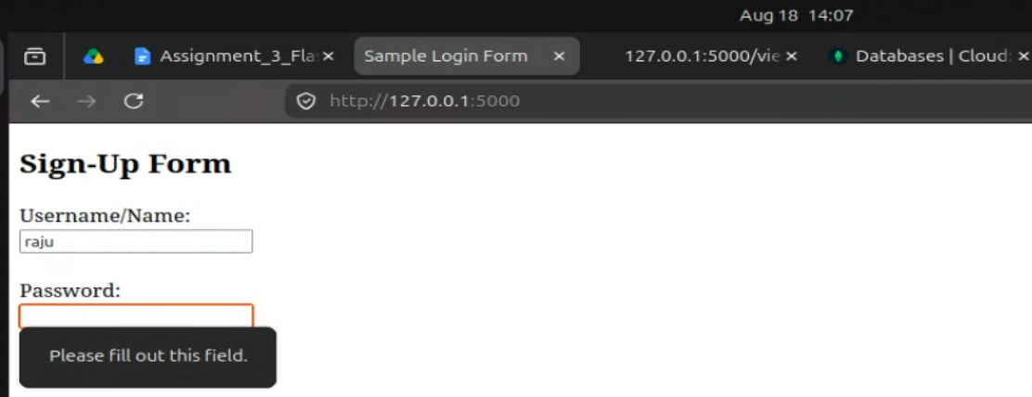

Values in MongoDB database:
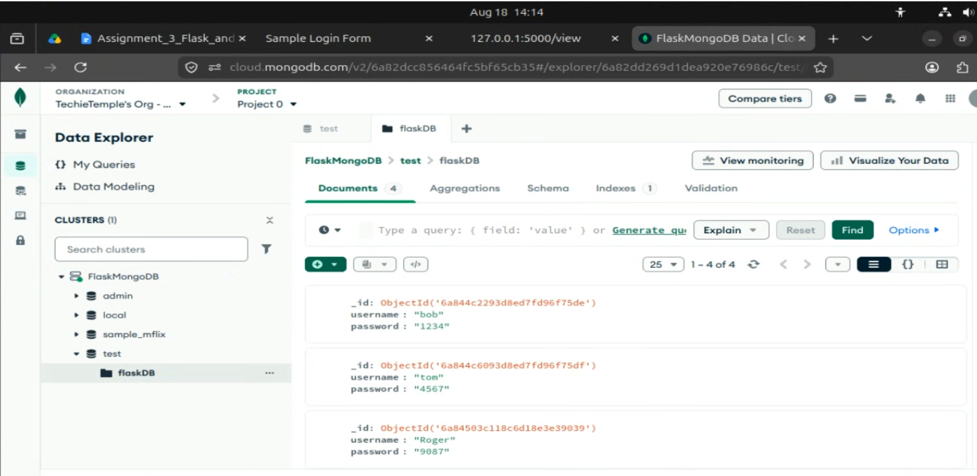

Success.html
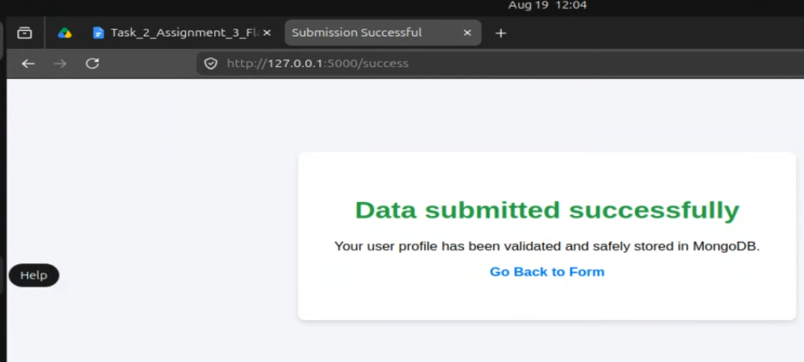

/View page to view data of mongodb container
